Migratory Determinants Between Member-States of the OECD

Table of Contents

# Citations in papaja, detele appropriately later

Add the bibtex entry in the .bib file. You can find the entries in Google scholar, but double check since it is not always correct.

Call the citations in the text:

Citation within parentheses (Aust and Barth 2020)

Multiple citations (Aust and Barth 2020; R Core Team 2021)

In-text citations Aust and Barth (2020)

Year only (2021)

Only if your citation appears in the text it will also show up in the Reference list. Don’t manually modify the Reference list.

## Executive Summary

(150 words) – 0.3 POINTS Summarize the report. Write this as the very last thing.

What is the main topic you are addressing?

what are your research questions and hypotheses?

what are your results and the main conclusion?

## Introduction

### Determinants of international migration

International migration is an important feature of global economy, continuously shaping the demographics of our globalized world. It is predicted that international migration is likely to grow and become more complex in the coming decades, due to factors such as an aging population, growing economic inequalities and climate change (Klugman 2009). As it has an impact on receiving as well as sending countries, researching why people migrate, how they choose their destination countries, and how this migration changes over time are important to better understand global trends and inform policy decisions.

One of the classical methods for investigating the determinants of migration are gravity models (Boyle, Keith, and others 2014), their main components are population size and geographical proximity. There are more factors that influence migration according to the available literature, and these are typically grouped in two categories: push and pull factors (Langley et al. 2016). Push factors are those associated with the country of origin of the migrant and are related to their decision to migrate, examples of these are natural disasters, violence, poverty, and unemployment. Pull factors are associated with the destination country of the migrant, these can be economic prosperity and employment opportunities, favourable climate, and political stability. Migration movements can also be encouraged by homophily in the dominant religion and language, which lower the expected costs of acculturation (Belot and Ederveen 2012).

### Network perspective

The flows of international migration naturally constitute a directed and valued network where nodes represent countries. The outbound edges are the number of citizens each country sends to every other country in the network, this way the inbound edges of a node represent the number of citizens received from each country. Characteristics describing the nodes and the edges between them can be included as covariates.

Statistical network analysis captures the interconnectedness of countries and allows for the influence of various factors on migration to be measured without assuming independence that does not hold in migration data (Desmarais and Cranmer 2012). Despite network analysis being suitable for modelling such phenomena, to this day surprisingly few studies have used this perspective to better understand international migration Windzio (2018).

An example of a study that looks at international migration from a network perspective was conducted by Windzio (2018). Their results from a global dataset were in line with the gravity models and theories of global inequality when examining the determinants of migration using temporal and cross-sectional exponential random graph models (ERGMs). ERGM is a method for statistical inference on networks, which, given a number of statistics that capture the essential generative structures of the network, estimates the probability of the observed network (Cranmer and Desmarais 2011). This method takes into account the interdependent nature of migration and allows for modelling both endogenous dependencies and exogenous covariates of the network. Instead of flows of migrants, however, Windzio (2018) used data on stocks of persons born in a different country, and instead of looking at the number of migrants, they used quartiles of the measure of the migration distribution in order to reduce the data into a binary network. While ERGMs are a ubiquitous means of network analysis, their inability to model networks with valued edges is a strong limitation for modelling migration networks, as thresholding weighted edges into binary ones leads to a considerable loss of information on the vastly different magnitudes of migration that different edges of the network represent.

The generalized exponential random graph model (GERGM), developed by Desmarais and Cranmer (2012), is a method that generalizes ERGMS to be used for value-edged networks, making it suitable for studying migration networks. Desmarais and Cranmer (2012) used GERGMs to model interstate migration flows within the United States, and Abramski (2018) used the method to study refugee migration flows from four countries experiencing violent conflicts, finding that the GERGM is a better way for modelling this specific problem compared to the ERGM.

### Our research

In this report, we aim to contribute to the literature on international migration by examining it from a network perspective using generalized random graph models. Using a dataset of migration flows within the member countries of the Organization for Economic Co-operation and Development (OECD) in 2019, we look at the properties of this network and set up a model on the determinants of international migration.

Using the network perspective, it becomes possible to quantify the network properties of the international migration network. It is generally assumed that migration networks exhibit a high level of clustering (Fagiolo and Mastrorillo 2013), but to statistically test this proposition, we apply a conditional uniform graph (CUG) test. We focus our attention to clustering only, as this is a network-level measure for which a generalization has been proposed and implemented which is suitable for weighted networks (Opsahl and Panzarasa 2009).

*Research question 1: Does the international migration network of the OECD countries exhibit a high degree of clustering?*

*Hypothesis 1: The international migration network of the OECD countries exhibits a high degree of clustering.*

We examine the effects of several driving factors of migration suggested by earlier literature: population, population density, shared borders, shared language, shared religion, GDP, crime index, freedom index, and unemployment rate Windzio (2018). Our contribution is examining this subject from the network perspective and employing GERGM, a model that is highly suitable for this kind of data but has not been used in the research of international migration before. This model allows for the inclusion of endogenous effects, regarding which we hypothesise that there is no significant reciprocity in the network, similarly to the interstate migration network within the United States studied by Desmarais and Cranmer (2012).

*Research question 2: What factors drive migration within the OECD countries?*

*Hypothesis 2: Large population, high population density, low GDP, high crime, low freedom, and high unemployment rate are push factors of international migration within OECD countries.*

*Hypothesis 3: Large population, high population density, high GDP, low crime, high freedom, and low unemployment rate are pull factors of international migration within OECD countries.*

*Hypothesis 4: Sharing the same dominant language, religion, as well as sharing borders increases migration between OECD countries.*

*Hypothesis 5: The international migration network of the OECD countries does not exhibit reciprocity.*

The structure of the rest of the report is as follows. The method section explains the data used in this study, and the methods we use to run our analysis. Subsequently, the results section presents and discusses the outcomes of the analysis for each research question respectively. Finally, the report is closed with a short conclusion section.

## Methodology

### Dataset

(about 500 words) 1 POINT (+ BONUS) * Which data set are you going to use? Three options:

o Use readily/easily available data (0 bonus points)

o Combine two or more existing datasets (max 0.5 bonus points)

o Scrape or collect your own data (max. 1 bonus point)

* Clearly explain where the data is coming from:

o Who collected the data?

o What is the source?

o When was the data produced?

o How was the data collected?

* Provide descriptive measures of your data (tables, plots, etc.)
* Why is this data useful to study your topic and answer your research questions?
* What is the potential bias in the data? How does this affect your results?

### Data analysis (Research Rationale)

(about 500 words) – 1 POINTS * Why are these two methods suitable for your data?

* Why are these two methods suitable for your research questions?
* Are there other methods to address these questions? If yes, why are the methods you chose better for this case?

## Results

(about 2000 words)

### Model 1

(about 1000 words) – 2.5 POINTS

* Present your results appropriately (plots, tables…) and discuss your findings in plain English
* Discuss the meaning of your findings in relation to your hypothesis. (half of the points evaluated in this other part)

|  |  |  |
| --- | --- | --- |
| age | gender | eyes_col |
| 7 | M | BLUE |
| 8 | F | BROWN |
| 8 | M | GREEN |
| 7 | F | PINK |

### ERGM

(about 1000) – 2.5 POINTS

* Present your results appropriately (plots, tables…) and discuss your findings in plain English
* Discuss the meaning of your findings in relation to your hypothesis. (half of the points evaluated in this other part)

Option 1:

|  |  |
| --- | --- |
|  | Model 1 |
| (Intercept) | 5.03 *** |
|  | (0.22) |
| groupTrt | -0.37 |
|  | (0.31) |
| R^2 | 0.07 |
| Adj. R^2 | 0.02 |
| Num. obs. | 20 |

Option 2

|  |  |  |
| --- | --- | --- |
|  | Model 1 | Model 2 |
| (Intercept) | 5.03 *** |  |
|  | (0.22) |  |
| groupTrt | -0.37 | 4.66 *** |
|  | (0.31) | (0.22) |
| groupCtl |  | 5.03 *** |
|  |  | (0.22) |
| R^2 | 0.07 | 0.98 |
| Adj. R^2 | 0.02 | 0.98 |
| Num. obs. | 20 | 20 |

Option 3

## Model: bars denote 0.5 (inner) resp. 0.95 (outer) confidence intervals (computed from standard errors).

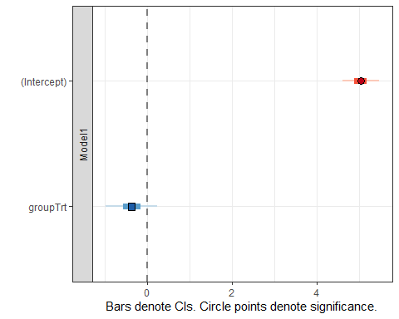

Option 4

## Models: bars denote 0.5 (inner) resp. 0.95 (outer) confidence intervals (computed from standard errors).

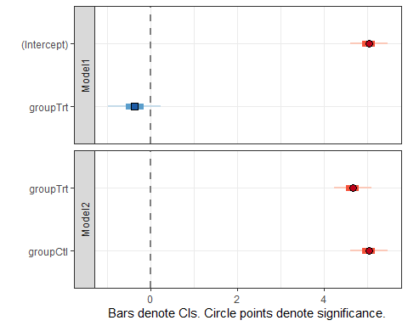

## Conclusion

(about 350 words) – 0.7 POINTS What were your topic and research questions again? (1 sentence)

What did you learn from the two analysis you run? *** most important point to address 0.5 POINTS here

Who benefits from your findings?

What does remain an open problem?

Can you give suggestions for future work in this area?

# References

Abramski, Katherine E. 2018. *A Network Based Analysis of the International Refugee Crisis Using GERGMs*. University of Rhode Island.

Aust, Frederik, and Marius Barth. 2020. *papaja: Create APA Manuscripts with R Markdown*. <https://github.com/crsh/papaja>.

Belot, Michèle, and Sjef Ederveen. 2012. “Cultural Barriers in Migration Between OECD Countries.” *Journal of Population Economics* 25 (3): 1077–1105.

Boyle, Paul, Halfacree Keith, and others. 2014. *Exploring Contemporary Migration*. Routledge.

Cranmer, Skyler J, and Bruce A Desmarais. 2011. “Inferential Network Analysis with Exponential Random Graph Models.” *Political Analysis* 19 (1): 66–86.

Desmarais, Bruce A, and Skyler J Cranmer. 2012. “Statistical Inference for Valued-Edge Networks: The Generalized Exponential Random Graph Model.” *PloS One* 7 (1): e30136.

Fagiolo, Giorgio, and Marina Mastrorillo. 2013. “International Migration Network: Topology and Modeling.” *Physical Review E* 88 (1): 012812.

Klugman, Jeni. 2009. “Human Development Report 2009. Overcoming Barriers: Human Mobility and Development.” *Overcoming Barriers: Human Mobility and Development (October 5, 2009). UNDP-HDRO Human Development Reports*.

Langley, S, M Vanore, M Siegel, I Roosen, M Rango, I Leonardelli, and F Laczko. 2016. “The Push and Pull Factors of Asylum Related Migration: A Literature Review.” *European Asylum Support Office*.

Opsahl, Tore, and Pietro Panzarasa. 2009. “Clustering in Weighted Networks.” *Social Networks* 31 (2): 155–63.

R Core Team. 2021. *R: A Language and Environment for Statistical Computing*. Vienna, Austria: R Foundation for Statistical Computing. <https://www.R-project.org/>.

Tranos, Emmanouil, Masood Gheasi, and Peter Nijkamp. 2015. “International Migration: A Global Complex Network.” *Environment and Planning B: Planning and Design* 42 (1): 4–22.

Windzio, Michael. 2018. “The Network of Global Migration 1990–2013: Using ERGMs to Test Theories of Migration Between Countries.” *Social Networks* 53: 20–29.