Game Design Document

Fill up the Following document

1. Write the title of your project.

Basket Ball Race

1. What is the goal of the game?

Each of the players has to come 1st in car racing by putting the basketball into the basket. Whenever the player puts the ball in to the basket, his car moves forwards to finish line.

1. Write a brief story of your game?

1. Which are the playing characters of this game?

* Playing characters are the ones which respond to the user based on the input from the user
* Cars, monkeys, dinos, wizards etc, are the playing characters in the game.

|  |  |  |
| --- | --- | --- |
| Number | Character Name | What can this character do? |
| 1 | Car1 |  |
| 2 | Car2 |  |
| 3 |  |  |
| 4 |  |  |
| 5 | Ball1 |  |
| 6 | Ball2 |  |
| 7 |  |  |
| 8 |  |  |

1. Which are the Non Playing Characters of this game?

* Non Playing characters are the ones which don't have an action or a behaviour when the user interacts with the game.
* Hurdles, stones, bananas, coins, etc are non playing characters in the game.

|  |  |  |
| --- | --- | --- |
| Number | Character Name | What can this character do? |
| 1 | Basket1/net1 |  |
| 2 | Basket2/net2 |  |
| 3 |  |  |
| 4 |  |  |
| 5 |  |  |
| 6 |  |  |
| 7 |  |  |
| 8 |  |  |

Draw your imagination of this game. What does this game look like?

* Draw the game either on your computer or on paper,
* Add images of scenes of the game to show each of the playing and non-playing characters at least once.

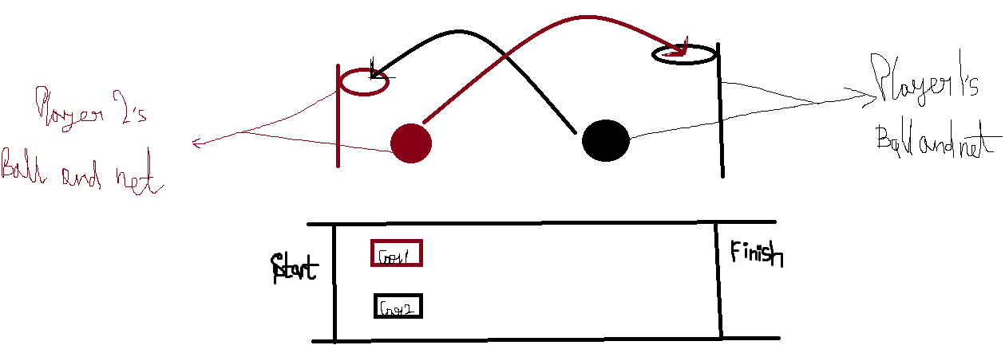

How do you plan to make your game engaging?

No plans

-Ritam Pore