ERD Diagram
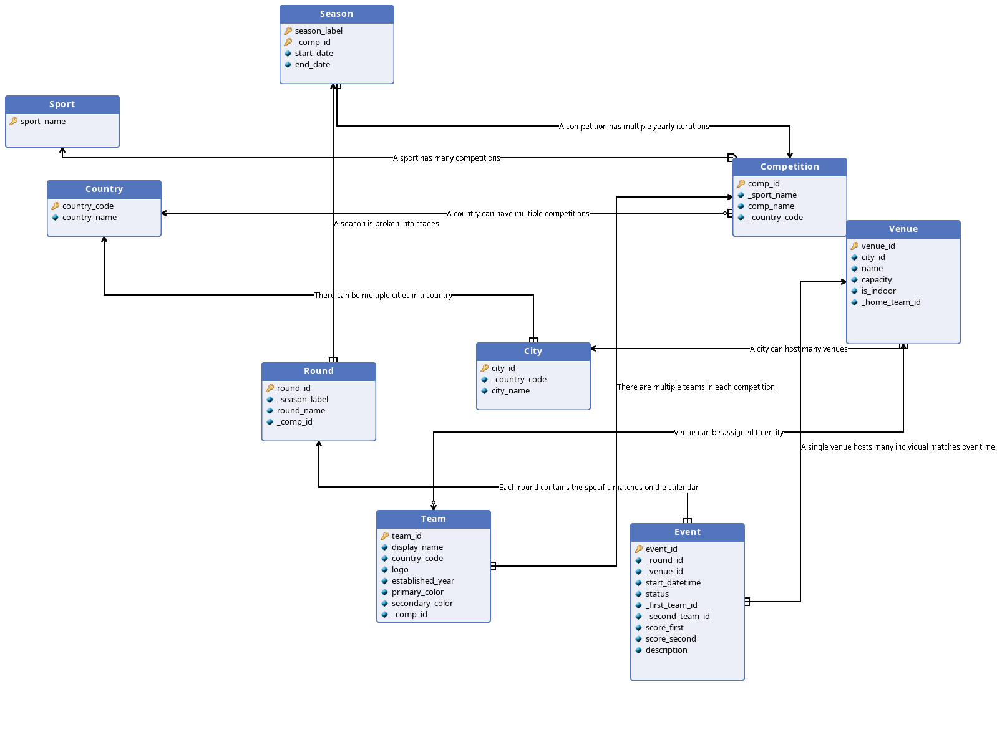
Entity Description
Sport
Name | Primary key | Type | Description
sport_name | Yes | VARCHAR(30) | The primary name of the sport

Competition
Name | Primary key | Type | Description
comp_id | Yes | SERIAL | Unique identifier for a tournament or league body
_sport_name | No | VARCHAR(50) | Categorizes the competition by sport type
comp_name | No | VARCHAR(255) | The specific name of the league
_country_code | No | INT | Country code of country where the competition is played

Season
Name | Primary key | Type | Description
season_label | Yes | VARCHAR(20) | The year or date range
_comp_id | Yes | SERIAL | Links the season to the specific league
start_date | No | DATE | The start of the official calendar window for the season
end_date | No | DATE | The end of the official calendar window for the season

Country
Name | Primary key | Type | Description
country_code | Yes | CHAR(3) | Unique 3-letter identifier (ISO 3166-1 alpha-3)
country_name | No | VARCHAR(70) | he full common name of the nation

City
Name | Primary key | Type | Description
city_id | Yes | SERIAL | Unique identifier for the city
_country_code | No | CHAR(3) | Links the city to its parent nation
city_name | No | VARCHAR(70) | The official name of the municipality

Venue
Name | Primary key | Type | Description
venue_id | Yes | SERIAL | Unique identifier for the stadium or arena
city_id | No | SERIAL | The city where the venue is physically located
name | No | VARCHAR(255) | The current commercial or traditional name of the venue
capacity | No | INT | Total number of spectators the venue can hold
is_indoor | No | BOOLEAN | A flag indicating if the venue has a roof/dome
_home_team_id | No | SERIAL | Links the venue to the entity

Team
Name | Primary key | Type | Description
team_id | Yes | SERIAL | A unique ID for any participant
display_name | No | VARCHAR(2150 | The name shown on scoreboards or broadcasts
country_code | No | CHAR(3) | Represents the entity's nationality or home nation
logo | No | BYTEA | Stores the logo of a team
established_year | No | INT | Shows which year the team was established
primary_color | No | VARCHAR(10) | Primary color of a table
secondary_color | No | VARCHAr(10) | Secondary color of a table
_comp_id | No | INT | References the competition id where teams starts

Event
Name | Primary key | Type | Description
event_id | Yes | SERIAL | Unique ID for an individual game
_round_id | No | SERIAL | Situates the match within the tournament structure
_venue_id | No | SERIAL | Where the match is Yesing place
start_datetime | No | DATETIME | The scheduled start of the game
status | No | VARCHAR(20) | The current state
_first_team_id | No | INT | Links the first team
_second_team_id | No | INT | Links the second team,
score_first | No | INT | The score of the first team
score_second | No | INT | The score of the second team
description | No | TEXT | Describes an event

Round
Name | Primary key | Type | Description
round_id | Yes | INT | Unique identifier for a specific stage
_season_label | No | VARCHAR(20) | Links the round to a specific year/iteration
round_name | No | VARCHAR(80) | The name of the stage
_comp_id | No | INT | The second part of season composite key

Relation description
Name | Entity 1 | Entity 2 | Relation type
There can be multiple cities in a country | City | Country | 1..n : 1
A sport has many competitions | Sport | Competition | 1 : 1..n
A competition has multiple yearly iterations | Competition | Season | 1 : 1..n
A season is broken into stages | Season | Round | 1 : 1..n
Each round contains the specific matches on the calendar | Round | Event | 1 : 1..n
A city can host many venues | City | Venue | 1 : 1..n
A single venue hosts many individual matches over time. | Venue | Event | 1 : 1..n
Venue can be assigned to entity | Team | Venue | 0..1 : 1
There are multiple teams in each competition | Team | Competition | 1..n : 1
A country can have multiple competitions | Country | Competition | 1 : 0..n

Relational database schema
Sport (PK: sport_name)
Country (PK: country_code, country_name)
City (PK: city_id, _country_code REF Country, city_name)
Competition (PK: comp_id, _sport_name REF Sport, comp_name, _country_code REF Country)
Season (PK: [season_label, _comp_id], start_date, end_date)
_comp_id REF Competition
Round (PK: round_id, [_season_label, _comp_id] REF Season, round_name)
Team (PK: team_id, _sport_name REF Sport, display_name, _comp_id REF Competition, logo, established_year, primary_color, secondary_color)
Venue (PK: venue_id, _city_id REF City, name, capacity, is_indoor, _home_team_id REF Team)
Event (PK: event_id, _round_id REF Round, _venue_id REF Venue, start_datetime, end_datetime, status, _first_team_id REF Team, _second_team_id REF Team, score_first, score_second, description)
This database will also include Views for each league.
Example view for a football league:
CREATE VIEW public.view_standings_premier_league AS
WITH matchstats AS (
SELECT e._first_team_id AS team_id,
CASE
WHEN (e.score_first > e.score_second) THEN 3
WHEN (e.score_first = e.score_second) THEN 1
ELSE 0
END AS points,
e.score_first AS goals_scored,
e.score_second AS goals_conceded,
e.event_id
FROM (public.event e
JOIN public.round r ON ((e._round_id = r.round_id)))
WHERE (((e.status)::text = 'final'::text) AND (r._comp_id = 3) AND ((r._season_label)::text = '2025-26'::text))
UNION ALL
SELECT e._second_team_id AS team_id,
CASE
WHEN (e.score_second > e.score_first) THEN 3
WHEN (e.score_second = e.score_first) THEN 1
ELSE 0
END AS points,
e.score_second AS goals_scored,
e.score_first AS goals_conceded,
e.event_id
FROM (public.event e
JOIN public.round r ON ((e._round_id = r.round_id)))
WHERE (((e.status)::text = 'final'::text) AND (r._comp_id = 3) AND ((r._season_label)::text = '2025-26'::text))
)
SELECT rank() OVER (ORDER BY (sum(ms.points)) DESC, (sum(ms.goals_scored) - sum(ms.goals_conceded)) DESC, (sum(ms.goals_scored)) DESC) AS "Pos",
t.display_name AS "Team",
count(ms.event_id) AS "Pld",
count(*) FILTER (WHERE (ms.points = 3)) AS "W",
count(*) FILTER (WHERE (ms.points = 1)) AS "D",
count(*) FILTER (WHERE (ms.points = 0)) AS "L",
sum(ms.goals_scored) AS "GS",
sum(ms.goals_conceded) AS "GC",
(sum(ms.goals_scored) - sum(ms.goals_conceded)) AS "GD",
sum(ms.points) AS "PTS"
FROM (public.team t
JOIN matchstats ms ON ((t.team_id = ms.team_id)))
GROUP BY t.team_id, t.display_name;

