Data is influenced by how it is collected and presented. For example, a company-sponsored survey might emphasize results that favour its product. Even a chart’s colour scheme, scale, or title can shape how people interpret the information. Asking questions about the source and purpose of data helps determine whether it’s trustworthy.
Beyond how data is presented, data literacy also requires adaptability. Tools, systems, and dashboards change frequently. Reports are updated, metrics shift, and trends evolve. Checking dates, noticing version numbers, and reviewing updates before relying on results helps prevent mistakes and builds confidence in the information being used.
Developing awareness, curiosity, and flexibility with data supports better decisions in every area of life. These skills help ensure that evidence, rather than assumptions, guides decisions.
PERSONAL DATA SOURCES.
- Social media
Social media apps collect information about what you like, share, and follow. The apps use this data to show posts, videos, and ads that match your interests. Paying attention to what you interact with provides insights into how your online activity shapes what you encounter each day.
For example, liking a few vacation photos might lead to more travel posts and suggestions for new connections who share similar interests.
- Fitness trackers
Fitness trackers collect data about your steps, heart rate, and sleep patterns. This information helps you identify trends in your activity and set realistic goals over time.
For example, your tracker might show that you sleep better on days when you walk more, which can help you adjust your routine.
- Digital entertainment
Streaming platforms record what you watch or listen to, and how you rate content. Platforms use this data to recommend shows, music, or movies that align with your preferences.
For example, watching several cooking shows could lead to recommendations for food documentaries or recipe videos.
- Online shopping
Online stores track what you view, add to your cart, and buy. Based on this information, stores recommend products you might want to buy. Reviewing your shopping data can help you identify spending patterns and frequently purchased items.
For example, order history can be used to compare prices, reorder supplies, or recognize how your interests have changed over time.

Actions such as browsing, shopping, and messaging generate data. Understanding these personal sources is the first step in recognizing how data is created and used. The same thinking applies in the workplace, where data also supports decisions and improves results.

Data in the workplace
Organizations rely on data to make informed decisions every day. Across departments, teams collect information, look for patterns, and use evidence to guide their actions.

Sales analytics
Sales data tracks purchases and customer orders to reveal trends. Sales teams use this information to plan marketing efforts, forecast demand, and identify products that need additional support.

Customer behaviour
Customer behaviour data shows how users interact with websites and apps. Product teams analyse clicks, time on pages, and support requests to understand what works well and where users experience difficulty, helping prioritize updates and improvements.

Inventory management
Inventory management data tracks stock levels and delivery times. Organizations use this information to reorder products before they sell out, reducing errors and preventing shortages.

Hiring decisions
Hiring data includes information from applications, interviews, and performance reviews. Organizations use this data to match candidates’ skills with job requirements and identify patterns that might reveal bias in hiring processes.

In each case, organizations collect relevant data, identify meaningful patterns, and use insights to improve results and plan.

WHAT IS BIG DATA?
Big data refers to large, complex datasets that traditional data systems cannot easily or efficiently store, manage, or analyse. Big data includes data created in high volume, at high speed, and in many different formats.
This massive growth underscores the importance of understanding big data. Big data has five key dimensions called the 5 V’s:

- Volume

- Velocity

- Variety

- Veracity

- Value

These dimensions explain the size, speed, types, trustworthiness, and usefulness of data.
Because big data is too large and complex to analyse manually, organizations rely on artificial intelligence (AI).
Artificial intelligence, or AI, is the ability of machines to perform tasks using algorithms that mimic tasks such as pattern recognition, language understanding, and decision-making assistance.
AI processes millions of data points in seconds, uncovering patterns people might miss. For example, in hospitals, AI analyses patient data in real time to alert doctors to early warning signs, enabling faster responses.
In everyday life and at work, AI helps organize complex data so people can focus on making informed decisions rather than sorting information.

The impact of big data
Big data influences decisions people and organizations make every day. In daily life, data helps individuals make decisions about health, learning, and finances. At work, data helps teams plan, solve problems, and reach goals.
Personal life.
Big data combines individual information with data from millions of others, allowing people to compare habits and outcomes.
Some examples include:
- Fitness trackers that compare your activity to broader trends
- Learning platforms that identify effective study methods
- Financial apps that reveal spending patterns across similar users
These insights help place personal behaviour in context and support realistic goal setting.
Workplace.
Organizations analyse data from thousands or millions of sources to detect patterns that individual records cannot show.
Some examples include:
- Hiring teams analysing performance data to predict success and reduce bias
- Factories monitoring sensor data to prevent equipment failures
- Marketing teams analysing customer interactions to predict purchasing behaviour
The scale of big data allows organizations to anticipate trends, allocate resources efficiently, and respond to issues before they escalate.

POINTS TO REMEMBER.
Where does data come from?
Every day, the world generates 2.5 quintillion bytes of data.¹ If you tried to download all of that information using a home internet connection, it would take more than 1.8 billion years. Much of this data is created through everyday activities, every purchase, message sent, and task completed produces small pieces of information that add up quickly.
But where does all this data come from?
When working with data in a business context, it helps to think about three primary sources: internal, external, and open.
Understanding how these sources differ makes it easier to identify which data is most useful for a given situation and where to find the data when you need it.

INTERNAL DATA.
Internal data is information generated within an organization. Organizations use internal data to understand daily operations, track performance, and make routine decisions. This data helps answer questions such as “Which products are selling?” or “When do we need more staff?”.
Sources of internal data include the following:
- Sales records
- Website analytics
- Support tickets
- Employee schedules
- Inventory counts

EXTERNAL DATA.
External data is generated outside an organization. It helps organizations understand broader context, such as market conditions, customer sentiment, and competitor performance, beyond what internal data can show.
External data provides perspective and comparison, allowing organizations to benchmark performance and identify trends they might otherwise miss.
Sources of external data include the following:
- Social media posts and comments
- Sensor data from company products
- Market research reports
- News articles
- Government statistics
- Competitor websites
- Industry surveys

OPEN DATA.
Open data is publicly available information that does not belong to any single organization. It is freely accessible, reusable, and often published by governments, research institutions, and nonprofit organizations to promote transparency and innovation.
Open data powers tools such as weather apps, mapping services, and public research projects.
Sources of open data include the following:
- Census data
- Weather records
- Public transit schedules
- Scientific research datasets
- City budget information

HOW IS DATA COLLECTED?
DATA COLLECTION METHODOLOGIES.
Marcus used several methods to collect data directly for his coffee shop. The methods Marcus used aren’t the only options. Marcus and other organizations can use data that has already been gathered by someone else. These pre-collected data sources save time and money, though each comes with its own trade-offs.
Pre-collected data types
Understanding the differences between syndicated, third-party and custom data helps you choose the right source, clarifies how each type serves unique organizational needs, and supports better decision-making.
Syndicated data
Research firms collect and sell syndicated data to multiple organizations. Syndicated data helps companies understand markets, consumer behaviour, and industry trends without conducting their own large-scale data collection.
Third-party data
One organization collects third-party data, then sells or shares it with other organizations. For example, browsing data collected by websites might be used by advertisers. Because this data involves user behaviour, organizations must carefully consider quality, consent, and privacy.
Custom data
An organization collects custom data specifically to answer a particular question. For example, a company might run a survey about a new product. Custom data is tailored to unique needs, making it highly relevant but often more time-consuming and costly to collect.

Which data handling tools are useful?
Data tools are like kitchen tools. They help transform raw ingredients into something useful. Just as cooking requires different tools for chopping, cooking, and serving, working with data requires tools for storing information, analysing patterns, and presenting insights.
Data storage tools
When working with information, you need a way to keep it safe and easily retrieve it later. Data storage tools fill this need.
Data storage tools are software systems that save information for future use.
These tools store everything from business records to shared documents, forming the foundation of all data work.

DATABASES.
Databases store structured data that can be searched and updated quickly. They support daily tasks such as managing customer records, sales data, or inventory. For example, organizations use MySQL to manage such tasks.
DATA WAREHOUSES.
Data warehouses combine data from multiple sources into one system optimized for reporting and trend analysis. For example, businesses might use IBM data warehouse solutions for these types of tasks.
CLOUD STORAGE.
Cloud storage allows files to be stored, accessed, and shared online, supporting collaboration across locations. For example, Google Drive is a cloud storage platform.
Storage tools keep data safe and organized, but storing information is only the first step. Once data is stored, it needs to be cleaned, sorted, and examined to find valuable insights.
Data manipulation and analysis tools
When you work with information, you often start with messy, unorganized raw data that doesn’t make much sense on its own. Data manipulation and analysis tools can help you clean, organize, and examine this raw data.
Data manipulation and analysis tools are programs or methods that you can use to organize, transform, and analyse data to identify patterns, answer questions, or make decisions.
These tools clean data, sort it into tables, and create summaries that support decision-making.
Spreadsheets
Spreadsheets support basic analysis, calculations, and charts, making them useful for everyday decisions and simple reports.
For example, a sales manager might use Microsoft Excel to track monthly sales and quickly create a chart to understand which products are selling best.
Structured query language
Structured Query Language, or SQL, is a language used to query databases so you can search, filter, combine, and summarize data stored in databases. SQL helps people extract specific information from large datasets.
For example, a retail analyst uses SQL to retrieve last quarter’s sales data for a specific region to compare how different stores performed.
Data processing platforms
Data processing platforms, such as Hadoop, are designed to handle very large datasets that are too large for traditional tools. These platforms help organizations analyse vast amounts of information quickly and efficiently.
For example, a telecommunications company uses a data processing platform to analyse network traffic data from millions of users to find patterns and improve service.
AI-powered analytics
AI-powered analytics tools use machine learning to detect patterns, make predictions, and automate insights. Responsible use is important to avoid bias and errors.
For example, a marketing team might use an AI analytics tool to identify emerging customer trends and automatically create reports with helpful recommendations.
After analysis tools help uncover patterns, trends, and answers in the data, the next challenge is communicating those findings clearly. To make insights easier to understand and share, the results often need to be presented visually for clarity.

Data visualization tools
Data visualization tools turn analytical results into clear visual formats, such as charts, graphs, and maps, making complex information easier to quickly understand. Visualization tools play a key role in telling an engaging, data-driven story.
A data visualization tool is software or an application that converts raw data into charts, graphs, maps, or other visual formats.
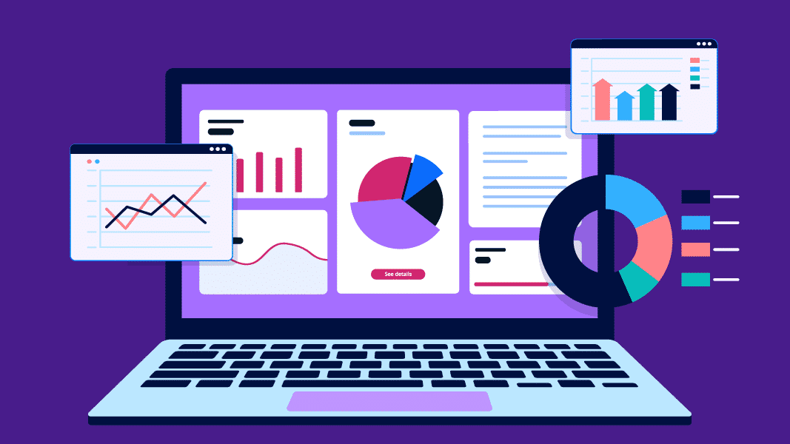
Data visualization tools help organizations turn complex data into clear and useful insights. Using the right visualization can help teams monitor progress, identify trends, and make decisions quickly.

Charts
Charts are simple visual representations, such as bar graphs or pie charts, often created in tools such as Microsoft Excel or PowerPoint. Charts provide a quick way to communicate trends, comparisons, or relationships in data. They are especially useful for visually sharing insights in meetings, presentations, or reports where clarity and speed are important.
For example, a project leader might create a bar chart comparing monthly expenses and present it in a team meeting to highlight cost-saving opportunities.
Dashboards
Dashboards provide organized, real-time views that consolidate key performance indicators (KPIs) and other important metrics into a single place. Dashboards help teams quickly monitor business health and performance, enabling faster decision-making. Tools such as Tableau and Power BI are often used to build dashboards that automatically update and highlight what matters most to organizations.
For example, a sales manager might use a dashboard to track daily sales, customer leads, and inventory levels, enabling them to quickly identify and respond to issues before they affect business operations.
Charts and dashboards help you communicate insights effectively, but it’s also important to understand how they fit into the broader data workflow of storing, analysing, and visualizing data.
Storage tools
Storage tools help keep raw digital data safe and organized, much like a filing cabinet. Storage tools serve as the foundation for securely storing all information before any analysis begins.
Analysis tools
Analysis tools help identify patterns and find answers in data, such as which products sell best each month. Analysis tools transform raw data into meaningful insights that guide decisions.
Visualization tools
Visualization tools help transform results into charts or graphs, making it easier to share insights with others. Visualization tools help communicate complex findings clearly through visuals and dashboards.

POINTS TO REMEMBER.
  - Data is generated constantly from everyday actions such as purchases, messages, and online activity, creating vast amounts of information that organizations analyse for insights.

  - Data sources in business are grouped into three main categories:
- Internal data comes from within the organization (for example, sales records, website analytics, support tickets), and supports operational decisions and performance tracking.
- External data comes from outside sources (for example, market reports, social media, government statistics), and helps businesses understand markets, trends, and competitors.
- Open data is freely available to the public (for example, census data, weather records, research datasets), and promotes transparency and innovation across industries.

  - Organizations collect data in several ways, depending on their needs:
- Syndicated data is purchased from research firms and shared across multiple organizations.
- Third-party data is gathered by one organization and sold to others, often for advertising or market insights.
- Custom data is collected for a specific purpose, such as a company-run survey or product test.

  - Working with data requires different kinds of tools, each serving a unique function:
    - Data storage tools, such as databases, data warehouses, or cloud systems, store and organize information.
    - Data analysis tools, such as spreadsheets, SQL, or AI analytics, clean, organize, and interpret data.
    - Data visualization tools, such as charts and dashboards, clearly and visually present findings.

WHY VISUALS MATTER?
When working with data, trends and relationships are often hard to identify using numbers alone. Data visualization converts numerical information into visual forms that make patterns easier to recognize, support deeper interpretation, and communicate insights clearly to others.
Data visualization turns numbers into charts, graphs, or maps, to make patterns easier to understand and identify.
Visualizations help identify trends, compare results, and detect outliers in data. They support better decisions, whether you’re working on a project, studying for school, or making business choices.
Different visual types tell different stories, even when they use the same data. For example, a line graph shows how sales change over time, while a pie chart using the same data shows how each product contributes to total sales.
Choosing the right visualization depends on what you want to communicate and who your audience is. A manager might want a quick snapshot of top-selling products, while a data analyst might look for long-term patterns. Selecting visuals intentionally helps ensure your message is clear and useful.
Data visualization in your daily life
Visualizations aren’t just used in classrooms or offices. People use charts and graphs every day on smartphones, smartwatches, and computers to make informed choices about health, finances, and energy use. Let’s see some applications:
Fitness dashboards display key health metrics, including the number of steps taken, sleep hours, and heart rate. These visualizations help people decide whether they need to walk more, get extra rest, or adjust their workout routines.
Financial apps use charts to show spending trends and budget breakdowns. These visuals help users identify where they spend the most money and identify opportunities to reduce expenses.
Smart home energy apps visualize energy use with charts and graphs. These tools help people understand when and how they use energy, enabling them to adjust routines and conserve power.

Data visualization in the workplace
Just as visualizations support personal decisions, they play a key role in workplace settings. Visual tools help teams quickly understand information, explain findings to others, track progress, and respond to changes.

SALES REPORTS
Sales reports use charts and graphs to compare results over time, such as months or quarters. These visuals help teams identify trends, forecast performance, and plan next steps.
PERFORMANCE DASHBOARDS.
Performance dashboards organize key performance indicators (KPIs) into a single location. Using gauges, graphs, and alerts, dashboards allow managers to monitor performance at a glance and respond quickly to issues.
PROJECT TRACKING APPS.
Project tracking apps use charts, such as progress charts, to show progress over time. These visuals help teams compare planned timelines with actual progress, enabling them to identify delays or risks early.
COMMON TYPES OF VISUALIZATIONS.
When you first start exploring data, everything can seem abstract. You encounter charts and graphs, but what does each one actually mean?
Let's break down the most common data visualizations and how to read them.
Say you're tracking your fitness progress. Maybe you're counting steps, logging workouts, or monitoring your heart rate. As your app collects these types of information, it displays the data using a variety of visualizations. Fitness apps often track how your fitness numbers change over time. A line chart is perfect for monitoring trends. Line charts use points connected by lines to demonstrate how values change over time. Line charts show whether values are increasing, decreasing, or remaining constant. Lines sloping upward indicate an increase. Downward sloping lines indicate a decrease. Waved lines indicate rhythms of increase and decrease, and straight lines indicate no change.
What type of visualization would you use to compare different parts of your training, such as the days, you're most active versus the days you're relaxing? For this type of comparison, your best option is a bar chart. Bar charts use horizontal or vertical bars to illustrate comparisons among different groups or categories. To read a bar chart, check the height of each bar. Taller bars mean higher values, and shorter bars mean lower values.
Sometimes you need to understand the range of your behaviours, such as how much time you spend in training sessions. Is the duration short, medium, or long? A histogram would be ideal in this case. Histograms display the distribution of numerical data by grouping data into bins. Histograms tell you how often something happened. The height of the bars is the key to interpreting the histogram. The tallest bars represent the most common values in your data, while the shorter bars represent the less common data values at other times. Your goal might be to examine how two variables interact, such as checking whether the number of steps you take affects your energy levels. A scatter plot uses dots to represent the values of two variables and just might be the most useful in this situation. A scatter plot shows you the relationship between your two variables. If the scatter plot shows a clear upward trend, then there's a positive relationship. Scattered points suggest a weak or even no relationship.
What if you want to find how your total training time breaks down across different activities? What visual tool would you use? The answer is a pie chart. Pie charts represent percentages of the whole, as in pie slices. The pie chart is ideal for displaying the composition of a whole. To read a pie chart, you just compare the size of each slice. Larger slices represent a greater proportion, while smaller slices represent smaller proportions.
Once you know what each visualization type communicates, interpreting data becomes much simpler. Data visualizations convert numbers into stories that are easy to understand. Whether you are tracking your personal fitness goals or analysing business data to identify trends, knowing which chart to use and how to read it helps you make informed, data driven decisions.

The right visualization can clarify complex data, but visualization alone isn’t enough. To use visualizations effectively, you also need to know how to read and interpret them correctly. Let’s explore what to search for in the different types of visualizations.
Reading visualizations
Viewing a chart is one thing, but interpreting it correctly is another. Data visualizations reveal patterns and trends at a glance, but understanding them requires knowing what to look for.
Just as reading text requires understanding letters and words, interpreting visualizations starts with understanding their key elements. Learning to recognize these components helps you obtain accurate information and avoid misinterpretation.
AXES
Axes form the edges of a chart and define what is being measured. The horizontal axis (along the bottom) usually shows categories such as time or product names, while the vertical axis (on the side) shows values such as sales or temperature.
For example, a weather chart displays temperature values along the horizontal axis and probability along the vertical axis.
LABELS.
Labels identify what each part of a chart represents. They explain categories, values, and units of measurement, helping readers understand exactly what is being compared.
For example, a bar chart labelled with student heights in inches helps clarify the values shown.
LEGENDS.
Legends explain what colours, shapes, or patterns represent. They are especially important when multiple data groups appear in a single chart.
For example, when using a donut chart to show customer segments, the legend matches each colour to a specific group.
SCALES.
Scales show the range and spacing of values on an axis. They affect how dramatic changes appear and can influence interpretation.
For example, the following two-line charts show the same increase in sales over time, but use different scales.
- In the chart on the left, the horizontal axis (time) is spread out, and the vertical axis (sales) uses a broader range, making the increase appear gradual.
- In the chart on the right, the horizontal axis is compressed, and the vertical axis is stretched, making the same data appear much steeper.
Although the underlying values are the same, the scale choices make the increase look more dramatic in the second chart.

Elements such as axes, labels, legends, and scales should appear in most charts to prevent misunderstandings and help with data interpretation. Each visualization type shows information in its own way, so knowing what to search for in each one helps extract the right insights.

BAR CHARTS
- What they’re used for:
  - Comparing values across different categories
- How to read them:
  - Notice the height or length of each bar. Examine the axis labels to confirm what is being measured.
- How to interpret them:
  - The tallest or longest bar shows the highest value. Use this to identify which category performs best or worst.
LINE GRAPHS.
- What they’re used for:
  - Showing how values change over time
- How to read them:
  - Follow the line from left to right. Notice where the line goes up, down, or stays flat.
- How to interpret them:
  - Upward slopes show increases, downward slopes show decreases, and flat sections show no change. Sharp changes indicate sudden shifts that might need attention.
PIE CHARTS.
- What they’re used for:
  - Showing how parts make up a whole
- How to read them:
  - Compare the size of each slice. Check the percentages or labels for exact values.
- How to interpret them:
  - Larger slices represent bigger portions of the total. Use this to identify which categories make up the majority.

SCATTER PLOTS.
- What they’re used for:
  - Showing relationships between two variables
- How to read them:
  - Notice how the dots are arranged across the chart. Notice whether they form any patterns.
- How to interpret them:
  - Dots forming an upward line show a positive relationship. Dots arranged in a downward line indicate a negative relationship. Scattered dots with no pattern suggest no clear relationship.

DASHBOARDS.
- What they’re used for:
  - Monitoring multiple metrics at once
- How to read them:
  - Scan the entire screen. Focus on highlighted numbers, color-coded alerts, or trend indicators.
- How to interpret them:
  - Green indicators typically show good performance, yellow shows concerns, and red shows problems. Use this for quick assessments of overall performance.

POINTS TO REMEMBER.

Visualizations make complex data easier to understand at a glance.

Data visualization turns information into visual formats for clearer decision-making.

Visuals such as line graphs, bar charts, and maps help people compare results, spot trends, and detect outliers.

Different visual formats highlight different aspects of the same data.
  - The best visual depends on the message and the audience’s needs.
  - Bar charts compare values across categories.
  - Line charts emphasize patterns over time.
  - Pie charts show how each part contributes to a whole.
  - Scatter plots reveal relationships between two variables by showing how data points are distributed.
  - Dashboards bring multiple charts and indicators together to give a quick overview of overall performance.

Organizations depend on visual tools to track performance and respond quickly.

The brain processes visuals much faster than text, making charts a powerful communication tool.

Understanding key parts of a chart helps accurate interpretation.
  - Axes show what is being measured.
  - Labels identify categories and values.
  - Legends explain colours or symbols.
  - Scales show value ranges and affect how data appears.

BEING A CRITICAL CONSUMER OF DATA.
Data influences many everyday decisions, from what people buy to how organizations solve problems. But not all data is trustworthy, and not all visualizations tell the whole story. Being a critical consumer of data means knowing how to question, evaluate, and interpret information before using it to make decisions.
Consider a marketing team that wants to send personalized emails to boost sales. They use online purchase data but exclude in-store purchases. They also never asked customers for permission to use their data. As a result, customers receive promotions for items they have already bought in stores. Sales do not increase, customers become frustrated, and complaints follow. The company’s reputation suffers, and they are fined for improper data use.
Had the team asked the right questions about the data first (what was missing and whether consent was given), they could have avoided such problems.
Asking the right questions before using data helps prevent costly mistakes. Four key questions can reveal both data quality problems and ethical concerns.
Where did the data come from?
Always check the data’s source for bias or mistakes. Data from reputable sites, respected research groups, or government agencies is often more reliable than data from unfamiliar websites.
Who collected the data?
The people or organizations collecting data can influence the quality of the data. Neutral experts tend to produce more reliable results, while parties with strong opinions or financial interests might introduce bias.
What’s missing in the data?
Always search for gaps in the data. Missing information can influence how data is interpreted. If certain groups, time periods, or responses are excluded, conclusions might be incomplete or misleading.
What assumptions underlie the data collection or presentation?
Always ask what was assumed or left out. Assumptions are decisions about what to include or exclude. If you don’t know the assumptions, you might misunderstand what the data shows.
These questions help you evaluate datasets carefully and avoid decisions based on unreliable or unfair information.

Ethical implications of data
Decisions about collecting, storing, or sharing data can affect people’s lives in significant ways. Leaked personal information can lead to identity theft. Data collected without permission can violate privacy. Two key ethical implications are data privacy and consent: understanding who owns data and ensuring it is used responsibly. These implications help to protect people’s information and maintain trust.
WHO OWNS YOUR DATA?
Data ownership refers to who has rights and controls over data. Who owns personal data depends on local laws and the agreements people make when they share information. Regardless of who owns the information, organizations that collect data act as stewards. Stewardship means organizations have a responsibility to protect and manage it appropriately.
For example, a company collecting customer email addresses for a newsletter must limit access to authorized staff and use the information only for agreed-upon purposes.
HOW IS THE DATA USED?
Responsible data use means being transparent about how data is collected, stored, and shared. Organizations should use data only for the specific purpose for which it was collected.
For example, if a school collects student data for class registration, it should not use that information for marketing without first obtaining consent.
Clarifying ownership and usage helps people make informed choices about sharing their information and builds trust in data systems. But how do organizations practice responsible data ownership and use?
Practices for responsible data collection and use
Responsible organizations follow clear practices to protect privacy, build trust, and reduce misuse. Five key practices guide responsible data collection and use.

- Transparency means being open about what data is collected, how it is used, and who has access to it. Transparency helps people make informed decisions and builds trust.
- Consent means obtaining explicit permission before collecting or using someone’s data. Consent gives individuals control over their information.
- Minimal collection means gathering only the data truly needed for a specific purpose. This practice reduces privacy risks and limits misuse.
- Security means protecting data so that only authorized people can access it. Strong security helps prevent data breaches and builds trust with the people sharing information.
- Purpose limitation means using data only for the reason it was collected. This practice prevents misuse and ensures predictable, fair data practices.
Even with strong practices, ethical risks can still arise, especially when data is used to train artificial intelligence systems.

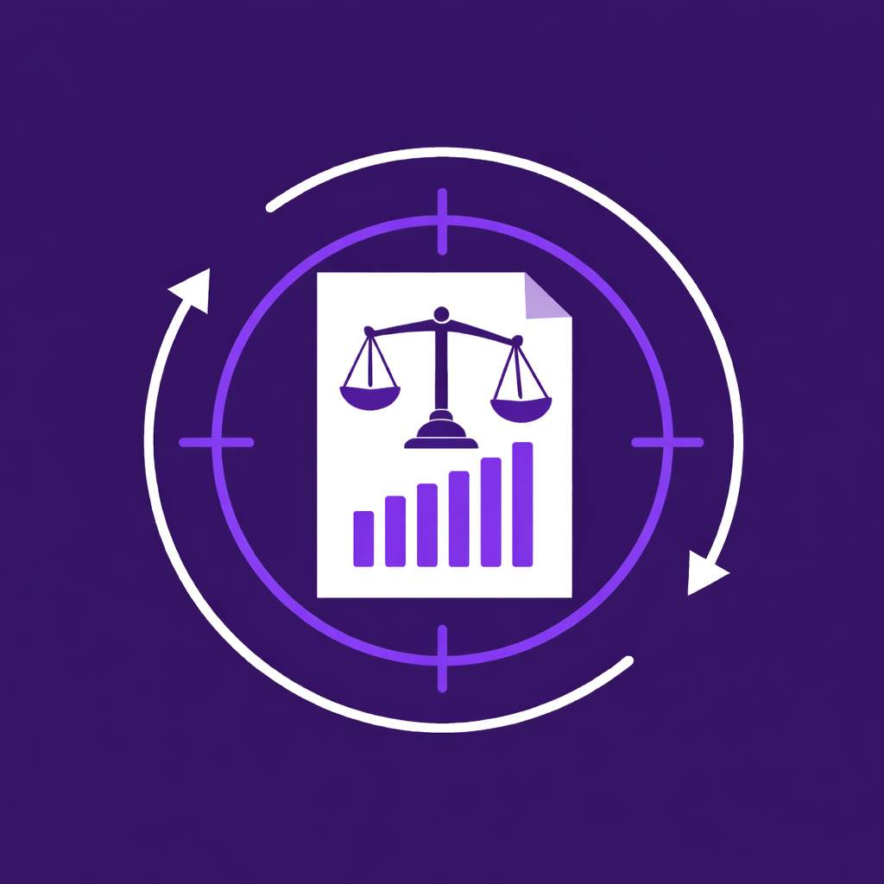
Bias in AI systems
AI systems learn patterns from data. If the training data is incomplete, unbalanced, or reflects unfair treatment, the AI might replicate those patterns.
For example, a hiring system trained only on resumes from current employees might favour candidates with similar backgrounds and overlook qualified applicants from different experiences. This is known as bias. Biased data leads to biased outcomes. Careful data collection, evaluation, and oversight help reduce this risk and support fairer AI decisions.
Understanding how bias enters AI systems through data is an important step toward recognizing ethical implications in data use.

WHAT MAKES DATA “GOOD” OR “BAD”?
Ethical practices guide how data should be collected and used, but they only work when the data itself is reliable. To evaluate data quality, organizations rely on data quality dimensions, characteristics that describe how well data supports accurate decisions.
Dimensions of data quality
By focusing on the key dimensions of data quality, organizations can better assess how reliable and fit-for-purpose their data is.
- Accuracy measures how closely the data reflects real-world conditions. Inaccurate data leads to analysis errors and poor business decisions.
For example, if a restaurant’s sales system records a $45 order as $4.50 because of a data entry error, revenue reports will underestimate sales and can lead to inventory or staffing issues.
- Completeness means that all required data is present. Incomplete data, such as missing fields or records, creates gaps, reducing reliability.
For example, missing customer contact details can lead to lost sales opportunities.
- Timeliness refers to how current and up-to-date the data is. Outdated data might no longer reflect reality.
For example, if inventory data isn’t updated regularly, products might sell out unexpectedly.
- Consistency means data follows the same formats and rules across systems. Inconsistent data can cause confusion and make it difficult to compare or combine information from different sources.
For example, using different date formats, such as MM/DD/YY versus DD/MM/YYYY, across departments can cause errors when merging data.

Common data quality issues
Data quality problems can occur at any stage of collection, storage, or processing. Data quality problems typically fall into three categories: data inaccuracy, data bias, and data incompleteness. Recognizing these common problems helps identify them quickly and take action before they lead to poor decisions or flawed analyses.
Data inaccuracy
Data inaccuracy issues occur when data doesn’t match the real-world condition it represents.
- Outdated information refers to data that no longer reflects current conditions, trends, or values. Suppose a retailer uses last year’s inventory data to plan orders; they might stock unwanted items and incur unnecessary costs.
- Measurement errors occur when tools record incorrect values because of equipment problems, poor setup, or human error. If a manufacturing plant’s sensor isn’t properly configured, it might report inaccurate temperatures, leading to production decisions that compromise product quality.
- Incorrect data entry involves typos or misplaced values during manual input. Suppose someone adds an extra zero to a financial report; the budget can look larger than it actually is, leading to wasteful spending. These errors can also appear in data analysis, reports, and dashboards.

Typos or misplaced values during manual input can distort results and reports. Relying on inaccurate data can waste resources and cause organizations to miss opportunities. Now, let’s explore the different types of data bias you might encounter in data.
Data bias
Data bias issues occur when data is skewed or unfair because of how the data is collected, sampled, labelled, or interpreted.
- Sampling bias happens when the group being studied does not truly represent the larger group. This can lead to inaccurate results. For example, company analyses customer feedback over several years and collects responses only from its rewards program users, but not from its non-rewards program shoppers. Because the sample does not reflect all customers, the results could lead to poor planning.

- Collection bias happens when the way data is gathered favour certain people or results over others. This can occur when data is collected with limited tools, inconsistent methods, or from a single source, affecting the analysis. For example, a retail company measures customer satisfaction solely by online star ratings submitted via a mobile app, while excluding in-store shoppers. Because the data collection method excludes in-store experiences, the results could overlook long wait times or service issues and misrepresent overall satisfaction.

- Representation gaps happen when important groups or details are missing from the data. When this occurs, conclusions might be incomplete or unfair, and real needs or risks might be overlooked. For example, a health study visualizes participants by age group using a pie chart. The chart includes only ages 0–60, and doesn’t include people over 60. Because older adults are excluded, the results could overlook age-related health risks and fail to support effective care decisions for that population.

Data incompleteness
Data incompleteness occurs when the necessary data is not present and available for analysis.
- Missing data refers to values that are absent in a dataset, such as empty fields in a table or survey responses left unanswered. Missing data reduces the amount of available information and can affect results, especially when missing values follow a pattern. Ignoring missing data can lead to unreliable insights and poor decisions.
For example, if a sales report lacks customer age data, the business might misjudge who is buying its products and make incorrect marketing decisions.
- Incomplete datasets occur when parts of the data are missing, such as entire time periods, regions, or data sources. When this happens, analysis is based on limited information and can lead to incorrect conclusions. Incomplete datasets make it harder for organizations to spot trends, compare results, or understand what is really happening.
For example, a financial analyst reviews quarterly results but lacks data from one region. In such scenarios, they might miss risks or overestimate the company’s performance.
When data is missing, teams might make decisions too early or with the wrong information. This can lead to wasted time, extra costs, or decisions that need to be fixed later.

POINTS TO REMEMBER.

- Being a critical consumer of data helps people make informed decisions.
  - Not all data or visualizations are complete or trustworthy.
  - Questioning information before using it prevents mistakes.

    - Identifying data quality starts with asking the right questions:
  - Where did the data come from?
  - Who collected it?
  - What might be missing?
  - What assumptions influence how the data is collected or presented?

    - Verifying data sources protects individuals and organizations from costly errors and increases confidence in decisions.

    - Responsible data use includes ethical considerations.
  - Ethical decisions promote fairness and responsible actions.
  - Data collection, storage, and sharing affect people’s privacy and rights.

    - Practices of responsible data collection and use involve ensuring transparency, consent, minimal collection, security, and purpose limitation, which build trust and support responsible data handling.

    - Key dimensions of high-quality data include accuracy, completeness, timeliness, and consistency.

    - Common data quality issues can be categorized into data inaccuracy, bias, and incompleteness. These issues can occur at any point in the data processing and distort results.

    - Data inaccuracy issues appear when data doesn’t match the real-world condition it represents. These issues occur because of:
  - Outdated information
  - Measurement errors
  - Incorrect data entry

    - Data bias occurs because of errors during collection, sampling, labelling, or interpretation.

    - Data incompleteness refers to whether all required data is present, recorded, and available for analysis. Common completeness data issues include:
  - Missing data
  - Incomplete datasets

