VU Software Engineering 2
DEAD

Personal data:
First name, Surname: | Klaus Bareis 01501513  Fabian Schmon 01568351  Margaryta Simkina 01446530
Date: | Januar 2019

Design patterns
discussing where the required design patterns occur in your solution. Discuss at least one occurrence for each required design pattern in the code in detail. Support the decision to use a specific pattern with compelling arguments. Create UML diagrams to illustrate how the
patterns have been applied.

• Proxy Pattern
The proxy pattern was meant to control the client's access to the screen. In normal operation, the contents should be transferred as html, when saving as svg. Saving was moved to the server. For this reason, the pattern is only partially implemented.
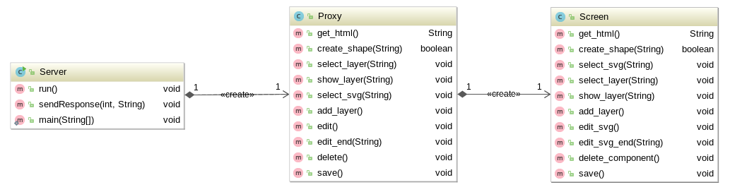

• Iterator Pattern
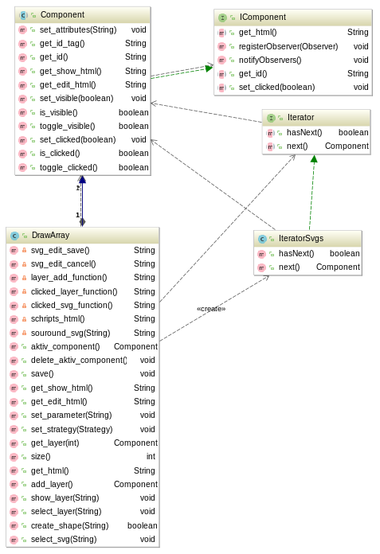

• Observer Pattern
One use of the observer in our application is that of ToolbarLayerObserver. In the toolbar there is a button to create new layer in/on the screen. A click on this button informs the screen that he should create a new layer. Also, enable and disable, and switching between layers via this signal/slot concept is monitored.
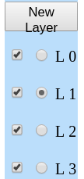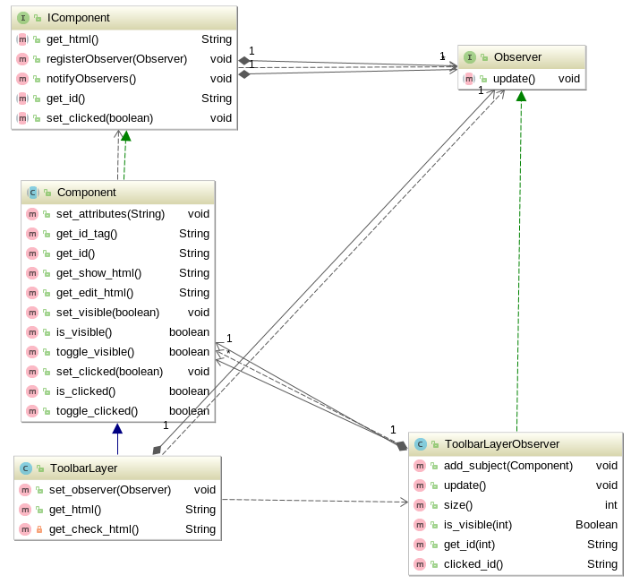
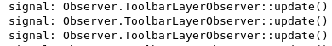

• Strategy Pattern
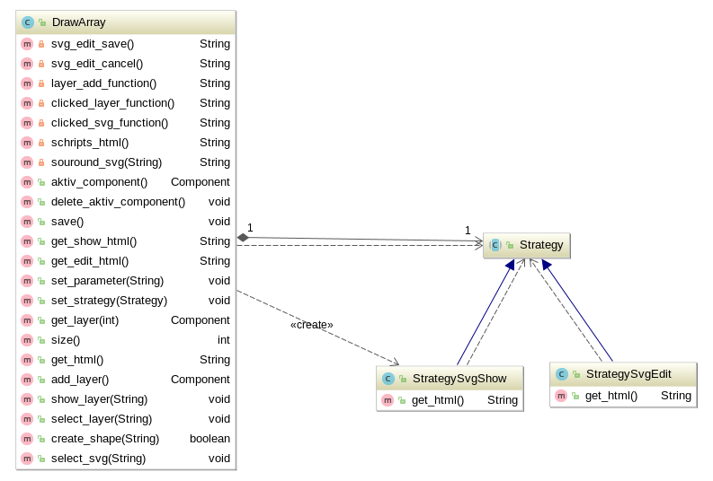
• Factory Method Pattern
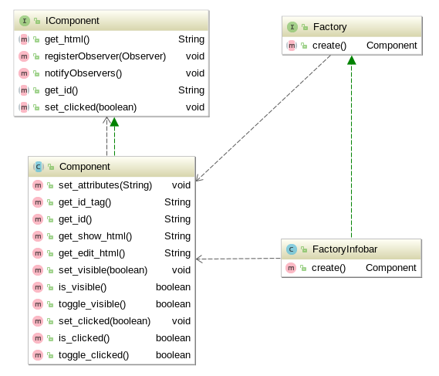

• Composite Pattern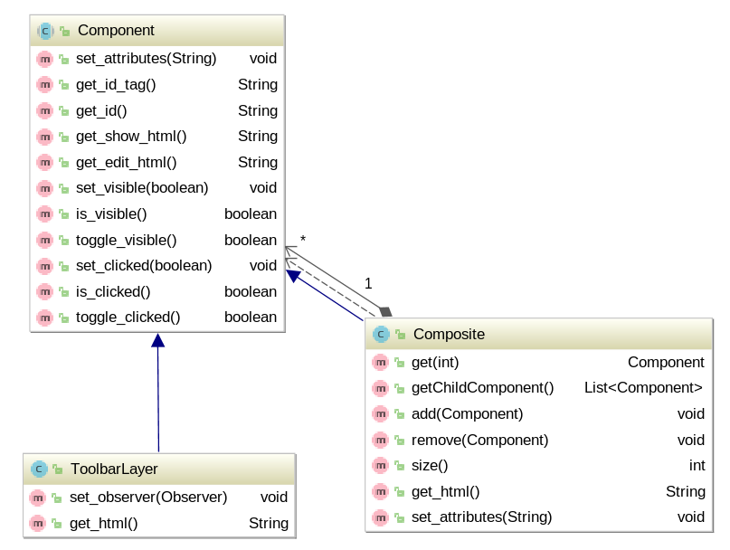

Coding practices
describing how and to what extent you have consid- ered coding practices. Discuss and show examples from your code.

Defensive programming
about how and to what extent you have considered defensive programming. Discuss and show examples from your code.

Code metrics
of your final implementation, covering the same code metric requirements as in SUPD. Include also a discussion on code bugs found, and their resolution.

Team contribution
Design: Bareis
Basic Implementation: Bareis

Functional Requirements (FRs)
FR1
• lines Bareis
• circles Bareis
• ellipses Bareis
• triangles Bareis
• quadrangles Bareis
• n-gons Bareis
• stars Bareis
• text Bareis

FR2
• addition Bareis
• deletion Schmon
• editing Bareis
• movement (Bareis over editing)

FR3
Bareis

FR4
Schmon

Quality Requirements (QRs)
QR1
QR2
QR3
QR4
QR5
QR6
QR7:

• Basic files Server Bareis, Schmon, Simkina
Toolbar Bareis, Schmon, Simkina
ToolbarLayer Bareis, Schmon, Simkina
ToolbarOperation Bareis, Schmon, Simkina
Menubar Bareis, Schmon
Draws Bareis, Schmon
• Observer Pattern ToolbarLayerObserver Bareis
• Strategy Pattern StrategySvgEdit Bareis
StrategySvgShow Bareis
• Iterator Pattern IteratorLayer (not used) Bareis
IteratorSvgs Bareis
• Composite Pattern for Screen Bareis
• Proxy Pattern Proxy for HTML Bareis, Schmon
• Abstract Factory Pattern ColorAbstractFactory Simkina
ColorDraw Simkina
Color Simkina
DrawAbstractFactory Simkina
DefaultAbstractFactory Simkina
• Factory Method Pattern FactoryDrawArray Bareis
FactoryInfobar Bareis
FactoryLayer Bareis
FactoryMenubar Bareis
FactoryToolbar Bareis
FactoryToolbarLayer Bareis
FactoryToolbarOperation Bareis
• Decorator Pattern Format Schmon
DecoratorFileSVG Schmon
PlainFormat Schmon
LightDesign Schmon
DarkDesign Schmon

QR8
QR9

HowTo
documenting how the application is to be launched, initialized, and tested.

