VU Software Engineering 2
DEAD

Personal data:
First name, Surname: | Klaus Bareis 01501513  Fabian Schmon 01568351  Margaryta Simkina 01446530
Date: | Januar 2019

Design patterns
discussing where the required design patterns occur in your solution. Discuss at least one occurrence for each required design pattern in the code in detail. Support the decision to use a specific pattern with compelling arguments. Create UML diagrams to illustrate how the
patterns have been applied.

• Proxy Pattern

The proxy pattern was meant to control the client's access to the screen. In normal operation, the contents should be transferred as html, when saving as svg. Saving was moved to the server. For this reason, the pattern is only partially implemented.
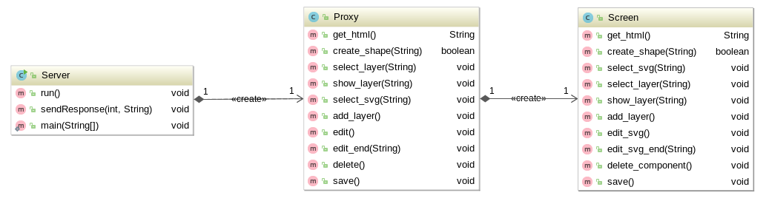

• Iterator Pattern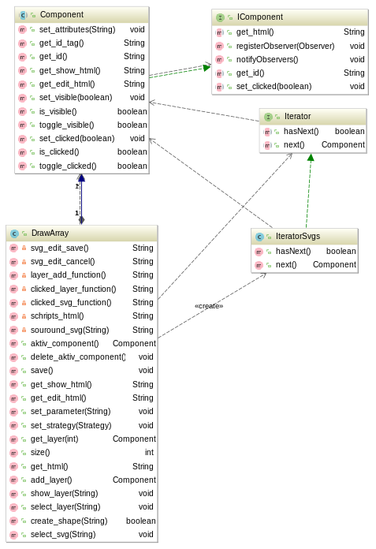

• Observer Pattern
One use of the observer in our application is that of ToolbarLayerObserver. In the toolbar there is a button to create new layer in/on the screen. A click on this button informs the screen that he should create a new layer. Also, enable and disable, and switching between layers via this signal/slot concept is monitored.
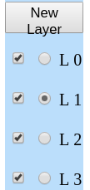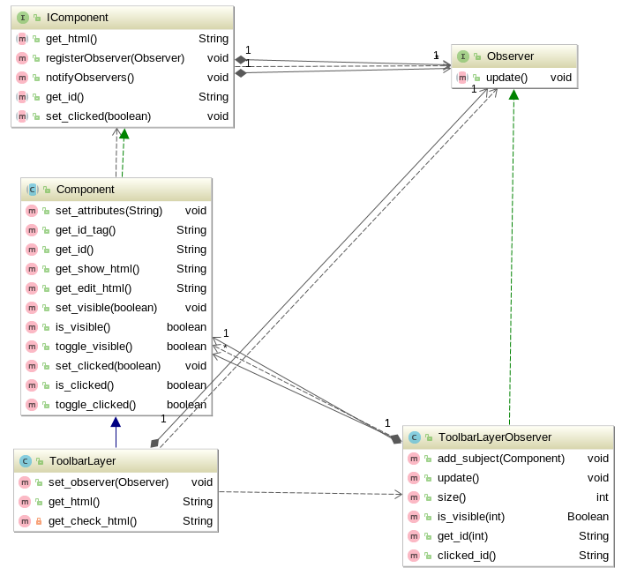
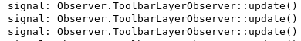

• Strategy Pattern
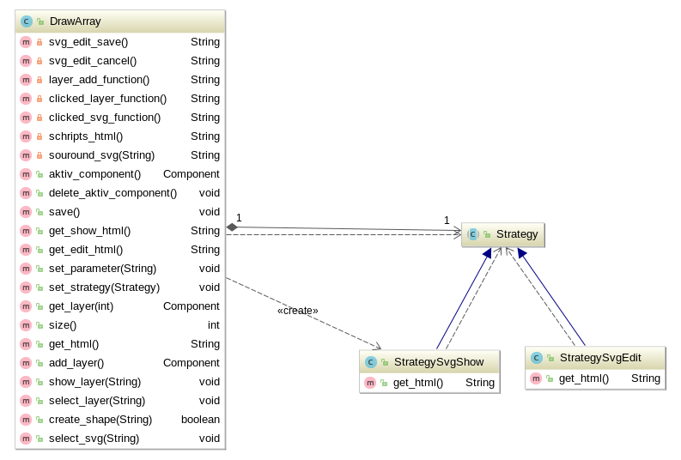

• Factory Method Pattern
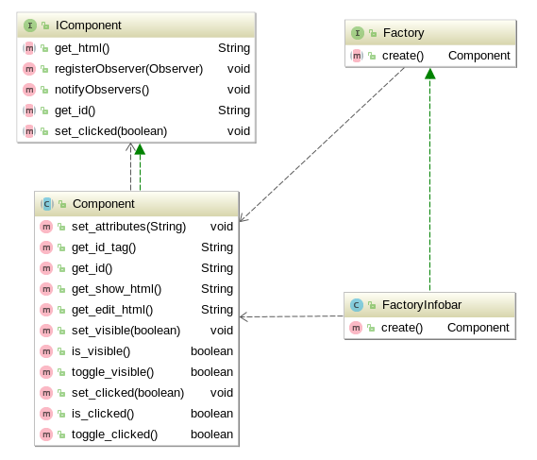

• Composite Pattern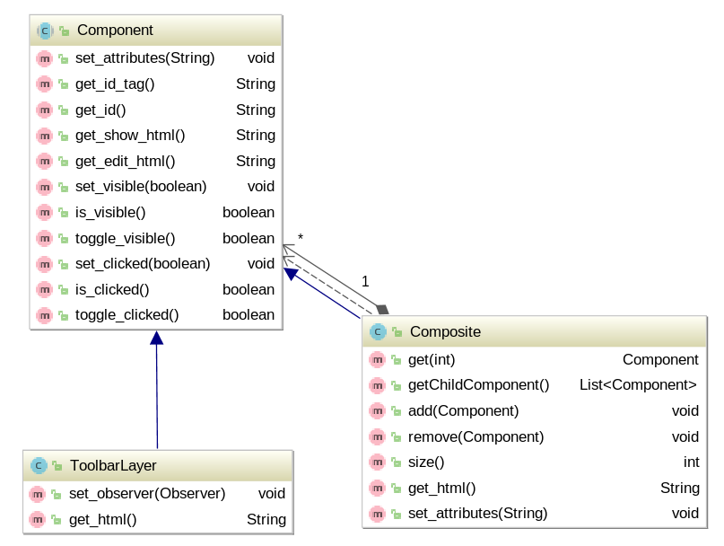
- Abstract Factory Pattern
Our AbstractoryFactory is initially responsible for creating multiple shapes with same attribute – in our case we chose color as an attribute which is to be given in a menu, and after that color is basically switched, we are creating shapes with the same color until we turn on the next color basically. In that perspective, we use ColorAbstractFactory(params) for specific “family of shapes” based on one factor together. Otherwise we use DefaultAbstractFactory(). In both ways, further on, we will create other factories inside of those factories, and Color one will still call ColorDraw with necessary parameters through Optional.
- Dependency inversion principle
We decided as well to add dependency inversion Principle as a very good practice among current approaches: this enables way of decoupling software modules, getting rid of strong dependencies and being able to “reach out” from different level to another one. In our case we used BeanContainer which stores Context object inside. In that way, we are able to use our context object (which, for instance, we used a lot for creating/editing shapes), we would be able to use Context Object from any part of a project basically.
- Decorator Patter
In our project, we decided to implement two different Decorator Patterns because it is considered to be extremely good practice if reading some news in this area, it is on a way to replace inheritance.
First decorator Pattern is a change of color of our scheme: on a Toolbar left, one can change it from light to dark and back without adding additional dependencies and implementing unnecessary methods.

Second decorator Pattern is position handler: we got a default one by simply clicking on a button, but also a Decorator one, when one gives parameters to create it in a. certain place. This wasn’t done with extension, but with external additional functionality in design pattern.
Further, when function will be called, it will still go through a default constructor, but code itself won’t be copied.
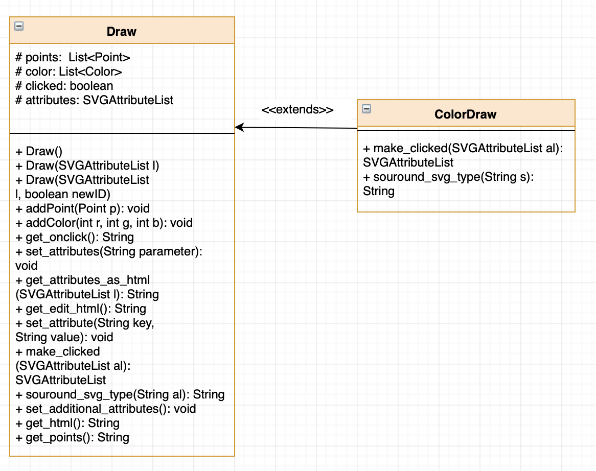

Coding practices
describing how and to what extent you have consid- ered coding practices. Discuss and show examples from your code.

Defensive programming
about how and to what extent you have considered defensive programming. Discuss and show examples from your code.

Code metrics
- Code Metrics General Analysis

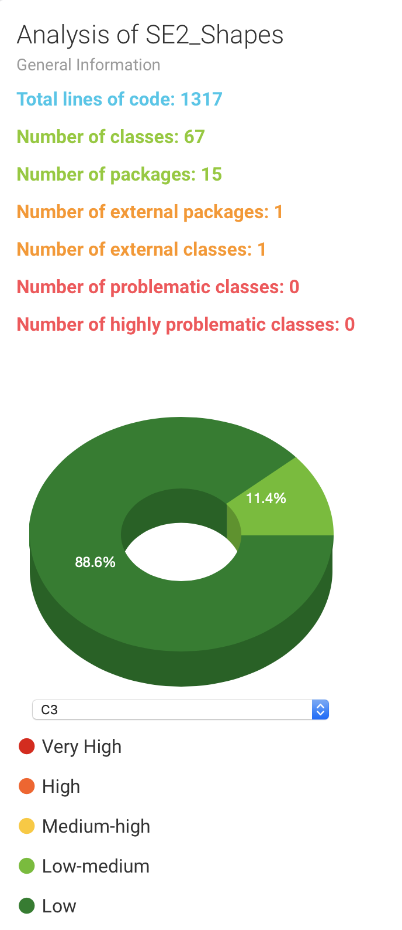

- Distribution of Quality Attributes
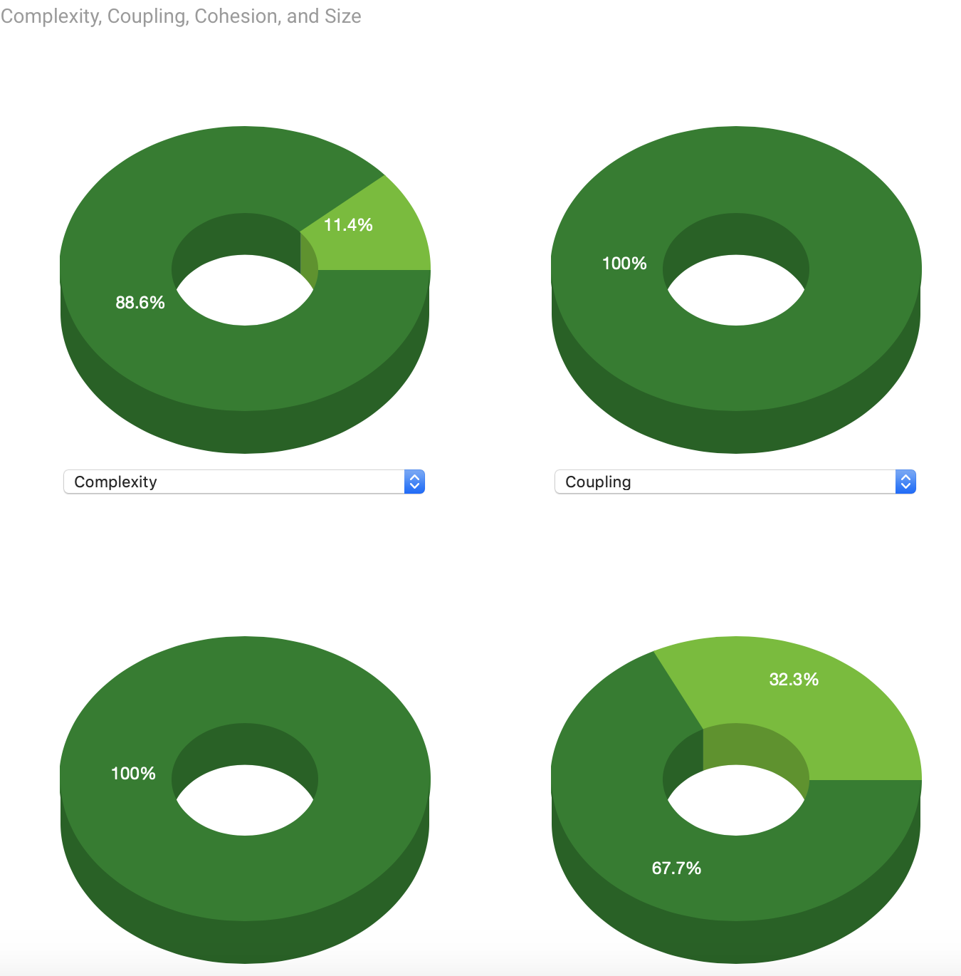

- Metric Values in Sunburst Chart

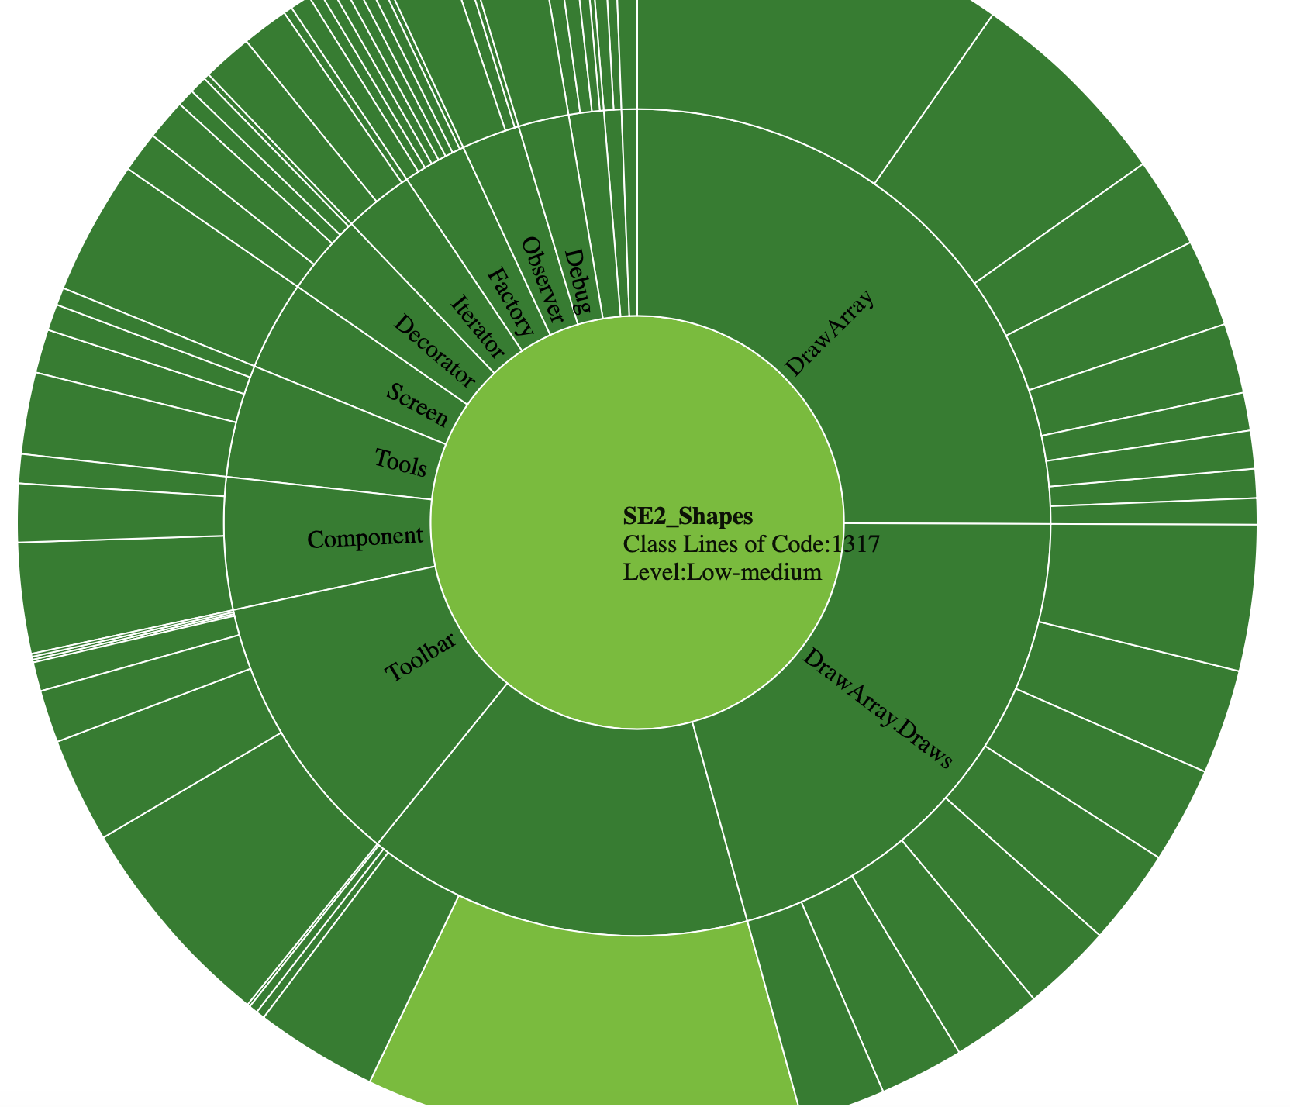

Metric Values by Packages

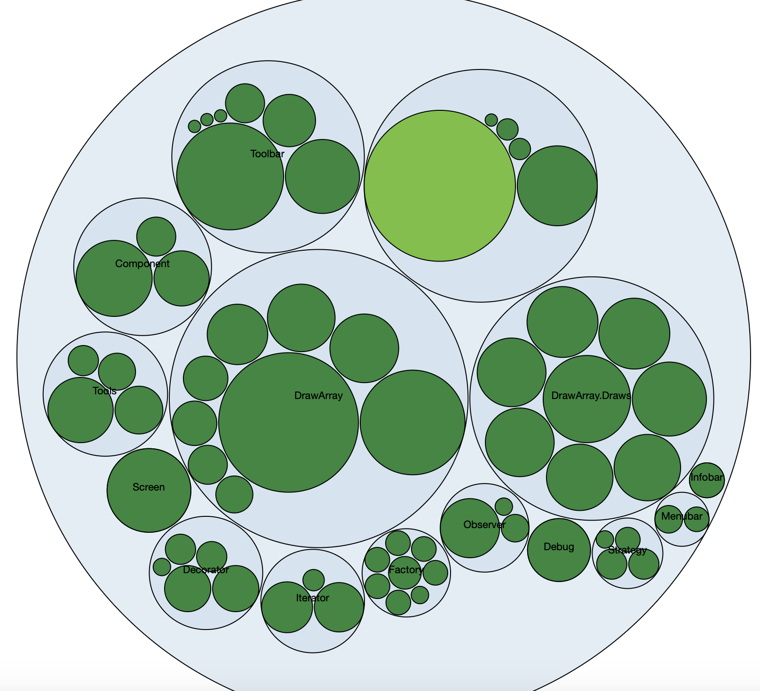

Metric Values in Treemap Chart
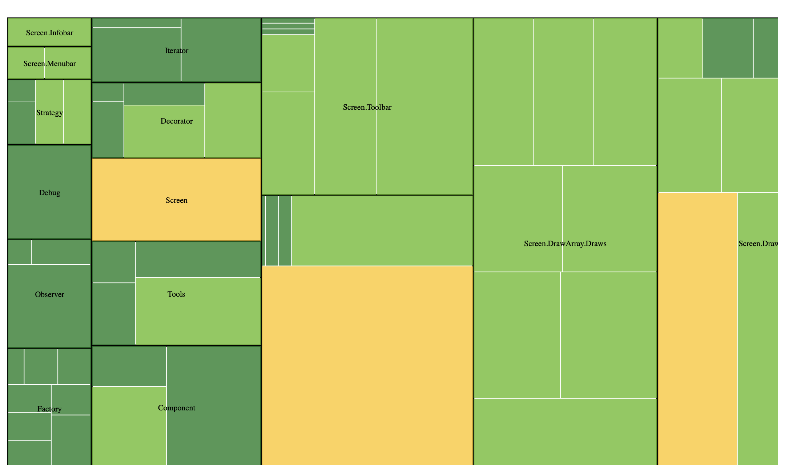

Package Dependencies
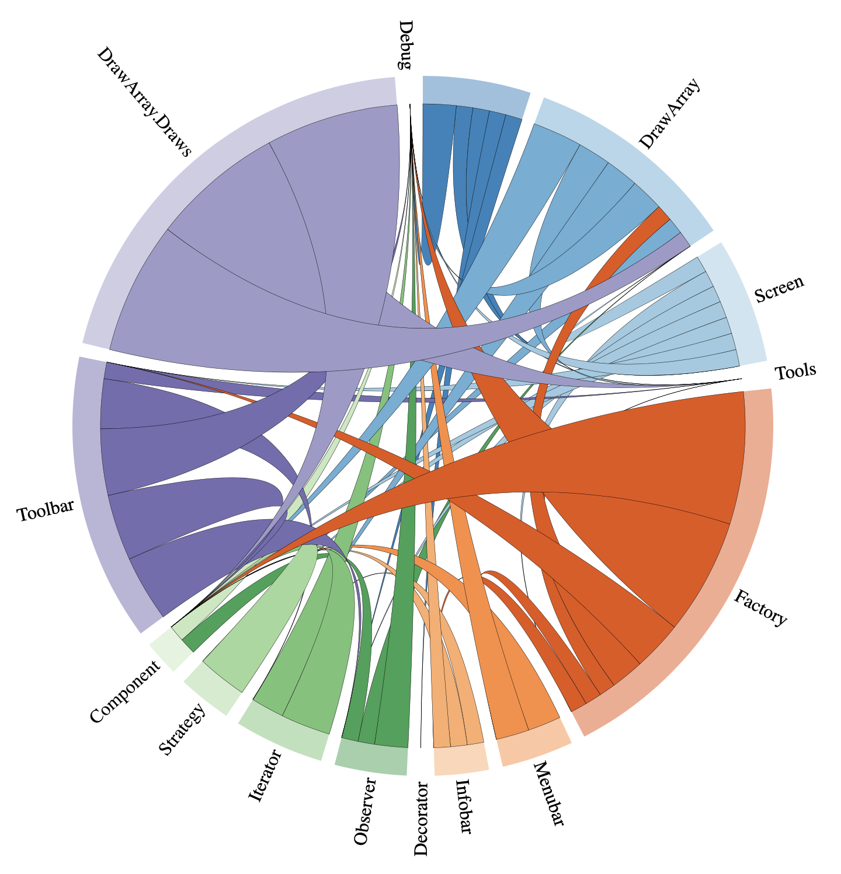

Team contribution
Design: Bareis
Basic Implementation: Bareis

Functional Requirements (FRs)
FR1
• lines Bareis
• circles Bareis
• ellipses Bareis
• triangles Bareis
• quadrangles Bareis
• n-gons Bareis
• stars Bareis
• text Bareis

FR2
• addition Bareis. Simkina
• deletion Schmon
• editing Bareis
• movement (Bareis over editing)

FR3
Bareis

FR4
Schmon

Quality Requirements (QRs)
QR1-QR2: Each team member was responsible for creating readable and self explainatory code, otherwise it should have been properly commented
Q3: We tried to avoid Code Grouping, limit line and class length/size, huge hierarchy and consistent indentation. Still, structure needed a refactoring which we implemented by coupling, creating new classes and dividing functionality into smaller pieces, but not dependent on each as in inheritance. We reduced switches size by some returns. Which did not work 100%, we still have big dependencies but that way we avoided too long and repetitive code. What we tried to organize well , was folder structure and proper classes and variables names.
Q4: We used defensive programming such as checking input function parameters, having a proxy which took care of further UI mistakes, as well, we used optional in order to avoid null returns.
Q5: We set up all necessary application type, concerns, technologies and so in a very beginning. Only things were added later by each team member were quality attributes. Our crosscutting concerns were Instrumentation and Logging (through a debug, we could also watch out threading).
QR6
QR7:

• Basic files Server Bareis, Schmon, Simkina
Toolbar Bareis, Schmon, Simkina
ToolbarLayer Bareis, Schmon, Simkina
ToolbarOperation Bareis, Schmon, Simkina
Menubar Bareis, Schmon
Draws Bareis, Schmon
• Observer Pattern ToolbarLayerObserver Bareis
• Strategy Pattern StrategySvgEdit Bareis
StrategySvgShow Bareis
• Iterator Pattern IteratorLayer (not used) Bareis
IteratorSvgs Bareis
• Composite Pattern for Screen Bareis
• Proxy Pattern Proxy for HTML Bareis, Schmon
• Abstract Factory Pattern ColorAbstractFactory Simkina
ColorDraw Simkina
Color Simkina
DrawAbstractFactory Simkina
DefaultAbstractFactory Simkina
• Factory Method Pattern FactoryDrawArray Bareis
FactoryInfobar Bareis
FactoryLayer Bareis
FactoryMenubar Bareis
FactoryToolbar Bareis
FactoryToolbarLayer Bareis
FactoryToolbarOperation Bareis
• Decorator Pattern Format Schmon
DecoratorFileSVG Schmon
PlainFormat Schmon
LightDesign Schmon
DarkDesign Schmon
• Decorator Pattern 2 ColorDraw Simkina
DrawArray Simkina
• Abstract Factory Pattern ColorAbstractFactor Simkina
DefaultAbstractFactor Simkina
DrawAbstractFactory Simkina
Proxy
• Dependency inversion BeanContainer Simkina
container Context Simkina

QR8: We have implemented the whole project using Maven.
QR9: In a package Runnable we got our JAR file.

HowTo
documenting how the application is to be launched, initialized, and tested.

Application can be launched by running a JAR in a terminal which is java -jar Shapes.jar.
Otherwise one can /implementation/src/main/Server.java “Run” -> “as Application” and then Application runs on port :8080. After that browser should be open on localhost.

