Software Engineering 2

g2018w_se3_0403

SUPD Report

A simple graphics editor

Team-Members:

Klaus Bareis 01501513

Fabian Schmon 01568351

Margaryta Simkina 01446530

Universität Wien, WS2018

Design Draft 1

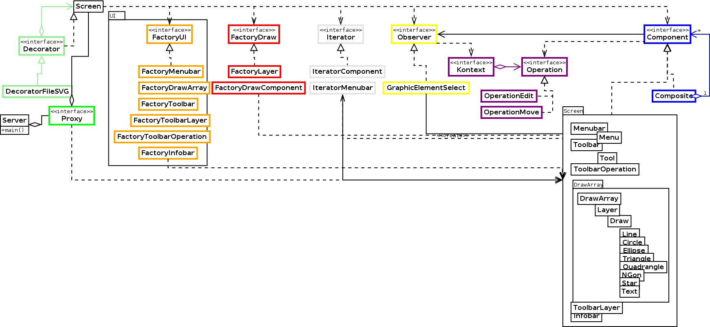**Class Diagram**

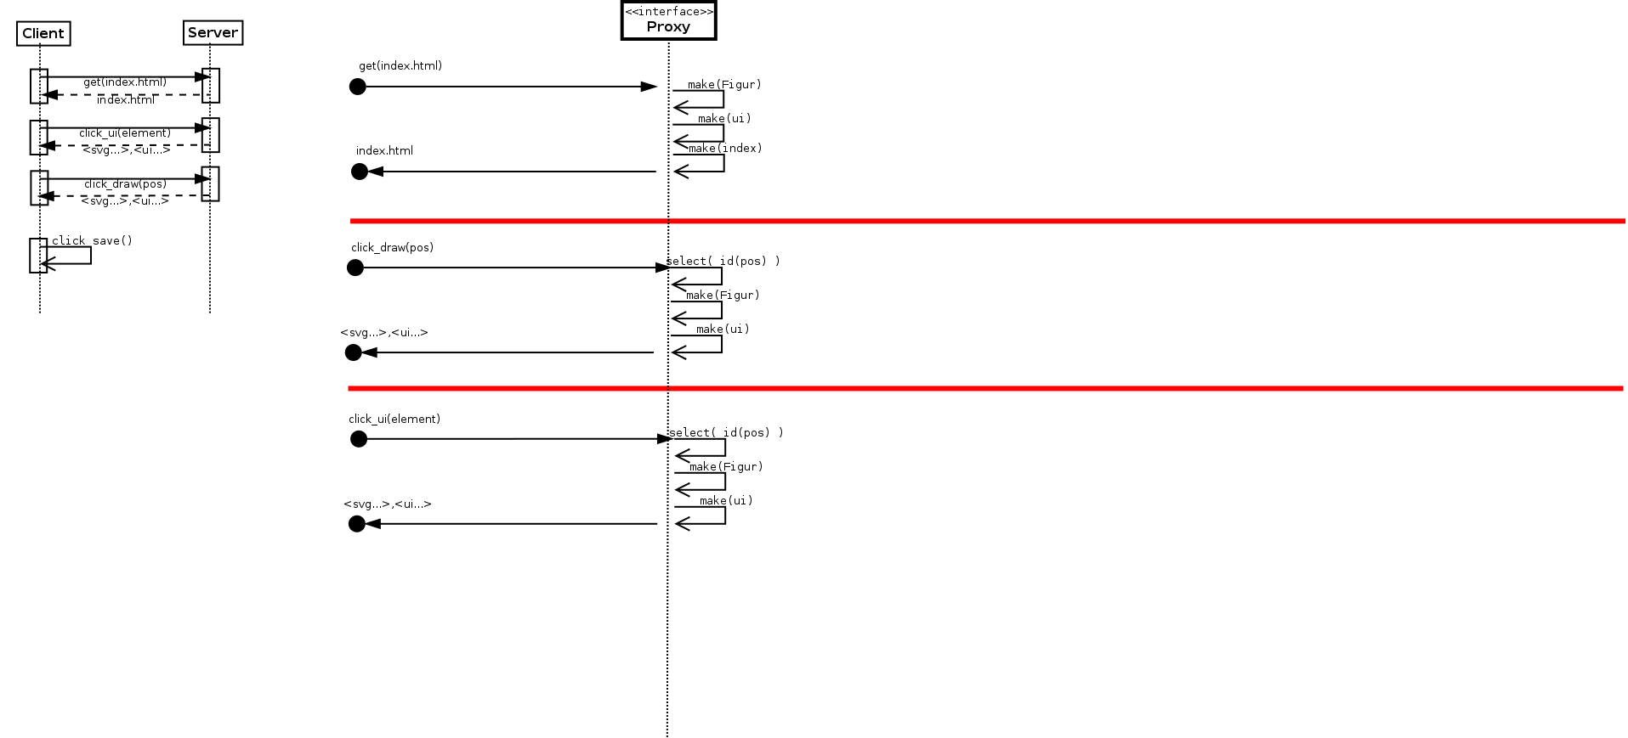**Sequence Diagram: Client & Server**

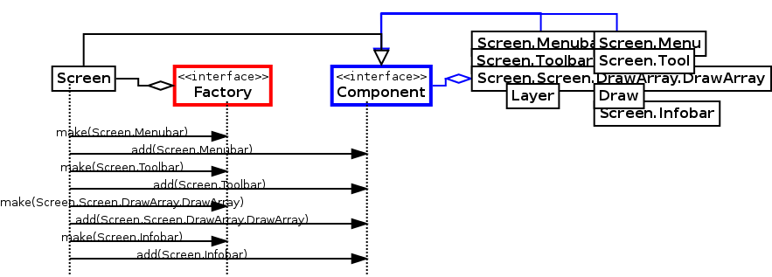**Sequence Diagram: Composite**

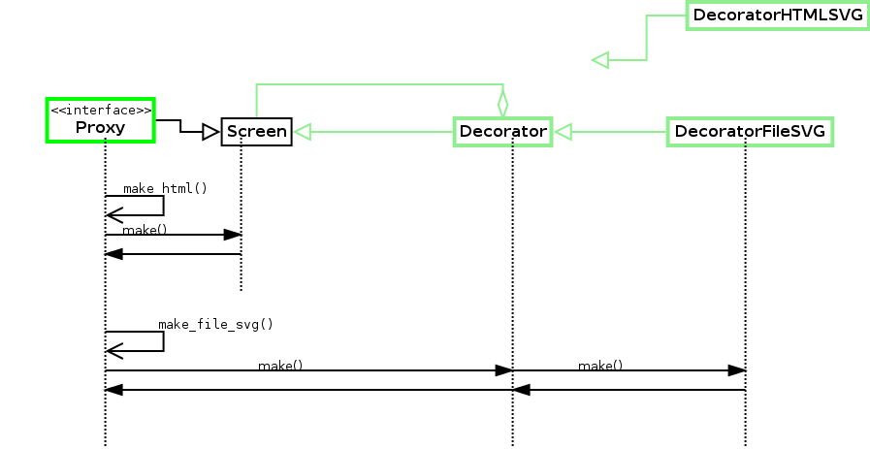**Sequence Diagram: Decorator**

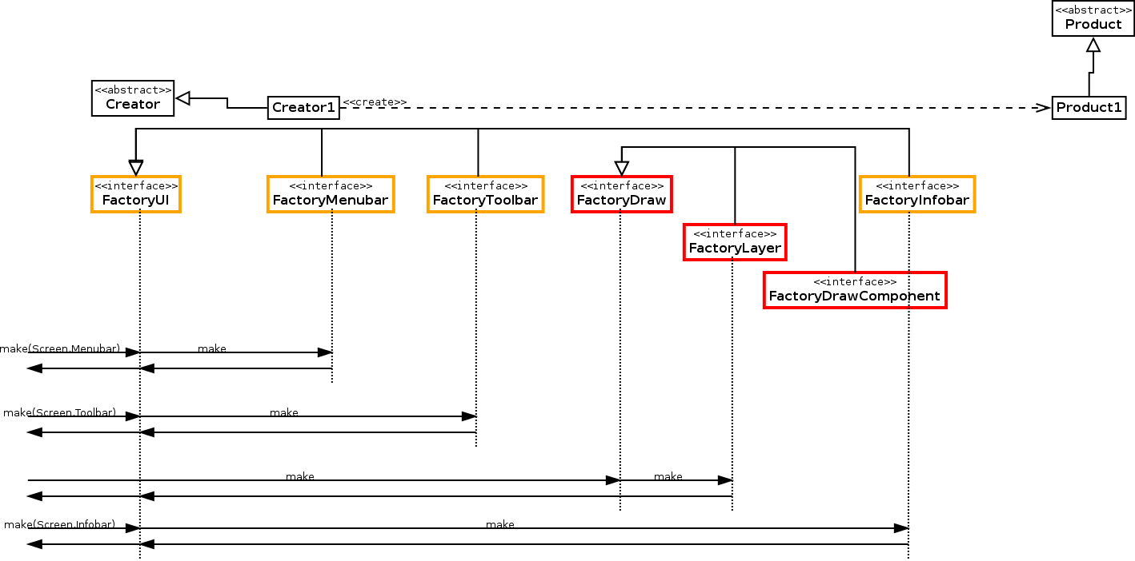**Sequence Diagram: Factory**

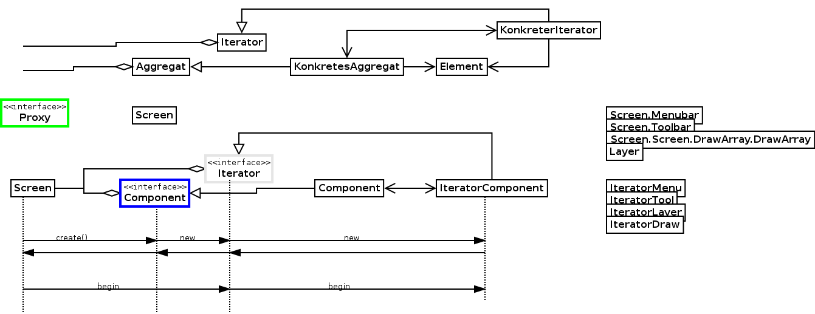**Sequence Diagram: Iterator**

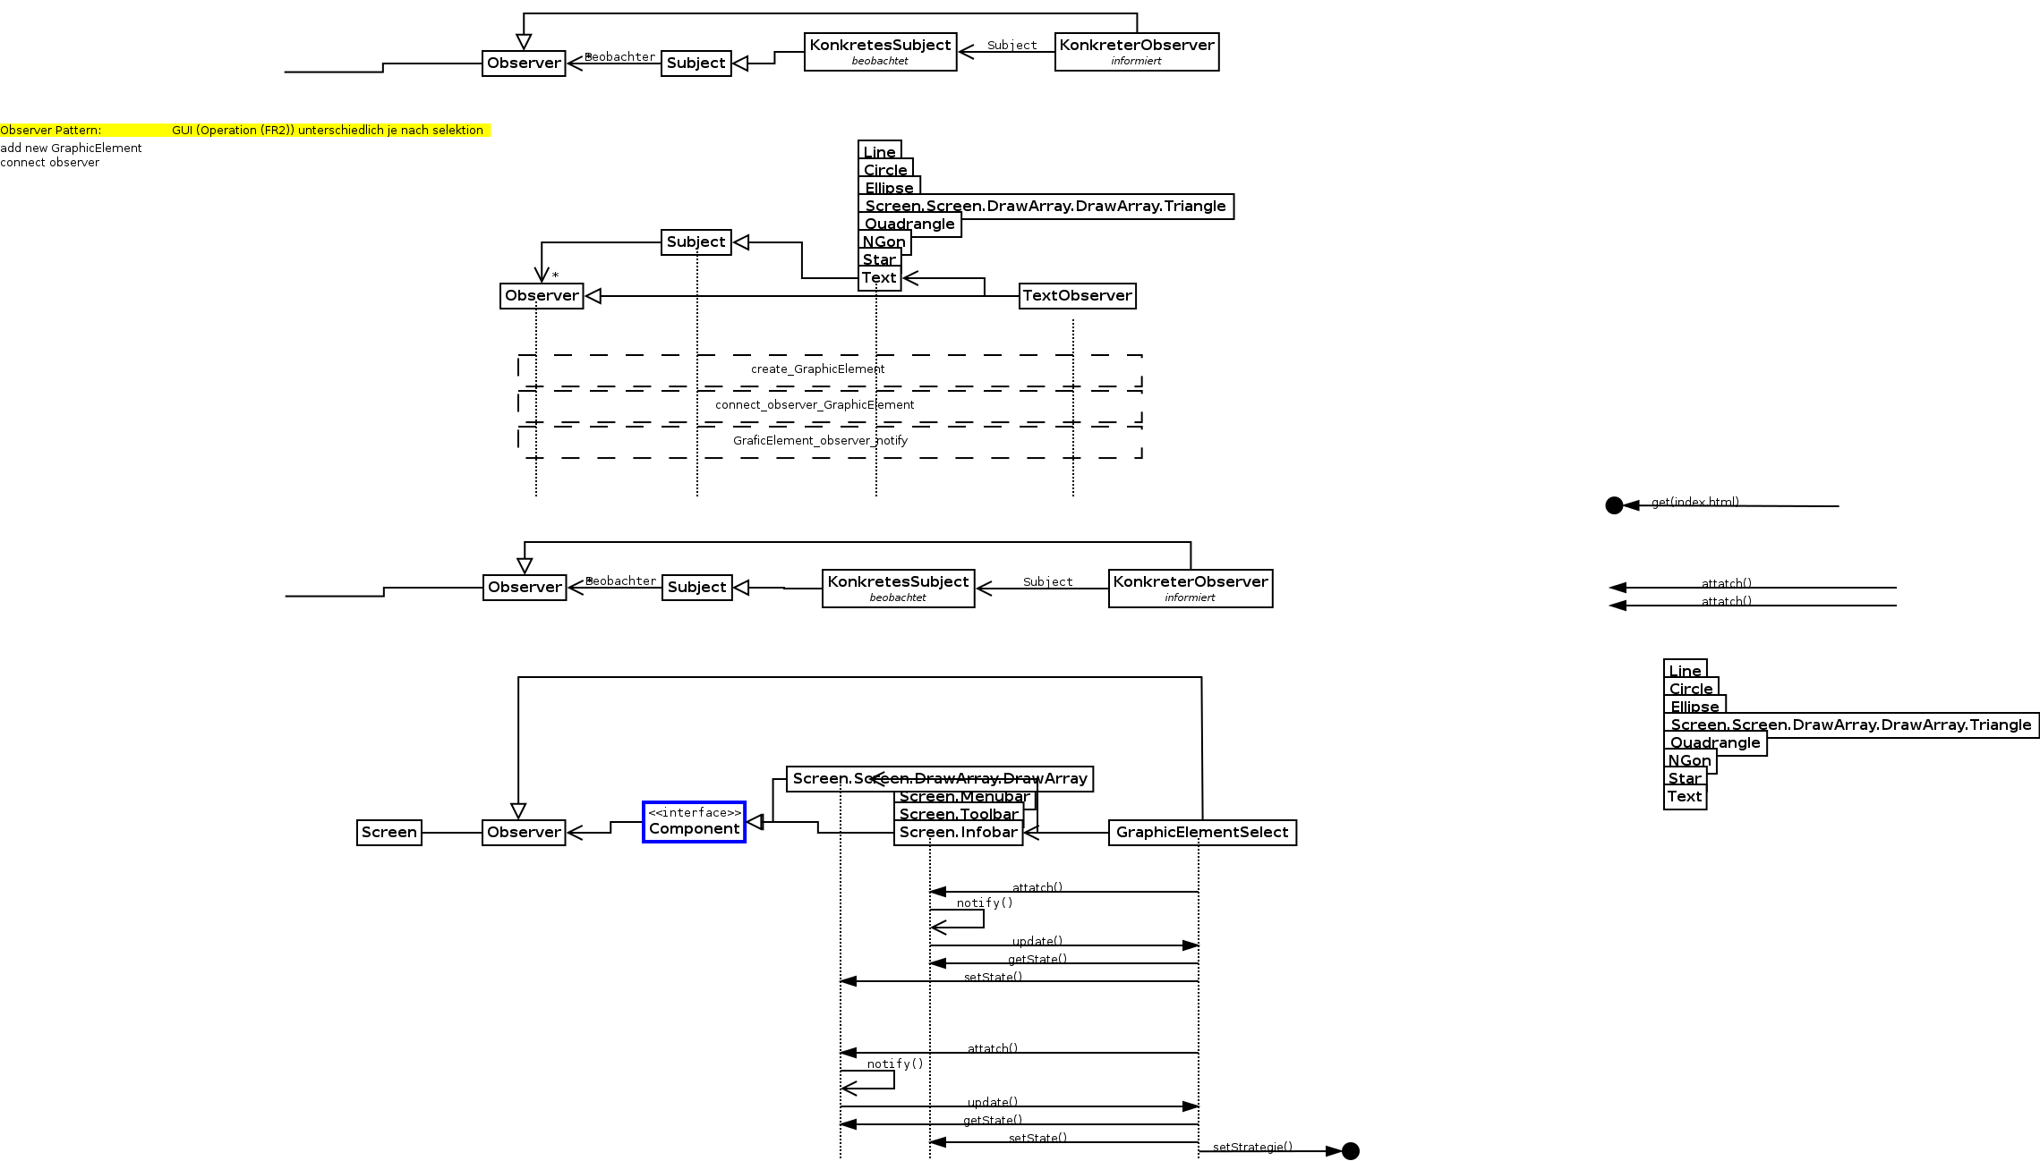**Sequence Diagram: Observer**

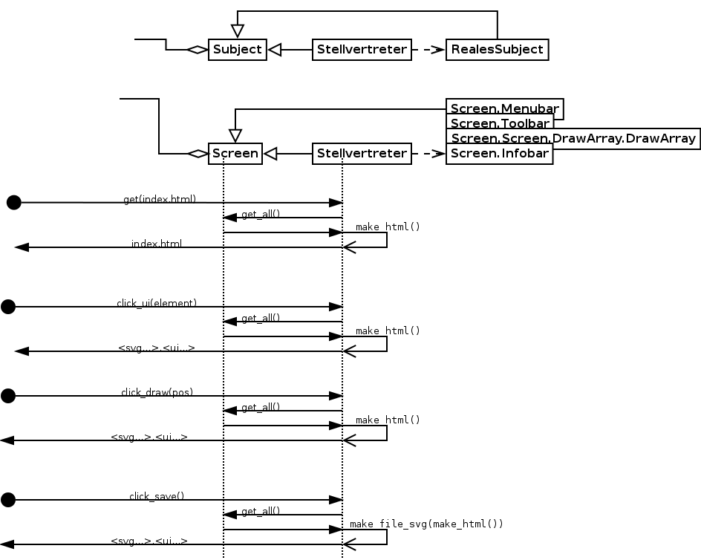**Sequence Diagram: Proxy**

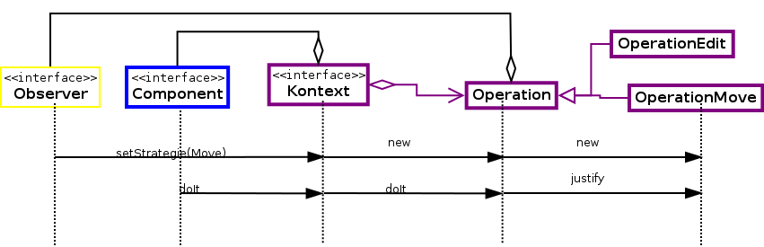**Sequence Diagram: Strategy**

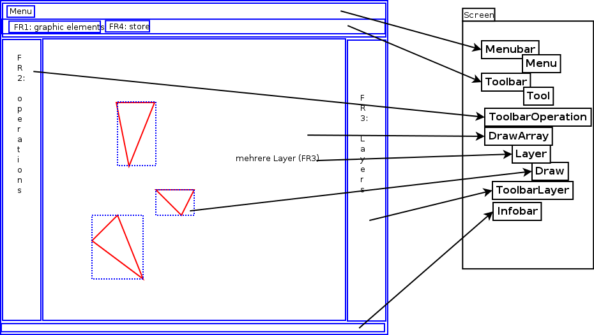**Diagram: UI – “Screen” Class**

**Design Pattern**

**TODO….**

**(**A section design patterns discussing how you applied the Observer Pattern and Strategy Pattern in your code.)

Design Draft 2

**Class Diagram**

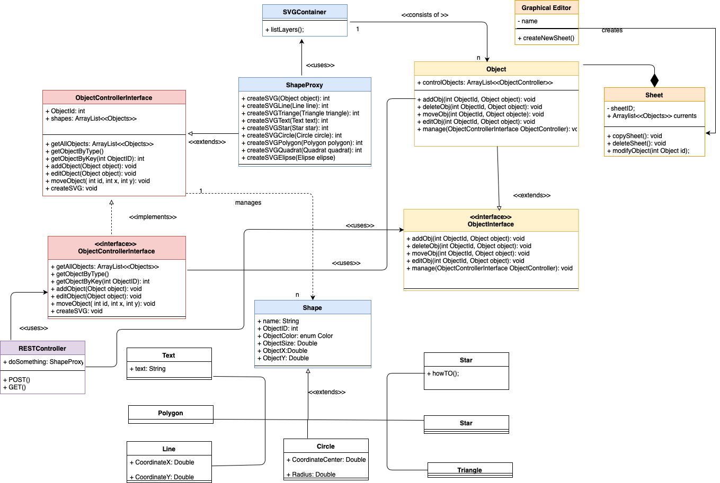

**Design Pattern**

**Observer Pattern**

LayerInterface is an abstract class which is further implemented by the class Shape. ObjectControllerInterface is basically an Observer Interface because it is controlling an Observervable (which is in this case LayerInterface). LayerInterface is an object which notifies ObjectControllerInterface about the changes in its state.

For instance, when any action in a class Shape was taken, like, an add/edit/delete/move, a controller gets a notification/update on exact changes and therefore ObjectController updates its Status.

**Strategy Pattern**

A class Shape is an abstract superclass which has 8 different impementations (basically, 8 shapes). Each time a constructor of a child was called, a constructor of a superclass was called, too. As well, ObjectControllerInterface is an abstract class which is implemented in an ObjectController.

**Iterator Pattern**

In ObjectController all the modifications on my Objects will be implemenated through a usage of a ListArray, where while add/delete/edit I access certain Shape (through a key), since they all are saved in ListArray and have ID which is a key. In a class MyShapes there is a method ListAll which goes through created shapes and list them with their keys – ids.

**Proxy Pattern**

The Proxy provides a surrogate or place holder to provide access to an object. In our case

we decided to prevent unnecessary usage of a memory, so that in a class ShapeProxy a

method will be called which is responsible for a creation of graphics through SVG. The

method called createShape first checks if Shape was already initialized or not. In first case

its further creates a shape. Otherwise it first initializes the object and then creates a shape.

This prevents initialization of an object twice.

**Composite Pattern**

Composite pattern will be mainly used for identification of a type of a Shape. For instance, user can search only triangles or so. For these purposes a method “classifyShape” will be used. In this case we are making a group of Objects answering certain parameters, so we make a composition of those. This will be done through a class MyObjects, where there is a

whole array of lists saved. Object controller is responsible for the group task as well. MyObjects basically represents all the created objects, also provides all the functionality that ObjectController provides.

**Abstract Factory Pattern**

In our class ConrollerCreator there will be few methods for the qualities of our Object: identShape, identColor, identPlace, and then its all divided in different classes where those extentions of a shape are to be implemented: AbstractShapeFactory, AbstractColorFactory, AbstractPlacement.

**Factory Method Pattern**

There is a factory for creation of Objects – different shapes. There is an interface BodyCreator. In this class Objects of a shape will be not only created, but also checked for Correctness through many assertions to minimize a number of errors during creation of an Object. It is responsible for

Nextly, Software quality will be proven through Requirements list, which should make a procedure of creation most efficient and free from mistakes, minimize waiting times and make modifiability higher. In order to create a Controller, there is a class ControllerCreator, which also minimized all possible mistakes is responsible for correct and consistent creation. Besides that, there is a a class ShapeProxy , where all the complexity/overhead of the target in the wrapper will be encapsulated.

**Decorator Pattern**

We do maintain the functionality of each interface. What is used here is that we came up to a conclusion its not necessary to create “child” classes each time super class was created. And since our Shape has 8 implemenations, would be irrational to create a polygon when a triangle was called, as an example. As well, in an ObjectController we have done edit function which is used for all our shapes – despite Shape has its children – we do just extend different edits for different figures, but we don’t have on ObjectController 8 different edits, so its interchangeable. The Decorator attaches additional responsibilities to an object dynamically. So, whenever a function was called, it will only edit objects dynamically.

API Specification

**TODO…**

(A section API specification of your service following recommendations given in the article REST API Documentation Best Practices.)

Code Metrics

**TODO…**

(A section code metrics (number of packages, lines of code, comment lines of code, number of classes, code bugs) covering your current implementation. It is expected that a work in progress will show a number of bugs; you are encouraged to use one or more static code analysis tools (e.g. SpotBugs for Java), and discuss the findings in the report.)