Beauty Treatment

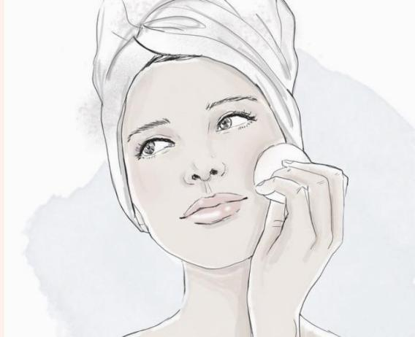

Sprint #2

**Student Number: A00267386**

**Web Technologies – Write Up for Sprint#2**

Sprint #2 Stories

**User Stories**

1. As the Store Administrator, I want to be able to edit entries in my data table using a modal filled in with information of the treatment I choose.
2. As the Store Administrator I want to be able to create a Beauty treatment, so that I can add new ones when they are released.
3. As the Store Administrator I want to be able to update a Beauty treatment as the information about I might change.
4. As the Store Administrator, I want to be able to delete a Beauty treatment, so that I can remove unwanted entries from the system.

# **Manual Testing**

|  |  |
| --- | --- |
| User Story | As the Store Administrator, I want to be able to edit entries in my data table using a modal filled in with information of the treatment I choose. |
| Test Case ID | 1 |
| Description | **Modal with information about beauty treatment** |
| Preconditions | 1.Tom cat is running  2.The browser is open  3.The database is available |
| Actions | 1. The address ‘http://localhost:8080/Beauty/’ is entered in the browser  2. The ‘Admin’ menu on the navbar is pressed  3. The ‘Edit’ button is pressed |
| Expected Results | 1. The table reloads  2. The modal appears  3. The modal is filled with information |
| Test Status | Passed |

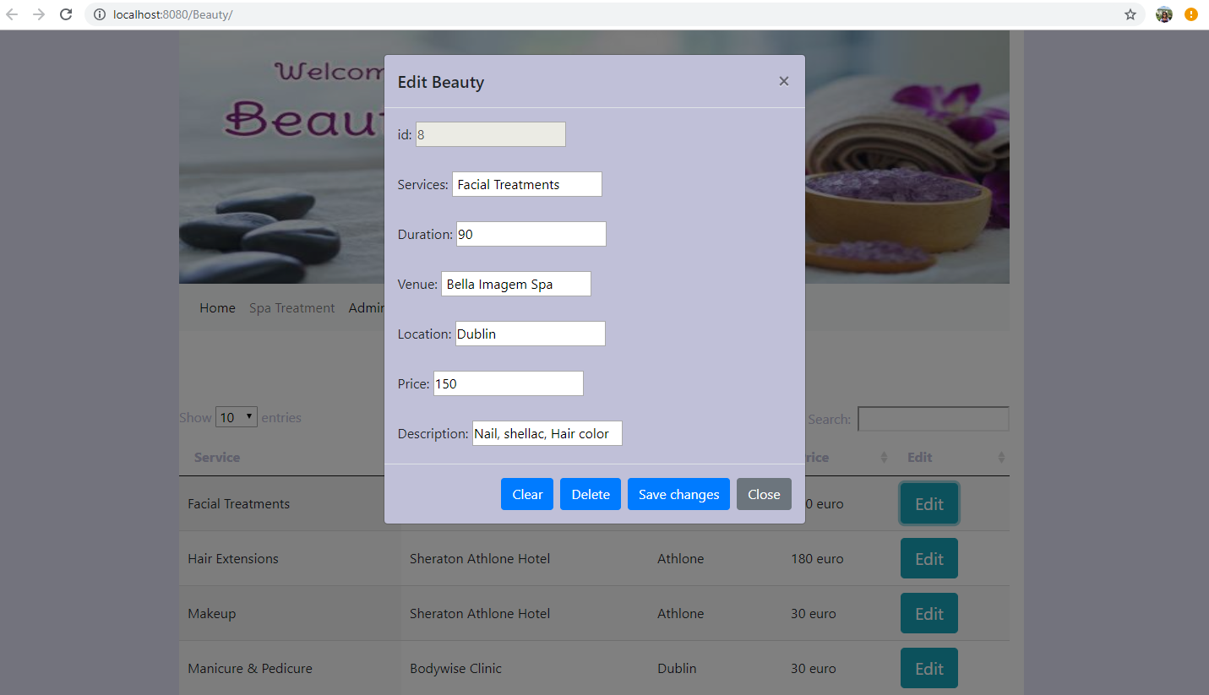

|  |  |
| --- | --- |
| User Story | As the Store Administrator I want to be able to create a Beauty treatment, so that I can add new ones when they are released. |
| Test Case ID | 2 |
| Description | **Clear** Beauty information |
| Preconditions | 1. Tom cat is running  2. The browser is open  3. The database is available |
| Actions | 1. The address ‘http://localhost:8080/Beauty/’ is entered in the browser  2. The ‘Admin’ menu on the navbar is pressed  3. The ‘Clear’ button is pressed |
| Expected Results | 1. The table reloads  2. The modal clears |
| Test Status | Passed |

[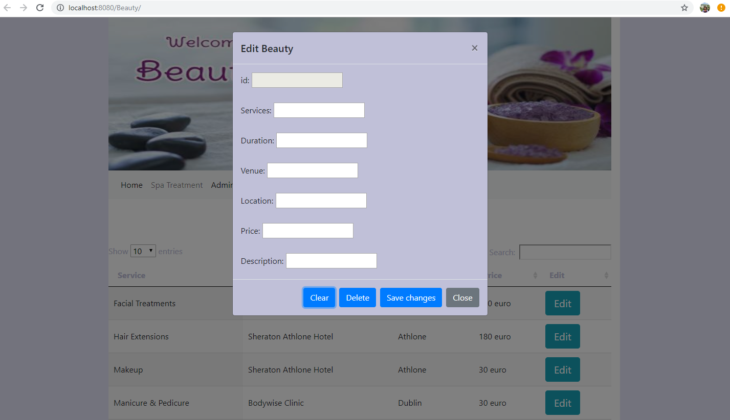](http://localhost:80#)

|  |  |
| --- | --- |
| User Story | As the Store Administrator I want to be able to create a Beauty treatment, so that I can add new ones when they are released. |
| Test Case ID | 3 |
| Description | **Create** Beauty information |
| Preconditions | 1. Tom cat is running  2. The browser is open  3. The database is available |
| Actions | 1.The address ‘http://localhost:8080/Beauty/’ is entered in the browser  2. The ‘Admin’ link on the navbar is pressed.  3. Edit button is pressed.  4. The changes are filled in  5. The ‘Save changes’ button is pressed |
| Expected Results | 1. A notification pops up with the following message: “Beauty add” update new Beauty”  2. New treatment is added |
| Test Status | Passed |

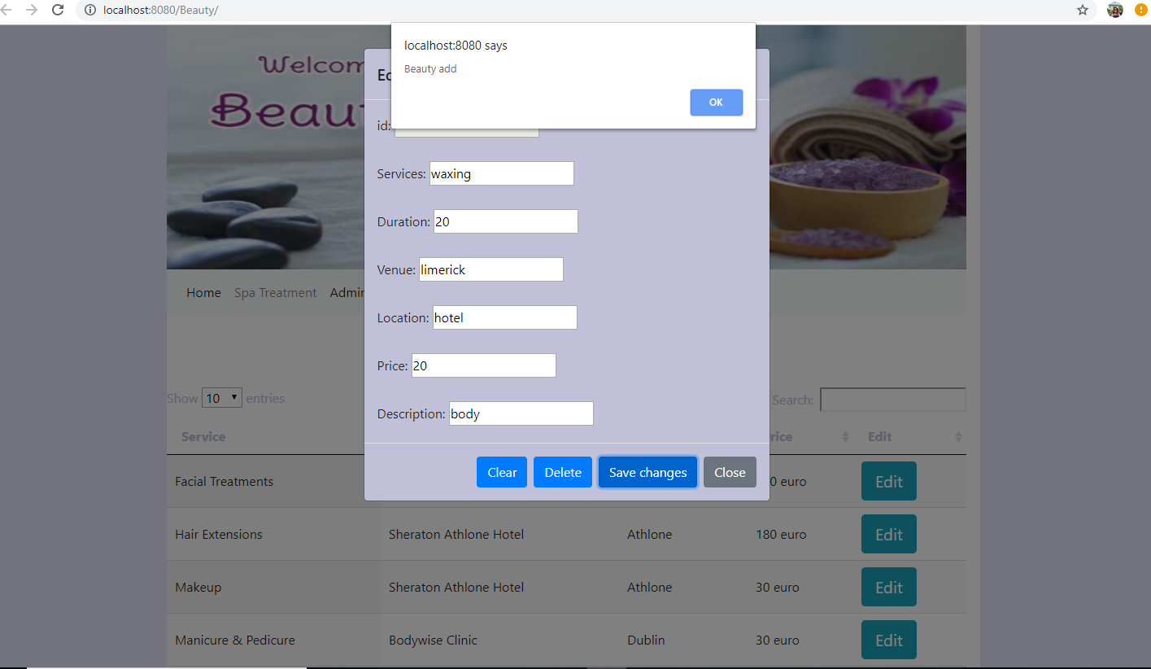

|  |  |
| --- | --- |
| User Story | As the Store Administrator, I want to be able to delete a Beauty treatment, so that I can remove unwanted entries from the system. |
| Test Case ID | 4 |
| Description | **Delete** Beauty |
| Preconditions | Tom cat s is running  1. The browser is open  2. The database is available |
| Actions | 1. The address ‘http://localhost:8080/Beauty/’ is entered in the browser  2. The ‘Admin’ link on the navbar is pressed  3. The ‘Edit’ button is pressed  4. The delete button is pressed |
| Expected Results | 1. A notification pops up with the following message: “Beauty deleted Successfully”  2. The table reloads  3. Treatment is deleted |
| Test Status | Passed |

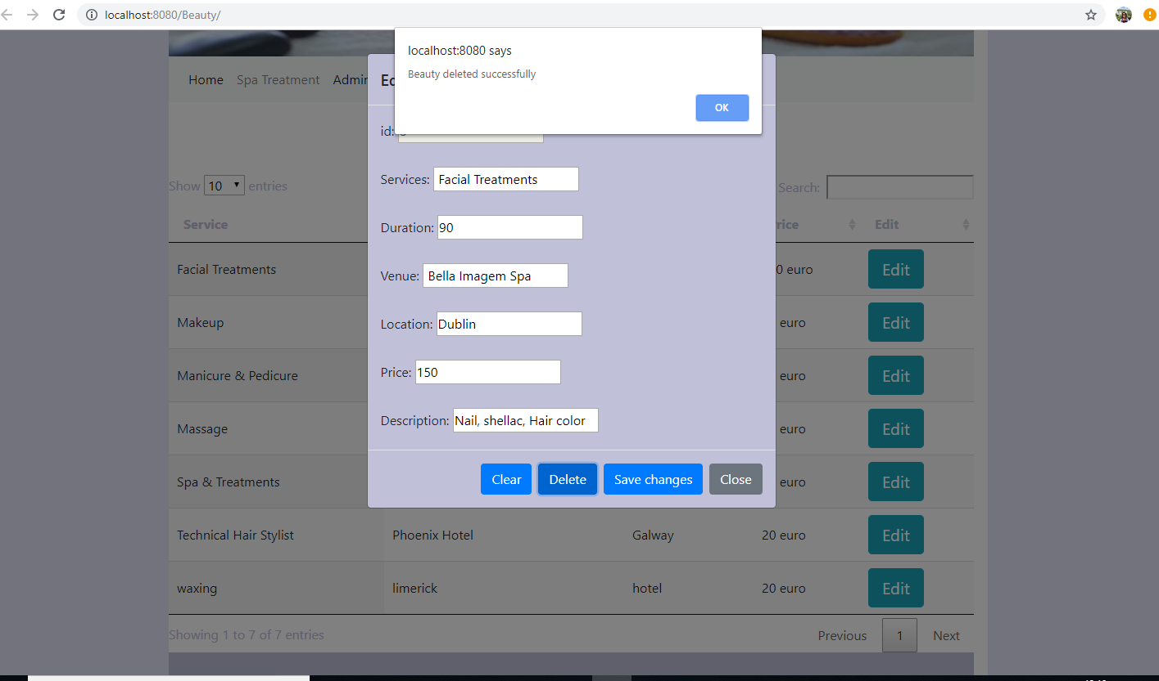

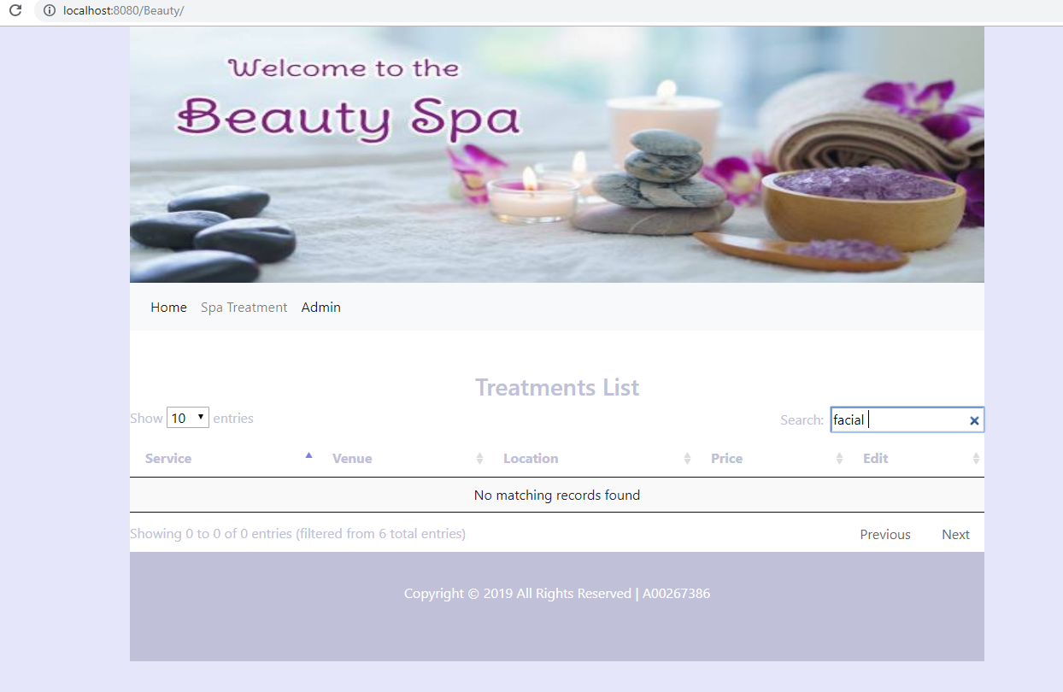

|  |  |
| --- | --- |
| User Story | As the Store Administrator I want to be able to update a Beauty treatment as the information about I might change. |
| Test Case ID | 5 |
| Description | **Update** Beauty |
| Preconditions | Tom cat s is running  1. The browser is open  2. The database is available |
| Actions | 1. The address ‘http://localhost:8080/Beauty/’ is entered in the browser  2. The ‘Admin’ link on the navbar is pressed  3. The ‘Edit’ button is pressed  4. Information is changed in the modal  5. ‘Save’ button is pressed within a modal |
| Expected Results | 1. A notification pops up with the following message: “Beauty updated Successfully”  2. The table reloads  3. Treatment is updated |
| Test Status | Passed |

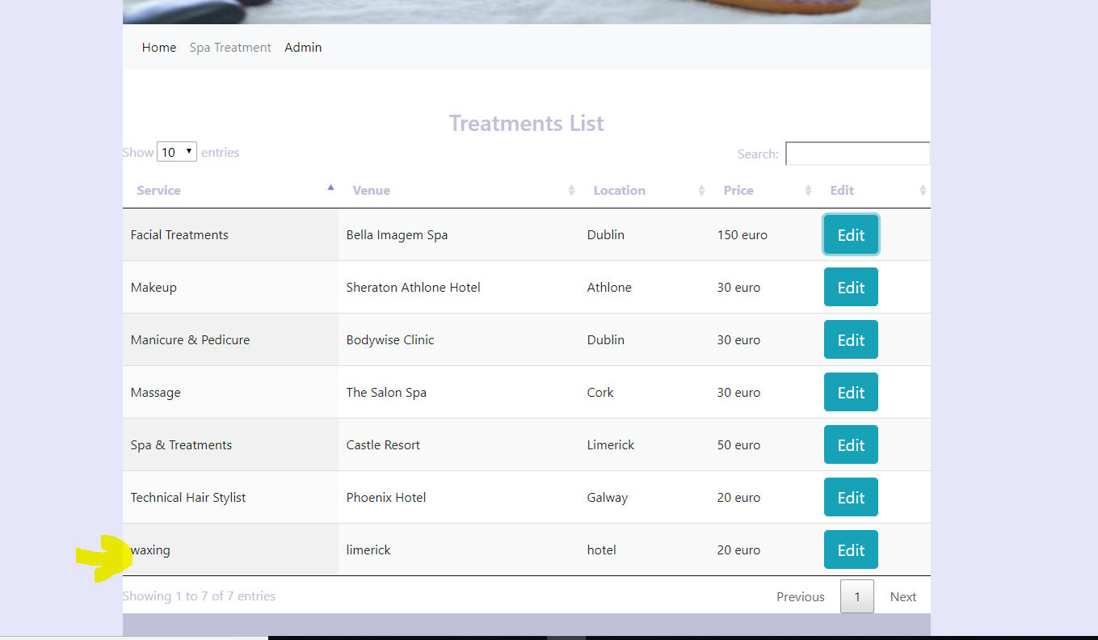

# **Test Report Summary**

|  |  |  |
| --- | --- | --- |
| **Test Type** | **Number Passed** | **Number Failed** |
| Manual | 5 | 0 |

# **Bug Report**

There are currently no known existing bugs in this project.