Robert Ritchie

18 September 2017

CSE 486 – Homework 1 Questions

2) **Scientists:**

* Donald Hebb – Inventor of Hebbian Learning, a model which remains influential today
* Judea Pearl – Her *Probabilistic Reasoning in Intelligent Systems* led to a new acceptance of probability and decision theory in AI.
* Herbert Gelernter – Designed the Geometry Theorem Prover which was able to prove theorems many students of math would find difficult.
* James Slagle – Created the SAINT program which was able to solve closed-form calculus integration problems
* Warren McCulloch & Walter Pitts – Wrote the work which is now generally recognized as the first work on AI.

3) **1.4** Suppose we extend Evan’s ANALOGY program so that it can score 200 on a standard IQ test. Would we then have a program more intelligent than a human? Explain.

The program would not be more intelligent than a human. IQ tests are simply metrics to which the program has been designed to perform for. While it can answer these questions more efficiently than most humans, it lacks intelligence in many other ways.

4)

AlphaGo

AlphaGo is the name of an AI computer program developed by Alphabet Inc’s Google DeepMind in London. As its name suggests, it plays the Chinese board game “Go”. Go originated in China over 3000 years ago. The rules are fairly simple, players take turns placing black and white stones trying to capture territory, however Go is considered to be a much more difficult game for a computer to play than other games such as chess, because of its high branching factor. There are approximately 10 to the power of 170 board configurations, making it a googol times more complex than Chess. Many traditional approaches to these games would never work as there are simply to many possible cases to be explored. Over the past few years however, AlphaGo has been able to learn the game to the point where it has beaten some of the best Go players in the world.

Before AlphaGo, no computer had been able to defeat a ranked Go player without a handicap. In 2012, a software program called Zen beat a 9-Dan (the highest rank achievable for Go players) player named Masaki Takemiya two times at five and four stones handicap. AlphaGo is a deep learning project inspired by previous Go AI attempts. It began in 2014 and by October 2015 it had defeated every other Go AI and became the first Go AI to beat a ranked human player. Over the years it continued to take games from professional Go players, and in 2017 it beat the number one ranked Go player in the world and was rewarded an honorary 9-Dan. So far, no other Go AI has come close to achieving the levels of Go play which AlphaGo has. However, AlphaGo is officially retired from entering any competitive play. In the near future data from AlphaGo’s playtime will be released for Go players to study.

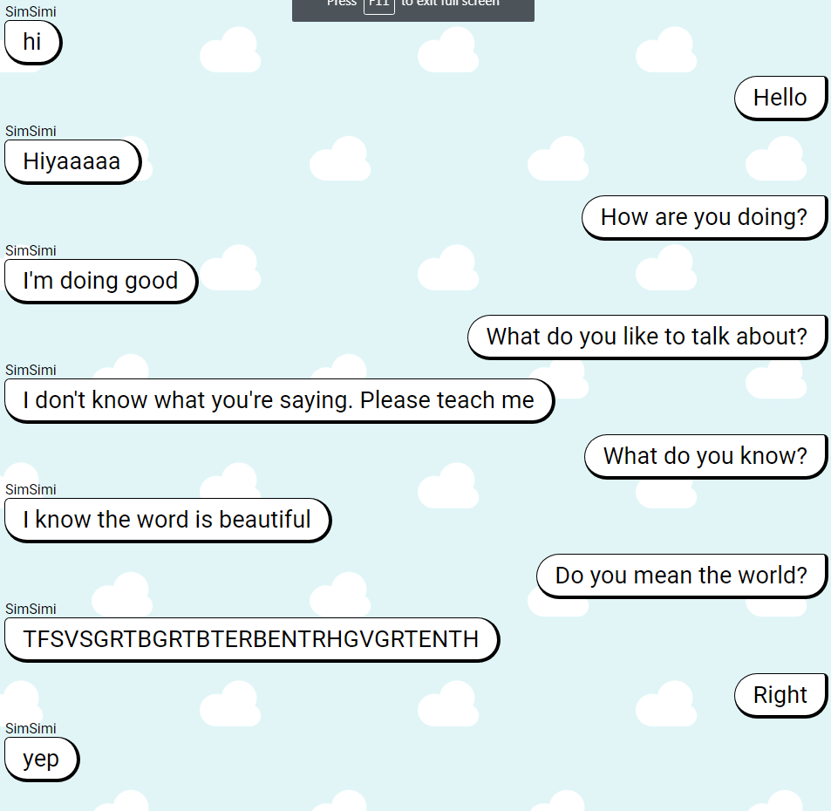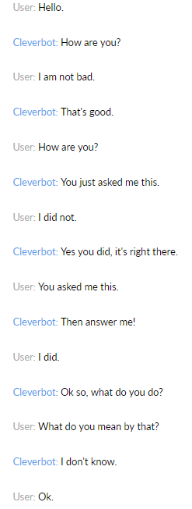5) Neither chatbot seemed to be very intelligent at all. They are able to provide simple responses to common questions such as “How are you?” but they often cannot even produce logical responses to statements. SimSimi in particular seemed to learn certain phrases which people have typed to it but have no meaning whatsoever.