Cloud Exceptions Dashboard

1.
Filter Bar (CMS / Cloud Service Provider / Guardrail / Account ID / Approval ID / Exception Status / Guardrail Layer)

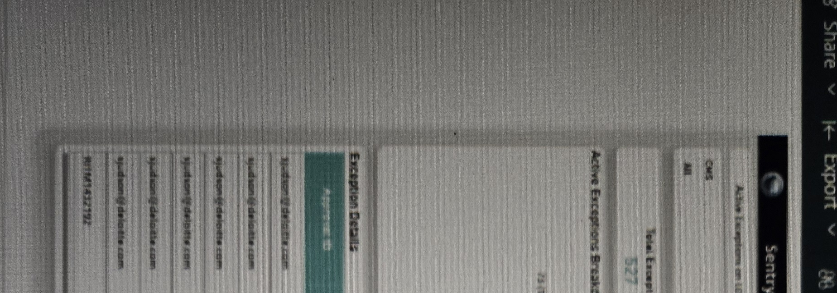

Intent: Give users a single control bar to slice the entire dashboard by CMS, Cloud Service Provider, Guardrail, Account ID, Approval ID, Exception Status, and Guardrail Layer, plus quick actions to reset or clear all filters.
Query: Filter Dashboard on cms = All, cloud_service_provider = All, guardrail = All, account_id = All, approval_id = All, exception_status = All, guardrail_layer = All
Data: Shows each filter as a dropdown defaulted to "All"; header shows the dashboard title "Active Exceptions on 10 Policies" with Reset Dashboard, Exceptions Expiring In, and Clear all filters controls.
Suggested Change(s): Add a persistent breadcrumb showing which filters are currently applied so users can see active filters without opening each dropdown.
2.
Total Exceptions



Intent: Show the total count of exceptions raised across all 10 policies.
Query: Count of Exception_ID (no status filter applied)
Data: Total Exceptions = 527
3.
Active



Intent: Show the number of exceptions that are currently in an Active status.
Query: Count Exception_ID where Exception_Status = "Active"
Data: Active = 219
4.
Expired

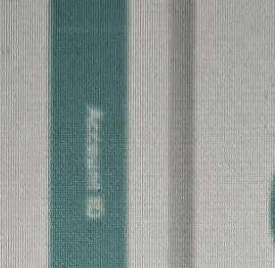

Intent: Show the number of exceptions whose end date has passed.
Query: Count Exception_ID where Exception_Status = "Expired"
Data: Expired = 308
5.
Expiring Soon

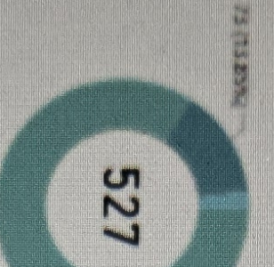

Intent: Flag exceptions that are approaching their end date so owners can renew or remediate before they lapse.
Query: Count Exception_ID where End_Date is within the next N days (e.g., 30 days) of current date
Data: Expiring Soon = 24
Suggested Change(s): Clarify the exact lookahead window (e.g., "next 30 days") in the card label so the threshold is explicit.
6.
Accounts with Active Exceptions

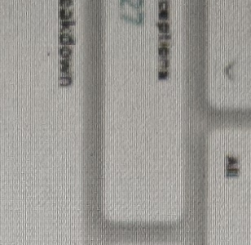

Intent: Show how many distinct cloud accounts currently carry at least one active exception.
Query: Count Distinct Account_ID where Exception_Status = "Active"
Data: Accounts with Active Exceptions = 8
7.
Guardrails with Active Exceptions

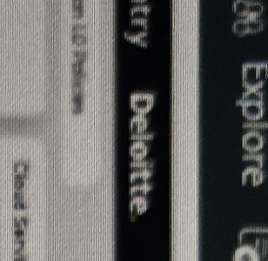

Intent: Show how many distinct guardrails have at least one active exception raised against them.
Query: Count Distinct Guardrail_ID where Exception_Status = "Active"
Data: Guardrails with Active Exceptions = 40
8.
Active Exceptions Breakdown

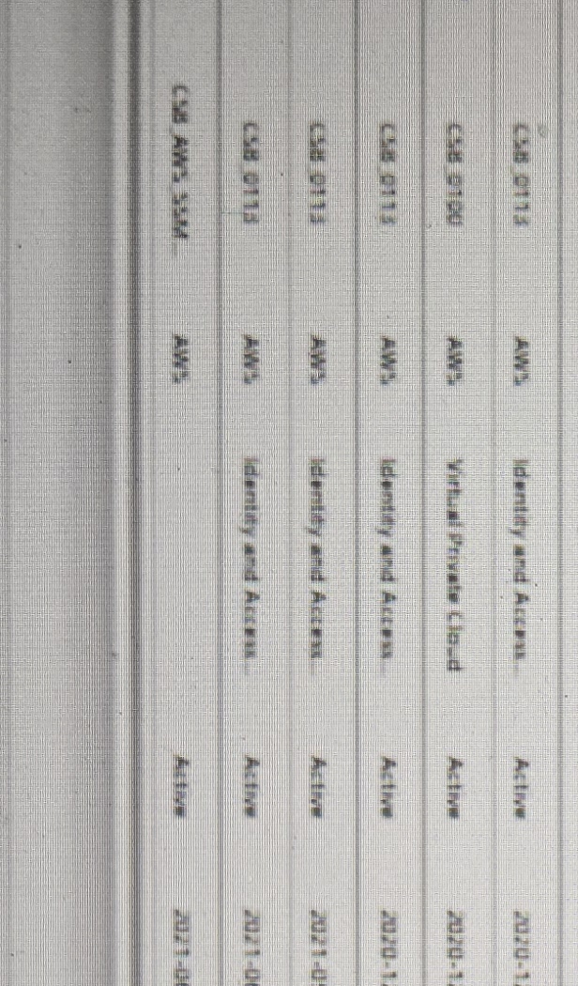

Intent: Show the split of active exceptions by Cloud Service Provider (AWS, Azure, GCP).
Query: Count Exception_ID where Exception_Status = "Active", split by Cloud_Service_Provider
Data: Donut chart totaling 527, broken out by provider — AWS accounts for the majority share (453, 84.35%) with the remainder split between Azure (~13.83%) and GCP.
Suggested Change(s): Label each donut segment directly with provider name, count, and percentage instead of relying solely on the legend, so the split is readable at a glance.
9.
Expiring Exceptions By Month

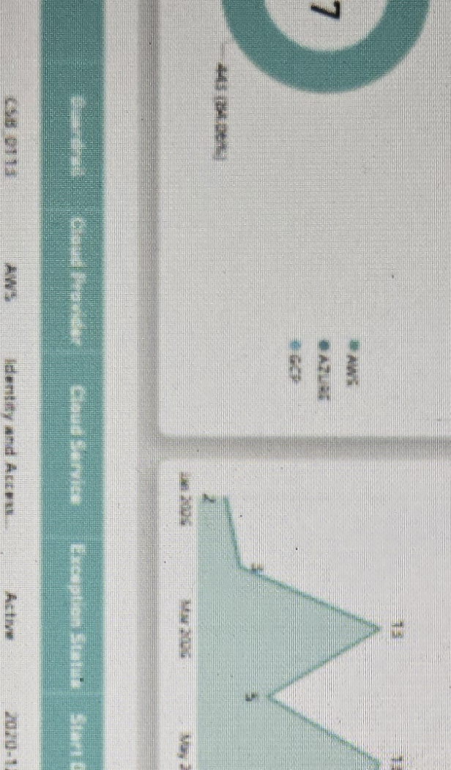

Intent: Show the trend of exceptions expiring, by month, so teams can plan renewal/remediation workload ahead of time.
Query: Count Exception_ID grouped by Month(End_Date), Jan 2026 – Nov 2026
Data: Area/line chart showing monthly expiring counts: Jan 2, Mar 13, May 5, Jul 11, 17, Sep 9, 14, Nov 4.
Suggested Change(s): Add a reference line or shaded band for the current month so users can immediately distinguish past-due months from upcoming ones.
10.
Active Exceptions By Guardrail

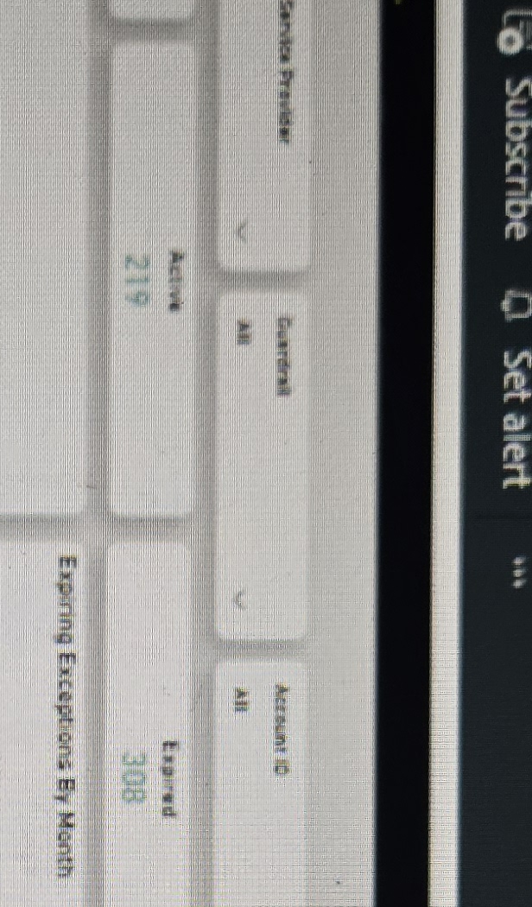

Intent: Rank the guardrails (CSB IDs) carrying the most active exceptions so remediation effort can be prioritized.
Query: Count Exception_ID where Exception_Status = "Active", grouped by CSB_ID (Guardrail), sorted descending, split by Severity
Data: List of top CSB IDs with active exception counts: CSB_0019 (32, High), CSB_0113 (30, High), CSB_0008 (14, High), CSB_0450 (8, High), CSB_0709 (6, Medium).
Suggested Change(s): Add the full guardrail description alongside the CSB ID, since IDs alone aren't meaningful to most stakeholders.
11.
Active Exceptions by Asset Class

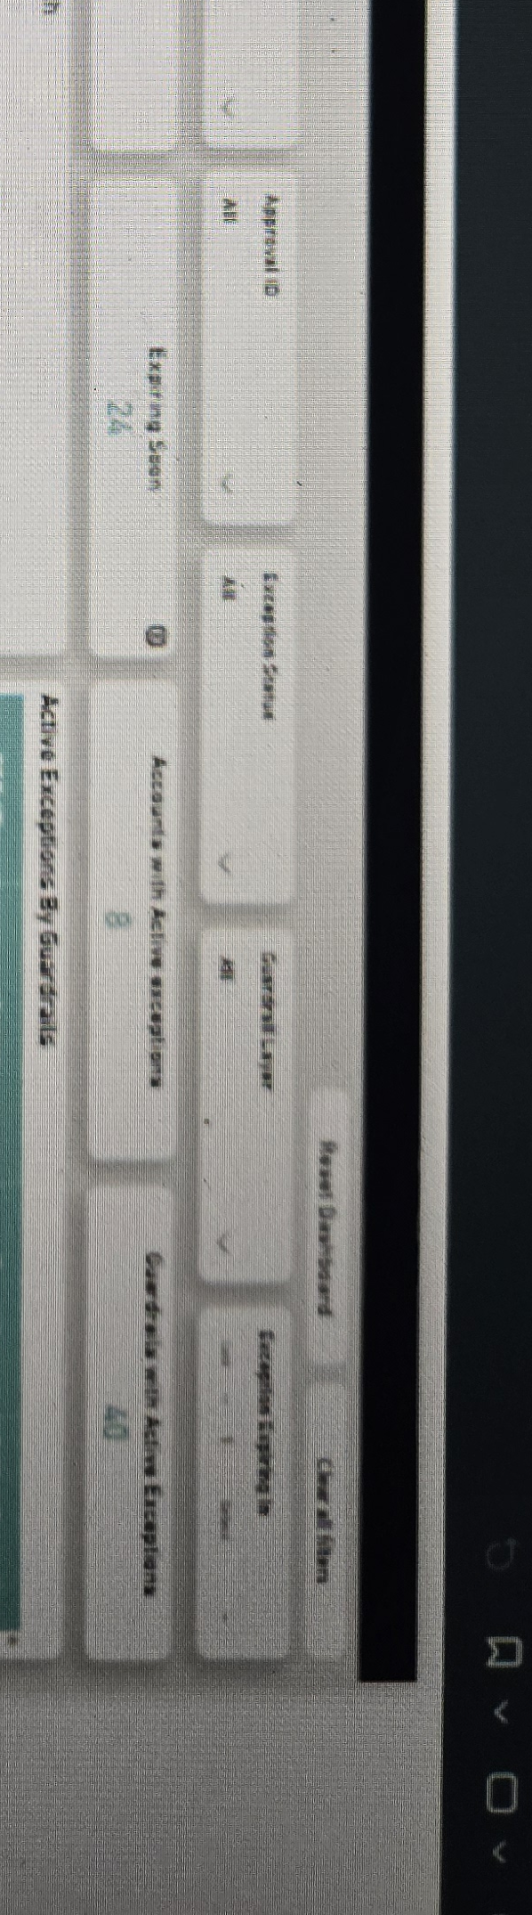

Intent: Show which asset classes carry the most active exceptions to help prioritize remediation by control domain.
Query: Count Exception_ID where Exception_Status = "Active", grouped by Asset_Class
Data: Horizontal bar chart: Public Access 163, Network Security 120, Encryption 88, Identity & Access Management 45, Security Logging 17, Platform 11.
Suggested Change(s): Sort is already descending; consider adding data labels at the end of each bar so exact counts don't require hovering.
12.
Exception Details

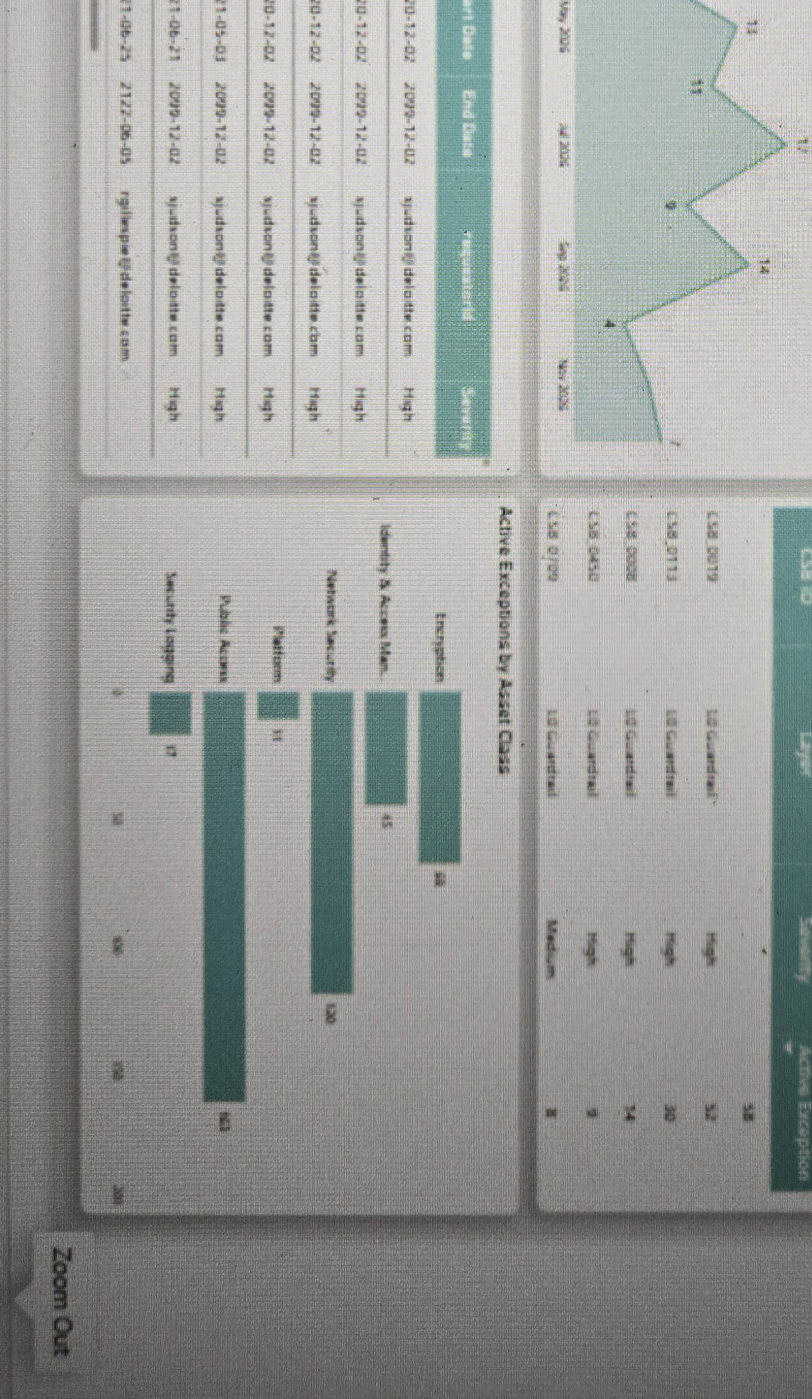

Intent: Provide the underlying record-level detail behind the summary cards and charts above, for audit and remediation tracking.
Query: Select Approval_ID, Account_ID, Guardrail, Cloud_Provider, Cloud_Service, Exception_Status, Start_Date, End_Date, Requested_By, Severity for each Exception_ID (filtered by the selections in the top filter bar)
Data: Table of individual exceptions, e.g. CSB_0113 / AWS / Identity and Access... / Active / 2020-12-02 – 2099-12-02 / sjudson@deloitte.com / High; CSB_0100 / AWS / Virtual Private Cloud / Active / 2020-12-02 – 2099-12-02 / High; CSB_AWS_SSM / AWS / Identity and Access... / Active / 2021-06-23 – 2122-06-05 / rgillespie@deloitte.com / High.
Suggested Change(s): Several records use an End_Date of 2099-12-02 (or later) as a de-facto "no expiry" placeholder — flag these separately from genuine long-dated exceptions so they don't mask true expiring-soon risk.

