Secrets in Code Dashboard
Widget Documentation — Intent, Query & Data Reference
1.
Filters / Search Criteria
Intent: One-click controls to scope the whole dashboard to a specific slice of the secrets-in-code data before reviewing the panels below.
Query: Filter Dashboard on Line of Business = [selected], Sub Org = [selected], Repository Name = [selected], Repository Names = [selected], Secret Validity = [selected], Secret Type = [selected], Secret Founder = [selected], Publicly Leaked Secrets = [selected], Date Range = [selected]
Data: Displays the currently selected value for each filter; all panels on the page recompute against this selection.
Suggested Change(s): Add a visual indicator (badge/count) on each filter showing whether a non-default value is applied, so users can tell at a glance which filters are narrowing the view.

2.
Summary KPI Cards
Intent: Give a headline, at-a-glance count of secrets and repositories for the current filter selection.
Query: Secrets in Code: Count of Secrets under the current filters. Active Secrets: Count where Secret State = Active. Publicly Leaked Secrets: Count where Publicly Leaked = True. Active Repositories: Count Distinct Repository where Repo Status = Active. Secrets in General History: Count where Secret Found In = Commit History. Total Secrets: Count of all Secrets (unfiltered by state). Total Repositories: Count Distinct Repository (all).
Data: Secrets in Code: 0 | Active Secrets: 2,627 | Publicly Leaked Secrets: 1,378 | Active Repositories: 7,634 | Secrets in General History: 99,946 | Total Secrets: 103,314 | Total Repositories: 9,998
Suggested Change(s): “Secrets in Code” reads 0 while every other card is non-zero — confirm this card's underlying filter/measure, and rename it so it's clearly distinct from “Total Secrets.”

3.
Active Secrets by LOB
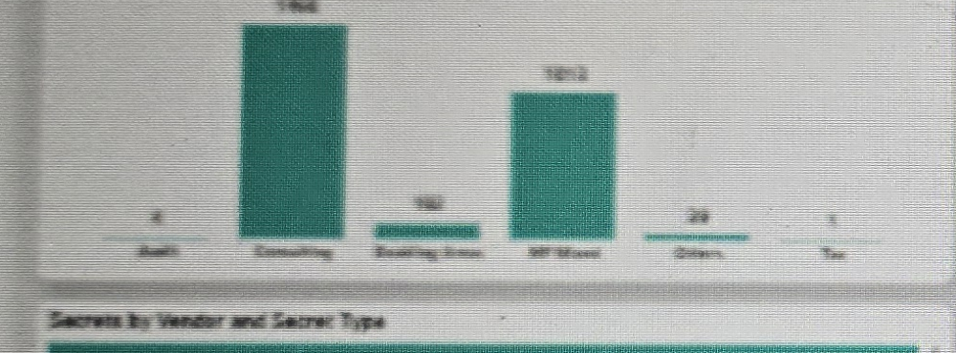
Intent: Show how active secrets are distributed across Lines of Business.
Query: Count of Active Secrets, split by Line of Business (Audit, Consulting, Enabling Areas, WP Mixed, Others, Tax).
Data: Consulting and WP Mixed carry the largest bars; Audit, Others and Tax are comparatively small. Exact per-bar labels are not fully legible in the source screenshot.
Suggested Change(s): Add data labels or a hover tooltip with the exact count per LOB so the chart doesn't need to be read by eye.

4.
Secret Count by Secret Category
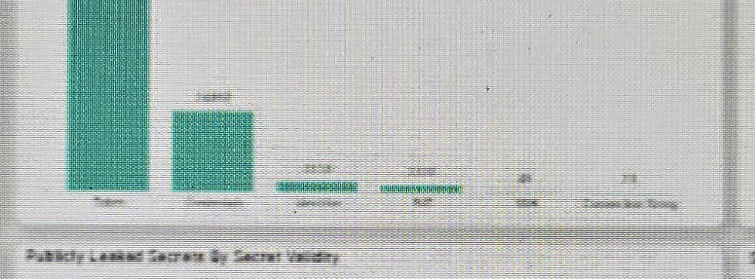
Intent: Break down all secrets in history by secret category/type.
Query: Count of Secrets grouped by Secret Category (Token, Credentials, Identifier, Key/ID, Connection String, etc.).
Data: Token and Credentials dominate the total; Identifier, Key/ID and Connection String make up a small remainder. Totals are broadly consistent with the 99,946 “Secrets in General History” KPI.
Suggested Change(s): Consider a log scale, or a separate breakout chart for the smaller categories, since Token/Credentials dwarfs the rest on a linear axis.

5.
Secrets Findings by Month
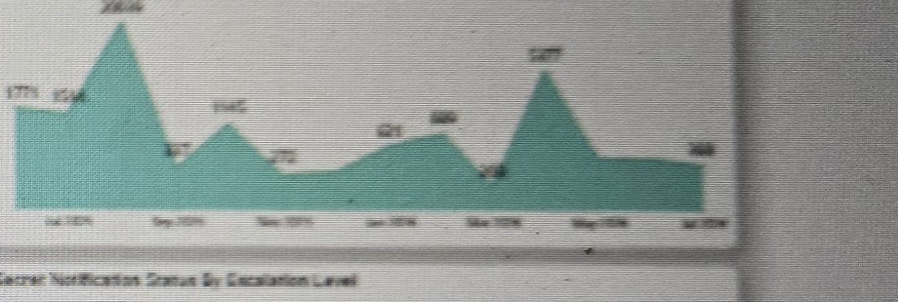
Intent: Track the trend of new secret findings over time.
Query: Count of Secrets grouped by Month (Created At / Found date).
Data: Monthly counts fluctuate over the observed period with a couple of visible peaks. Exact monthly figures are not clearly legible in the source screenshot.
Suggested Change(s): Add a rolling 3-month average line to smooth month-to-month volatility and make the underlying trend easier to read.

6.
Secrets by Vendor and Secret Type
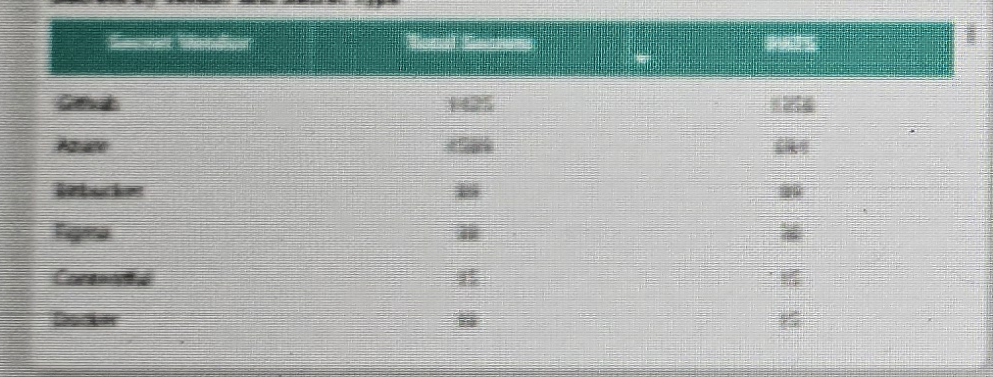
Intent: Show which secret vendors/services contribute the most secrets in code.
Query: Count of Secrets grouped by Secret Vendor, shown as Total Secrets vs. a second (currently hard to read) column.
Data: Github and Azure account for the large majority of secrets; Bitbucket, Figma, Confluence and Docker are minor contributors by comparison.
Suggested Change(s): Clarify the header of the second numeric column (not clearly legible in the source image) and sort rows descending by Total Secrets.

7.
Publicly Leaked Secrets by Secret Validity
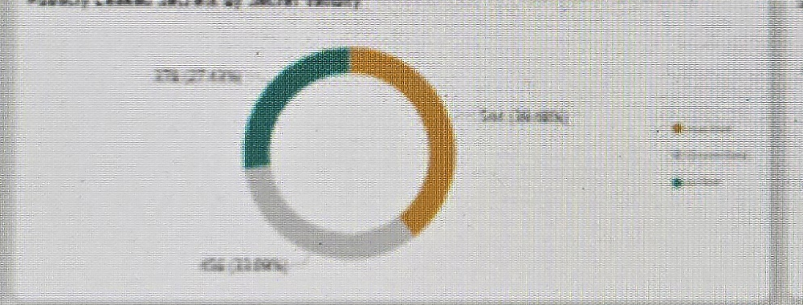
Intent: Show how many publicly leaked secrets are still valid/active versus inactive or unverified.
Query: Count Distinct Publicly Leaked Secrets, split by Secret Validity (Active / Unverified / Inactive).
Data: Roughly a three-way split across the validity states, at approximately 27%, 40% and 33% of leaked secrets respectively.
Suggested Change(s): Reorder the legend so the highest-risk state (Active) is listed first, and use a red/amber/grey palette instead of teal/gold/grey to better signal risk severity.

8.
Secret Notification Status by Escalation Level
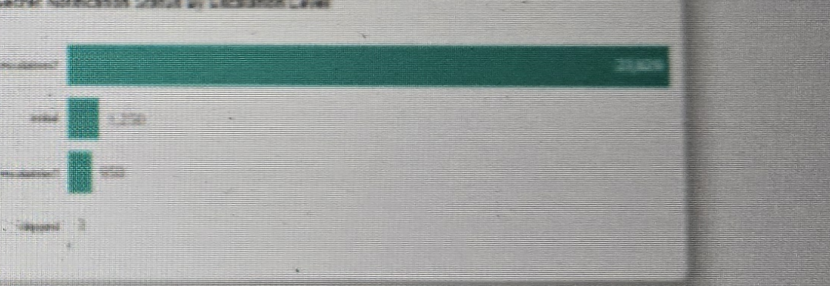
Intent: Show how many secret notifications sit at each escalation stage.
Query: Count of Secret Notifications grouped by Escalation Level (e.g., Escalated, Initial, further escalation tiers, Skipped).
Data: The top-level escalation status carries the largest volume; remaining tiers are progressively smaller, with a small “Skipped” count.
Suggested Change(s): Add a “days open” measure alongside the count so overdue escalations stand out rather than just the raw volume per tier.

9.
Details (Drill-down Table)
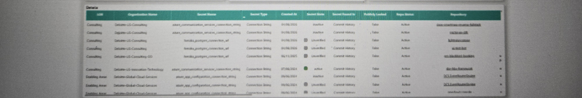
Intent: Provide row-level detail for every secret, filterable by all criteria above, for investigation and remediation tracking.
Query: Show LOB, Organization Name, Secret Name, Secret Type, Created At, Secret State, Secret Found In, Publicly Leaked, Repo Status and Repository for all secrets matching the current filters.
Data: Individual secret records (e.g., azure_communication_services_connection_string, heroku_postgres_connection_url) with states such as Active / Inactive / Unverified and Repo Status = Active.
Suggested Change(s): Add a direct link/action column to open the finding in the source repository, and a “days since created” column to help prioritize remediation.

