Active Exceptions on LD Policies — Dashboard
Sentry | Deloitte

1. Global Filters
Intent: Allow users to slice the dashboard by CMS, Cloud Service Provider, Guardrail, Account ID, Approval ID, Exception Status, Guardrail Layer, and Exception Expiring In.
Query: Apply selected filter values as global WHERE conditions across all visuals on the dashboard.
Data: Shows the filter control bar with default value = All for every field.
Suggested Change(s): Add a persistent "Applied Filters" summary chip row beneath the filter bar so users can see active selections without opening each dropdown.

2. Total Exceptions

Intent: Show the overall count of exceptions raised against LD Policies, regardless of status.
Query: Count Approval_ID (distinct) across all Exception records.
Data: Total Exceptions = 527.
Suggested Change(s): Add a small trend arrow/sparkline showing change vs. prior period.

3. Active Exceptions
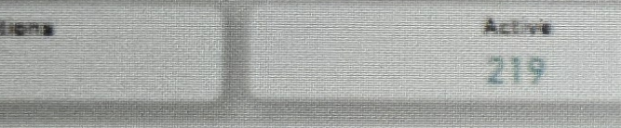
Intent: Show how many of the total exceptions are currently in Active status.
Query: Count Approval_ID where Exception_Status = Active.
Data: Active = 219.
Suggested Change(s): Make the card clickable to cross-filter the Exception Details table to Active rows only.

4. Expired Exceptions

Intent: Show how many exceptions have passed their End Date.
Query: Count Approval_ID where Exception_Status = Expired.
Data: Expired = 308.
Suggested Change(s): Rename to "Expired Exceptions" for parity with the Active card, and add a tooltip explaining expiry logic.

5. Expiring Soon

Intent: Give an early warning of exceptions that will expire within the selected lookahead window.
Query: Count Approval_ID where Exception_Status = Active and End_Date is within N days of today.
Data: Expiring Soon = 24.
Suggested Change(s): Expose the lookahead window (currently an info icon) as an editable parameter directly on the card.

6. Accounts with Active Exceptions

Intent: Show the number of distinct cloud accounts that carry at least one Active exception.
Query: Count distinct Account_ID where Exception_Status = Active.
Data: Accounts with Active Exceptions = 8.
Suggested Change(s): Add a breakdown by Cloud Service Provider (AWS/Azure/GCP) on hover.

7. Guardrails with Active Exceptions

Intent: Show the number of distinct guardrails (LD policies) that have at least one Active exception.
Query: Count distinct Guardrail/CSB_ID where Exception_Status = Active.
Data: Guardrails with Active Exceptions = 40.
Suggested Change(s): Split by Guardrail Layer so users can see which layer (e.g., LD Guardrail) is most exception-heavy.

8. Active Exceptions Breakdown
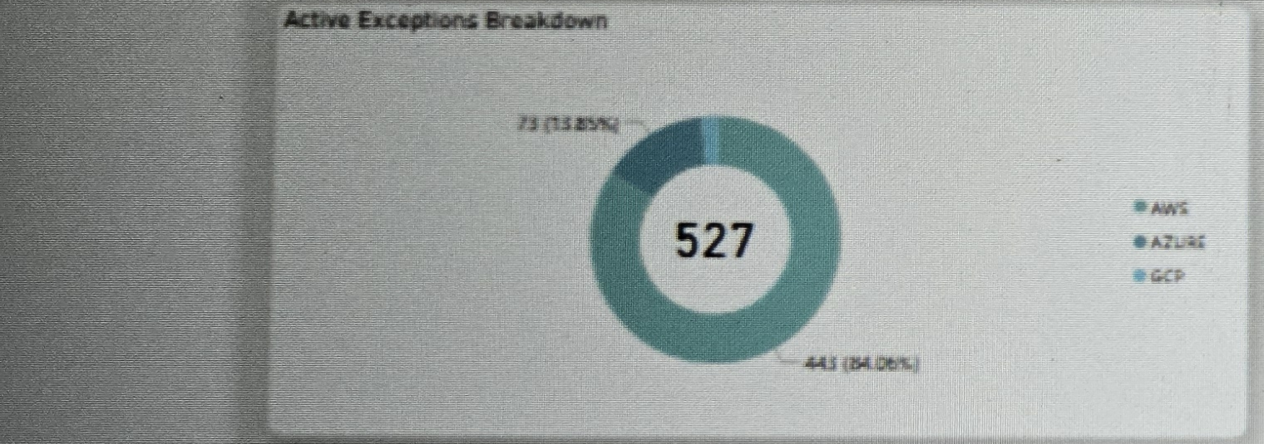
Intent: Show the split of active exceptions by Cloud Service Provider.
Query: Count Approval_ID grouped by Cloud_Service_Provider where Exception_Status = Active.
Data: AWS = 443 (84.06%), Azure/GCP = 73 (13.85%), center total = 527.
Suggested Change(s): Label the small GCP slice directly on the chart instead of relying only on the legend, since it is easy to miss at this size.

9. Expiring Exceptions By Month
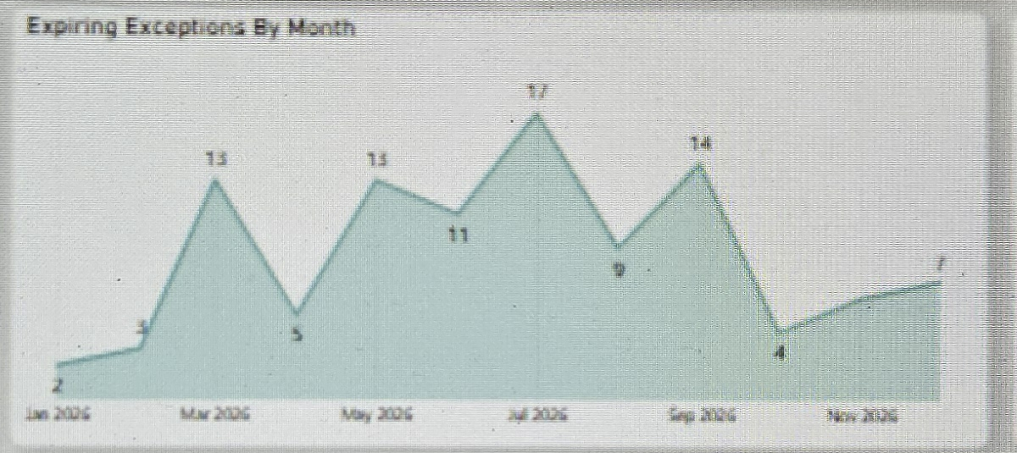
Intent: Show the forward-looking volume of exceptions expiring each month so teams can plan renewals.
Query: Count Approval_ID grouped by month of End_Date, for the next 12 months (Jan 2026–Nov 2026).
Data: Monthly counts ranging from 2 (Feb 2026) to 17 (Jul 2026).
Suggested Change(s): Add data labels on each point and a reference line for the current month.

10. Active Exceptions By Guardrails
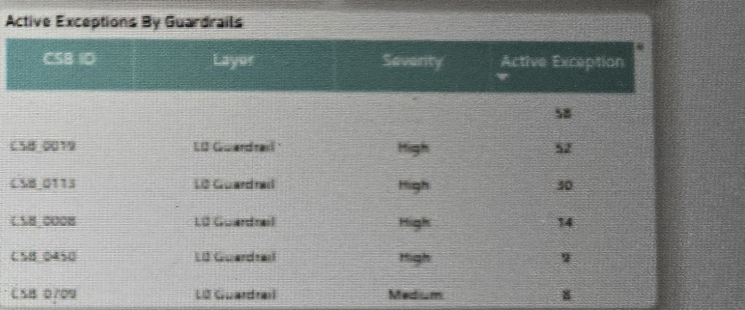
Intent: Rank guardrails by their number of Active exceptions to surface the riskiest policies.
Query: Count Approval_ID grouped by CSB_ID/Guardrail and Layer, where Exception_Status = Active, sorted descending.
Data: Top rows: CSB_0019 (58), CSB_0113 (52), CSB_0008 (30), CSB_0450 (14), CSB_0709 (9) — all High severity except CSB_0709 (Medium).
Suggested Change(s): Add conditional-formatting color to the Severity column (e.g., red for High) for faster scanning.

11. Exception Details
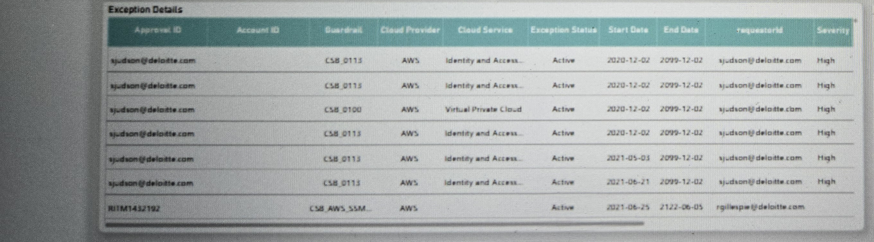
Intent: Provide row-level detail for every exception so analysts can audit individual approvals.
Query: List Approval_ID, Account_ID, Guardrail, Cloud_Provider, Cloud_Service, Exception_Status, Start_Date, End_Date, requestorId, and Severity for all records matching the active filters.
Data: Table currently shows AWS-based Active exceptions across Identity and Access, Virtual Private Cloud, and other services, requested primarily by sjudson@deloitte.com and rgillespie@deloitte.com.
Suggested Change(s): Flag rows with End_Date far in the future (e.g., 2099-12-02, 2122-06-05) as "No Expiry / Needs Review" since these look like placeholder dates rather than real expirations.

12. Active Exceptions by Asset Class
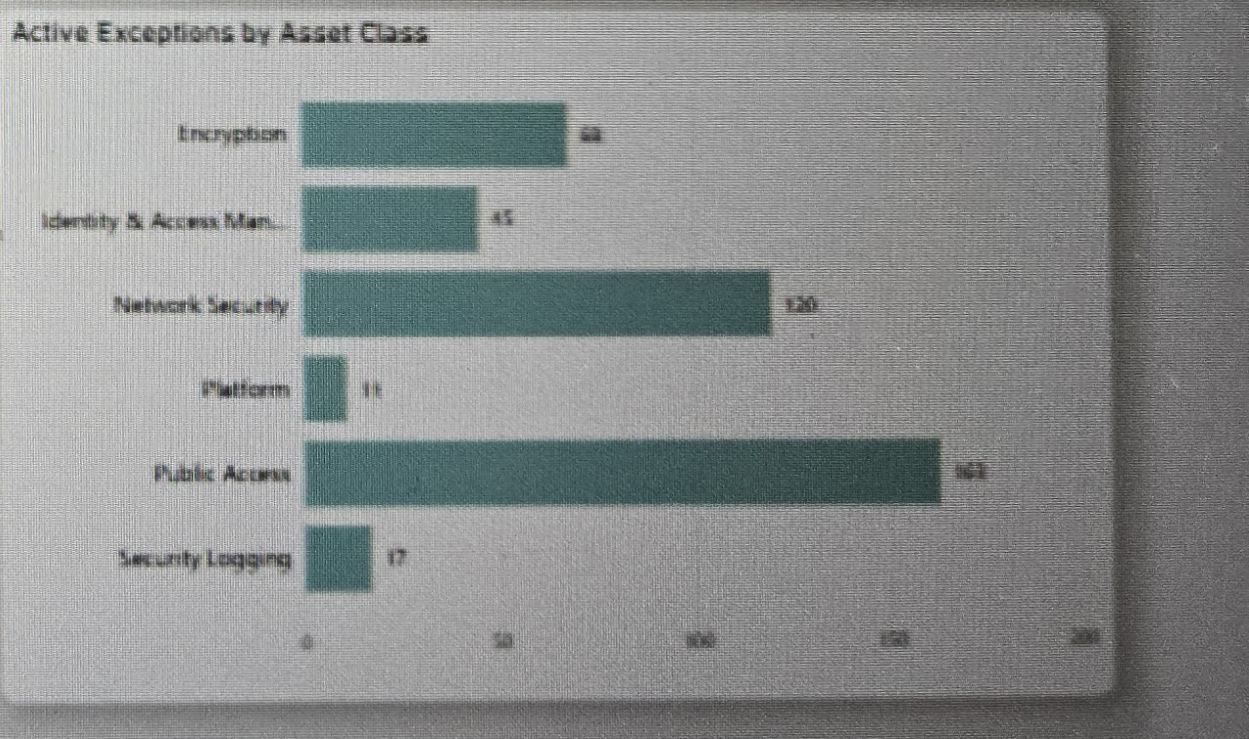
Intent: Show which asset classes carry the most Active exceptions.
Query: Count Approval_ID grouped by Asset_Class where Exception_Status = Active, sorted descending.
Data: Public Access (~163) and Network Security (~120) are the largest categories, followed by Encryption (~68), Identity & Access Management (~45), Security Logging (17), and Platform (11).
Suggested Change(s): Move this chart next to "Active Exceptions By Guardrails" so severity and asset-class risk can be compared side by side.

