Sentry Dashboard
1.
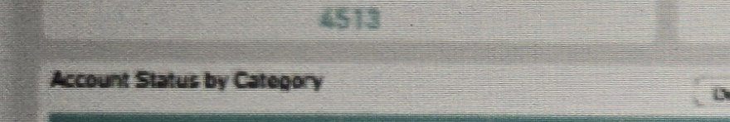
Intent:
Single-value tile showing the total number of cloud accounts onboarded across all Lines of Business (LOBs), tenants, and Cloud Service Providers.
Query:
Filter Dashboard on: LOB = All, Tenant = All, Cloud Service Provider = All
Count Distinct Account ID across all onboarded accounts
Data:
Shows the current total account count (4513) reflecting all filter selections applied at the top of the dashboard.
Suggested Change(s):
Add a month-over-month trend indicator (e.g., arrow/percentage) next to the total so users can see onboarding velocity at a glance.

2.

Intent:
Single-value tile showing the number of accounts currently in an Error state.
Query:
Filter Dashboard on: Account Status = Error
Count Distinct Account ID where Account Status = Error
Data:
Shows the current count of accounts with errors (70).
Suggested Change(s):
Make the tile clickable to drill directly into the filtered list of erroring accounts, consistent with the Detailed Logs pattern used elsewhere on the dashboard.

3.

Intent:
Single-value tile showing the number of accounts currently in a Warning state.
Query:
Filter Dashboard on: Account Status = Warning
Count Distinct Account ID where Account Status = Warning
Data:
Shows the current count of accounts with warnings (2100).
Suggested Change(s):
Split by Category so users can see which categories (Agentless Scanning, Audit Logs, Authentication, etc.) are driving the warning volume without opening the detail table below.

4.

Intent:
Single-value tile showing total platform credits consumed across all onboarded services.
Query:
Filter Dashboard on: LOB = All, Tenant = All
Sum of Credits Utilized across all Services
Data:
Shows the current total credits utilized (29,961), aggregated across all services shown in the Credit Utilization by Service panel.
Suggested Change(s):
Add a secondary label showing credits remaining / total allocation so utilization can be read as a percentage rather than a raw count.

5.
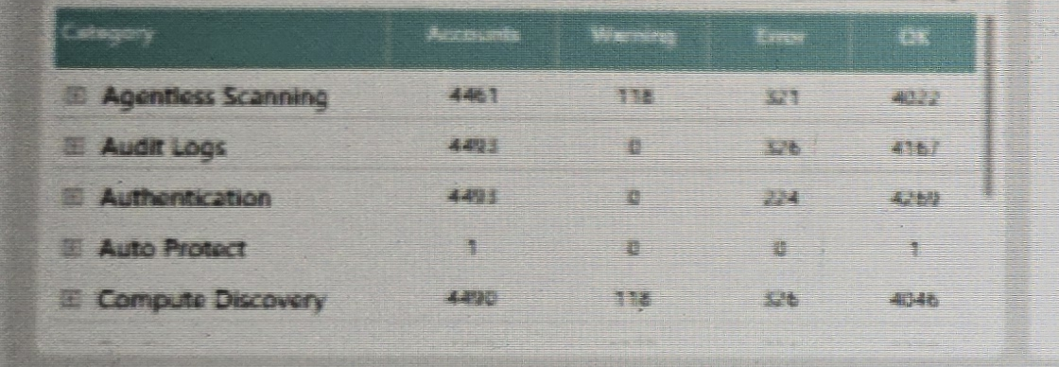
Intent:
Table view showing account health broken down by security category, so users can see where Warnings/Errors are concentrated.
Query:
Group accounts by Category (Agentless Scanning, Audit Logs, Authentication, Auto Protect, Compute Discovery, etc.)
Count Distinct Account ID per Category, split by Status (Warning, Error, OK)
Data:
Shows, per Category, the total Accounts, Warning count, Error count, and OK count. A "Detailed Logs" button opens the underlying account-level records.
Suggested Change(s):
Add sorting by Error count descending by default so the highest-risk categories surface to the top of the table.

6.
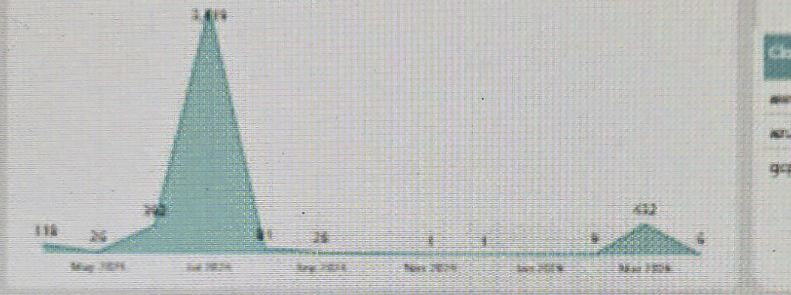
Intent:
Area/line chart showing the number of new accounts onboarded per month, to track onboarding trends over time.
Query:
Group Accounts by Onboarded Month
Count Distinct Account ID per month
Data:
Shows monthly onboarding volume from May 2025 through March 2026, including a large spike (~1,419) in one month and a smaller secondary spike (~432) later in the period.
Suggested Change(s):
Annotate the spike months with tooltips explaining the cause (e.g., bulk migration, new tenant onboarding) so viewers don't misread them as anomalies.

7.
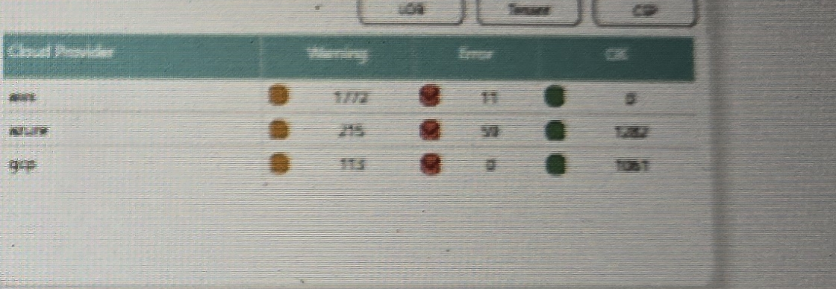
Intent:
Table view showing account health broken down by Cloud Service Provider (AWS, Azure, GCP).
Query:
Group Accounts by Cloud Provider
Count Distinct Account ID per provider, split by Status (Warning, Error, OK)
Data:
Shows, per Cloud Provider, the Warning, Error, and OK counts using colored status indicators (amber/red/green). Toggle buttons at the top allow switching the grouping to LOB or Tenant.
Suggested Change(s):
Keep the same color legend visible on this panel (currently only implied by the dots) so it is unambiguous without cross-referencing the Account Status by Category table.

8.
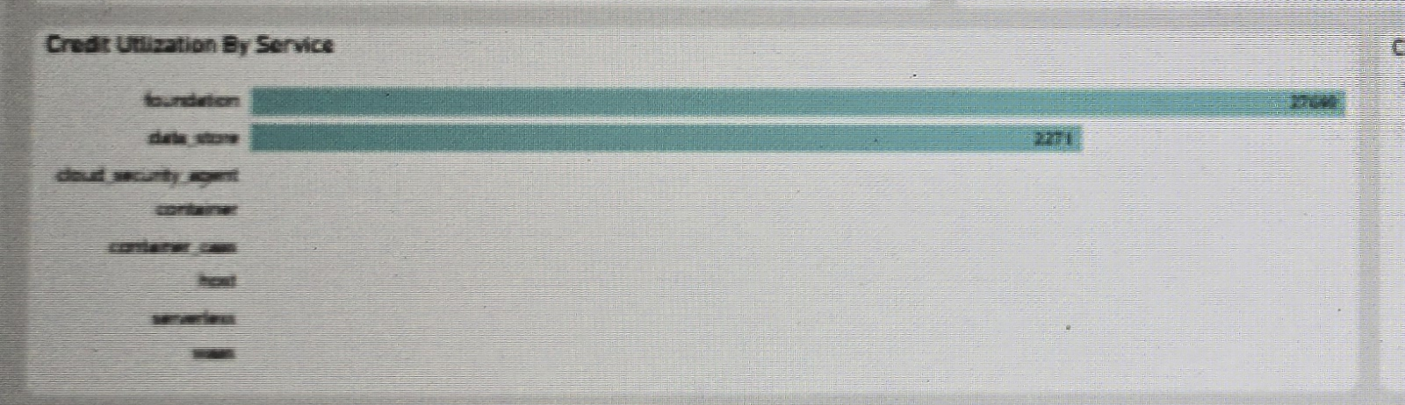
Intent:
Horizontal bar chart showing platform credit consumption broken down by service type.
Query:
Group Credits Utilized by Service (foundation, data_store, cloud_security_agent, container, container_cam, host, serverless, waas)
Sum Credits Utilized per Service
Data:
Shows that "foundation" (27,690) and "data_store" (2,271) are the dominant consumers of credits, while the remaining services show negligible or zero utilization in the current filter selection.
Suggested Change(s):
Collapse or hide services with zero utilization by default to reduce visual clutter, with an option to show all services on demand.

9.
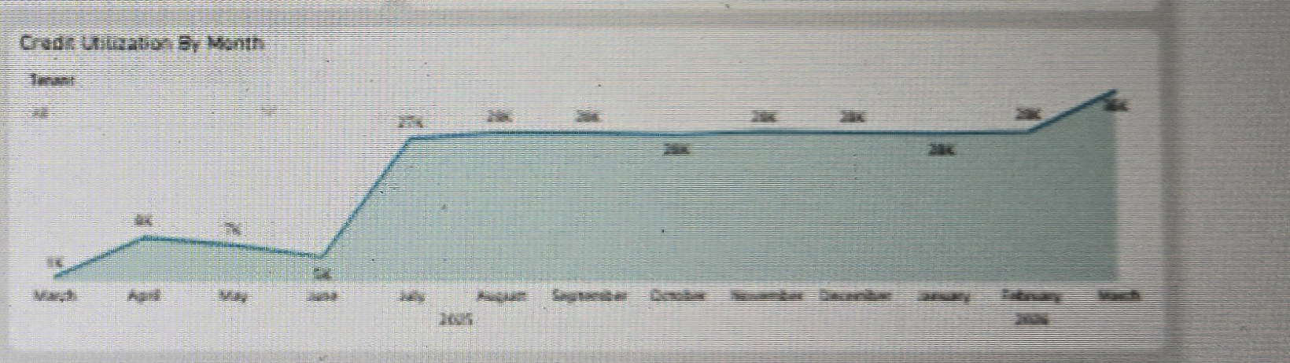
Intent:
Area chart showing total credit utilization trending by month, to track consumption over time relative to allocation.
Query:
Group Credits Utilized by Month
Sum Credits Utilized per month, filterable by Tenant
Data:
Shows a step-up in monthly utilization from roughly 1K–8K (March–June 2025) to a sustained ~28K level from July 2025 through March 2026.
Suggested Change(s):
Overlay a target/budget line on the chart so users can immediately see utilization against an allocated credit ceiling.

10.
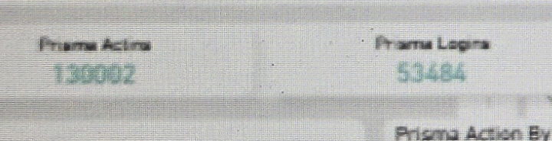
Intent:
Single-value tile showing the total number of Prisma platform actions recorded in the Audit Logs.
Query:
Filter Dashboard on: Action Type = All, Tenant = All, Action Response = All
Count of all logged Prisma Actions
Data:
Shows the current total action count (130,002) across all logged activity.
Suggested Change(s):
None at this time.

11.
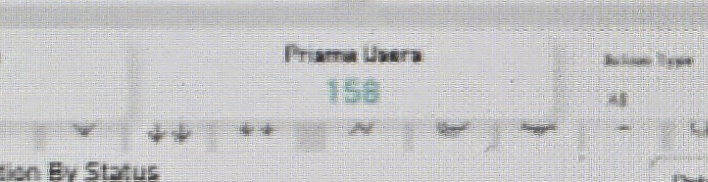
Intent:
Single-value tile showing the total number of Prisma login events recorded in the Audit Logs.
Query:
Filter Dashboard on: Action Type = LOGIN
Count of all logged Prisma Login actions
Data:
Shows the current total login count (53,484), which reconciles with the LOGIN row in the Prisma Action By Status table below.
Suggested Change(s):
None at this time.

12.
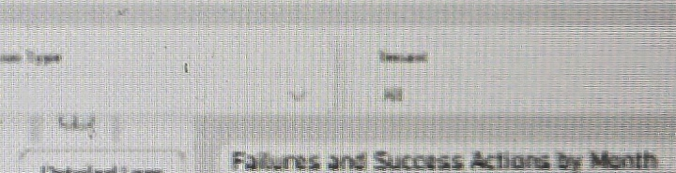
Intent:
Single-value tile showing the count of distinct Prisma users represented in the Audit Logs.
Query:
Count Distinct User ID across all logged Prisma Actions
Data:
Shows the current distinct user count (158).
Suggested Change(s):
None at this time.

13.
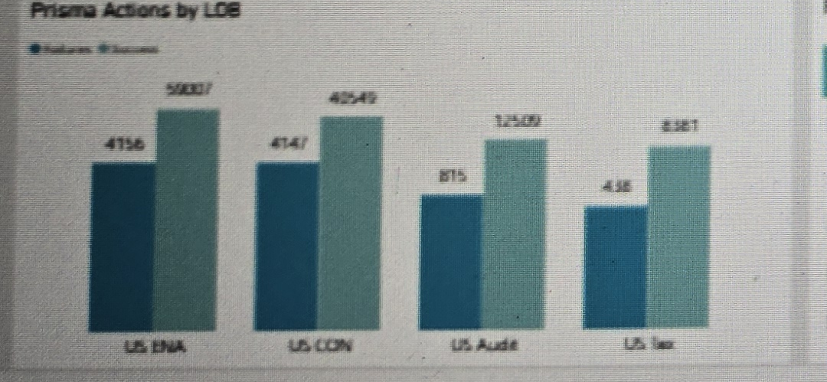
Intent:
Grouped bar chart comparing Failures vs. Success action counts by Line of Business (LOB).
Query:
Group Prisma Actions by LOB (US ENA, US CDN, US Audit, US Tax)
Count Actions per LOB, split by Failures and Success
Data:
Shows, per LOB, the count of failed vs. successful actions (e.g., US ENA: 4,156 failures / 59,007 success; US Audit: 815 failures / 12,509 success).
Suggested Change(s):
Add a failure-rate percentage label above each bar pair so relative risk across LOBs is comparable at a glance, not just absolute counts.

14.
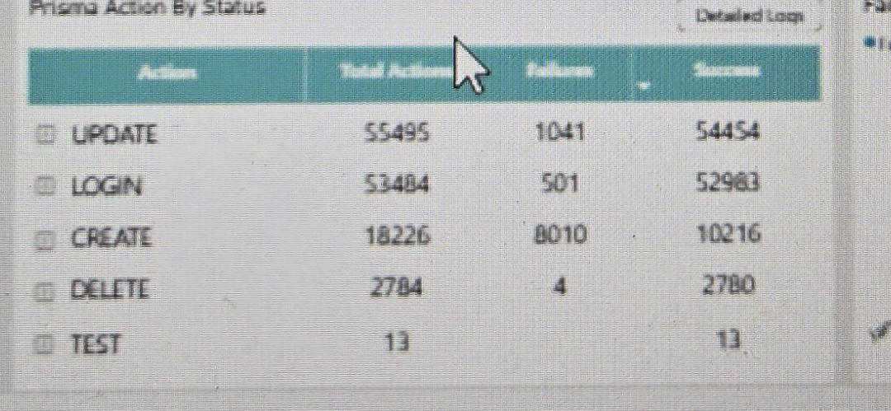
Intent:
Table view showing Prisma action volume broken down by action type and outcome.
Query:
Group Prisma Actions by Action (UPDATE, LOGIN, CREATE, DELETE, TEST)
Count Total Actions per Action, split into Failures and Success
Data:
Shows, per Action type, Total Actions, Failures, and Success counts (e.g., UPDATE: 55,495 total / 1,041 failures / 54,454 success; CREATE: 18,226 total / 8,010 failures / 10,216 success). A "Detailed Logs" button opens the underlying records.
Suggested Change(s):
Highlight rows where the failure rate exceeds a defined threshold (e.g., CREATE at ~44% failure) so high-risk action types are immediately visible.

15.
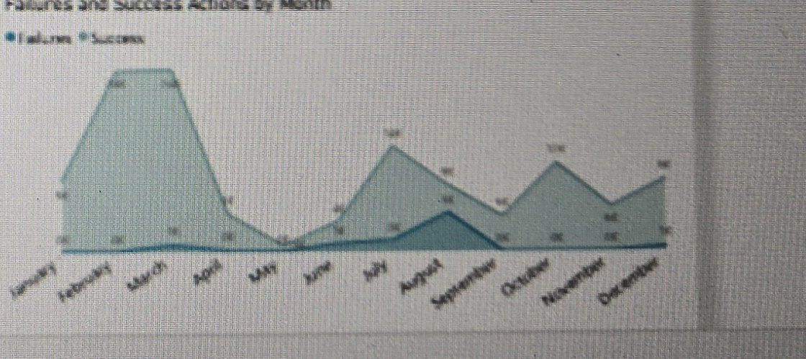
Intent:
Area chart showing the trend of Failures vs. Success actions by month across the full year.
Query:
Group Prisma Actions by Month
Count Actions per month, split into Failures and Success series
Data:
Shows monthly trend from January through December, with a pronounced Success peak in February–March and comparatively low, stable Failures throughout the year with minor bumps in July–August and October–November.
Suggested Change(s):
Add year-over-year comparison as a secondary series so seasonal peaks can be validated against prior-year patterns.

