Node.js Application Deployment on

AWS EC2 using Ansible

1. Introduction
This project demonstrates how to deploy a Node.js web application on an AWS EC2 Ubuntu server using Ansible. The entire setup is automated using Ansible roles and playbooks, ensuring repeatable and reliable deployment. The project also involves configuring AWS networking components such as VPC, Subnet, Route Table, Network ACL, and Security Groups.

2. Objectives
- Deploy a Node.js application on AWS EC2
- Automate the deployment using Ansible
- Configure AWS networking for internet access
- Run the application and access it via public IP
- Follow industry best practices

3. Tools & Technologies Used
- AWS EC2 (Ubuntu 24.04)
- Ansible
- Node.js (v16)
- Git & GitHub
- Linux (Ubuntu)
- SSH

4. Architecture Overview
- Local Machine (Ansible Controller)
- AWS EC2 Instance (Managed Node)
- Public Subnet with Internet Gateway
- Security Group allowing SSH (22) and App Port (3000)

5. AWS Setup

5.1 EC2 Instance Configuration
- AMI: Ubuntu 24.04 LTS
- Instance Type: t2.micro
- Key Pair: node.pem
- Public IP Enabled

5.2 Networking Configuration
- VPC with Public Subnet
- Route Table: 0.0.0.0/0 → Internet Gateway
- Network ACL: Allow All Inbound & Outbound
- Security Group Inbound Rules:
  - SSH (22) – My IP
  - Custom TCP (3000) – 0.0.0.0/0

6. Ansible Project Structure
nodejs-ansible/
├── ansible.cfg
├── inventory
├── playbook.yml
└── roles/
└── nodejs/
└── tasks/
└── main.yml

7. Ansible Configuration Files

7.1 ansible.cfg
[defaults]
inventory = inventory
host_key_checking = False
remote_user = ubuntu
private_key_file = /home/admin/node.pem
interpreter_python = auto_silent

7.2 inventory
[nodejs]
ec2 ansible_host=52.66.211.139 ansible_user=ubuntu ansible_ssh_private_key_file=/home/admin/node.pem

7.3 playbook.yml
---
- name: Deploy Node.js Application on AWS EC2
hosts: nodejs
become: yes
roles:
- nodejs

8. Node.js Role Tasks
---
- name: Update apt cache
apt:
update_cache: yes
cache_valid_time: 3600
- name: Install required packages
apt:
name:
- curl
- git
state: present
- name: Add Node.js repository
shell: curl -fsSL https://deb.nodesource.com/setup_16.x | bash -
args:
executable: /bin/bash
- name: Install Node.js
apt:
name: nodejs
state: present
- name: Clone Node.js application
git:
repo: https://github.com/heroku/node-js-getting-started.git
dest: /home/ubuntu/node-app
force: yes
- name: Install npm dependencies
npm:
path: /home/ubuntu/node-app
- name: Start Node.js application
shell: nohup npm start > app.log 2>&1 &
args:
chdir: /home/ubuntu/node-app
environment:
PORT: 3000

9. Execution Steps
- Configure AWS EC2 and networking
  - Launch Ubuntu EC2 instance
  - Configure VPC, Subnet, Route Table, NACL, and Security Group
  - Enable ports 22 and 3000
- 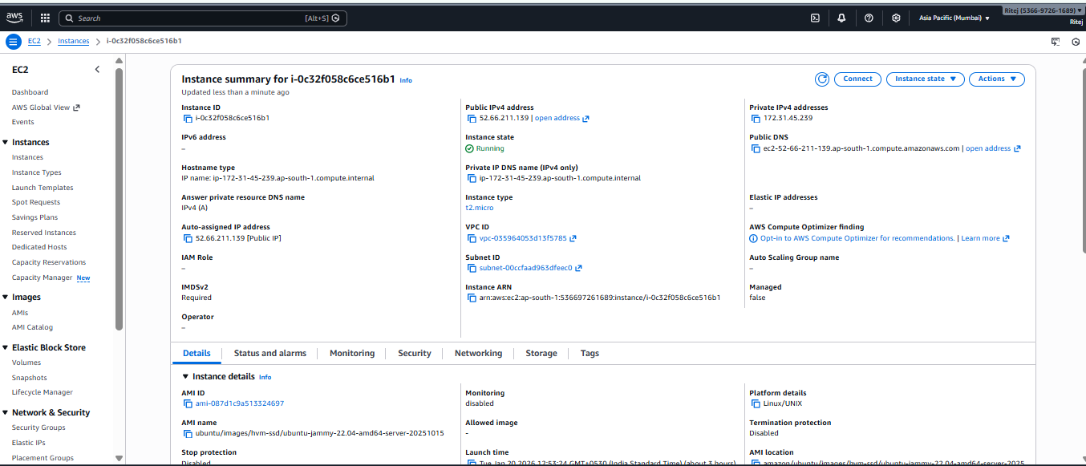

- Install Ansible on local machine
- Create Ansible project structure
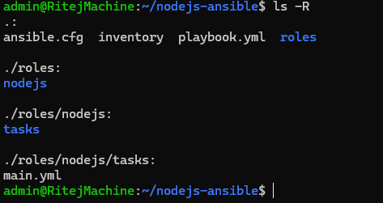
- Configure inventory and playbook
- Run Ansible playbook
- ansible-playbook playbook.yml
- 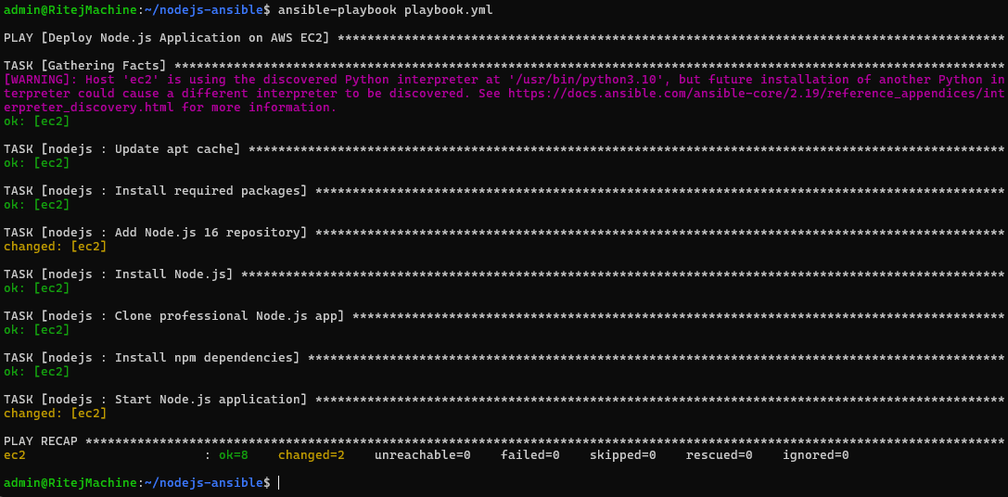

10. Verification
- Access application in browser:
- 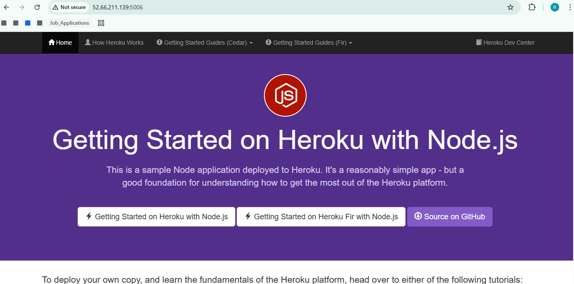
- Browser showing Node.js application running on http://52.66.211.139:5006

11. Issues Faced & Resolutions
Issue | Resolution
No internet access | Fixed NACL outbound rules
SSH permission denied | Correct user and key pair
App not reachable | Identified correct port
File permission issue | Fixed ownership / used env variables

12. Best Practices Followed
- Infrastructure automation using Ansible
- Use of roles for modular design
- Environment variables for configuration
- Secure SSH access

13. Conclusion
This project successfully demonstrates automated deployment of a Node.js application on AWS EC2 using Ansible. It covers real-world DevOps practices including automation, cloud networking, and troubleshooting, making it suitable for academic submissions and interviews.

