CSE 5345- Fundamentals of Wireless Networks

Final Report

Interfacing a Wireless Device with a Computer

SUBMITTED BY:

Ritesh Deshmukh

Pranav Diwate

INDEX

1. Introduction 3

2. User Interface 4

3. Output 7

4. AppendEX 9

# 1. Introduction

Implement an application that interacts with a computer wirelessly. Either the mobile or the computer can initiate a connection to the other device.

* Using Connection oriented TCP IP sockets, we have successfully achieved communication between a client and a server Wirelessly.
* In this case, the server is the Computer(PC) and the Mobile(Android) device is the client and vice versa.
* The server initiates the connection opening its ports for the client to connect.
* The ports used may vary and can be changed as needed.
* We first download a Text(.txt) file from the server on the client portal designed on an Android platform. Here, the Computer is the server and the Mobile device is the client.
* If the Computer downloads a file from the Mobile device, the mobile device acts as a server and the computer acts as a client as stated above.
* We use the IP Address of the Computer and the Mobile device for the connection in sockets.
* After the Client sends a request to the Server, the files are visible, Example: The files present on the computer are displayed on the mobile device in a list view.
* Similarly, we can upload a file from the Mobile device to the Computer where the Mobile device acts like a server, and after the successful transfer, the file uploaded will be visible on the Computer in the folder specified.
* The Desktop application is built using Java and is divided into three files, the upload, download and main agent. All three must run concurrently in the Command Prompt windows.
* The Android application has several pages based in the requirements and can be navigated based on the activity. Its functionality as a Client and as a Server are mentioned differently.
* The activities shown in the screenshots below will give a broader view of the working of the application on the Computer as well as the Mobile device:

# 2. User Interface

Screenshots below are taken on the Android Mobile device:

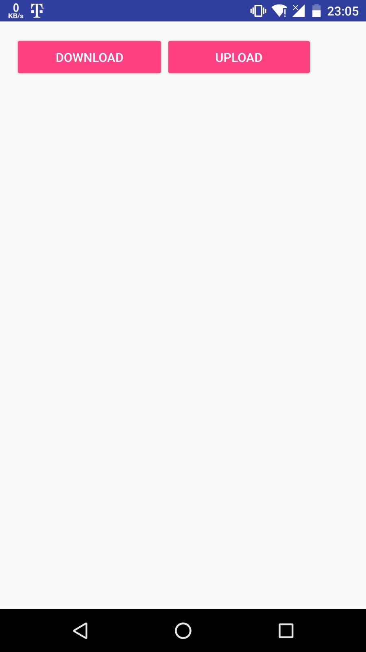

**Screenshot 1**: Shows the opening page of the app where the user is asked to either Download a file from the Server(Computer) or act as a Server and Upload a file to the Client(Computer).

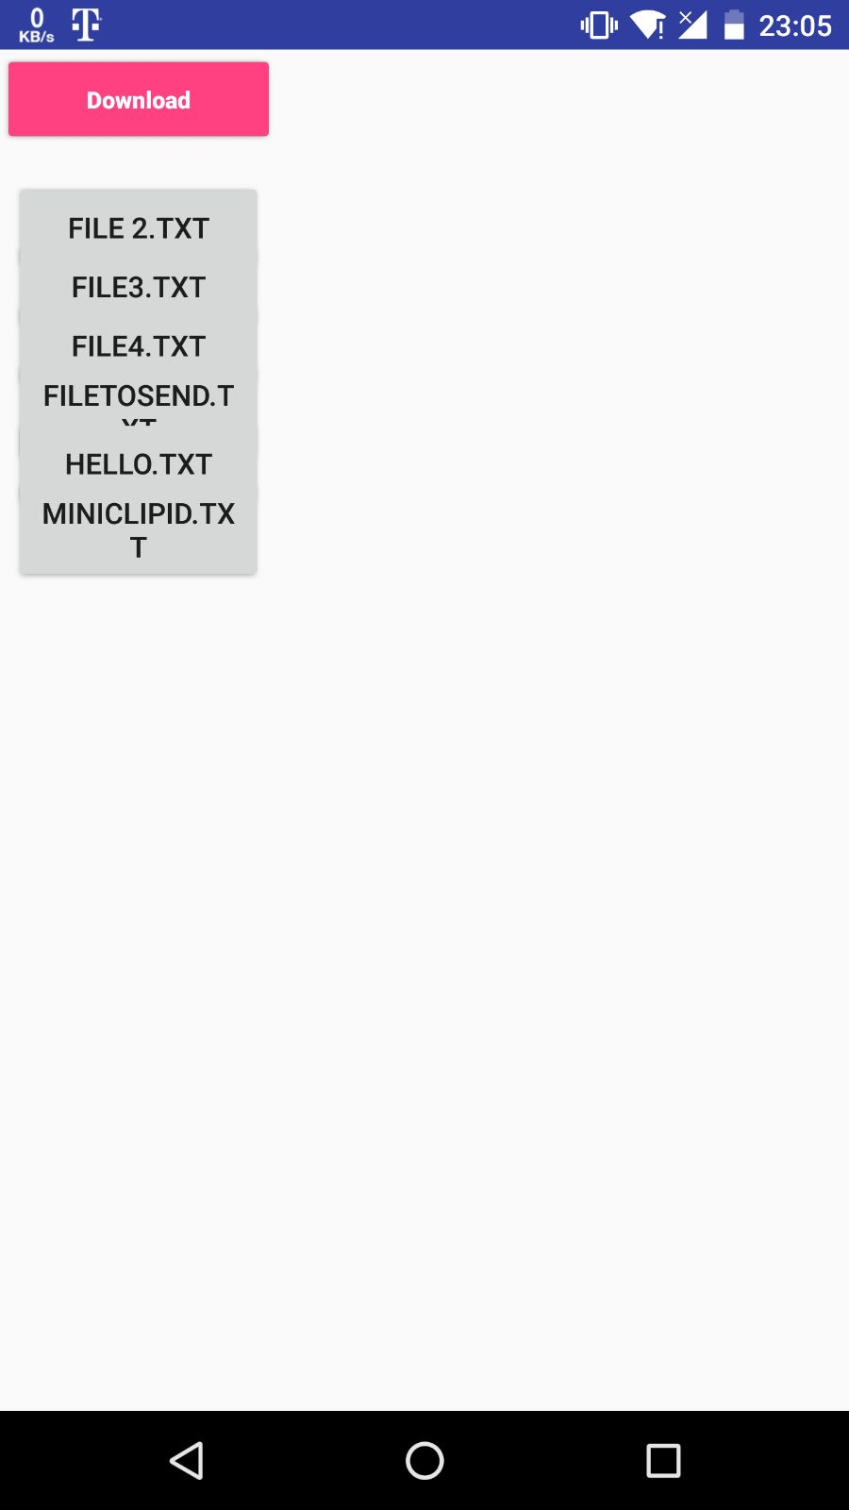

**Screenshot 2**: If the user chooses to download a file from the Computer, the user is navigated to a page where the files present on the Server(Computer) are shown. The user must click on the name of the file and click on Download.

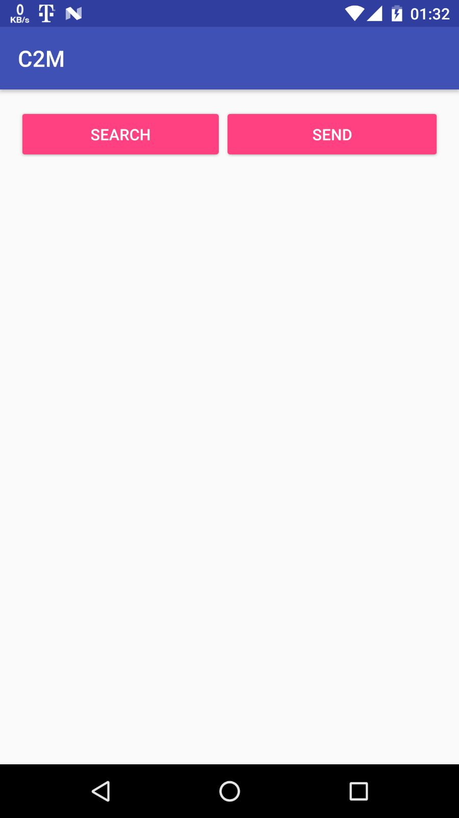

**Screenshot 3**: If the user wants the Mobile device to act as a Server, the Upload button in Screenshot 1 needs to be clicked to be able to Upload a file to the Client(Computer). The user will then be navigated to another page shown in Screenshot 3. The search button shows the list of files available on the Mobile device that can be uploaded on the Computer(Client).

# 3. Output

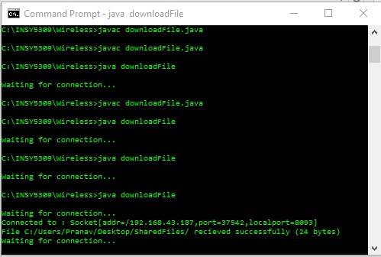

Screenshot 4: downloadFile.java

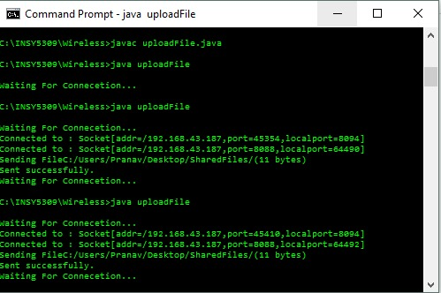

Screenshot 5: uploadFile.java

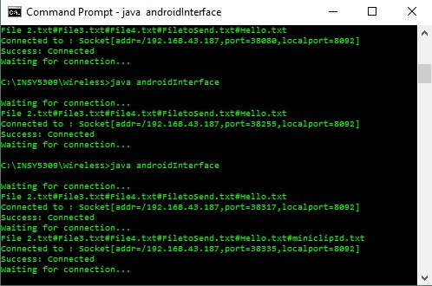

Screenshot 6: androidInterface.java

Screenshot 4,5,6: These screenshots show the desktop application to initiate the connection for the successful Upload and Download. The details of the connection like IP Address and the Port used are also shown. All the three files need to run simultaneously.

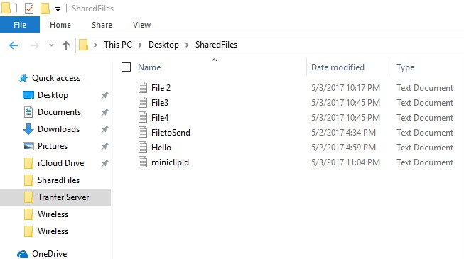

Screenshot 7: SharedFiles Folder

Screenshot 7: This screenshot shows the list of files available on the Desktop machine for sharing wirelessly with the Mobile device.

# 4. Appendex

References:

1. https://developer.android.com/reference/android/os/AsyncTask.html
2. http://commons.apache.org/proper/commons-net/
3. <https://github.com/mayfourth/WiFi-Direct-File-Transfer>
4. http://projectsgeek.com/2015/01/smart-ftp-client-android-project-source.html
5. <https://developer.android.com/training/connect-devices-wirelessly/wifi-direct.html>
6. <https://github.com/cedrus/qt/blob/master/qtbase/src/gui/doc/src/dnd.qdoc>
7. <https://developer.android.com/reference/android/net/nsd/NsdServiceInfo.html>
8. <http://stackoverflow.com/questions/4687615/how-to-achieve-transfer-file-between-client-and-server-using-java-socket>
9. <http://www.java2s.com/Open-Source/Android_Free_Code/Development/wifi/mayfourth_WiFi_Direct_File_Transfer.htm>
10. <http://stackoverflow.com/questions/9373424/converting-a-string-to-binary-using-utf-8-encoding>
11. <http://androidsrc.net/android-client-server-using-sockets-client-implementation/>
12. <https://developer.android.com/training/beam-files/send-files.html>
13. <https://developer.android.com/training/beam-files/receive-files.html>