Queues used to assign leads to reps-SMB SM’s

Just follow the steps below to assign new leads to your reps.

1. Click on the Leads tab 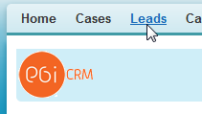
2. Select the view you want to use to reassign leads. In this screenshot we are using the one called My Leads

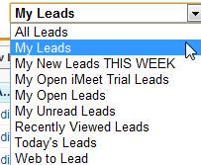

1. You can select up to 200 leads at a time once you are inside the view. It can be as few as 10 also. This screenshot shows where you change that amount at.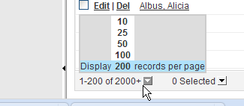
2. To select the maximum leads that your view is allowing, just click the upper most square in the upper left right next to the word Action. 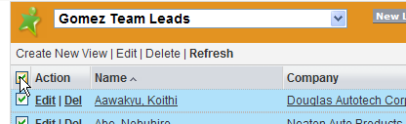
3. Now select the button called Change Owner to the right of the views dropdown menu. 
4. The last thing to do is select which rep you want to assign the leads to, and then hit save. (DO NOT CHECK THE SEND NOTIFICATION EMAIL CHECKBOX, IT WILL SEND AN EMAIL FOR EACH LEAD YOU ARE REASSIGNING!!)