**Opportunity Line Item Update**

To standardize our reporting in Salesforce.com (SFDC), CRM users will need to update Opportunities to include new required fields. The owners of opportunities migrated from NetSuite and Leadworks will be required to add a new line item and delete the legacy line item in the SFDC opportunity record. The owner of the opportunities will need to populate new fields such as unit price, quantity and term, in order to calculate contract and monthly recurring revenue (MRR). This is essential to reporting, since records will reflect a $0 associated with Annual Value & Contract Value fields.

A report has been created to identify each product/line item that requires updating in your opportunities thereby allowing historical line items to be deleted. All relevant information from NetSuite and Leadworks will be included in this report. Please visit your Opportunities tab that will identify the opportunities that need to be updated. In the reports tab, select the 1st option “1- **My Opps to Update Historical Products**”. You should see this list decrease after you delete each historical Product. If the opportunity is dead/closed lost, then set the stage to Closed Lost (and identify the reason code), and it will be removed from the “Legacy Opportunity line item update report”.

***Steps to update legacy opportunity line items:***

**Step 1 – Pull a legacy opportunity line item report in the reporting tab**

* Use this link <https://na1.salesforce.com/00O30000006uNQX> to access the “Legacy Opportunity line item update report”.
* Select Export Details
* Working from your exported file, copy and paste the Opportunity Name into Search and select go.
* This step will take you directly into the opportunity.

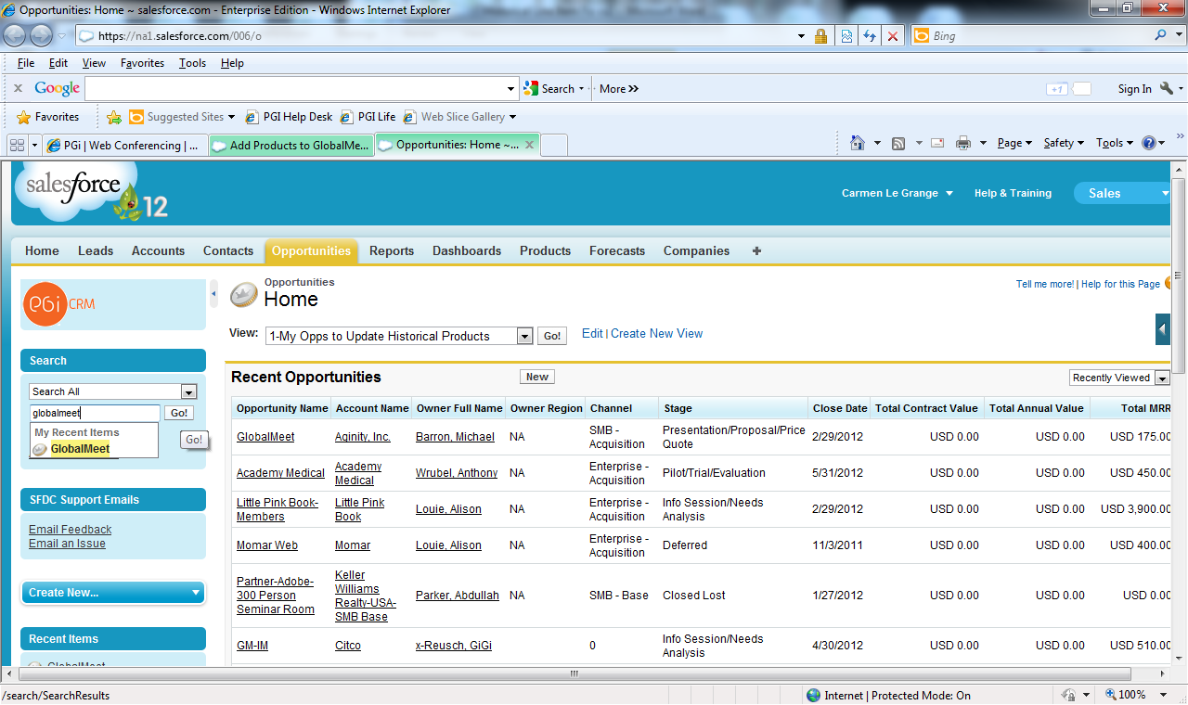

**Replacing Line item**

**Step 2 - Add a new line item**

* To add the new Product line item, hover over “Products (Standard Price Book)” and select Add Product.
* Find the Product by typing in a keyword or scroll down the list, then check the product and press select.
* Add the mandatory fields, listed below and save your product.
  + Quantity – enter a number greater than 0
  + Unit Price – enter a number greater than 0 (enter per minute, per license etc.)
  + Unit Type – Drop down selection
    - Minutes
    - Licenses
    - Ancillary
  + Billing Frequency – select from the drop down selection
    - **Monthly** - Billing occurring on a monthly basis
    - **One time event** – Billing occurring 1 time
    - **Quarterly** - Billing occurring 4 times a year
    - **Annually** – Billing paid once upfront or paid once a year
  + Contract term – reflect contract term in months. Also Contract Term must be greater than zero. For example if the contract term is 1 year then 12 should be reflect as the contract term.
    - **Monthly** - Reflect the contract term in months. For example, 1 year should be reflected as 12.
    - **One time event** – reflect contract term as 1
    - **Quarterly** - reflect in terms of months. If there are 4 quarters the contract term should be reflected as 12.
    - **Annually** – Billing paid once upfront or paid once a year
  + Additional information
    - If Billing Frequency = One Time event ,then Unit Price” x “Quantity”
    - If Billing Frequency = Monthly, then “Unit Price” x “Quantity” x “Contract Term (months)”
    - If Billing Frequency = Quarterly, then Unit Price x Quantity / 3 months x Contract Term
    - If Billing Frequency = Annually, then Unit Price x Quantity x (Contract Term months / 12

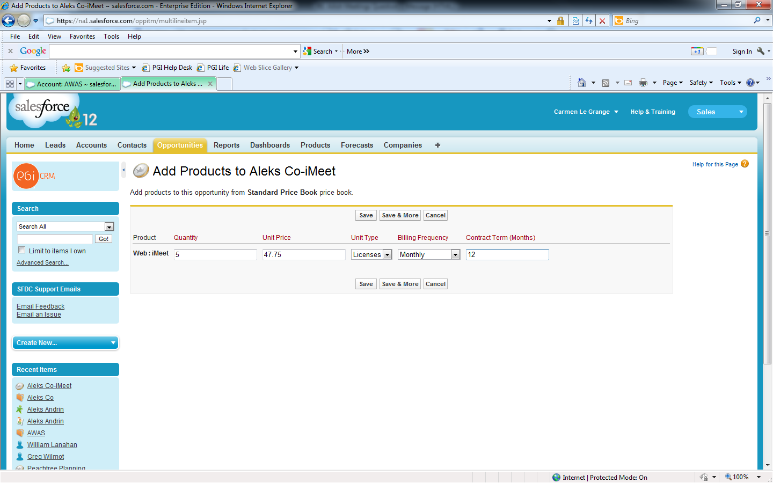

**Step 3 - Delete the legacy line item**

* To delete the existing product, hover over “Products (Standard Price Book)”, find the appropriate product and select Del OR scroll down to the Products section and select Del.

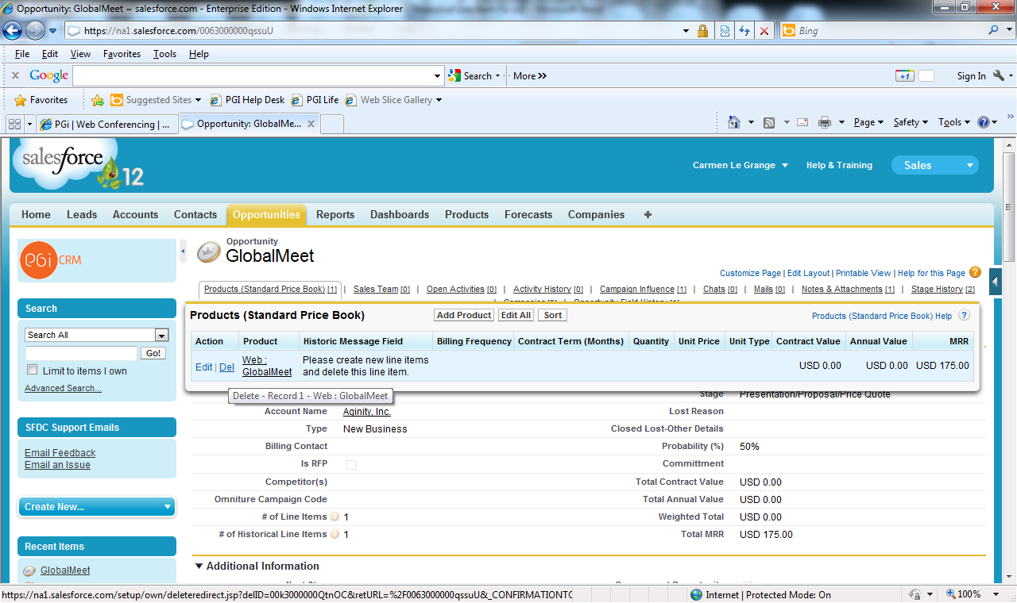

This will take you back to the opportunity page.

**Step 4 – Review new product line item.**

Once saved, this is what your new product line item will look like:

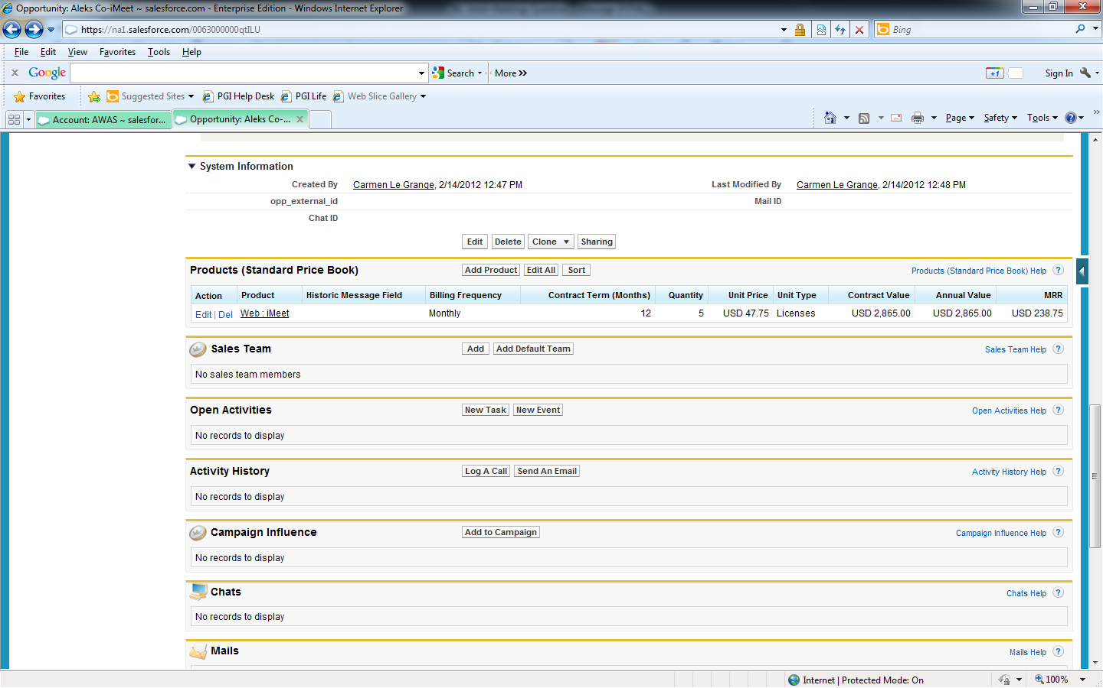

**Step 5 – Save the line item entry**

**Step 6 – Repeat process for each line item**

**CIF Form and SFDC Enhancement:**

To streamline the provisioning process and create tighter integration between Billing, Tesla and SFDC, the CIF form will be auto-generated out of SFDC and critical SFDC data fields will be pre-populated. Beginning with the launch of SFDC new accounts and rate change requests must be accompanied by the auto-generated CIF form when submitting CSO, CSAs and/or other sanctioned agreements to the Rate Change Team. IF YOU WILL BE PROVISIONING ACCOUNTS THROUGH THE GATEWAY, please disregard the CIF generated from SFDC and sent to your email.

The following key steps describe the new process that is required when submitting documentation to the Rate Change Team (RCT) for a new account setup or new rate implementation (*Reminder: when submitting new customers to the RCT for set up, the CIF form much accompany the CSO or CSA for the new company set up)*. Please note, these steps are described in more details in the training tutorial about Closed/Won Opportunities in Salesforce.

1. Prior to closing an Opportunity with a stage equal to Closed/Won, ensure you have identified the Billing Contact with the Opportunity.

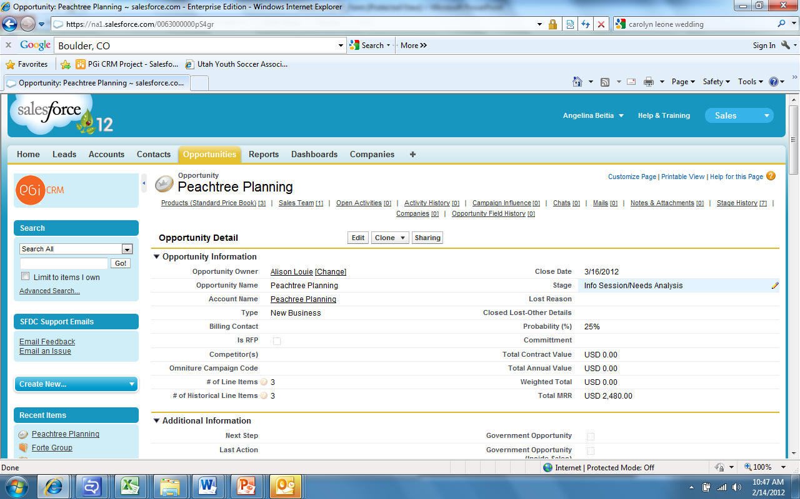

1. Upon entering the required field in Salesforce and setting the Opportunity Stage to Closed/Won, the system will send an email version of the **CIF form** to your Outlook Inbox.

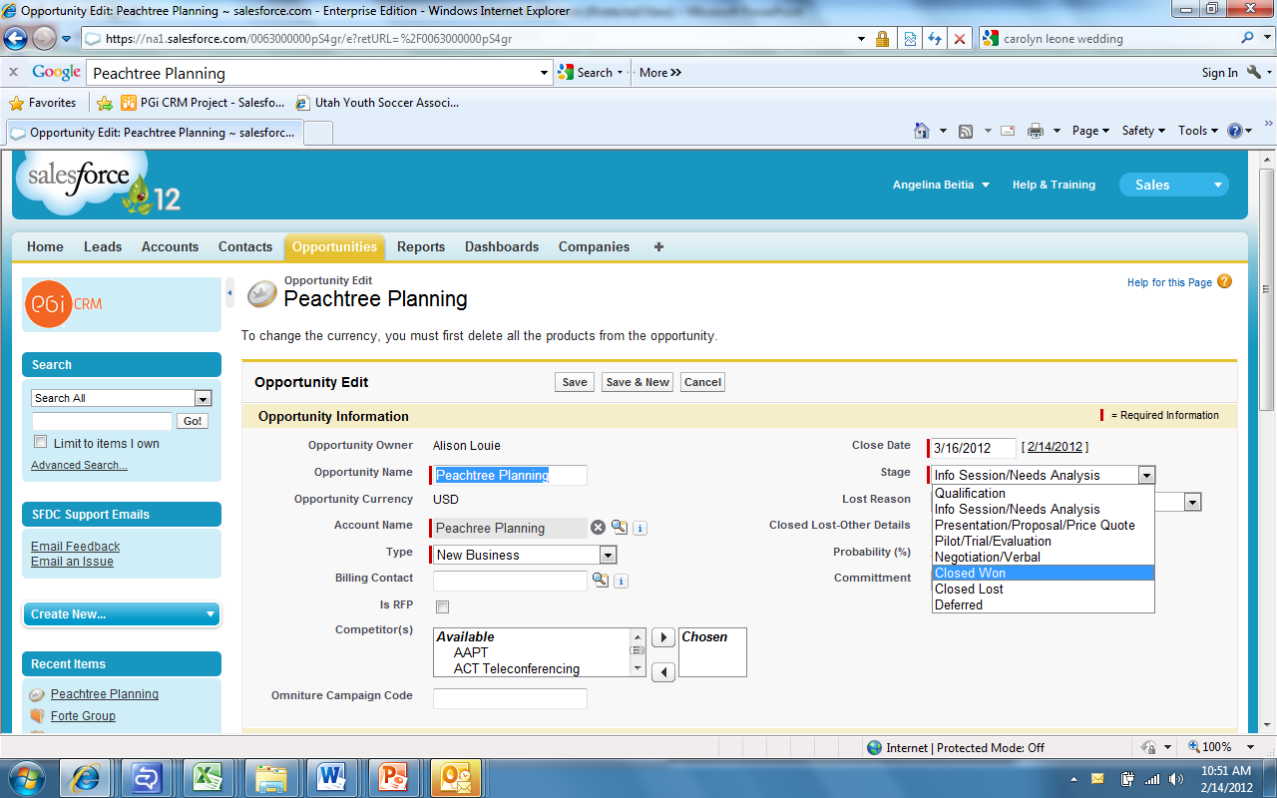

1. The email-based CIF form will be automatically pre-populated with key details such that the **SFDC Account ID** and the **Billing Contact** that you entered in the Opportunity record.

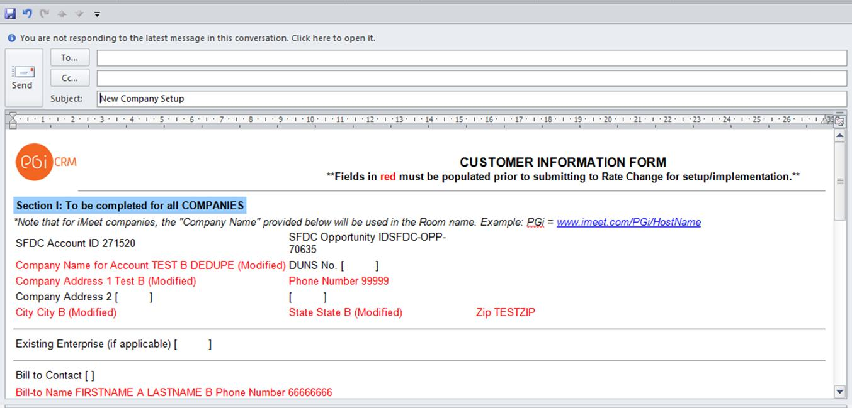

**SFDC Account ID**

1. After opening the email in Outlook, please select the **Forward** option and then add the additional required details to the CIF form prior to emailing to RCT.
2. Once you have finished adding all the relevant information to the email form, please attach all relevant documents (i.e. CSO or CSA) that are needed by the Rate Change and Contracts Teams and then send the completed CIF to the **Rate Change Team** ([RateChange.team@pgi.com](mailto:RateChange.team@pgi.com)) and to the **Contracts Team** (Contracts. . .. ) for provisioning to commence.

The attached slides show some visual details that will help you to understand what you should expect to see. However, it is imperative that you go through the Salesforce tutorials to gain a deeper understanding of this topic (specifically, details for this topic can be viewed in the **Closed Won** tutorial for North America).

For more information regarding this process please contact Shakeria Walker, Sales Operations.

**Credit Trouble Tickets & Netsuite Licenses**

Since PGi’s Trouble Ticket System is still maintained in Netsuite, Credit Trouble Tickets will continue to be processed through Netsuite. In order to allow Sales to create and view the status of Credits and Trouble Tickets, we have retained some Netsuite licenses for the Sales Team. We have assigned channel representatives from each sales team to manage Netsuite login information and instruction on process management particular to each sales team.  Please refer to your contact from the list below which can advise who on their team has NetSuite licenses:

* Diamond:  Jamie Pasquith
* Enterprise:  Gina Marshall
* Partner:  Heather Clark
* SMB Base:  Neal Harnden
* SMB Acquisition/Budget:  Kemberly Reed

If you have questions or problems, please refer questions to your designated channel contact and they can escalate to the appropriate area for resolution.

Thank you for your patience as we are working towards an enhance solution to the process.