Software Architecture and Design Specification
Project: Blood Bank Management System
Team: Team 9
Version: 1.0
Authors: Reyansh (PES2UG24CS401), Ritesh Babu Reddy (PES2UG24CS403), Ritesh Kumar Sharma (PES2UG24CS404), Rithish P M (PES2UG24CS405)
Date: 02-10-2026
Status: Draft

Revision History
Version | Date | Author | Change Summary
1.0 | 02-10-2026 | Team 9 | Initial SAD draft for Blood Bank Management System

Approvals
Role | Name | Signature/Date
Course Coordinator

1. Introduction

1.1 Purpose
This document specifies the architecture and design of the Blood Bank Management System, developed by Team 9, covering its component structure, chosen patterns, API design, and security architecture.
1.2 Scope
Covers donor registration, blood donation recording, inventory management, blood search and request handling, issue/dispatch tracking, and administrative reporting, built on a Django (Python) backend with a Node.js notification service.
1.3 Audience
Developers, QA engineers, security auditors, instructors, and maintenance teams.
1.4 Definitions
BBMS, API, ADR, JWT, TLS, RBAC, DB.

2. Document Overview
2.1 How to use this document
Provides architectural deliverables including UML diagrams, architecture decision rationale, threat models, and API design for the Blood Bank Management System.
2.2 Related Documents
SRS, Software Test Plan (STP), Requirements Traceability Matrix (RTM).

3. Architecture

3.1 Goals & Constraints
Goals: secure handling of donor/medical data, reliable inventory accuracy, 99.5% availability, maintainable modular codebase. Constraints: Django REST Framework and Node.js runtime dependency, data-privacy norms for medical records, limited concurrent-user budget for a student project deployment.

3.2 Stakeholders & Concerns
- Donors: data privacy, easy registration and donation tracking
- Blood Bank Staff/Admin: accurate inventory, efficient request approval
- Hospitals/Recipients: fast search and reliable request fulfillment
- Developers: modularity, maintainability, clear API contracts

3.3 Component (UML) Diagram

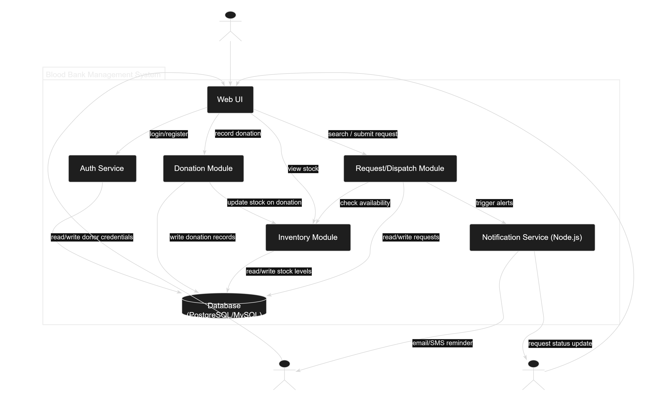

3.4 Component Descriptions
- Web UI: role-based dashboards for Donor, Staff, Hospital, and Admin users.
- Auth Service (Django): handles registration, login, password hashing, and JWT issuance.
- Donation Module: records donations and validates donor eligibility (90-day rule).
- Inventory Module: maintains real-time blood stock counts, expiry tracking, and low-stock alerts.
- Request/Dispatch Module: manages blood search, request submission, approval, and issue tracking.
- Notification Service (Node.js): sends email/SMS reminders and alerts asynchronously.
- Database: stores donor, donation, inventory, and request records (PostgreSQL/MySQL).

3.5 Chosen Architecture Pattern and Rationale
A layered (n-tier) architecture is chosen, separating the presentation layer (web UI), application layer (Django REST APIs and Node.js notification service), and data layer (relational database). This provides clear separation of concerns and is appropriate for the project scale. A full microservices approach was considered but rejected as unnecessarily complex for a single-team academic project with modest concurrency requirements.

3.6 Technology Stack & Data Stores
Backend: Python with Django REST Framework. Auxiliary service: Node.js for real-time notifications. Frontend: JavaScript-based responsive web client. Database: PostgreSQL or MySQL. Communication secured via TLS 1.2+. Authentication via JWT tokens.

3.7 Risks & Mitigations
Risk | Mitigation
Inventory count drifting out of sync during concurrent donations/issues | Use database transactions and row-level locking on stock updates
Notification service (Node.js) downtime delaying donor alerts | Queue notifications and retry with backoff; treat as non-blocking to core workflow
Unauthorized access to sensitive donor medical data | Enforce RBAC and encrypt data in transit (TLS) and at rest where feasible

3.8 Traceability to Requirements
- BBMS-F-001 (Donor registration) -> Auth Service
- BBMS-F-010 (Record donation) -> Donation Module
- BBMS-F-020 (Inventory tracking) -> Inventory Module
- BBMS-F-031 (Submit blood request) -> Request/Dispatch Module
- BBMS-F-051 (Donor notifications) -> Notification Service (Node.js)

3.9 Security Architecture
Threat Modeling (STRIDE): Spoofing -> JWT-based authentication and credential verification; Tampering -> server-side validation and database transaction integrity; Information Disclosure -> TLS 1.2+ encryption and role-based data access; Denial of Service -> rate limiting on API endpoints; Elevation of Privilege -> role-based access control (RBAC) enforced at the API layer.

4. Design

4.1 Design Overview
The Blood Bank Management System is designed with layered modules (UI, API, service logic, data access) to keep donor management, inventory, and request/dispatch logic independently testable and maintainable.

4.2 UML Sequence Diagrams
(1) Donor Registration and Blood Donation flow and (2) Hospital Blood Request and Dispatch flow.

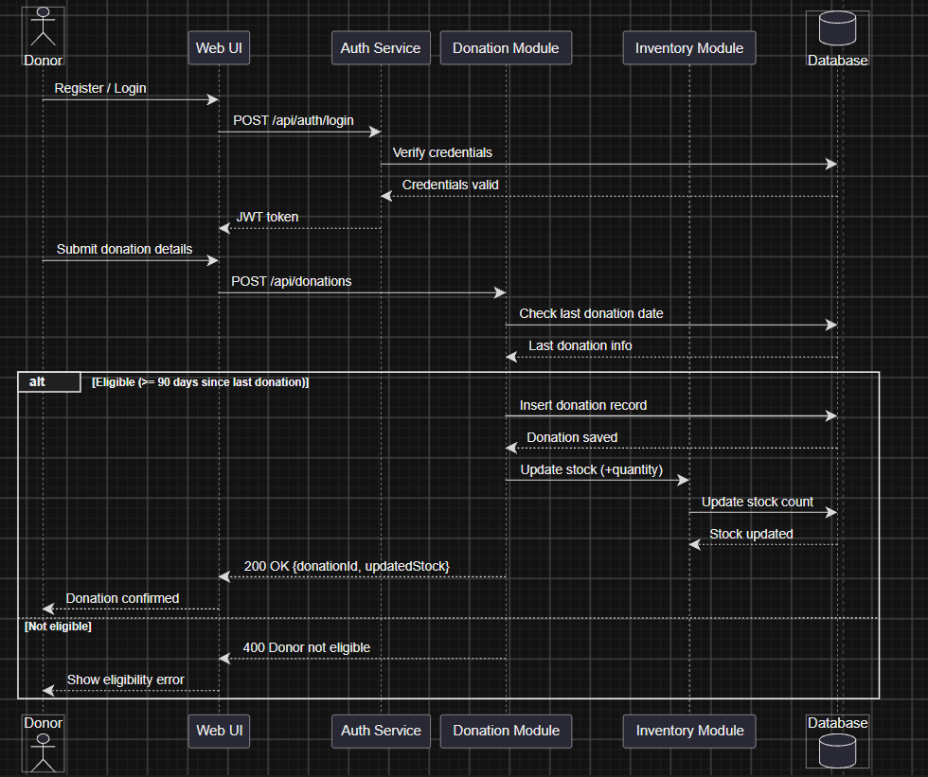
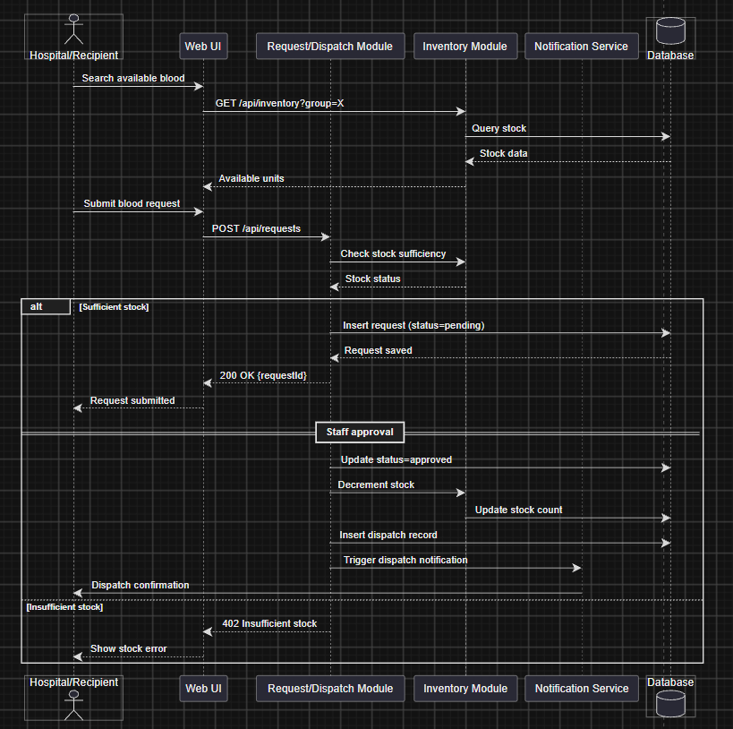

4.3 API Design
Interface definitions for at least 2 components:
Endpoint: /api/donations
Method: POST
Request: {donorId, bloodGroup, component, quantity, donationDate}
Response: {status, donationId, updatedStock}
Errors: 400 Donor not eligible (90-day rule), 404 Donor not found

Endpoint: /api/requests
Method: POST
Request: {hospitalId, bloodGroup, component, quantity, urgency}
Response: {status, requestId}
Errors: 402 Insufficient stock, 401 Unauthorized

4.4 Error Handling, Logging & Monitoring
Standardized JSON error responses across all APIs. No donor PII or medical data written to plaintext logs. Monitoring includes inventory discrepancy alerts, request approval latency, notification delivery failure rate, and system uptime.

4.5 UX Design
Role-specific dashboards with color-coded stock-level indicators (e.g., red for low stock), accessible font sizes, and clear step-by-step flows for donation recording and request submission to minimize staff training time.

4.6 Open Issues & Next Steps
Future enhancements: mobile app for donors, integration with national blood-donor registries, predictive analytics for stock shortage forecasting, and SMS-based OTP verification for donor check-in.

5. Appendices
5.1 Glossary: BBMS, API, ADR, JWT, TLS, RBAC.
5.2 References: IEEE 42010, OWASP, NIST SP 800-160.
5.3 Tools: PlantUML, draw.io, Swagger.

