A -

� ◊ m
�
□� □ □ � •

Electron Microscopy (EM) Journal Articles (.pdf) LLM Atomistic Images Simulations

B
■■
ROI EM images

Detecting lattice vectors
■■
c �

D

Structure information
Materials with multi-dimensions:
LI(1D) Nanotube
LI(2D) Electronic materials
LI(3D) Energy storage materials
(CIFfile)

E G
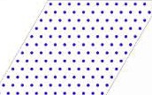
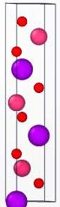
^{P}.^{r}.^{is}.^{t}.^{i}.^{n}.^{e}......

Internal validation
_._:::(£t§t:
,·:::·:::·::.1/

Vacancies

Layered LCO

