**PIZZA SALES SQL QUERIES:**

**KPI’s**

**TOTAL REVENUE:-**

SELECT SUM(total_price) AS total_price_of_Pizza

FROM pizza_sales

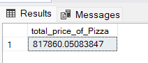

**AVERAGE ORDER VALUE:-**

SELECT SUM(total_price)/COUNT(DISTINCT order_id) AS Avg_Order_Value

FROM pizza_sales

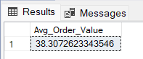

**TOTAL PIZZA SOLD:-**

SELECT SUM(quantity) AS Total_Pizza_Sold

FROM pizza_sales

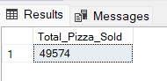

**TOTAL ORDERS**

SELECT COUNT(DISTINCT order_id) AS Total_Orders

FROM pizza_sales

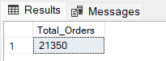

**AVERAGE PIZZA SOLD PER ORDER**

SELECT CAST(CAST(SUM(quantity) AS DECIMAL (10,2)) /CAST(COUNT(DISTINCT order_id) AS DECIMAL (10,2)) AS decimal (10,2)) AS Avg_Pizza_Sold_per_Order

FROM pizza_sales

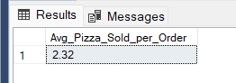

Note:- In order to get the exact number for Average pizza sold per order we need to calculate without round off values. Hence we have used **CAST(value, decimal(10,2))** to get the exact value up to 2 decimal places.

--Daily Trends for total orders

SELECT DATENAME(DW,order_date) AS Order_day, COUNT(DISTINCT order_id) AS Total_orders

FROM pizza_sales

GROUP BY DATENAME(DW,order_date)

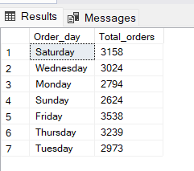

**NOTE:- DATENAME** takes **DW** as parameter that is Day of the Weeks

--Hourly Trends for total orders

SELECT DATEPART(HOUR, order_time) AS Order_hours, COUNT(DISTINCT order_id) AS Total_orders

FROM pizza_sales

GROUP BY DATEPART(HOUR, order_time)

ORDER BY DATEPART(HOUR, order_time)

**NOTE:- DATEPART takes HOUR**  as parameter

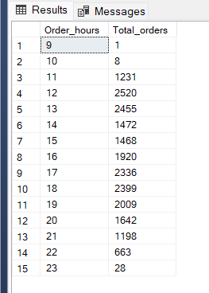

--Percentage of sales by pizza category

SELECT pizza_category, SUM(total_price) AS Total_Sales, SUM(total_price)*100/ (SELECT SUM(total_price) FROM pizza_sales) AS Total_Sales_Percentage_Per_Category

FROM pizza_sales

GROUP BY pizza_category

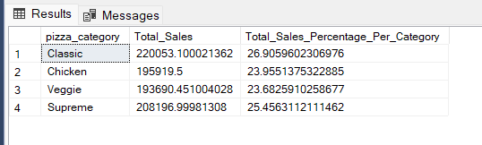

--Percentage of sales by pizza category for specific month

SELECT pizza_category, SUM(total_price) AS Total_Sales, SUM(total_price)*100/ (SELECT SUM(total_price) FROM pizza_sales WHERE MONTH(order_date) = 1) AS Total_Sales_Percentage_Per_Category

FROM pizza_sales

WHERE MONTH(order_date) = 1

GROUP BY pizza_category

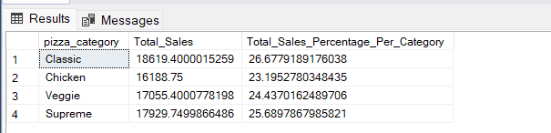

--Total pizza sold by category:

SELECT pizza_category, SUM(quantity) AS Total_pizza_sold_by_category

FROM pizza_sales

GROUP BY pizza_category

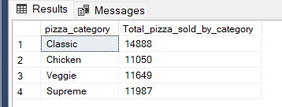

--Top 5 Best selling pizza by total pizza sold

SELECT TOP 5 pizza_name, SUM(quantity) as Total_Pizza

FROM pizza_sales

GROUP BY pizza_name

ORDER BY Total_Pizza DESC

