REPORT ON

WEB DEVLOPMENT

(csy-1028)

COURSEWORK-1

 

**UNIVERSITY : Northampton University**

**College : NAMI College**

**Module Code : CSY-1018**

**Submitted by : Ritesh Phuyal**

**UN id : 17425082**

**Submitted To: Ganesh Khatri**

Table of Contents:

1. Introduction:
2. Design:
   * Wireframe

Homepage

Bio page

CV page

Contact page

* + - * Wireframe(Responsive)
* Homepage
* Bio page
* CV page
* Contact page

3.Evidence of good practice and page load speed:

* Visual Appeal
* Navigation

1. Progression of website over 12 weeks:

* Week 1-4
* Week 4-8
* Week 8-12

1. Reference:

**1.INTRODUCTION**

Web Development is one of the important course which will demonstrate to us a way toward the future. No issue whether you have less learning or less data about this course. This is a big platform where you can have engaged in whether for business, entertainment or education. This is my first time I have made webpages. In the webpages, it contains four-page they are, home, bio, CV and contact. In home page, I have presented myself and in bio there is my memoir, in CV there is my skills, experience, and so on. Furthermore, in contact I have gave my contact through which viewers can get in touch with me. To make this page I search couple of website to get some knowledge and to know how they will make a personal web page.

* <https://www.google.com.np/search?q=cv&source=lnms&tbm=isch&sa=X&ved=0ahUKEwjh1M2quYXTAhVIPo8KHQw3CDsQ_AUICCgB&biw=616&bih=586&dpr=2.5>
* <https://joel.sh/contact>

2.**DESIGN**

* **Wireframe**

Firstly, to design webpage, wireframe is most important part whether you made it in copy or mind. Like that I also had made a wireframe.

* **This is my overview page of my website:**

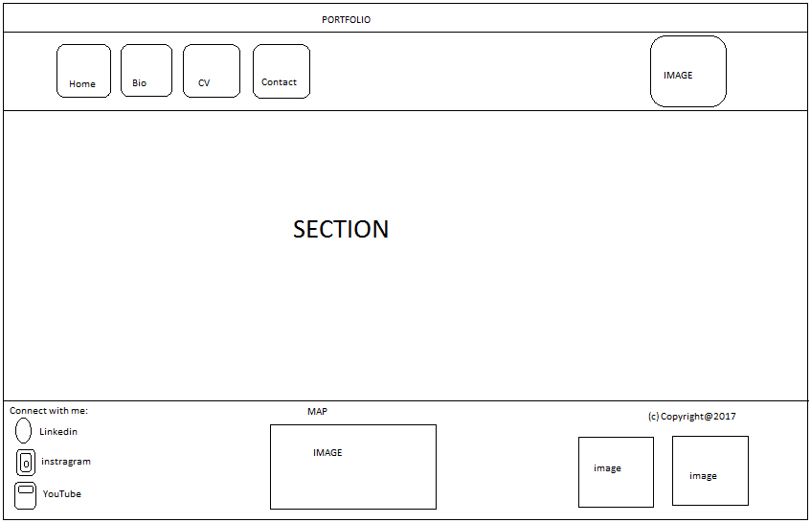

* **Wireframe of homepage**

This is the wireframe of my homepage.

In the homepage, I have kept a background in the body part and gave a short introduction about me.

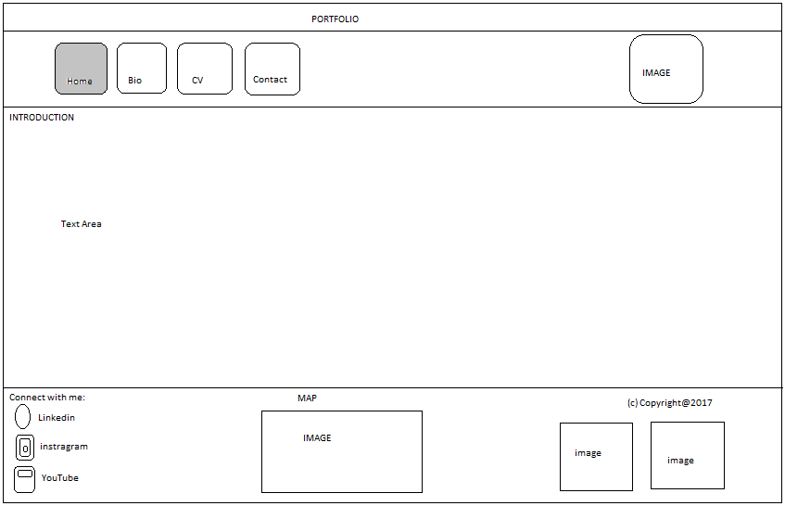

* **This is wireframe of my Bio.**

In the bio I kept my one photo and I gave my full information so that viewers can get information about me.

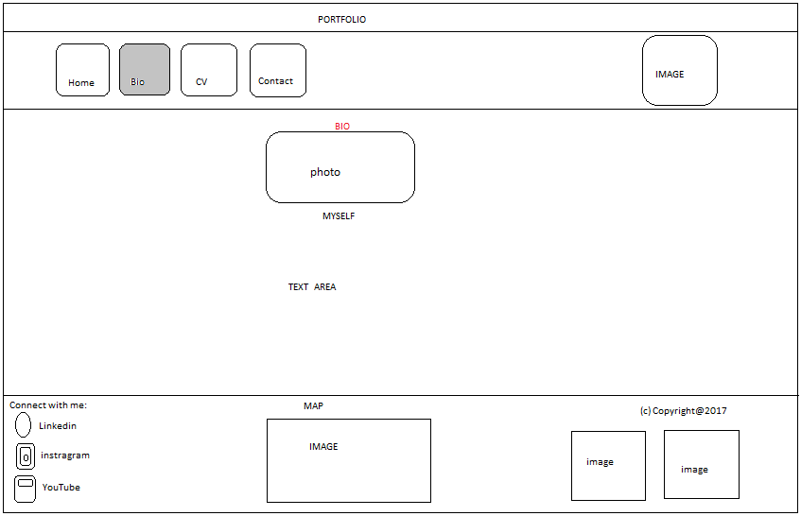

* **This is my wireframe of CV.**

The CV I have created is simple which include all my information like my skills, experiences, and so on.

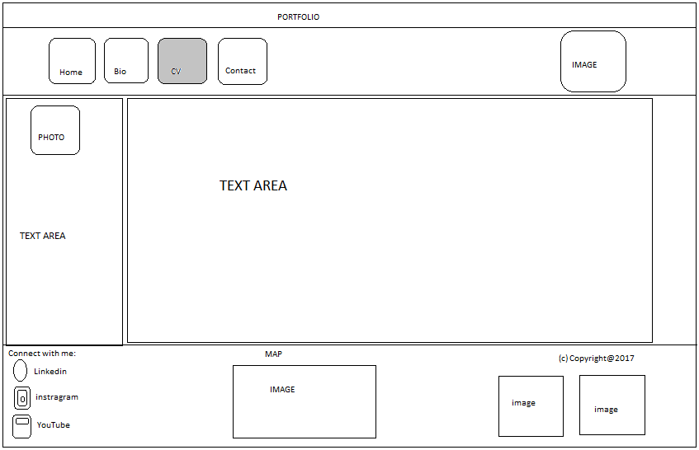

* **This is wireframe for my contact.**

In this contact people contact with me also they can put their information as well as can give feedback. I also have kept background to look more attractive on my contact page.

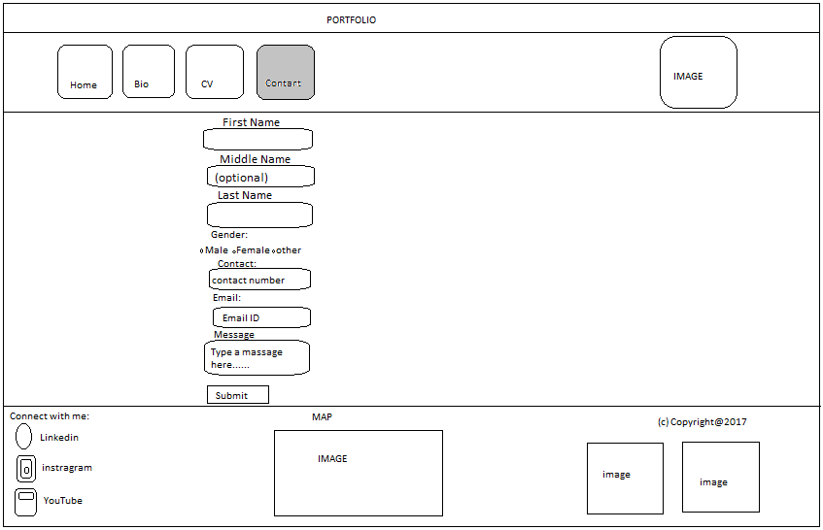

* **Wireframe for Responsive:**

In this 21St century many of people use android phone so if we make any website they mostly visit from mobile so responsiveness is one of the important factor in web designing and here are the responsive pages:

* **For Homepage**

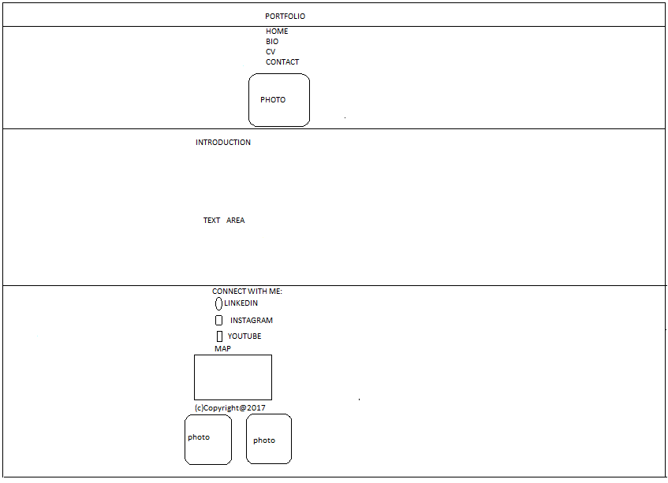

* **For bio**

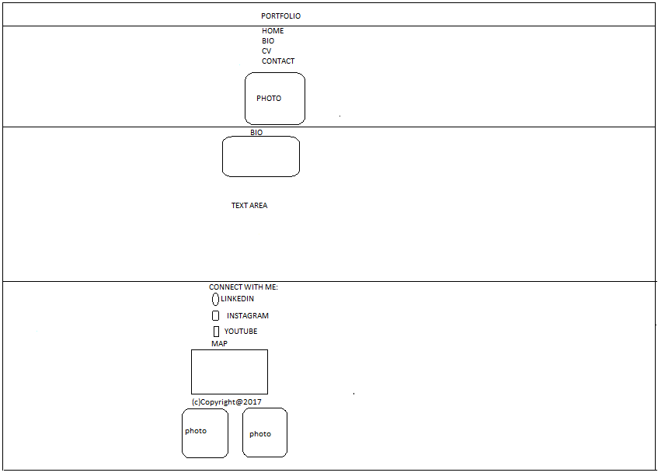

* **For cv**

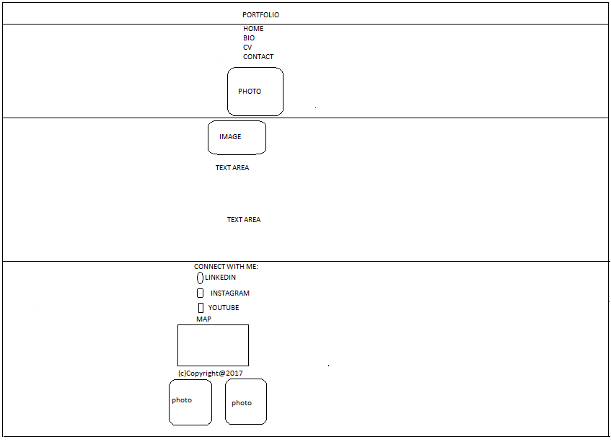

* **For contact**

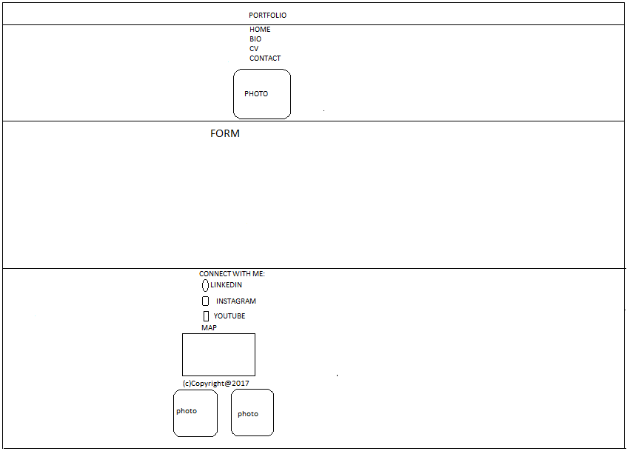

* **Image I have created:**

I just slightly know about photoshop, so to make logo I had tried a lot but I was unsuccessful so I consult with my friend,” how to make logo” they told,” use internet and download logo” but I dislike it. And I tried a make but can’t and I research in internet I found a lot and I download from there but I didn’t paste as it is. I make it nice from photoshop and keep it as logo and they are of my starting first name and last name.

 

1. **Evidence of good practice and page load speed:**

* **Validation**

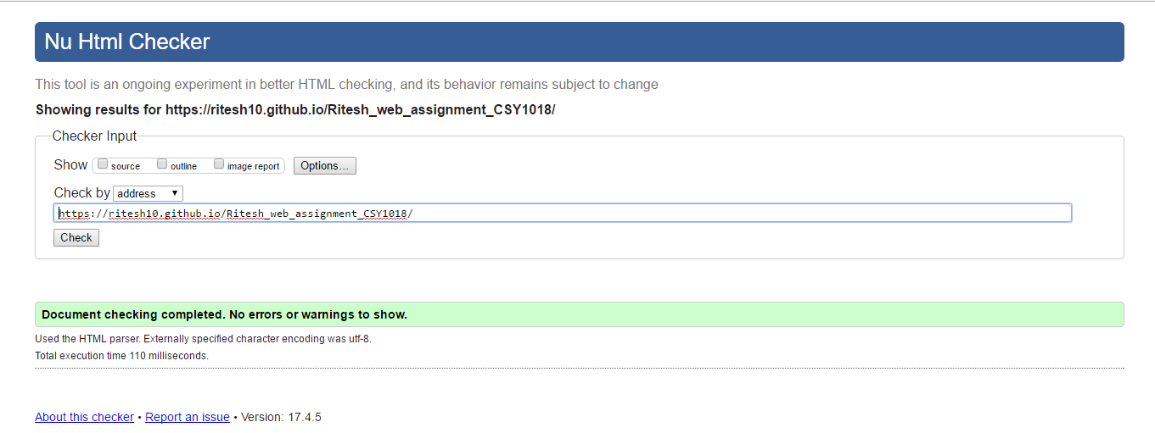

I had checked my code error of my page and the result shows positive as no error found.

* **Page loading speed**

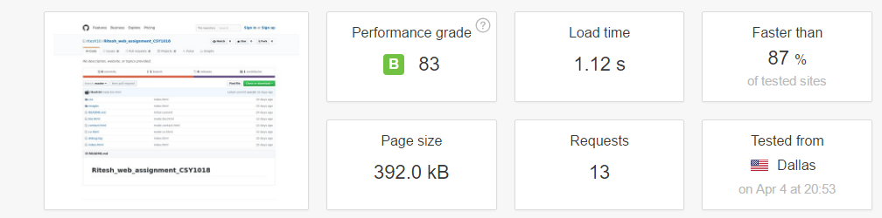

In internet, the most important factor is speed. Webpage will be better when it will open fast and any viewers who open this webpage they will love it. I have tested it from pingdom.com and my web page loads in 1.12s and also faster than 87% of tested sites and page size is of 392.0 KB.

* **Visual Appeal:**

Firstly, I was unknown about HTML and CSS, then I start to learn it I feels interesting and I research a lot and I looked many personal webpages of others and I got some knowledge from there and my friends is also one part of it without them it was unsuccessful they teach me a lot. So that I can make a good web pages.

* **Navigation:**

Navigation is one of the most important factor to make our websites. Navigation should be simple and attractive so that viewers will be happy to see that. Navigation should be at top so that people can easily recognize. When we put it in the navigation in the top then viewers can easily come back to the certain pages.

1. **Progression of website over 12 weeks:**

**Week 1-4**

: In the first session of the study I was fully unknown about the HTML and CSS. I was a science student as a physical group and I got some knowledge about computer but fully unknown how to make webpages. I learnt a lot in the first and second week and I looked many personal web pages and I got some knowledge about HTML and CSS. There is big hand of my friend they helped me a lot. I got so interest on this subject and I start to make my home pages first.

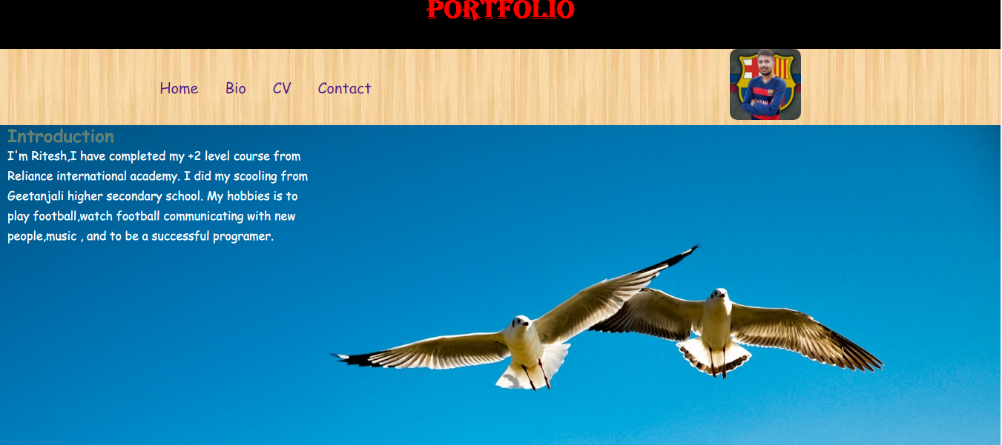

Mostly I used background to make my webpage attractive and I tried a lot to make this in four week only making this and practicing waste my time.

**Week 4-8**



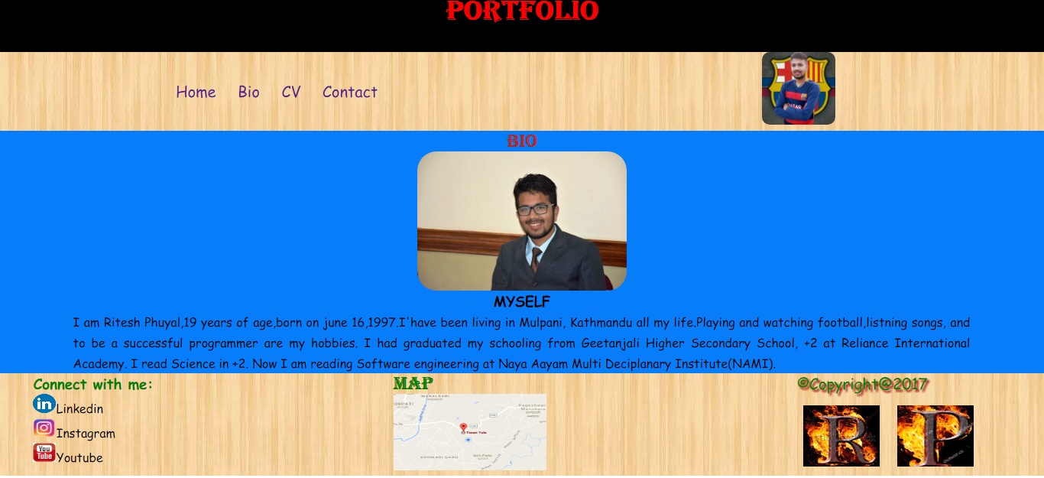

In this 4 weeks, I understand many things about HTML and CSS tagging. I believe that practice make a man perfect, I practice a lot and I was success to make what I thought to make. And I started to make cv than it was too hard to make that cv because I was unknown what to write but I know idea how to write so my teacher told me wireframing is most important. I didn’t have any wireframing so it was hard to make in this week.

**Week 8-12**

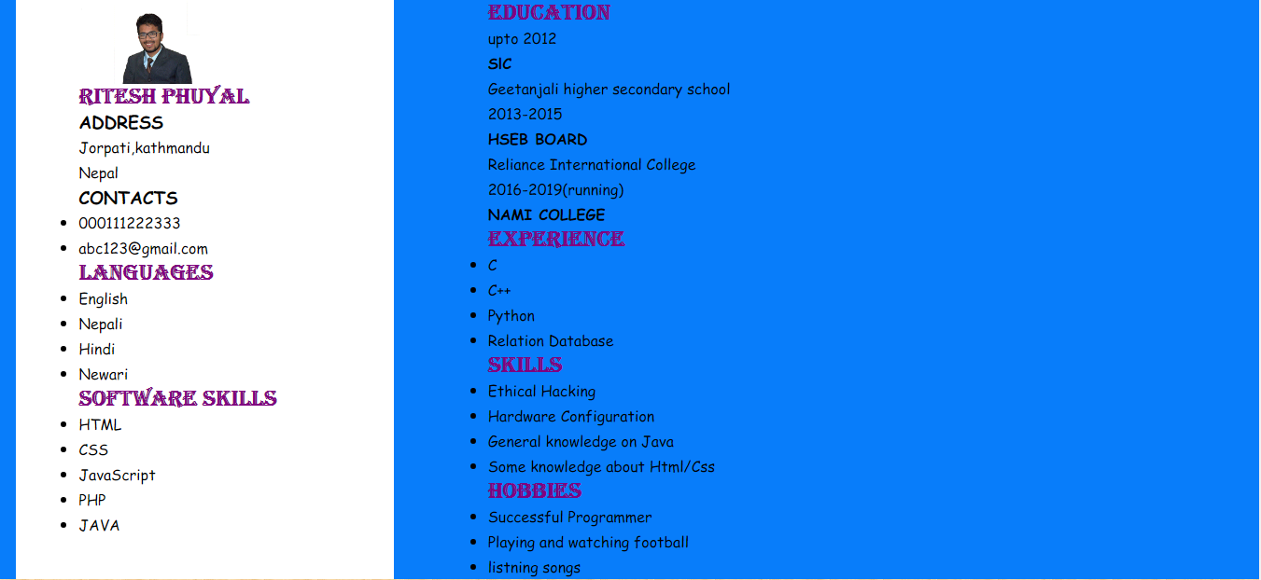

Finally, I got an idea to make a cv. I got this idea from internet and it make me too easy to make a page. And the assignment date also was coming near there was many pressure and I was unknown to make a form and teacher took an extra class to teach, “how to make a form”? and I learnt it and made it finally.

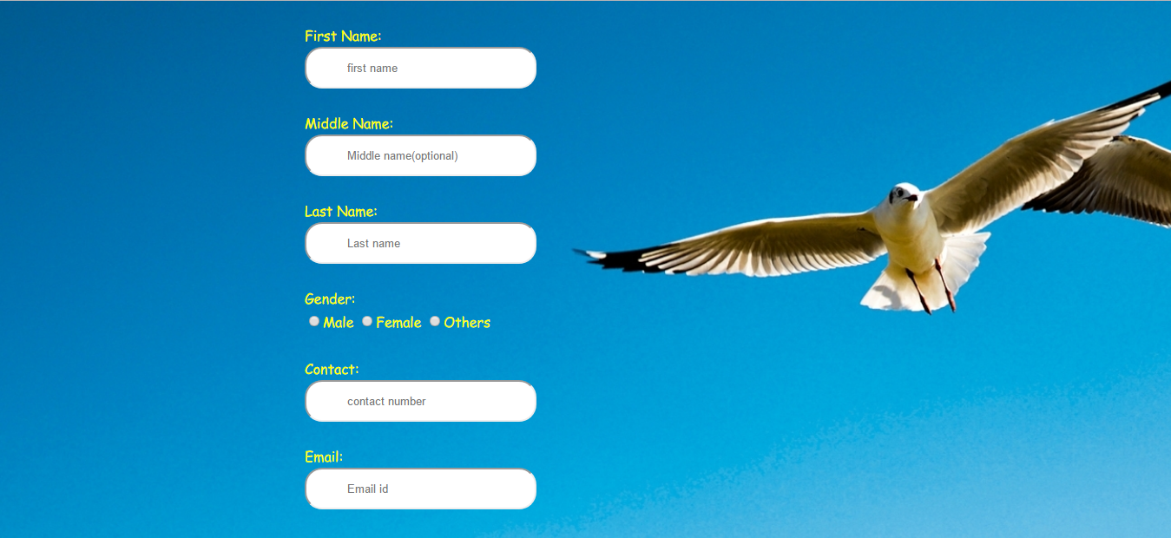

**5.CONCLUSION:**

Finally, I learnt many things from this assignment. Now I can make any web pages with HTML and CSS. I got many experience though I have to learn more things now to be a good in future.

**6. REFERENCE:**

1. Customize my tumber.com(2017)*untitled*[image] Available from:<http://static.tumblr.com/ge74hdk/G3flw5yrs/wood_pattern.png>[Accessed 22 February 2017].

2.