# “BLOOD CONNECT SYSTEM”

## MAJOR PROJECT - 1

***Submitted By***

Ritesh Ramchandani Enroll No- 0206IT161041

Pranshul Jain Enroll No- 0206IT161038

Ayush Gupta Enroll No- 0206IT161015

***In partial fulfillment for the award of the degree of***

## BACHELOR OF ENGINEERING

***in***

## COMPUTER SCIENCE& ENGINEERING



**DEPARTMENT OF COMPUTER SCIENCE & ENGINEERING** GYAN GANGA INSTITUTE OF TECHNOLOGY AND SCIENCES JABALPUR (M.P)

RAJIV GANDHI PRODYOGIKI VISHWA VIDYALAYA BHOPAL (M.P)

**Session 2019-2020**

***CERTIFICATE***

This is to certify that the Minor Project Report entitled **“Blood Connect System”** submitted by **Ritesh Ramchandani ,Pranshul Jain, Ayush Gupta** has been carried out under my guidance & supervision. The project report is approved for submission towards partial fulfillment of the requirement for the award of degree of **BACHELOR OF ENGINEERING** in **COMPUTER SCIENCE & ENGINEERING** from **RAJIV GANDHI PRODYOGIKI VISHWA VIDYALAYA, BHOPAL (M.P).**

## Prof. Sourabh Kapoor Dr. Ashok Verma Guide HOD

Dept. of Computer science & Engg. Dept. of Computer science & Engg.

***CERTIFICATE***

This is to certify that the Minor Project Report entitled **“Blood Connect System”** submitted by **Ritesh Ramchandani ,Pranshul Jain, Ayush Gupta** for the fulfillment of the requirement for the award of degree of **BACHELOR OF ENGINEERING** in **COMPUTER SCIENCE & ENGINEERING** from **RAJIV GANDHI PRODYOGIKI VISHWA VIDYALAYA, BHOPAL (M.P).**

Internal Examiner External Examiner

Date: Date:

***DECLARATION***

We hereby declare that the project report entitled **“Blood Connect System”** which is being submitted in partial fulfillment of therequirement for the award of degree of **BACHELOR OF ENGINEERING** in **COMPUTER SCIENCE & ENGINEERING** to**“RAJIV GANDHI PRODYOGIKI VISHWA**

**VIDYALAYA, BHOPAL (M.P)”** is an authentic record of our own work done under the guidance of Prof. **Sourabh Kapoor,** Department of Computer Science & Engg., **GYAN GANGA INSTITUTE OF TECHNOLOGY AND SCIENCES, JABALPUR.**

The matter reported in this project has not been submitted earlier for the award of any other degree.

**Date:**

**Place: Jabalpur**

***ACKNOWLEDGEMENT***

We sincerely express indebtedness to esteemed and revered guide **“Prof. Jitendra Prithviraj”,** of **“Department of Computer Science & Engg.”** for his invaluable guidance, supervision and encouragement throughout the work. Without his kind patronage and guidance the synopsis would not have taken shape.

We take this opportunity to express deep sense of gratitude to “Prof. Ashok Verma”, Head of **“Department of Computer Science & Engg.”** for his encouragement and kind approval. Also we thank him in providing the computer lab facility. We would like to express our sincere regards to him for advice and counseling from time to time.

We owe sincere thanks to all the Facilities in **“Department of Computer Science & Engg.”** for their advice and counseling from time to time.

**Date: Ritesh Ramchandani**

**Place: Jabalpur Pranshul Jain**

**Ayush Gupta**

**TABLE OF CONTENTS**

**Serial No. Title**

1. **INTRODUCTION**
   1. Purpose of Project
   2. Project and Product Overview
   3. Intended Audience
   4. Team Architecture
   5. Overall Description
   6. Product Perspective
2. **PROBLEM STATEMENT**
   1. Business Requirements
      1. Entry Point
      2. Selection of Product
   2. System Requirement
3. **PROJECT UNDERSTANDING DOCUMENT**
   1. Purpose of Project
   2. Objective
4. **REQUIREMENTS**
   1. Specific Requirements
      1. External Interface Requirements
      2. Hardware Interface
      3. Software Interface
   2. Non – Functional Requirements
   3. Software System Attributes
5. **DESIGN TECHNIQUES**
   1. HTML: Hyper Text Markup Language
   2. PHP: Hypertext Preprocessor
   3. MySQL
6. **TIER ARCHITECTURE**
   1. Advantages
   2. Disadvantages
7. **SOFTWARE PROCESS MODEL**
   1. Why not Evolutionary models?
   2. Why not Waterfall model?
   3. Why Agile?
   4. Observation
   5. Determining Project Feasibility
8. **DESIGN**
   1. BPNM Model
   2. Data Flow Diagram
   3. Use Case Diagram
   4. Sequence Diagram
   5. Class Diagram
9. **SCREENSHOTS**
10. **INTRODUCTION**

"We make a living by what we get. We make a life by what we give.” Winston Churchill. There is no doubt that mankind achieved many great things in medicine in the 20th and 21st century. One the most important achievement was blood transfer and blood banks. However, without technology the medicine will not be developed. It is even impossible to imagine medicine without technology.

One of the high achievements in medicine was blood transfer. In 1901, blood types were discovered by Karl Landsteiner. Moreover, LudvigHektoen an American pathologist suggested that the blood transfer should be done among the same blood group. However, in 1940, the U.S government tried to organize blood donation by establishing the national blood collection program. In 1941, Shocking from Peril Harbour attacks; The Red Cross started a blood donation program for the U.S military figure. Since then, the need for blood donation has not changed. Wars, accidents, natural calamities and chronic disease are the entire major factor in developing blood banks and their systems.

In the past years, people have also witnessed a revolution in communications. Social networks have become part of the daily life. People are spending most of their time communicating with their friends and it is so easy to get addicted to it. Nevertheless, Social network is a market of ideas where people share their experience, and seeking help. One of the most common use of social network is looking for a blood donor. It is very difficult because it is not easy to find someone who is willing to donate his blood and has the appropriate type of blood. Many people find it very annoying and time wasting.

However, no one can deny the development in communication in the last years, which are, can only be described as a revolution. People are spending more time in social networking chatting, arguing discussing and seeking help. Many people who need blood donor are using social networking to find one. For example, if someone has an accident and he needs blood, his family and friends will directly post in the social networks asking for blood donors.

Nevertheless, it is not that easy to find a blood donor who is willing to donate his blood and has the needed blood type. Nevertheless, one problem is still disturbing blood banks, which is how to reach people with the required blood t88ype and who are willing to donate.

That is how the idea of this project "The Blood Bank application" came out. This project is designed to make finding a blood donor who has an appropriate type of blood and willing to donate easier and time saving by using smartphones with IOS system. This is an web based project that can only be used by the blood bank employee, and its idea is very simple. Instead of randomly looking for a donor, this program is linked to the blood bank database will send messages to people who are registered in the blood bank as a constant donor and have the required blood types. It will save time and effort for both the people who are working in the blood bank and those who need blood. Moreover, since this program is linked to the blood bank database, it will directly send messages to the donors as soon as there is a shortage in the blood supply informing them with the type if blood is needed.

## PURPOSE OF PROJECT

With rapid increase in the usage of social networks sites across the world, there is also a steady increase in blood donation requests as being noticed in the number of posts on these sites such as Facebook and twitter seeking blood donors. Finding blood donor is a challenging issue in almost every country. There are some blood donor finder applications in the market such as Blood app by Red Cross and Blood Donor Finder application by Neologix. However, more reliable applications that meet the needs of users are prompted.

## PROJECT AND PRODUCT OVERVIEW

With the revolution of communications nowadays, people need technologies developments in all domains, especially in health domains. This paper presented an application with a system designed to provide all of the information available for the blood group or clique that is always demand on an ongoing basis. This system is characterized by ease of use and contact with other donors and the needy for different blood groups. The website allows user to access and ensure the arrival of the largest possible number of blood donors in the country. It linked the blood bank with the donors by sending messages to the donor who could donate only blood types which enables the patient to take advantage of them.

## INTENDED AUDIENCE

This text belongs to all the team workers and is intended for the project in-charge and the people who want knowledge about various modules of Blood Connect System. This report contains the overview of the whole system in which each feature is examined according to its precedence.

## TEAM ARCHITECTURE

There are three members in our team which are divided into two sub-teams.

### TEAM 1:

**TEAM 2:**

* Planning & Maintenance
* Designing the Project and Database
* Maintaining donation information
* Maintaining requestor information
* Maintaining the details on the website

## OVERALL DESCRIPTION

**Ease of access:** Peoples who are in need of blood can easily find the available donor within the safe time.

**Reliable platform:** This application provides a reliable platform to connect local blood donors with patients. It creates a communication channel through authenticated clinics whenever a patient needs blood donation.

**Time & Life Saving:** Our Blood Connect App is developed with a primary aim of 'Saving Life and Time'. Person in need of blood can find the door in safe time.

**Region wise:** This application stores the donor’s information region wise, so the person in need of blood can find the blood in his local area.

## PRODUCT PERSPECTIVE

What is the advantage of creating the website? Nowadays everything is becoming computerized. Previously everyone has to search for the location of these organizations and if don’t get the information then the donation may be given to someone else or to nobody. Sometimes people want to help but neither do they know about the organization, nor do they know about the requirements of those organizations. But our website solves all these problems first of all by providing the list of the all donors with the nearest location details.

In this project the main perspective was to make the administrator, donor and user’s easy access to the necessary details so that the functions and activities carried out in any organization can run smoothly.

## PROBLEM STATEMENT

With the revolution of communications nowadays, people need technologies developments in all domains, especially in health domains. This paper presented an application with a system designed to provide all of the information available for the blood group or clique that is always demand on an ongoing basis. This system is characterized by ease of use and contact with other donors and the needy for different blood groups. The application is installed on smart devices to ensure the arrival of the largest possible number of blood donors in the country. It works on the smartphones with IOS system by the blood bank employee. It linked the blood bank with the donors by sending messages to the donor who could donate only blood types which enables the patient to take advantage of them.

## BUSINESS REQUIREMENTS:

### ENTRY POINT

The system is required to have three entry points:

* + - 1. **Donor:**The donor needs to register with the website by entering all the details. The donor can get login by entering valid username and password. The donor can search details of the patient and can contact them directly.
      2. **Requestor:** The receiver needs to register first with the website by entering all the details. Receive can get login by entering valid username and password. Receive can search details of the donor and can contact them directly.
      3. **Admin:** Admin user can manage users and analyze data. Admin can track the list of donations made at all clinics using “View Donations”. This donations’ follow up can be used to alert those donors who have frequent donations to avoid risks explained earlier. Admin can also view all requests made by clinics “View Requests”.

### SELECTION OF PRODUCT

Based on the user’s request the availability of nearby Blood donor is evaluated. Theuser’s request is fulfilled according to donor available at the moment.

### SYSTEM REQUIREMENT

Performance and Scalability: The system is required to scale to support simultaneous Donors. Application should be light weight and fast to respond.

### USABILITY

The web forms should be self-explanatory and usable. We do not want prospective clients dropping of the website because they cannot understand the forms and find them cumbersome.

### PROJECT UNDERSTANDING DOCUMENT

* 1. **PURPOSE OF PROJECT**

The purpose of a Blood Connect System is to manage Blood donors, Blood requestor, and clinics, increase visibility, and ease to find and donate the blood.

While simple in scope, different products as per vendors can be managed for effective Business prospects .Interactions and subsequent actions and create a variety of potential outcomes, both productive and counterproductive to business development.

### OBJECTIVE

Our objective is to create a Web site for social work which will help the Blood requestors to find the donor. The website will maintain a proper database of the details of the donor and organizations. The website will be kept updated with current blood donors and blood requestors. This website will create a needed connectivity between the donors and the requestors, which leads to the enhancement of the benefits these organizations gets when helped by people.

* Planning and Maintenance
* Donor’s registration (Donor Application)
* Blood Requestor and booking an appointment(User Application)

The above are the modules of Blood Connect System.

### REQUIREMENTS

* 1. **SPECIFIC REQUIREMENTS**
     1. **EXTERNAL INTERFACE REQUIREMENTS**

The system provides security features through username-password matching where only authorized user can access the system with different authorization level. Admin Input:-Username, Password Output: - Invalid or Update Blood Details, logout Donor Profile Registration This allows healthy public to register as volunteer donor. Input:- Donor/ Recipient Id, Name, Date of Birth, Sex, Blood Group, Address, Contact Number, Email Address, Diseases (if any),AadharCard No. Output: - Successfully Registered. Blood Stock Management the blood bank staffs can manage the blood stock starting from the blood collection, to blood screening, processing, storage, transference and transfusion through this system. Each process or work-flow can be traced from the database. The system will also raise alert to the staff whenever the blood quantity is below its par level or when the blood in stock has expired. Donor/Recipient Management the records of all donors/recipient and their history are kept in one centralized database and thus reducing duplicate data in the database. The record of donation is maintained by the system. Input:-Blood Type Output:-No. of Blood Bottle Available= Reporting the system is able to generate pre-defined reports such as the list of donors, recipients, staffs, the blood quantity in the bank and charts. Input:-Admin Username, Admin Password Output:-Today’s Report, Month Report, Year Report.

### HARDWARE INTERFACE

We require the following hardware devices:

* RAM: 4 GB or more
* Hard Disk: 20 GB or more
* Processor: 2.0 GHz or Higher
* Input Devices: Keyboard, Mouse
* Output Devices: Monitor, Printer
* Network Speed: 100 Mbps or more
* Display : 1024 x 768

### SOFTWARE INTERFACE

We require the following Software:

* Programming Language: PHP
* Designing Tool: HTML, CSS, JavaScript
* Back Hand Tool: SQL (MySQL)
* Supporting Tool: Blue print foundry 4.0
  + Microsoft PowerPoint Presentation 2013
  + Microsoft Word Document 2013

### NON – FUNCTIONAL REQUIREMENTS

* + **Performance Criteria:**When connecting to the server the delay is based editing on the distance of the 2 systems and the configuration between them so there is high probability that there will be or not a successful connection in less than 20 seconds for sake of good communication
  + **User friendly**: Our Blood Connect App should be more users friendly. The user interface should be kept simple and uncluttered. Since different type of people will interact in this process so our project should be very easy to them to understand.
  + **Flexibility:** Our project should be so flexible that whenever we want to make changes in it very easily it can be done on
  + **Portable:** Our project should be portable on any platform and available on websites easily and at a faster speed than others.
  + **Reusable:** All the client web pages that are being used for donor’s information should be

easily get processed so that many requestors can interact with us very easily and very fast without any information destroy.

### SOFTWARE SYSTEM ATTRIBUTES Availability

* The system should be available at all times, meaning the user can access it using application.
* In case of a of a hardware failure or database corruption, a replacement page will be shown. Also in case of a hardware failure or database corruption, backups of the database should be retrieved from the application data folder and saved by the administrator.
* It means 24 x 7 availability.

**Security**

* The system use SSL (secured socket layer) in all transactions that include any confidential customer information.
* The system must automatically log out all customers after a period of inactivity

**Performance**

* The system is interactive and the delays involved are less.
* When connecting to the server the delay is based editing on the distance of the 2 systems and the configuration between them so there is high probability that there will be or not a successful connection in less than 20 seconds for sake of good communication.

**Reliability**

* As the system provide the right tools for problem solving it is made in such a way that the system is reliable in its operations and for securing the sensitive details.

### DESIGN TECHNIQUES

Design of the site has been done using the following technologies:-

* + HTML
  + MYSQL
  + PHP

### HTML: HYPER TEXT MARKUP LANGUAGE

In computing, Hypertext Markup Language (HTML) is a markup language designed for creation of web pages with hypertext and other information to be displayed in a web browser. HTML is used to structure information denoting certain text as headings, paragraphs, lists and so on and can be used to describe, to some degree, the appearance and semantics of a document. HTML’s grammar structure is the HTML DTD that was created using SGML syntax.

The HTML document format is used on the Web. Web pages are built with HTML tags (codes) embedded in the text. HTML defines the page layout, fonts and graphic element as well as the hypertext links to other documents on the web. Each link contains the URL, or address, of a Web page residing on the same server or any server worldwide, hence “World Wide Web”.

HTML 2.0 was defined by the Internet Engineering Task Force (IETF) with a basic set of features, including interactive forms capability. Subsequent versions added more features such as blinking text, custom backgrounds and tables of contents. However, each new version requires agreement on the tags used, and browsers must be modified to implement those tags.

HTML is a markup language (the ML in HTML) that uses a fixed set of markup tags. A markup language can also be thought of as a “Presentation Language”, but it is not a programming language. You cannot “if this-do that” like you can in Java, JavaScript or C++. However, in order to make pages interactive, programming code can be embedded in an HTML page. For example, JavaScript is widely interspersed in Web pages (HTML pages) for that purpose. HTML was conceived as a simple markup language to render research documents. No one envisioned Web pages turning into multimedia extravaganzas. HTML pages have been reworked, jury-rigged and extended into full-blown applications.

As a result, the source code behind today’s Web pages is often a hideous concoction of tags and scripting.

### PHP: HYPERTEXT PREPROCESSOR

PHP is a server-side scripting language designed primarily for web development, but also used as a general-purpose programming language. Originally created by RasmusLerdorf in 1994, the PHP reference implementation is now produced by The PHP Development Team.[6] PHP originally stood for Personal Home Page, but it now stands for the recursive acronym PHP: Hypertext Pre-processor.

PHP code may be embedded into HTML code, or it can be used in combination with various web template systems, web content management systems and web frameworks. PHP code is usually processed by a PHP interpreter implemented as a module in the web server or as a Common Gateway Interface (CGI) executable. The web server combines the results of the interpreted and executed PHP code, which may be any type of data, including images, with the generated web page. PHP code may also be executed with a command-line interface (CLI) and can be used to implement standalone graphical applications.

The standard PHP interpreter, powered by the Zend Engine, is free software released under the PHP License. PHP has been widely ported and can be deployed on most web servers on almost every operating system and platform, free of charge.

### MySQL

Modern day web sites seem to be relying more and more on complex database systems. These systems store all of their critical data, and allow for easy maintenance in some cases.

The Structured Query Language (SQL) is a very popular database language, and its standardization makes it quite easy to store, update and access data. One of the most powerful SQL servers out there is called MySQL and surprisingly enough, it’s free.

Some of the features of MySQL Include: Handles large databases, in the area of 50,000,000+ records. No memory leaks. Tested with a commercial memory leakage detector (purify). A privilege and password system which is very flexible and secure, and which allows host-based verification. Passwords are secure since all password traffic when connecting to a server is encrypted.

### TIER ARCHITECTURE.

The various classes as obtained from the business class diagram is categorized as follows-

|  |  |  |
| --- | --- | --- |
| **Form of the project** | **Class** | **Class** |

**Application or Presentation Layer**

**Data Layer or Data Access Layer**

**Business Layer or Logical Layer**

The 3 tier architecture consists of three layers:

**Presentation Layer** - The web site or windows forms application is called the presentation layer. The presentation layer is the most important layer simply because it’s the one that everyone sees and uses. Even with a well-structured business and data layer, if the presentation layer is designed poorly, this gives the users a poor view of the system.Presentation layer is the form where we design using the controls like textbox, labels, command buttons etc.

**Business Layer** - Though a web site could talk to the data access layer directly, it usually goes through another layer called the business layer.

This layer is a class which we use to write the function which works as a mediator to transfer the data from Application or presentation layer data layer. In the three tier architecture we never let the data access layer to interact with the presentation layer.

This layer is also a class where we declare the variable corresponding to the fields of the database which can be required for the application and make the properties so that we can get or set the data using these properties into the variables. These properties are public so that we can access its values.

One of the best reasons for reusing logic is that applications that start off small usually grow in functionality. For instance, a company begins to develop a web site, and as they realize their business needs, they later decide to add a smart client application and windows service to supplement the web site. The business layer helps move logic to a central layer for “maximum reusability.”

Business layer have been presented having two roles

* + client application
  + server component

### EXAMPLE OF BUSINESS LAYER-

The Business layer has functions of which takes the parameters from the example given in the presentation layer .As the user inputs the data values, corresponding functions are called in the business layer which are further passed on through the data layer where corresponding procedures are called and the data is been updated.

Business layer is the class where we write the functions which get the data from the application layer and passes through the data access layer.

**Data layer** - The key component to most applications is the data. The data has to be served to the presentation layer somehow. The data layer is a separate component whose sole purpose is to serve up the data from the database and return it to the caller. This layer is also a class which we use to get or set the data to the database back and forth. This layer only interacts with the database. We write the database queries or use stored procedures to access the data from the database or to perform any operation to the database.

### ADVANTAGE OF 3 TIER ARCHITECTURE

* + - Client-Server architecture is 2-Tier architecture because the client does not distinguish between Presentation layer and business layer.
    - The increasing demands on GUI controls caused difficulty to manage the mixture of source code from GUI and Business Logic .
    - Further, Client Server Architecture does not support enough the Change Management. Let suppose that the government increases the Entertainment tax rate from 4% to 8 %, then in the Client-Server case, we have to send an update to each clients and they must update synchronously on a specific time otherwise we may store invalid or wrong information.
    - The Client-Server Architecture is also a burden to network traffic and resources. Let us assume that about five hundred clients are working on a data server then we will have five hundred ODBC connections and several ruffian record sets, which must be transported from the server to the clients .
    - This categorization of the application makes the function more reusable easily and it becomes too easy to find the functions which have been written previously. If programmer wants to make further update in the application then he easily can understand the previous written code and can update easily.

### DISADVANTAGES

* + - Increase complexity /effort
    - More difficult to build 3 tier architecture rather than a 2 tier.
    - Points of communication are doubled
    - Maintenance tools are currently inadequate for maintaining server libraries.

### SOFTWARE PROCESS MODEL

* 1. **Why not Evolutionary models?**

These models are best suited where requirements are fuzzy. These models are best suited for the systems where requirements keep on changing. But for our system requirements are crystal clear so it is not feasible to adopt any of the evolutionary models.

### Why not Waterfall model?

Waterfall model can be adopted because in our case because requirements are known

in advance but there are some limitations of waterfall model due to which it is not feasible to adopt:

* + - No parallelism of work.
    - Time consuming

### Why Agile?

Agile Methodology is a type of project management process. The agile method anticipates change and allows for much more flexibility than traditional methods. Clients can make small objective changes without huge amendments to the budget or schedule. The process involves breaking down each project into prioritized requirements, and delivering each individually within an iterative cycle. Iteration is the routine of developing small sections of a project at a time. Each iteration is reviewed and assessed by the development team and client. The insights gained from the assessment are used to determine the next step in development. Clients come to prescheduled regular meetings to review the work completed the previous iteration, and to plan work for the upcoming iteration. Detailed goals are set in each iteration meeting such as; expected changes, time estimates, priorities and budgets.

The agile method is based on giving high priority to customer participation, from the very beginning of the development cycle. The objective is to keep the client involved at every step so that they have a product that they are happy with at the end. This method saves the client money and time because the client tests and approves the product at each step of development. If there are defects or challenges, then changes can be made during production cycles to fix the issue. Traditional models of project management would not find defects as early because they do not test as often. Typically (in traditional methods of production) defects that are not discovered at the different stages can find their way into the final product. This can result in increased overhead prices and client dissatisfaction.

Businesses have proven this model of project management with their increased client satisfaction rate. The value for businesses that use this model include:

Lower Cost

Enables clients to be happier with the end product by making improvements and involving clients with development decisions throughout the process.

Encourages open communication among team members, and clients.

Providing teams with a competitive advantage by catching defects and making changes throughout the development process, instead of at the end.

Speeds up time spent on evaluations since each evaluation is only on a small part of the whole project.

Ensures changes can be made quicker and throughout the development process by having consistent evaluations to assess the product with the expected outcomes requested.

It keeps each project transparent by having regular consistent meetings with the clients and systems that allow everyone involved to access the project data and progress.

Businesses use this model of project management to ensure that throughout the process customers save time, money, and have the flexibility to make changes anytime during the development process.

### Observation

We have observed that our system that is Blood Connect App and Costing would be of immense help to the blood donors and requestors as currently everything is done manually, which results in a lot of time consumption and is error prone. Moreover such a manual system of managing donor/requestor information is quite unstructured. Our system would be efficient, accurate and easy to use.

### Determining Project Feasibility

The feasibility study is not a full-blown systems study. Rather, the feasibility study is used to gather broad data to make a decision on whether to proceed with system study. System project feasibility is assessed in three principal ways:

* Economically
* Technically
* Operationally
* Economic Feasibility

The organization has evaluated cost of software and hardware required for the system including the storage of data. The benefits expected from the system are studied to assess the reduced cost due to the new system.

### Technical Feasibility:

Organization has shown willingness to purchase all hardware and software tools which we recommend to successfully implement the system. Hence technically there are no limitations for the development of the system. Thus the project is technically feasible.

### Operational Feasibility:

Operational feasibility is dependent on the humans who will be using the software once it’s ready and installed for use. The software will have a user friendly interface which will be much convenient as compared to the current manual procedure. Thus the project is operationally feasible

### DESIGN

* 1. **BPMN**

The Business Process Modeling Notation (BPMN) specification provides a graphical notation for specifying business processes in a Business Process Diagram (BPD).

### Login

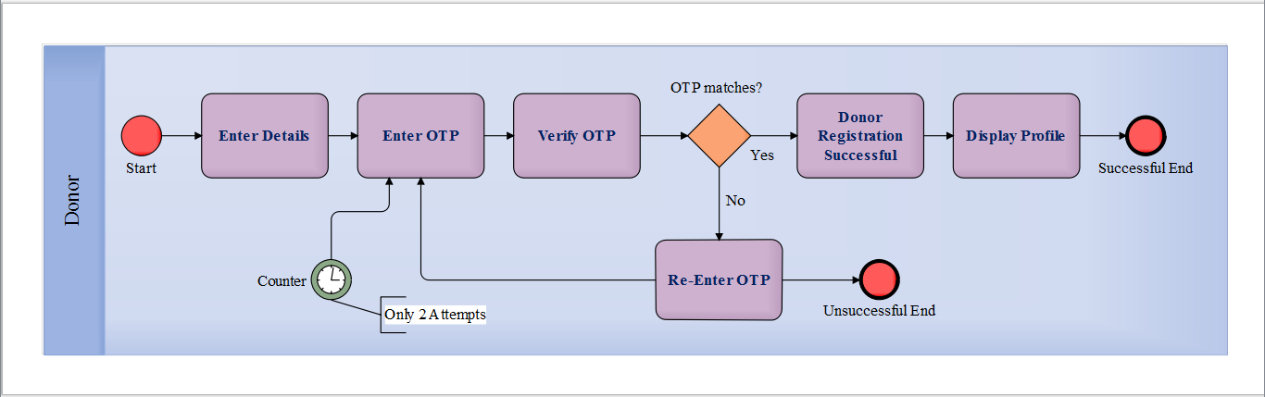

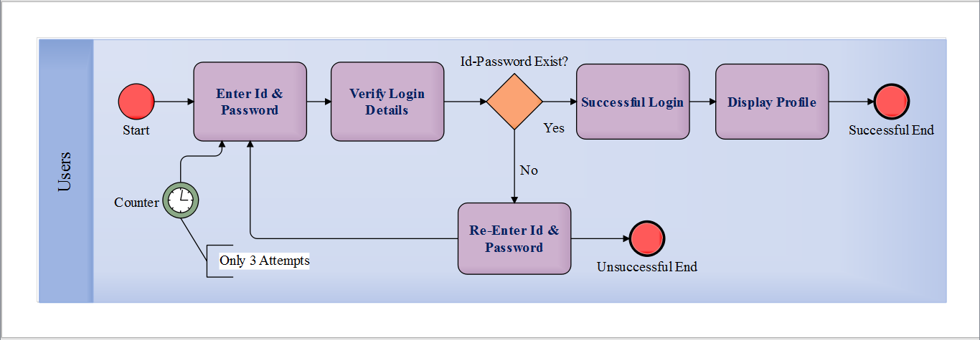

**Fig 1.1.1 BPMN Diagram for Login**

1. **DONATION PROCESS BPMN DIAGRAM**

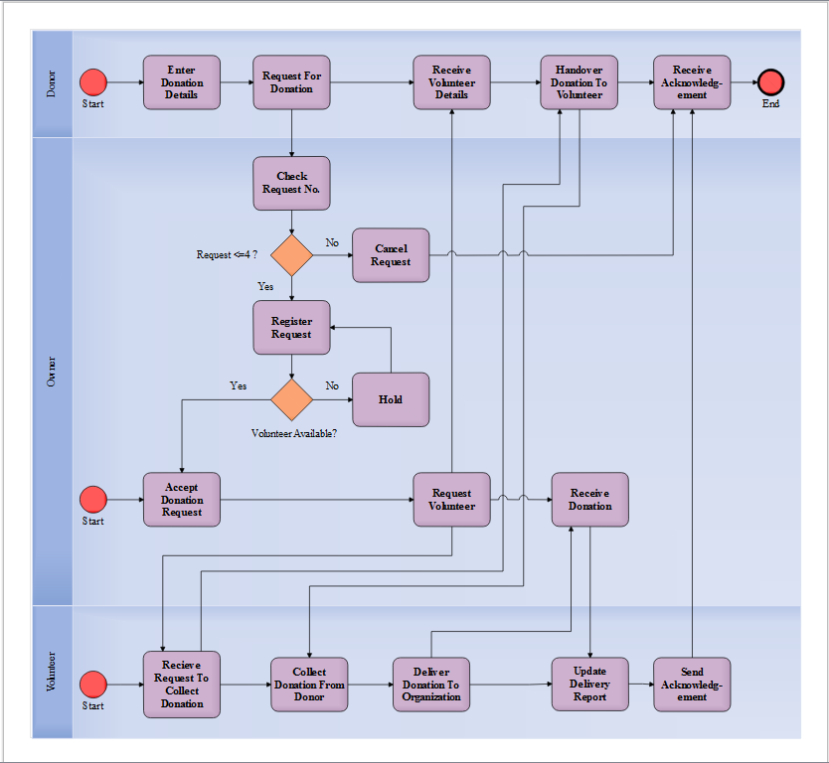

## ENTITY-RELATIONSHIP DIAGRAM

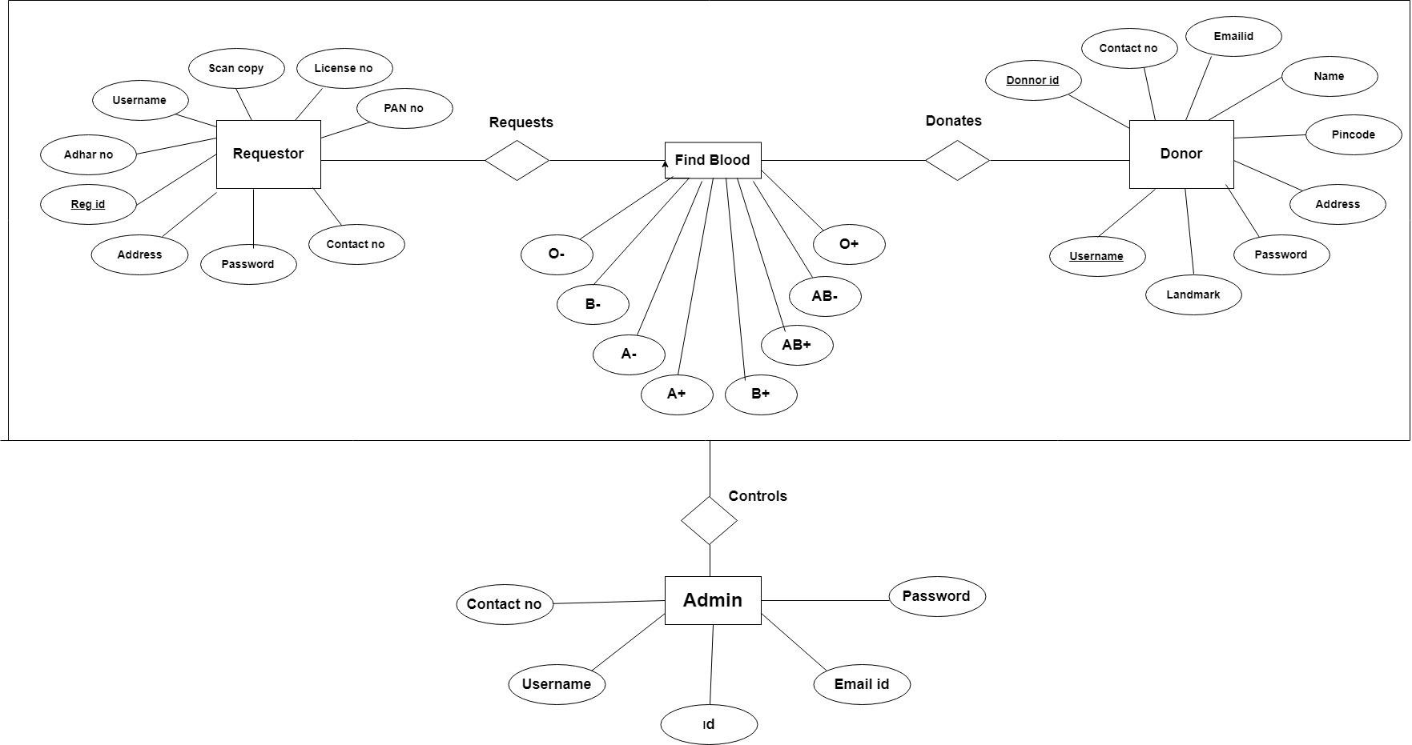

**Fig. 2.1** - ER Diagram for BCS

## DATA FLOW DIAGRAM

### LEVEL-0 DFD

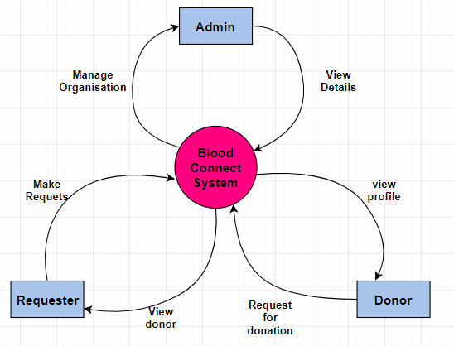

* 1. **USE CASE DIAGRAM**
     1. **LOGIN USE CASE**

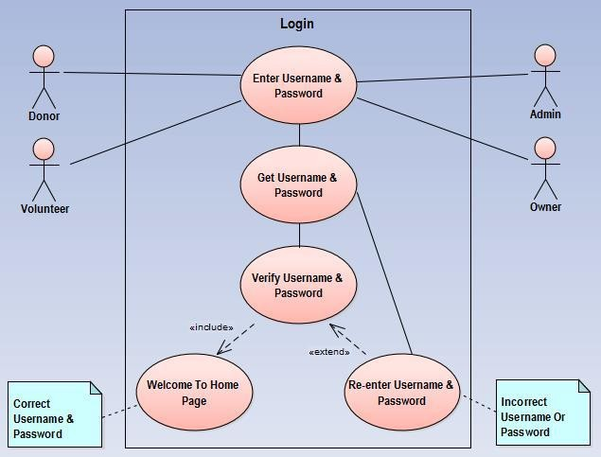

* + 1. **REGISTRATION USE CASE**

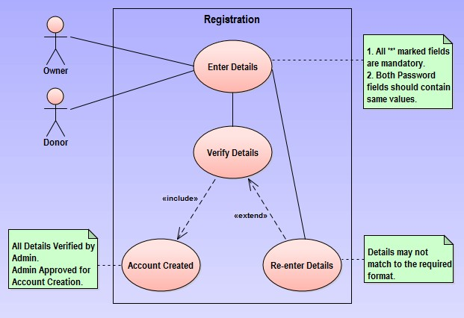

* + 1. **ADMIN USE CASE**

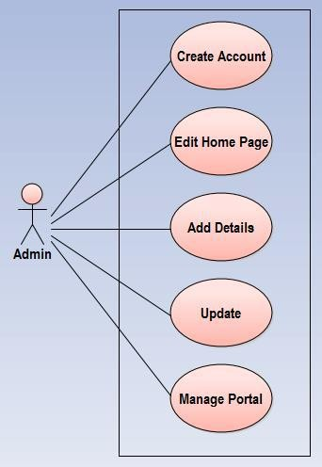

* + 1. **DONOR USE CASE**

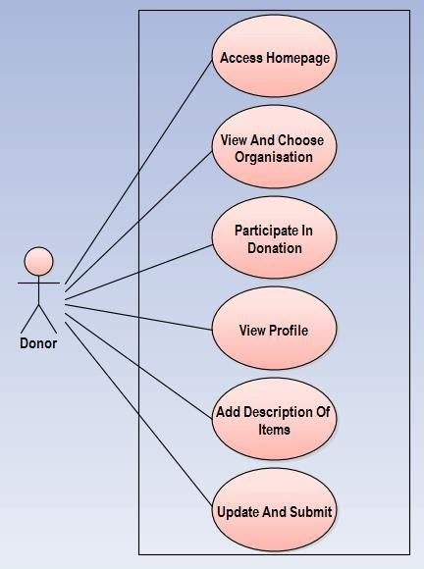

* 1. **SEQUENCE DIAGRAM**
     1. **LOGIN SEQUENCE DIAGRAM**

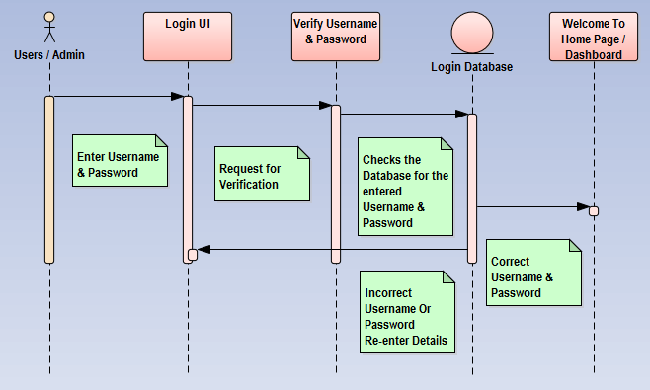

* + 1. **REGISTRATION SEQUENCE DIAGRAM**

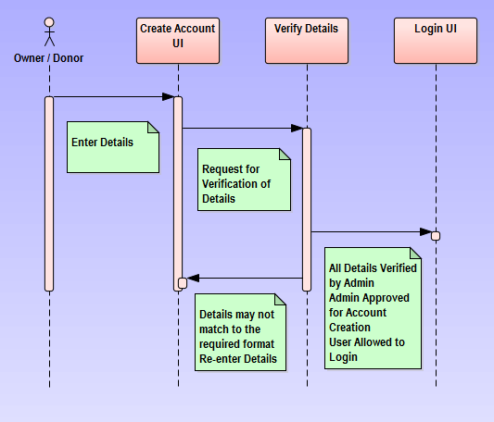

* 1. **CLASS DIAGRAM**
     1. **LOGIN CLASS DIAGRAM**

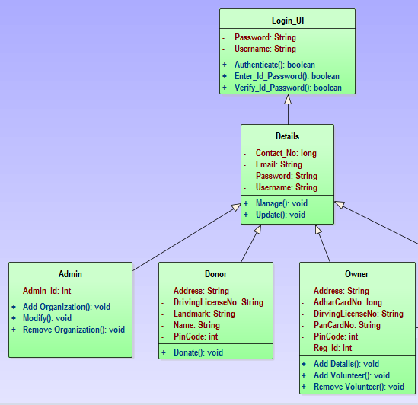

* + 1. **REGISTRATION CLASS DIAGRAM**

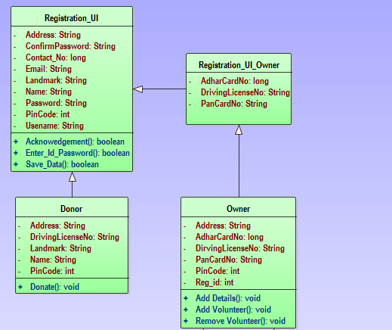

**Requestor**

* + 1. **DBP CLASS DIAGRAM**

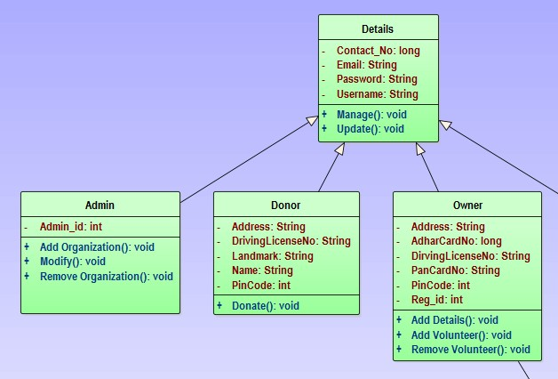

**9. SCREENSHOTS**

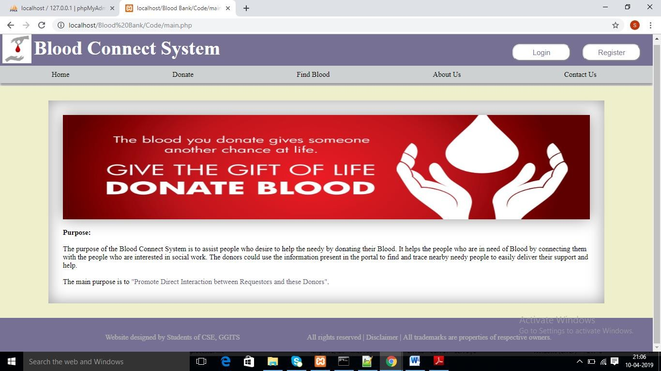

**Fig. 7.1** - Home Page of BCS

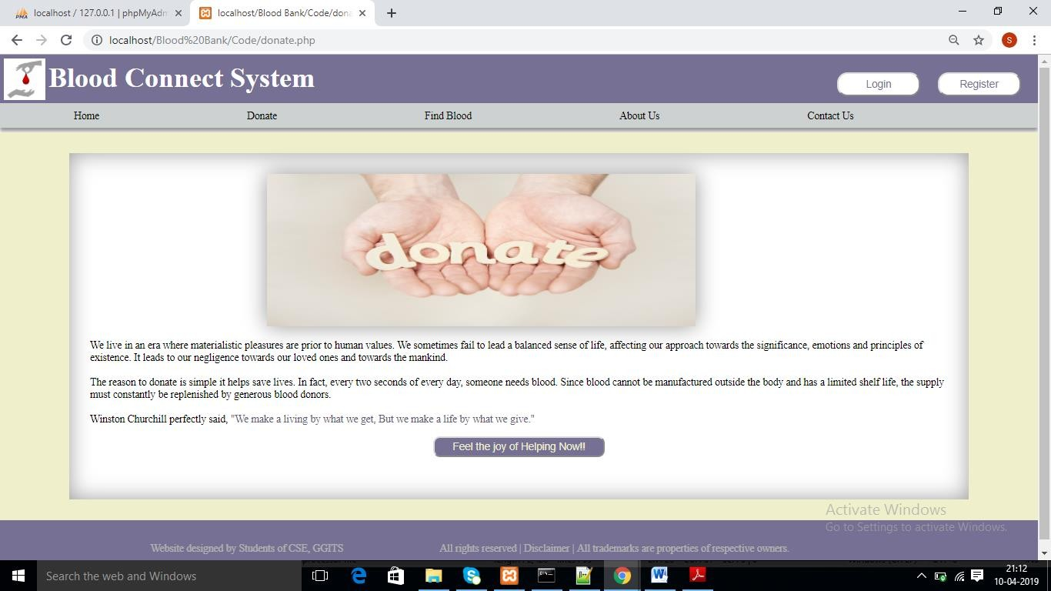

**Fig. 7.2** - Donate Page (Navigation Tab) of DBP

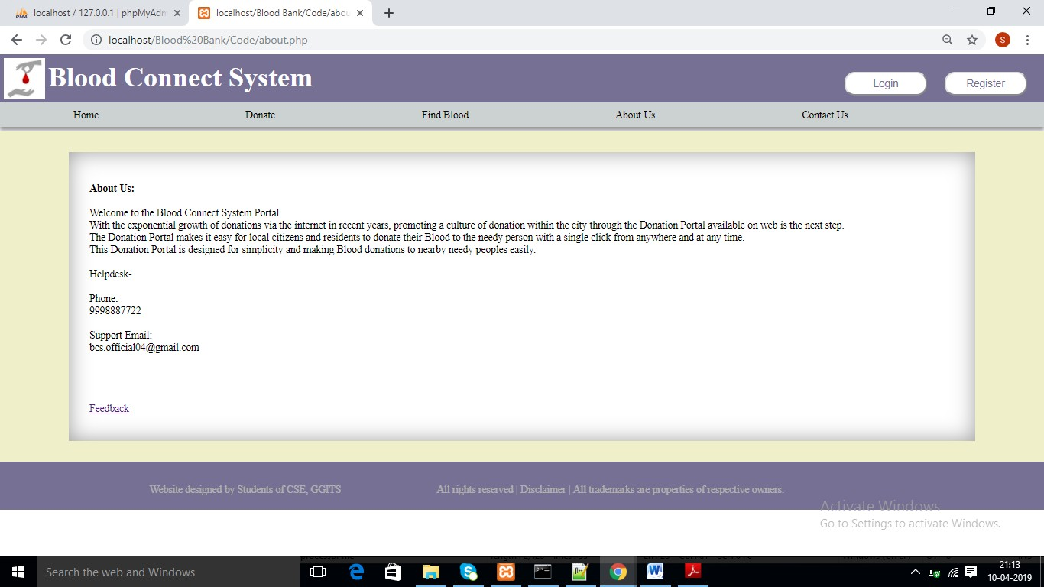

**Fig. 7.4** - About Us Page (Navigation Tab) of BCS

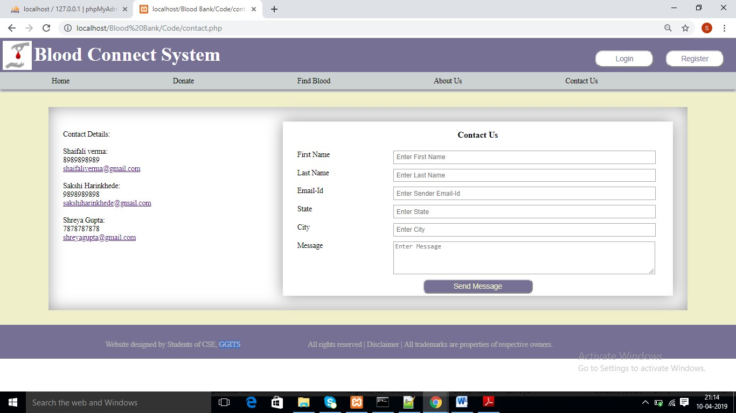

**Fig. 7.5** - Contact Us Page (Navigation Tab) of BCS

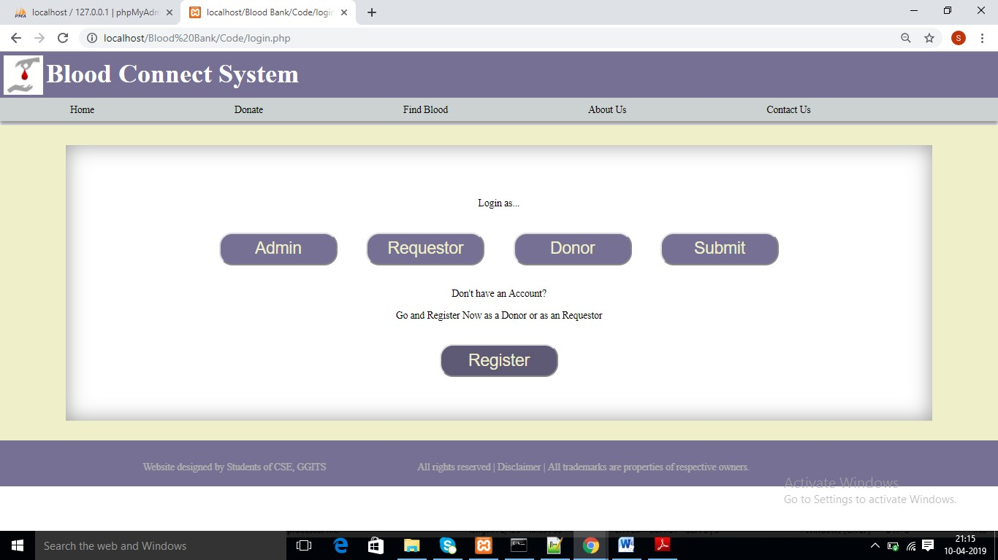

**Fig. 7.6** - Login Page of BCS

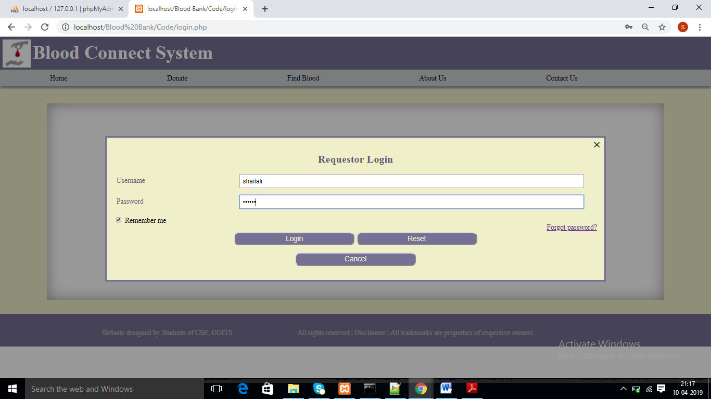

**Fig. 7.7** - Requestor Login Page of BCS

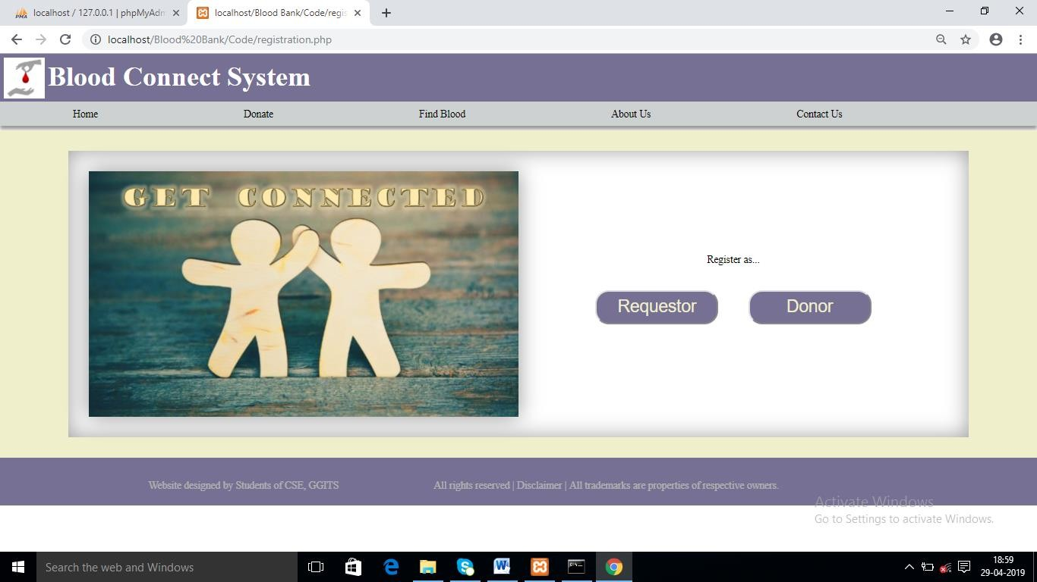

**Fig. 7.8** – Registration Page of BCS

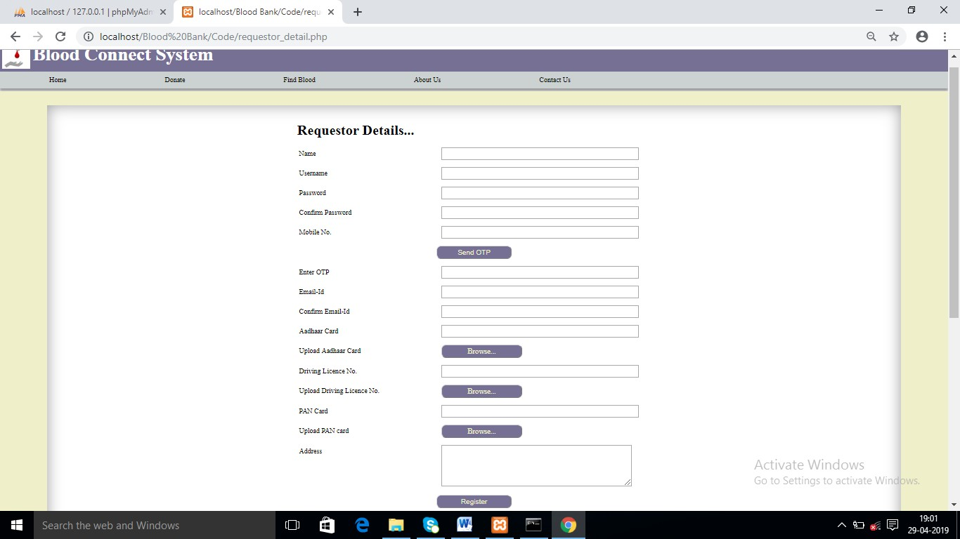

**Fig. 7.9** –Requestor Registration Page of BCS

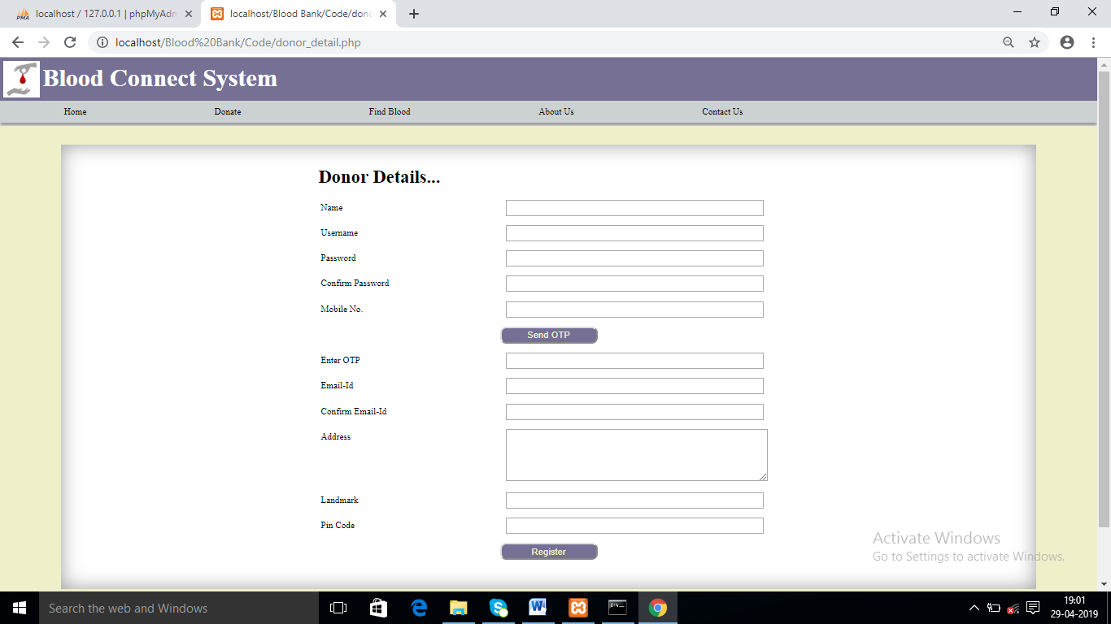

**Fig. 7.9** –Donor Registration Page of BCS