Assignment 02:

Write the SELECT queries to do the following:-
Note : To solve below queries use “sales” database

1. Write a query that produces all rows from the Customers table for which the salesperson’s number is 1001.
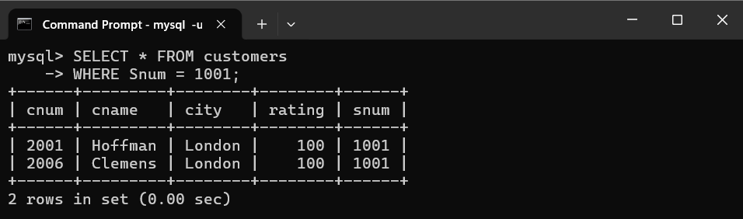

2. Write a select command that produces the rating followed by the name of each customer in San Jose.
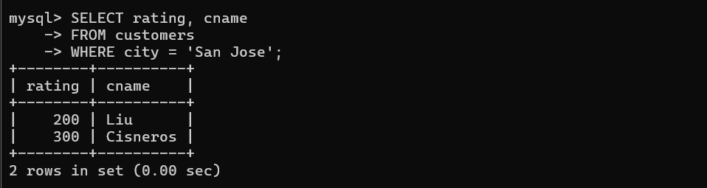

3. Write a query that will produce the snum values of all salespeople from the Orders table (with the duplicate values suppressed).
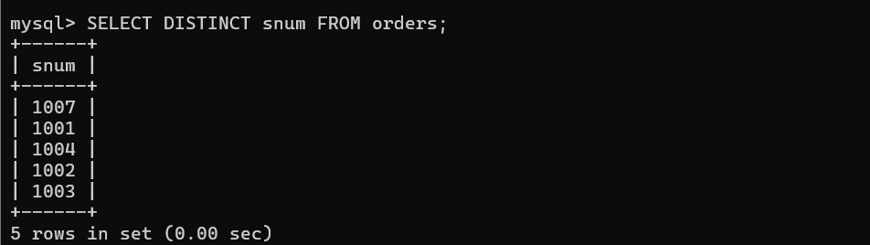

4. Write a query that will display all the orders for amount more than Rs. 1,000.
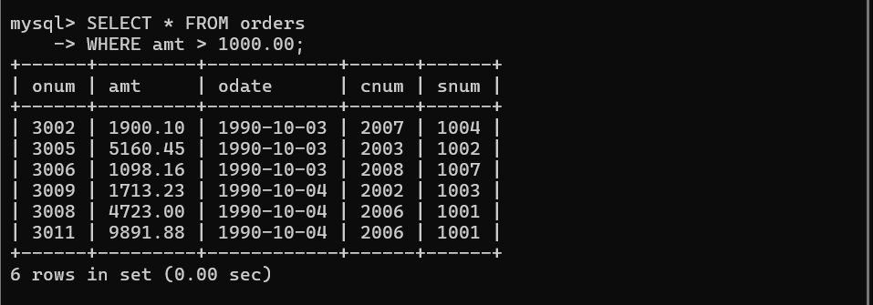

5. Write a query that will give you the names and cities of all salespeople in London with a commission above 0.10.
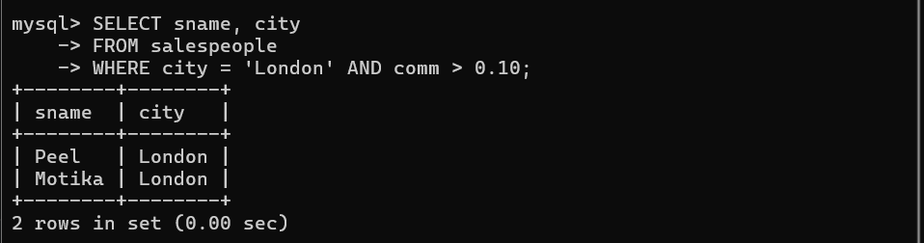
6. Write an SQL query that returns all customers who have a rating greater than 100, along with the customers located in Rome regardless of their rating.
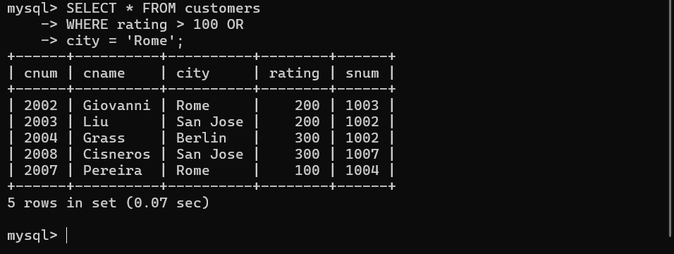

7. What will be the output from the following query? Select * from Orders where (amt < 1000 OR NOT (odate = ‘1990-10- 03’ AND cnum > 2003));
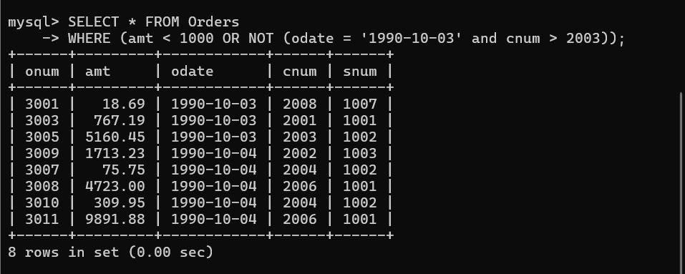
8. What will be the output of the following query? Select * from Orders where NOT (odate = ‘1990-10-03’ OR snum >1006) AND amt >= 1500;
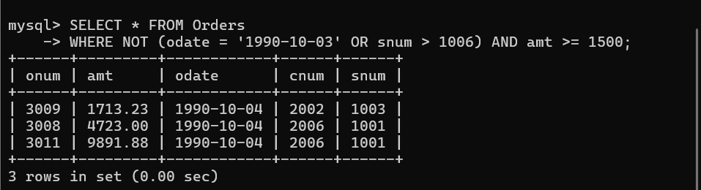

9. What is a simpler way to write this query? Select snum, sname, city, comm from Salespeople Where (comm >= .12 AND comm <= .14);
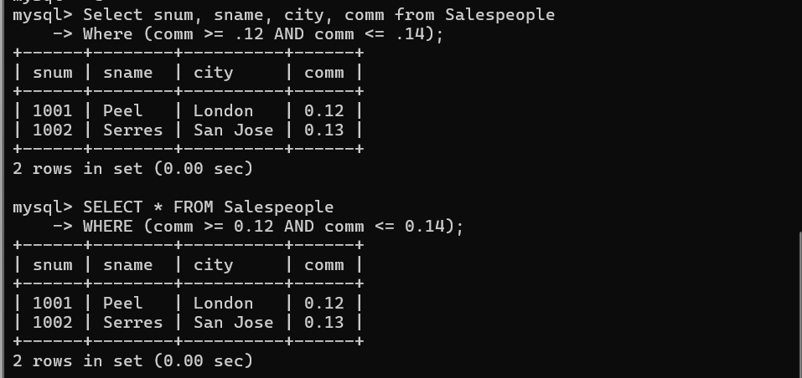

10. Write a query that selects all orders except those with amount less than 100.


