Assignment 03 :

- Write a query to get unique department ID from employee table.

SELECT DISTINCT EMPLOYEE_ID FROM employees;

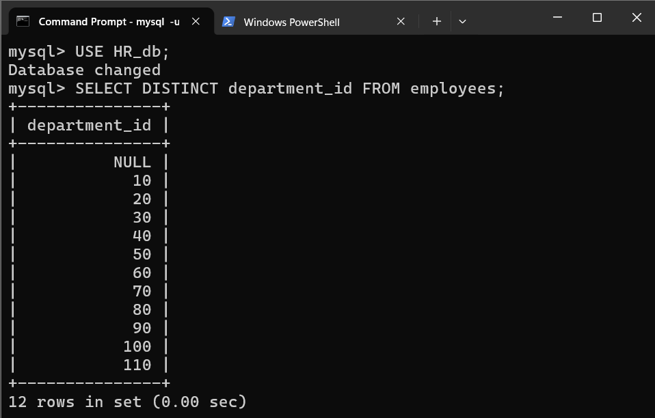

- Write a query to get all the employee’s details from the employees table displaying the first names in descending order.

SELECT * FROM employees ORDER BY first_name DESC;
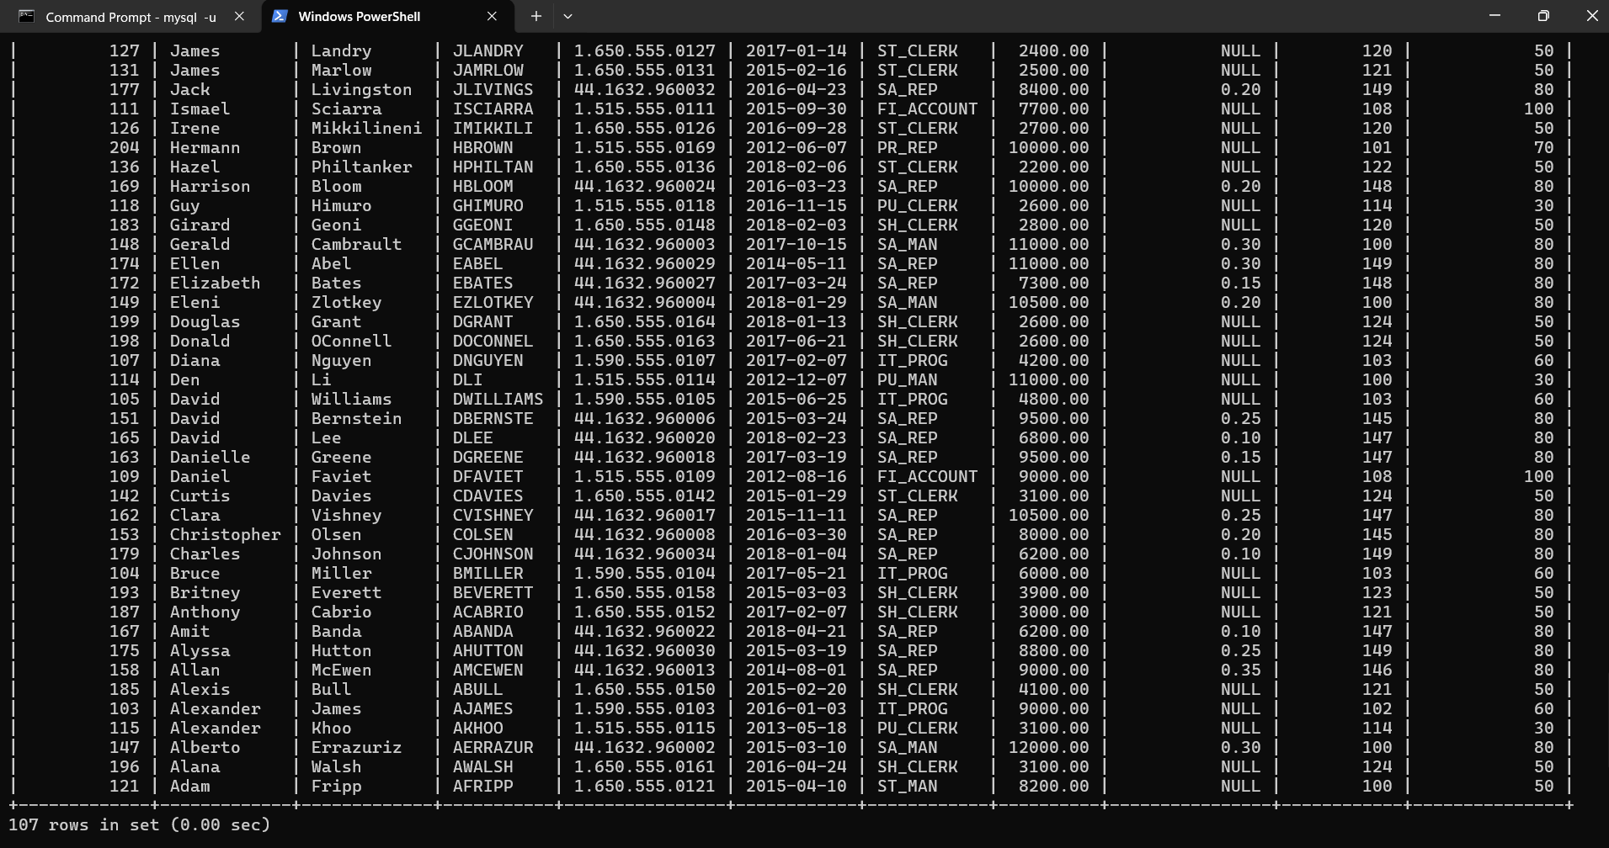
- Write a query to get the employee ID, names (first_name and last_name), salary in ascending order of salary.

SELECT employee_id, first_name, last_name, salary
FROM employees
ORDER BY salary ASC;

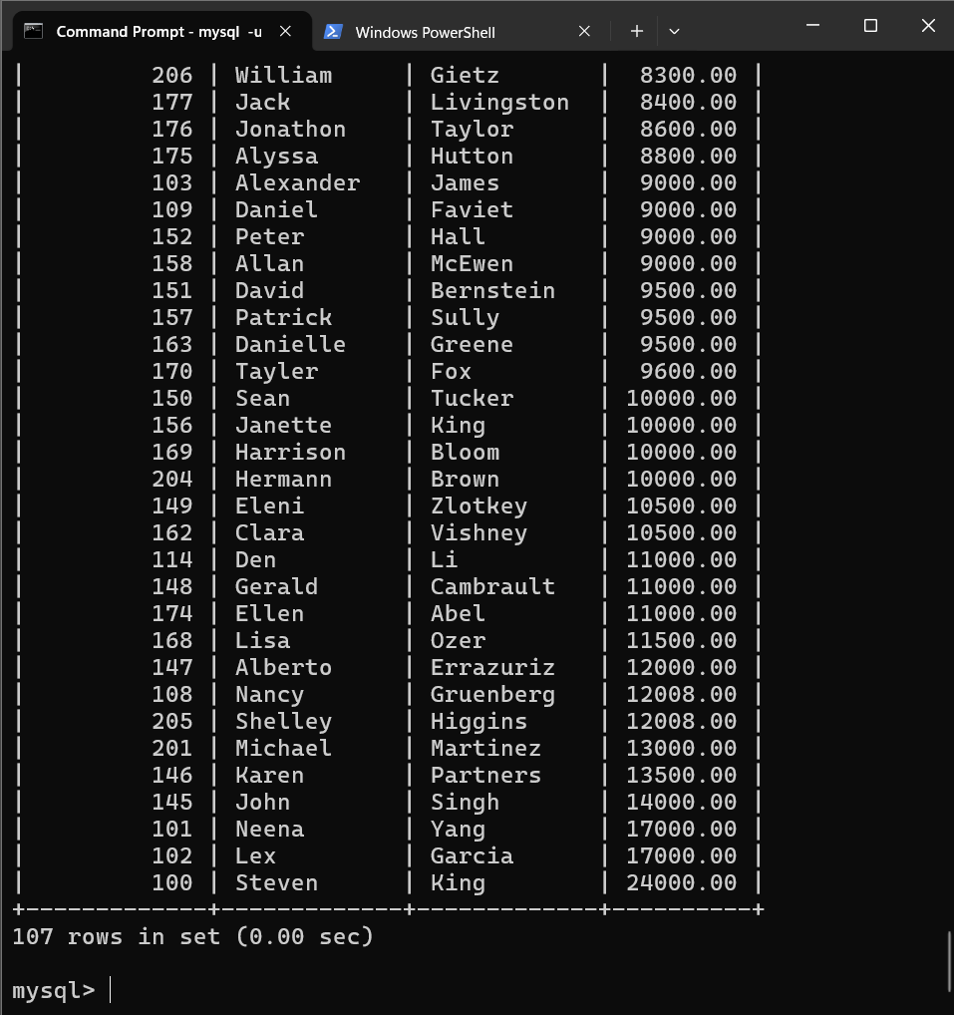
- Display first name and joining date of the employees who are either IT Programmer or Sales Man.

SELECT `first_name`, `hire_date`, `job_id`
FROM employees
WHERE `job_id` IN(‘IT_PROG’, ‘SA_MAN’);
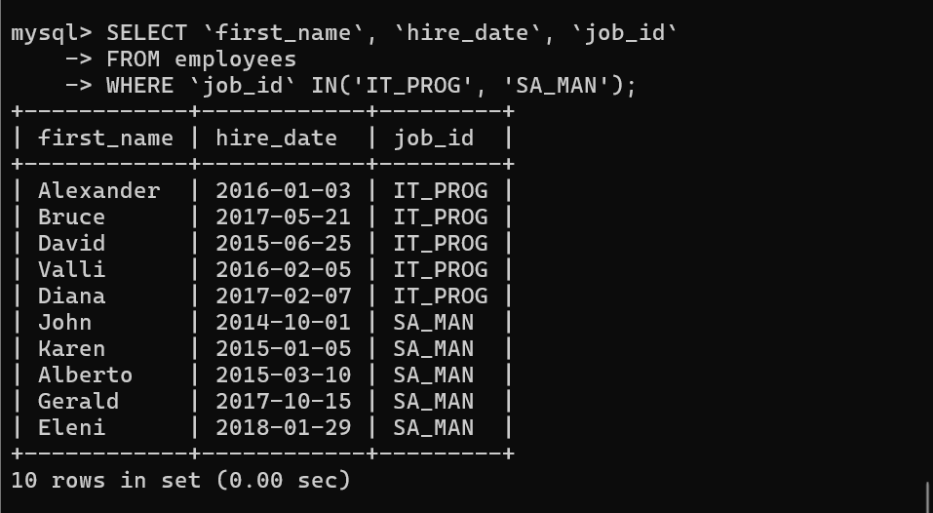

- Display details of employees with employee ID 150 or 160.

SELECT * FROM employees
WHERE `employee_id` IN(150, 160);

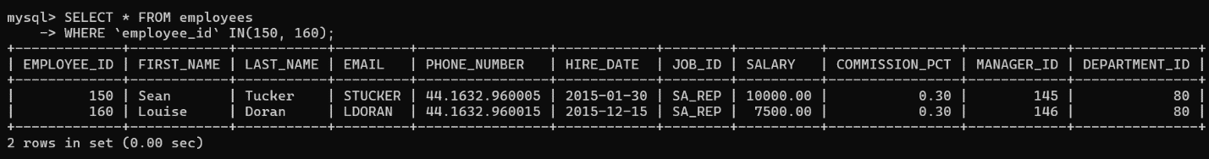

- Display first name, salary, commission pct, and hire date for employees with salary less than 10000.

SELECT `first_name`, salary, `commission_pct`, `hire_date`
FROM employees
WHERE salary < 10000;

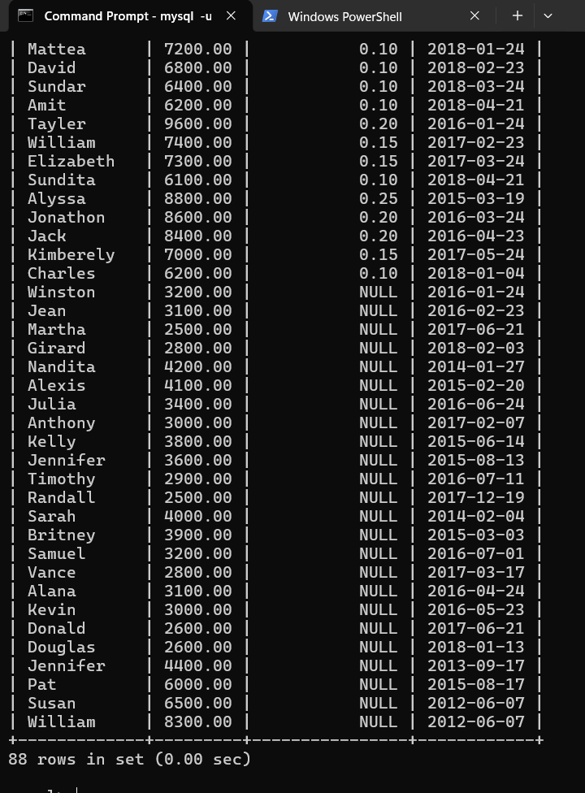

- Display employees where the first name or last name starts with S.

SELECT `employee_id`, `first_name`, `last_name`
FROM employees
WHERE `first_name` LIKE 'S%' OR `last_name` LIKE 'S%';

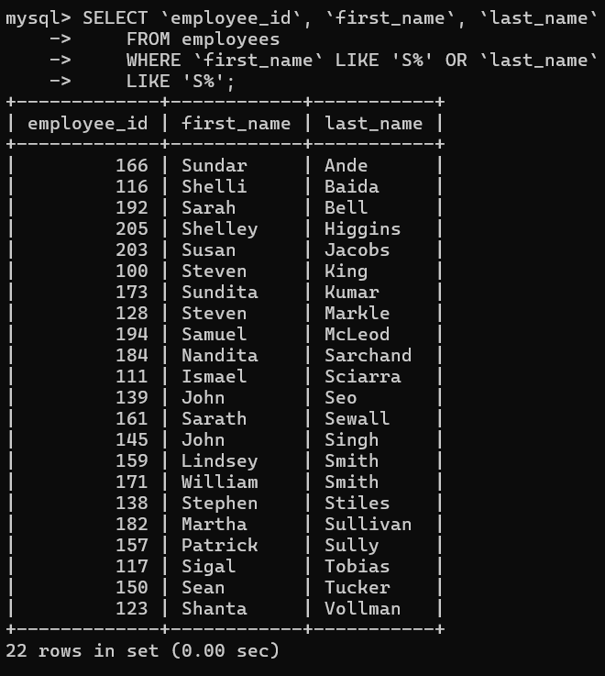

- Display details of jobs in the descending order of the title.

SELECT * FROM jobs ORDER BY job_title DESC;

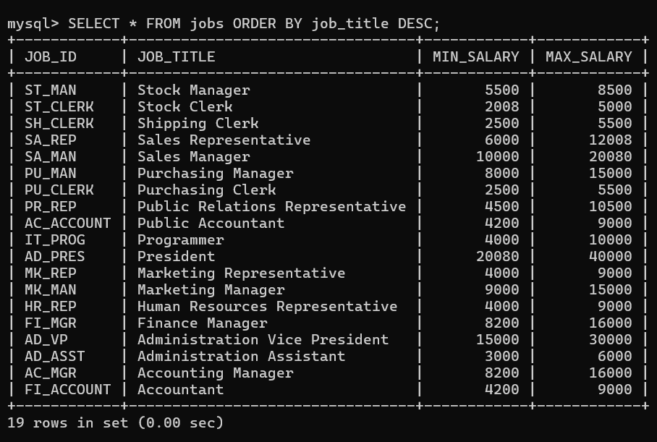

- Display the details of the employees from department 30, earning the salary greater 10000 but do not receive the commission.

SELECT * FROM employees
WHERE `department_id` = 30 AND salary > 10000 AND `commission_pct` IS NULL;
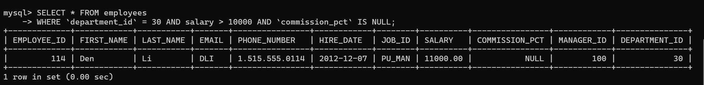
- Display the details of employees reporting to the managers with employee id 100 and 120.

SELECT * FROM employees
WHERE `manager_id` IN(100, 120);

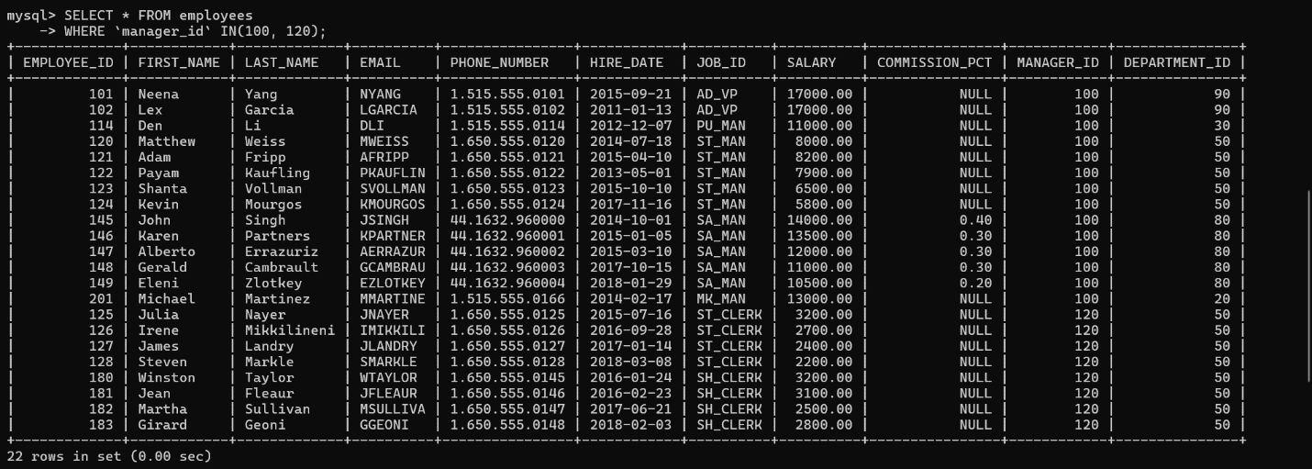

- Display the unique country_id from locations table.

SELECT DISTINCT `country_id` FROM location;

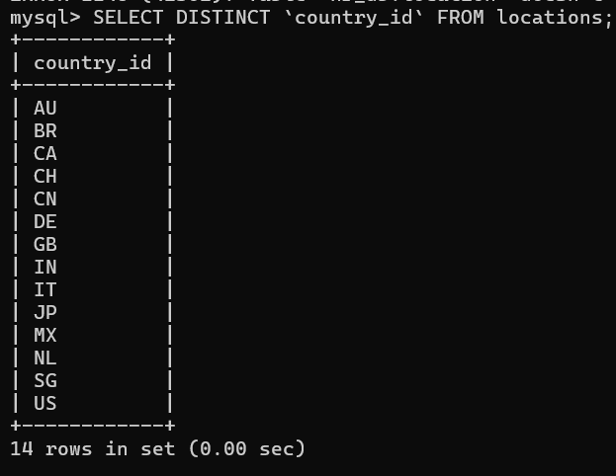
- Display all employees whose have the job_id as IT_PROG and FI_ACCOUNT.

SELECT * FROM employees
WEHRE `job_id` IN(‘IT_PROG’, ‘FI_ACCOUNT’);

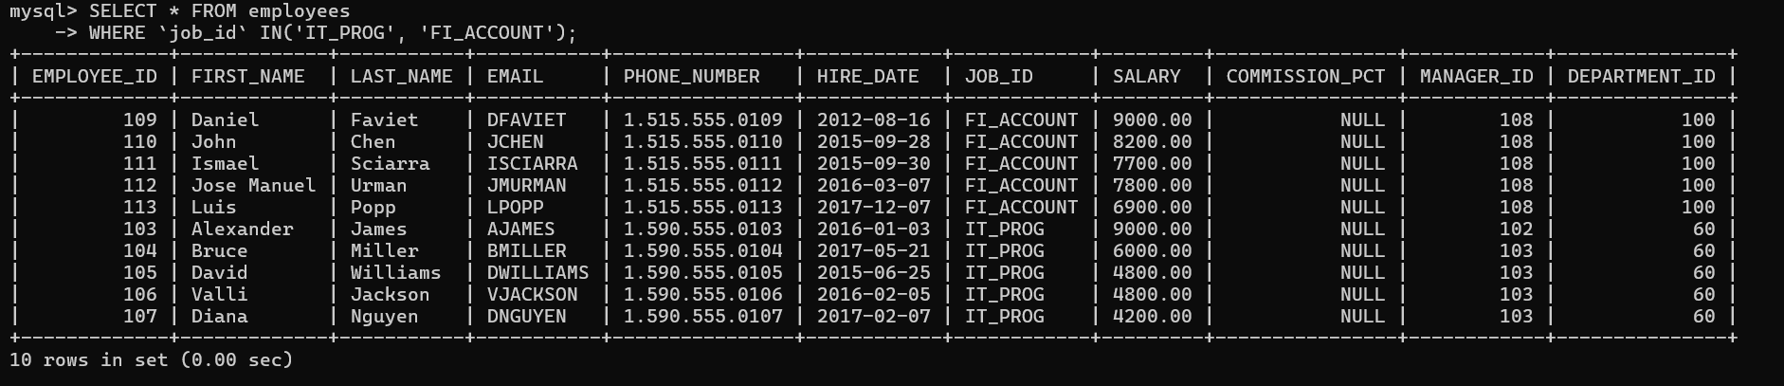

- Display all countries in ascending order.
SELECT * FROM countries ORDER BY ‘country_name’ ASC;



