Assignment 1:

Q1. Create 'spj' database'. (Database for suppliers, parts and jobs)
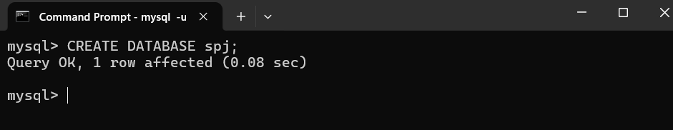

Q2. use spj database
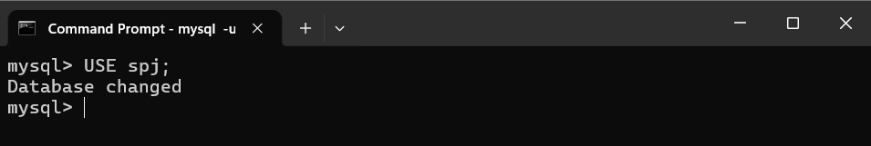

Q3. Create following tables in spj database.
Note : S denotes the Suppliers Table.
P denotes the Parts table.
J denotes the Jobs table.

CREATE TABLE S (S# CHAR(5) NOT NULL, Sname CHAR(20), status SMALLINT, city CHAR(15)); TABLE S
CREATE TABLE P (P# CHAR(6) NOT NULL, Pname CHAR(20), color CHAR(6), weight SMALLINT, city CHAR(15)); TABLE P
CREATE TABLE J (J# CHAR(4) NOT NULL, Jname CHAR(10), City CHAR(15));

Table S:

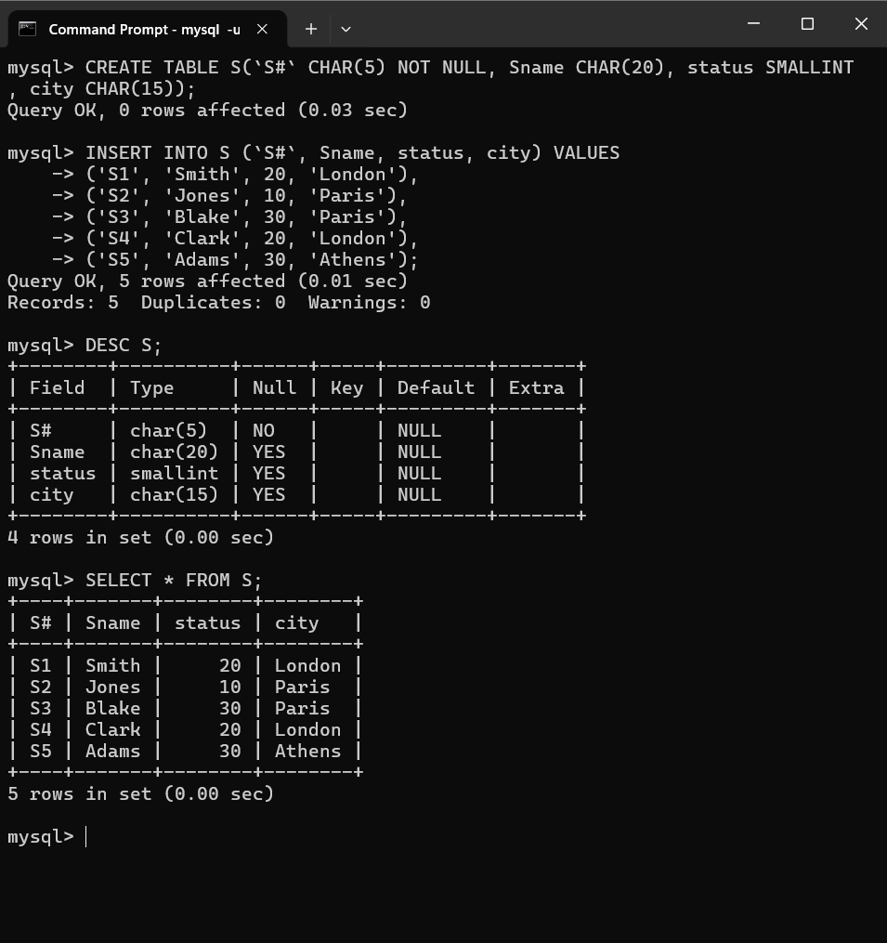

Table P

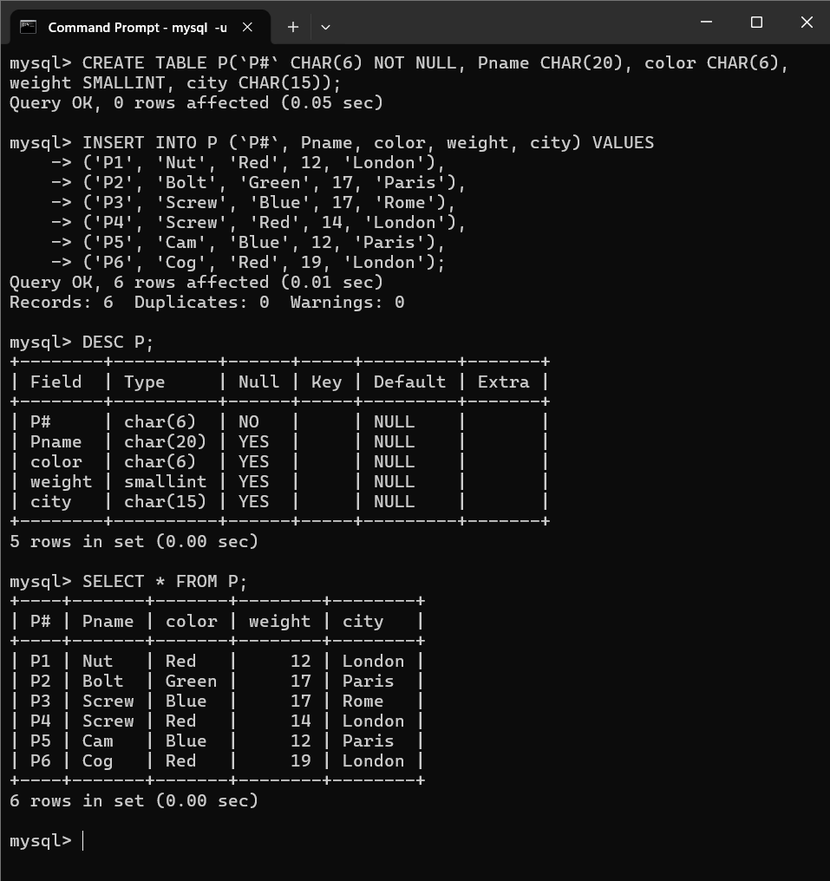

Table J:

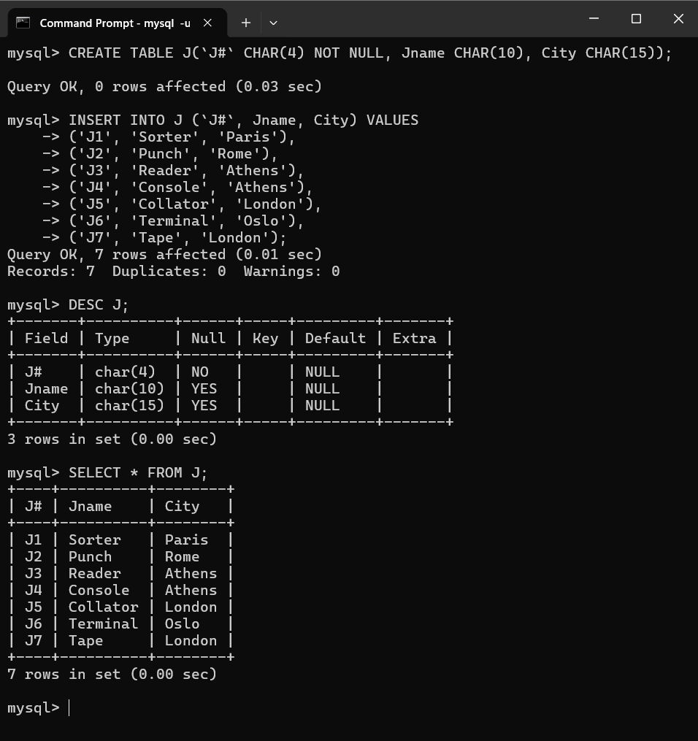

Table sp:

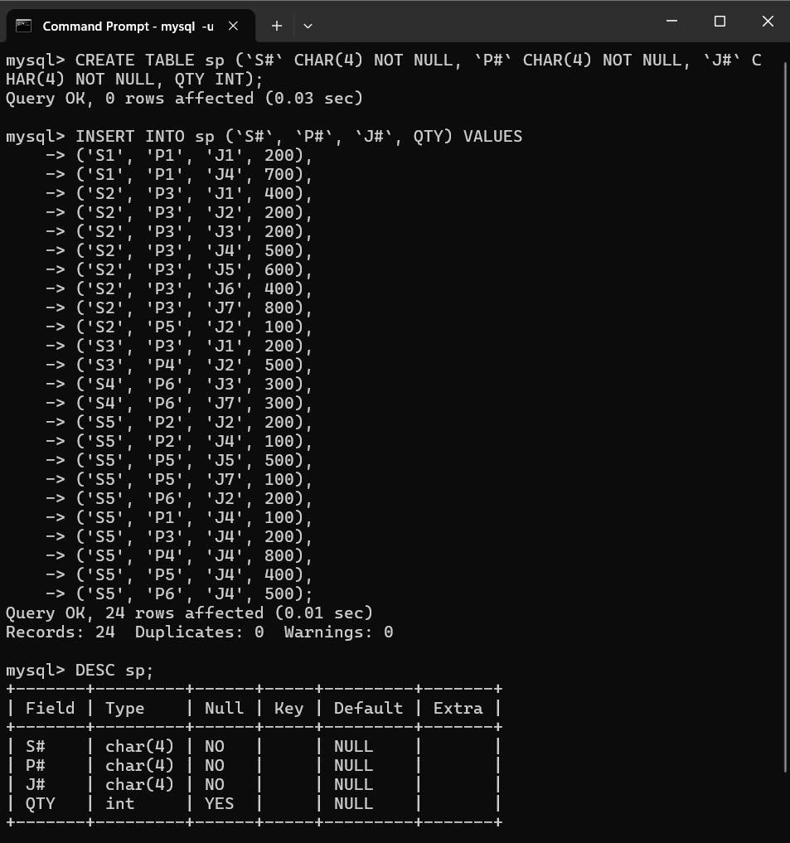

Table sp:

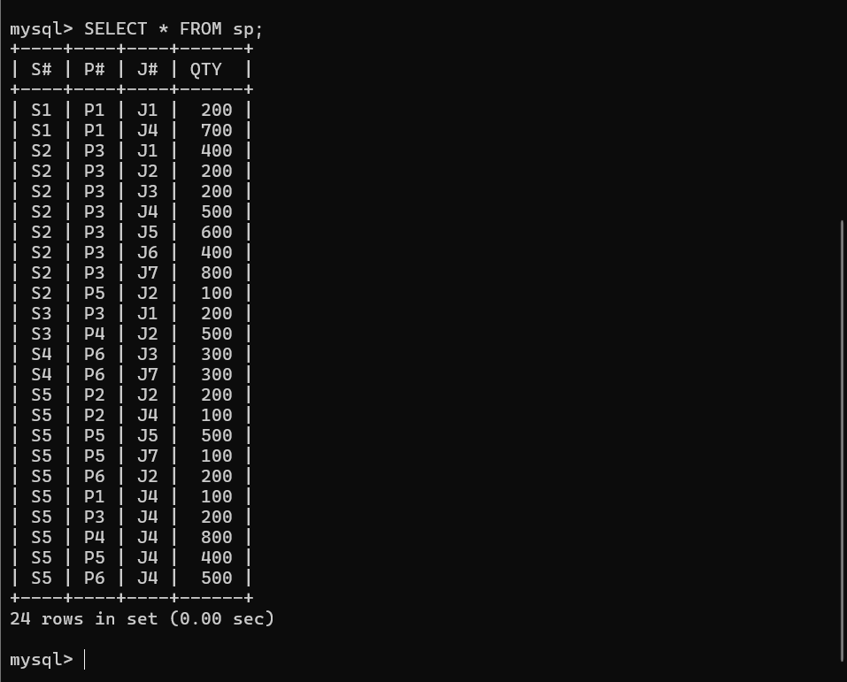

1. Create 'hr' database. Import hr-db.sql.
2. Create 'sales' database. Import sales-db.sql.
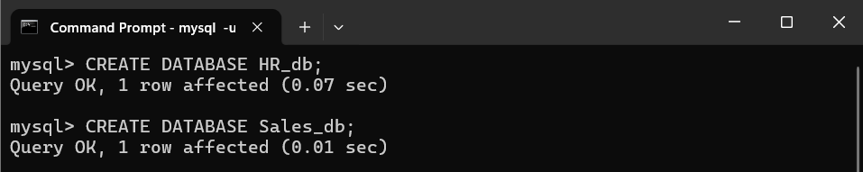
3. Tables of HR_db :

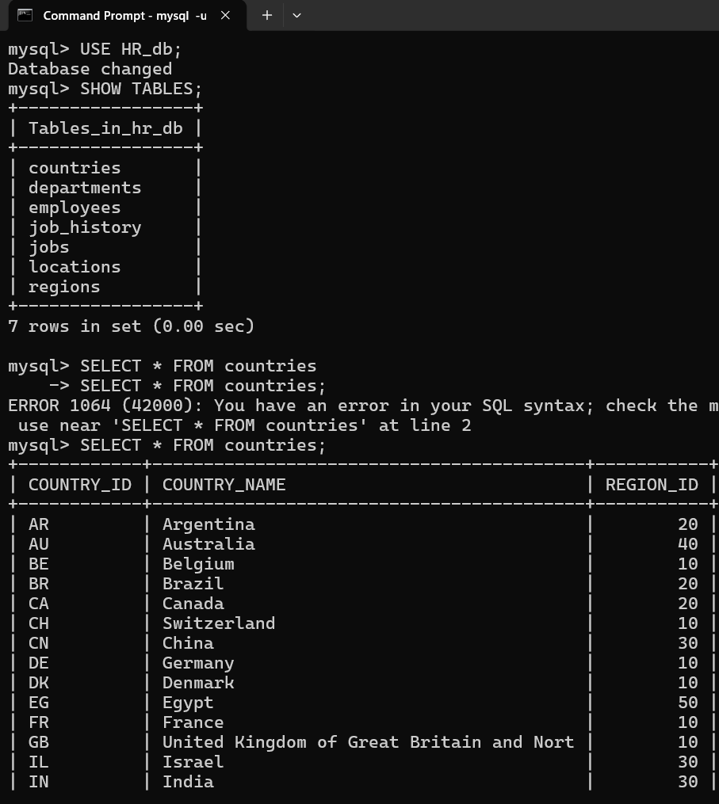

4. Tables of Sales_db :



