1. 1.To implement fontawesome we have to go fontawesome.com
2. And click on Docks tab
3. On Below Using Fontawesome with and click on React

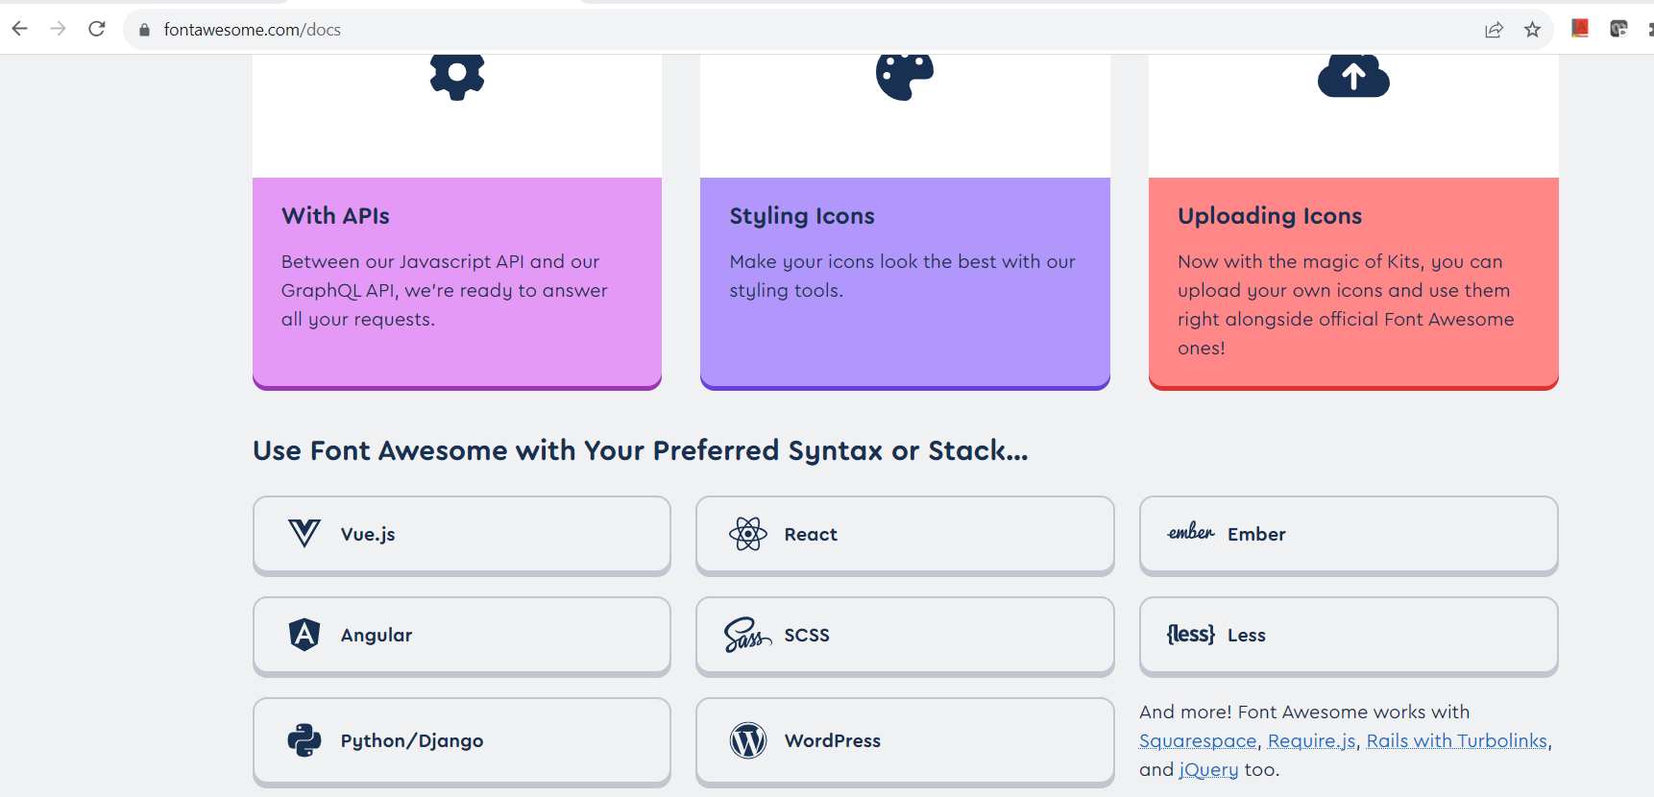

1. Ten go to Api Dock as shown below



Run the following command as follows:

# Free icons styles

*npm i --save @fortawesome/free-solid-svg-icons*

*npm i --save @fortawesome/free-regular-svg-icons*

*npm i --save @fortawesome/free-brands-svg-icons*

*npm i --save @fortawesome/react-fontawesome@latest*

*npm i --save @fortawesome/fontawesome-svg-core*

*npm i --save @fortawesome/free-solid-svg-icons*