Ritesh Shrestha

Technische Universität Darmstadt
STUDY AND EVALUATION OF SHARDED DISTRIBUTED DATABASES
Bachelor’s Thesis

Table of Contents
Introduction 3
Background and Motivation 3
Research Question and Objectives 3
Contributions 3
Literature Review and Related Works 4
Centralized and Distributed Database 4
Scalability Approaches of Databases 4
Architectures for Distributed Database Management Systems 4
Client-Server Systems 4
Collaborating Server Systems 4
Middleware (Proxy-based) Systems 5
Distributed Data Storage 5
Data Partition and Sharding 5
Data Replication 5
Data Distribution 5
Sharded Distributed Databases 6
Sharding Strategies 6
Sharded Data Distribution 7
Distributed Transaction and Query Processing 7
Distributed Concurrency Control 7
Distributed Recovery 7
Design Considerations 8
Redis Key-Value Store 8
Consistent Hash Sharding in Distributed Key-Value Stores 8
Implementation 9
Middleware Design and Architecture 9
Operations (Set and Update, Get, Delete, Intra-Shard and Inter-Shard Transactions) 9
Sharding in Redis Key-Value Stores 9
Evaluation and Results 10
Latency, Response Time, and Scalability Analysis 10
Evaluation of Sharding in Database 11
Impacts of Sharding 13
Discussion 14
Analysis of Middleware-based Sharded Distributed Databases 14
Use Cases of Sharded Distributed Databases 14
Limitations and Future Work 14
Conclusion 15

Introduction

Background and Motivation

Research Question and Objectives

Contributions

Literature Review and Related Works

Centralized and Distributed Database

Distributed database is a single logical database comprising of multiple physical database servers. It is a collection of multiple, logically interrelated databases located at different physical sites. A distributed database management systems (distributed DBMS, DDBMS) refers to a software system that permits the management of the distributed databases, making the distribution transparent to end users. In DDBMS, data is stored across several sites, and each site is typically managed by a DBMS capable of running independent of the other sites. The location of data items and the degree of autonomy of individual sites have a significant impact on all aspects of the system, including query optimization and processing, concurrency control, and recovery.
Types of Distributed Databases:
- Homogeneous Distributed Database Systems
- Heterogeneous Distributed Database Systems/Multi-database systems.

Scalability Approaches of Databases

Architectures for Distributed Database Management Systems

Client-Server Systems

Collaborating Server Systems
The Client-Server architecture does not allow a single query to span multiple servers because the client process would have to be capable of breaking such a query into appropriate subqueries to be executed at different sites and then piecing together the answers to the subqueries. The client process would therefore be quite complex, and its capabilities would begin to overlap with the server; distinguishing between clients and servers becomes harder. Eliminating this distinction leads us to an alternative to the Client-Server architecture: a Collaborating Server system. We can have a collection of database servers, each capable of running transactions against local data, which cooperatively execute transactions spanning multiple servers.
When a server receives a query that requires access to data at other servers, it generates appropriate subqueries to be executed by other servers and puts the results together to compute answers to the original query.

Middleware (Proxy-based) Systems
We can think of this special server as a layer of software that coordinates the execution of queries and transactions across one or more independent database servers; such software is often called middleware. The middleware layer can execute joins and other relational operations on data obtained from the other servers but, typically, does not itself maintain any data.

Distributed Data Storage

Data Partition and Sharding

Data Replication

Data Distribution

Sharded Distributed Databases

Database sharding splits a large dataset from a single database node into multiple shards. Each shard contains unique information that one can store separately across multiple database sites. A single site can contain multiple shards. Although the shards are distributed over multiple sites, they share the original database’s schema or design. Before sharding, one should determine a shard key to partition the dataset. Shard key determines which data are grouped together. Shard key is, either selected from an existing key in the dataset or created based on the properties of the existing data.
Approaches for sharding databases: Database sharding methods apply different rules to the shard key to determine the correct site for a particular set of data.

Sharding Strategies

- Range-based Sharding (Dynamic sharding):
In range-based sharding, data is partitioned based on a key range. For example, data for all users with user IDs between 1 and 1000 might be stored on one site, while data for users with IDs between 1001 and 2000 might be stored on another site. This type of sharding is useful when the data can be easily partitioned based on a specific key range. Depending on the data values, range-based sharding can result in the overloading of data on a single site, resulting an uneven distribution of data. In the preceding example, the first shard with user IDs between 1 and 1000, might contain a much larger amount of data than the second shard with user IDs between 1001 and 2000. However, this approach is easier to implement.
- Hashed-based Sharding (Algorithmic Sharding):
In hash-based sharding, a hash function is used to determine which site, a piece of data (shard) should be stored in. The hash function takes a key (such as a user ID) as input and produces a hash value that is used to determine which site the data should be stored on. This type of sharding is useful when the data does not have a natural key range and when it is important to evenly distribute the data across the sites. Although hashed-based sharding results in even data distribution among physical shards, it does not partition the database based on the meaning of the information. Therefore, one might face difficulties reassigning the hash value when adding more physical shards to the computing environment.
- Geo Sharding (Zone-based sharding):
In zone-based sharding, data is partitioned based on geographic regions or other criteria related to locations. This type of sharding is useful when it is important to store data closer to the users or applications that will access it. If data access patterns are predominantly based on geography, then this works well. However, geo sharding can also result in uneven data distribution.
- Entity-/Relationship-based/Directory-based Sharding:
In directory-based sharding, a central directory is used to map keys to nodes. When a client wants to store or retrieve data, it looks up the appropriate site in the directory based on the key. This type of sharding is useful when the number of sites or the data distribution is likely to change frequently. This approach also keeps related data together on a single physical shard.
- Multi-level sharding: In multi-level sharding, data is partitioned using multiple levels of sharding. For example, data might be first sharded by range and then further partitioned by hash within each range. This type of sharding can be useful when it is important to scale the system beyond what is possible with a single level of sharding.

Sharded Data Distribution

Distributed Transaction and Query Processing

Distributed Concurrency Control

Distributed Recovery

Design Considerations

Redis Key-Value Store

Consistent Hash Sharding in Distributed Key-Value Stores

Implementation

Middleware Design and Architecture

Operations (Set and Update, Get, Delete, Intra-Shard and Inter-Shard Transactions)

Sharding in Redis Key-Value Stores

Evaluation and Results

Latency, Response Time, and Scalability Analysis

Latency is a time duration between the initiation of a request transmission by a source and the reception of the corresponding message by the destination. Such latency manifests as the time in which the request is held in a waiting state prior to processing. Round-trip latency, whereas, is defined as time elapsed between the transmission of a request and the receipt of the corresponding response. It does not account for the processing time incurred at the destination.
Processing time refers to the duration of time taken by a processing system to execute a received request. It is computed as the time duration between the moment when the system receives the final byte of the request and the moment when it transmits the first byte of response.
The response time of a distributed system is the total duration elapsed from the initiation of a request transmission to the receipt of the corresponding response. It represents a cumulative time duration, comprising both the round-trip latency and internal processing time of the system.

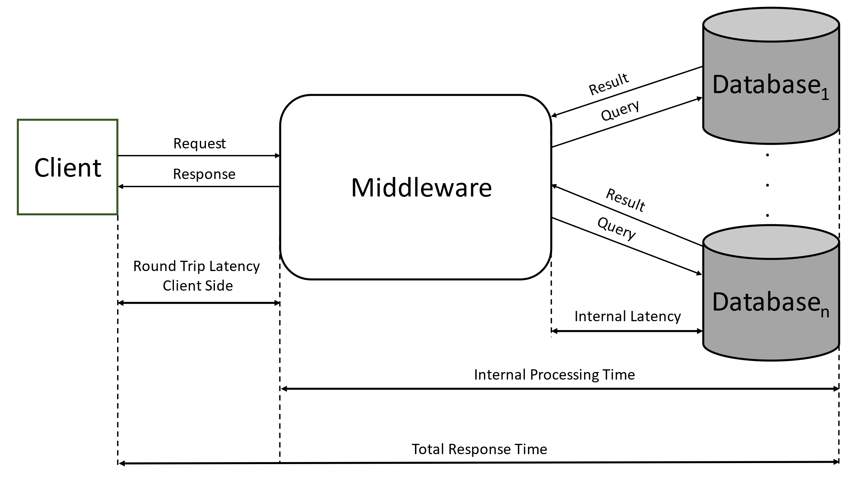

Evaluation of Sharding in Database

Without Middleware:

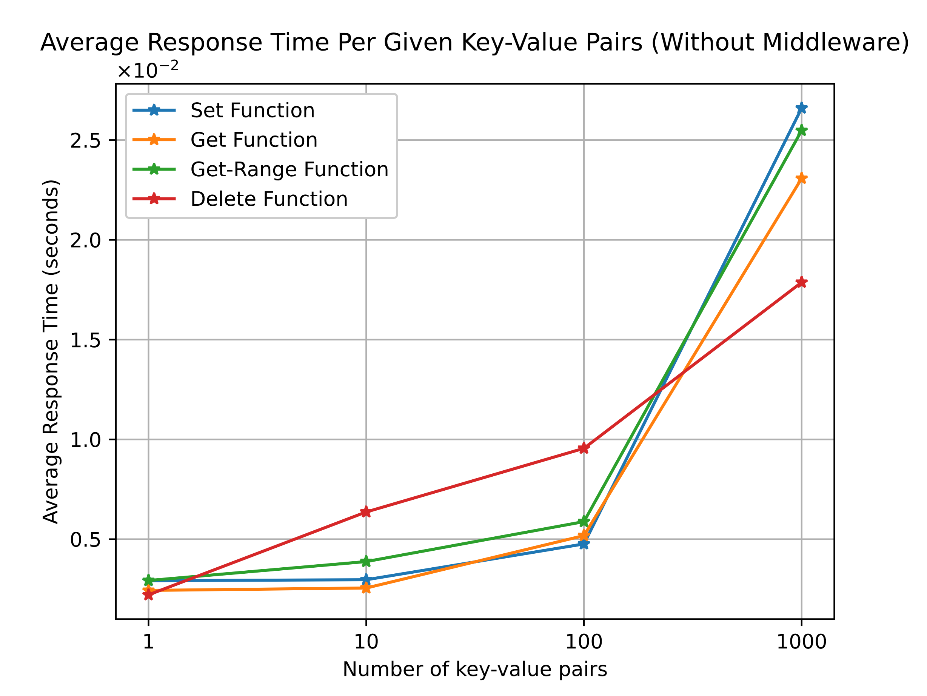

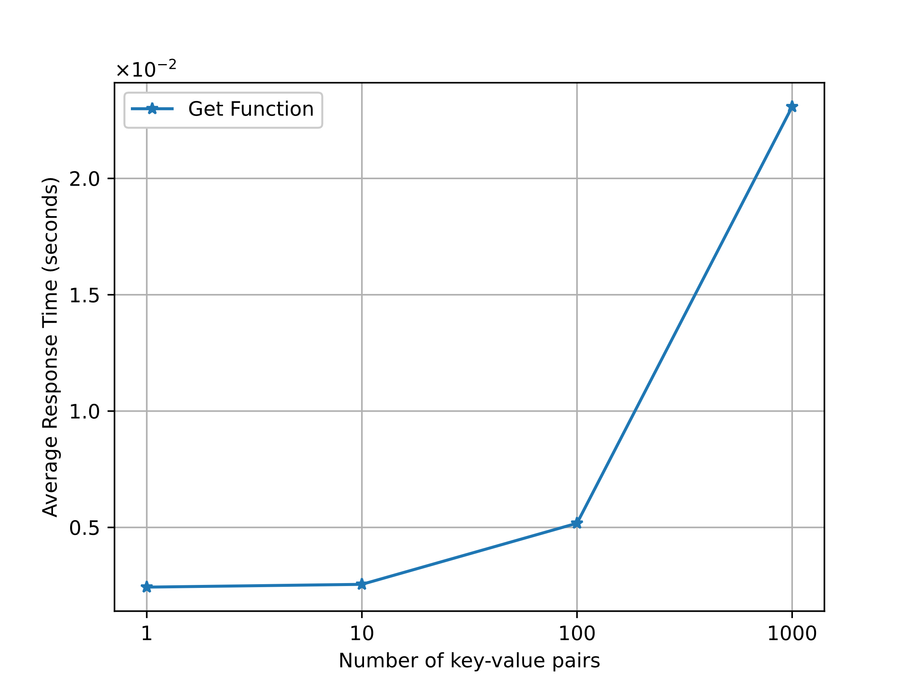
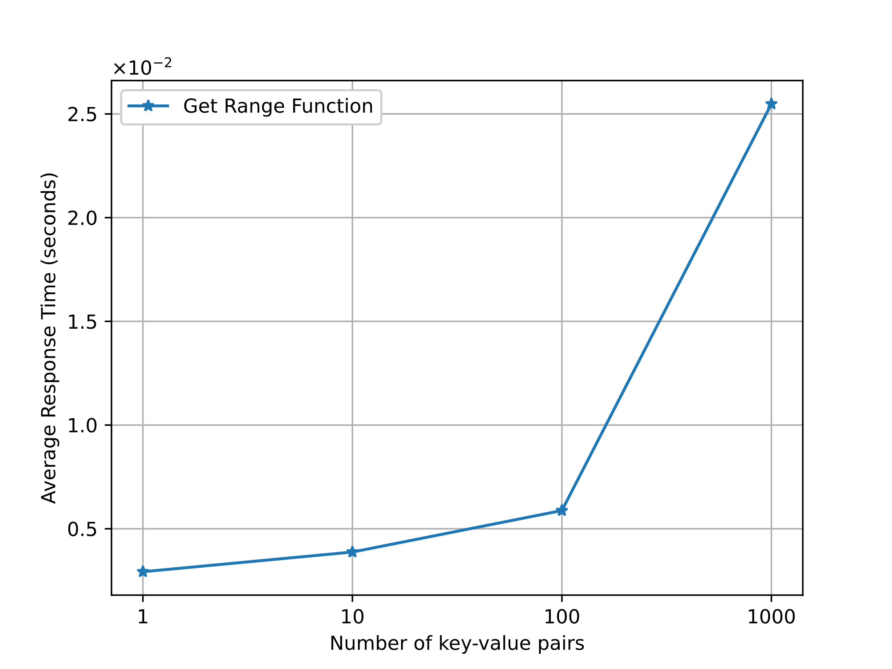
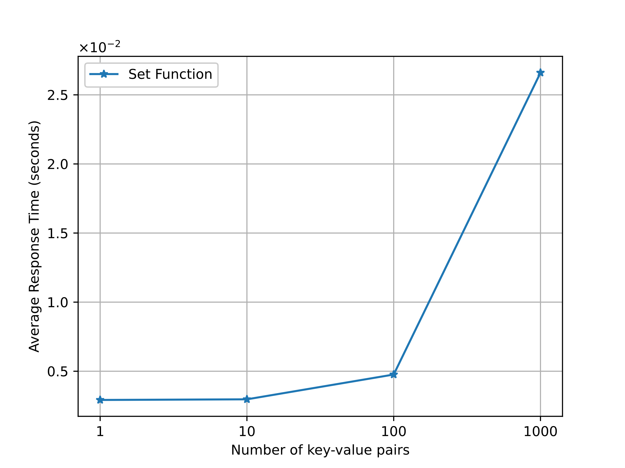
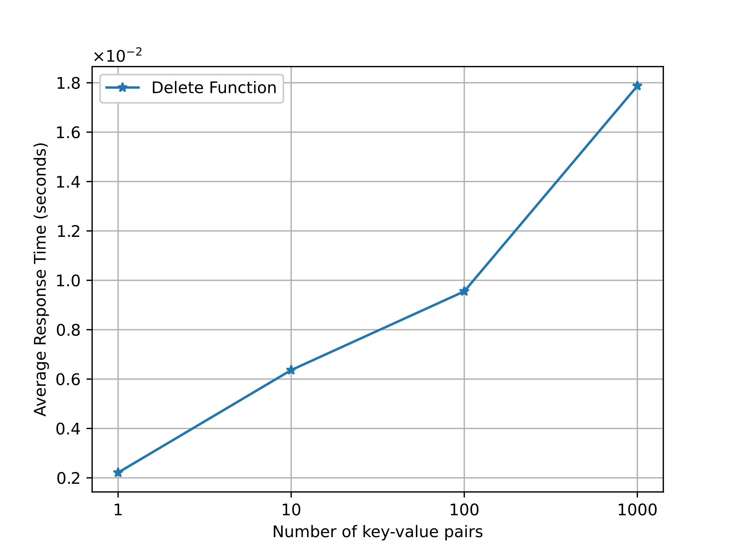

Operations  (With Middleware) | Number of Requests | Number of Failures | Requests per Second (RPS) | Average Response Size (Bytes)
Set Function (Single Key-Value Pair)
Set Function
(Multiple Key-Value Pairs)
Get Function (Single Key-Value Pair)
Get Function (Multiple Key-Value Pairs)
Get-Range Function (Range Of Key-Value Pairs)
Delete Function (Single/Multiple Key-Value Pairs)

Operations  (With Middleware) | Minimum Response Time (ms) | Maximum Response Time (ms) | Average Response Time (ms) | 100th Percentile: Response Time
Set Function (Single Key-Value Pair)
Set Function
(Multiple Key-Value Pairs)
Get Function (Single Key-Value Pair)
Get Function (Multiple Key-Value Pairs)
Get-Range Function (Range Of Key-Value Pairs)
Delete Function (Single/Multiple Key-Value Pairs)

Impacts of Sharding

Discussion

Analysis of Middleware-based Sharded Distributed Databases

Use Cases of Sharded Distributed Databases

Limitations and Future Work

Conclusion
(Implications and Practice of Sharded Distributed Databases, Findings and Contribution)

