Eclipse 5.35pm

Ritesh Added this file from new branch

Login and Create New Repository

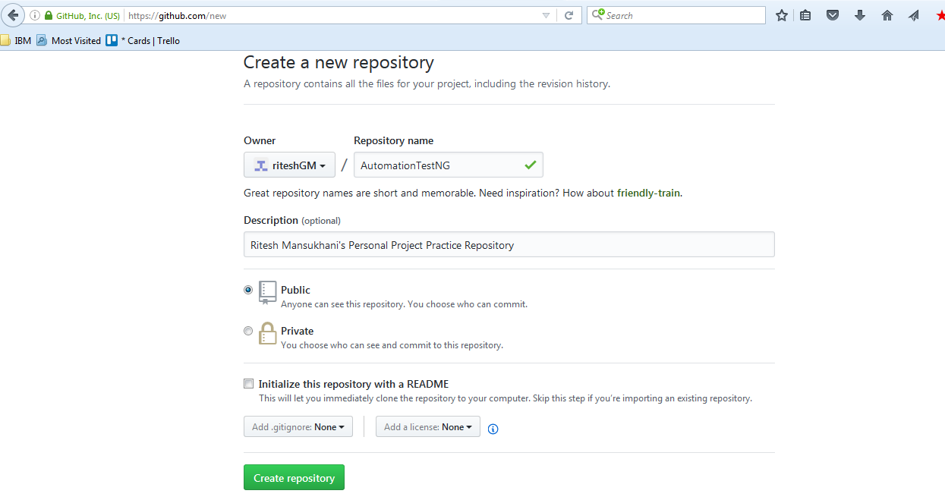

Next Page Comes as

So my repository

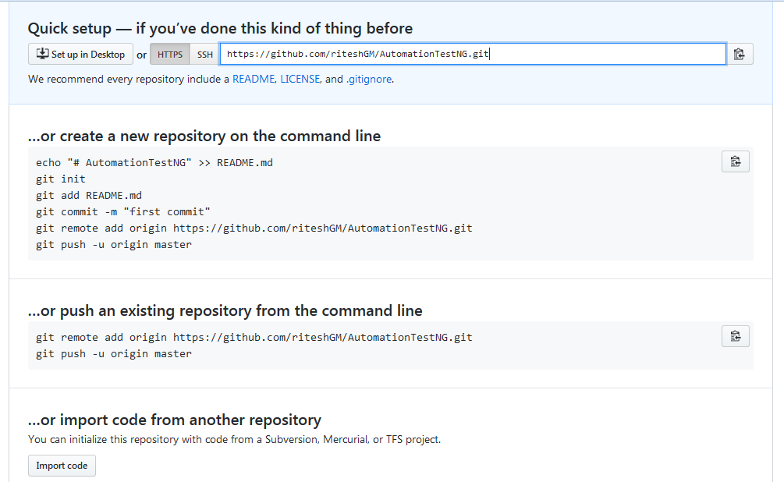

Create a Folder in your local drive the do following in your git bash

To create A new Repository from command line

echo "# AutomationTestNG" >> README.md

git init

git add README.md

git commit -m "first commit"

git remote add origin https://github.com/riteshGM/AutomationTestNG.git

git push -u origin master

git remote add origin <https://github.com/riteshGM/Important-Study-Documents.git>

git push -u origin master

or push an existing repository from command line

git remote add origin https://github.com/riteshGM/AutomationTestNG.git

git push -u origin master

Pushed code to Remote Repository

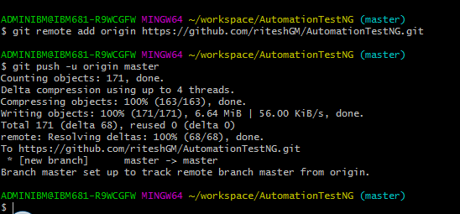

Please see the notes in book, we have hand written notes.

We need to install Eclipse plugin from <http://download.eclipse.org/egit/updates>**, to work with GIT from eclipse**