**Internal Hard Drive Buying Guide**

**Table of contents**

* [What is the Internal Hard Drive?](http://www.newegg.com/product/CategoryIntelligenceArticle.aspx?articleId=209#topic1)
* [Applications overview](http://www.newegg.com/product/CategoryIntelligenceArticle.aspx?articleId=209#topic2)
* [Understanding Hard Drive Specifications](http://www.newegg.com/product/CategoryIntelligenceArticle.aspx?articleId=209#topic3)
* [How do I Choose the Right Internal Hard Drive?](http://www.newegg.com/product/CategoryIntelligenceArticle.aspx?articleId=209#topic4)

**What is the Internal Hard Drive?**

The internal hard drive is a data storage device installed and used in desktop PCs, workstations, and servers, as well as certain consumer electronic products (these mainly use small form factor internal hard drives) such as digital cameras and digital audio/video players. Internal hard drives provide massive storage capacities for all types of data including images, documents, movies, music, games. This means more fun for you and greater functionality for your computer and devices!   
  
**Technical Information**

This type of storage device is non-volatile, meaning that it does not require constant power to maintain data. Inside the internal hard drive, there are one or several platters for data storage and read/write heads used to access or record data. A set of components drives the platters and the heads perform data operations on the platters as they spin. The internal hard drive uses a mechanical design, which is markedly different from the other popular permanent storage solution: Flash Memory.

[**^ Back to top**](http://www.newegg.com/product/CategoryIntelligenceArticle.aspx?articleId=209#top)

**Applications overview**

**Personal storage**

Nearly all storage applications on the desktop PC can be classified as personal storage. Personal storage applications do not require the hard drive to work non-stop, meaning they make fewer read/write operations. Most personal storage applications don’t require extreme performance, but high reliability is still a necessary trait.   
  
**Consumer electronics**

The consumer electronics domain is an exciting new playing ground for internal hard drives because digital cameras and digital audio/video players are constantly throwing up new requirements balancing increased capacity and cost, which is what the internal hard drive does best. Since most consumer electronic devices try to be as small as possible, fitting the standard 3.5” hard drive has proven unfeasible. Manufacturers have opted to use the much smaller “Microdrive” instead.   
  
**Enterprise storage**

Enterprise applications are closely related to workstations and servers, for example, CAD/CAM, digital video editing and production, as well as database. Enterprise storage applications have higher performance and reliability requirements than other applications, and the hard drive workload is very heavy. Server hard drives are expected to run normally without the slightest interruption 24 hours a day, 7 days a week.

[**^ Back to top**](http://www.newegg.com/product/CategoryIntelligenceArticle.aspx?articleId=209#top)

**Understanding Hard Drive Specifications**

**Form factor**

There are several form factors to ensure the compatibility of the internal hard drive with a variety of different devices.

**3.5-inch**

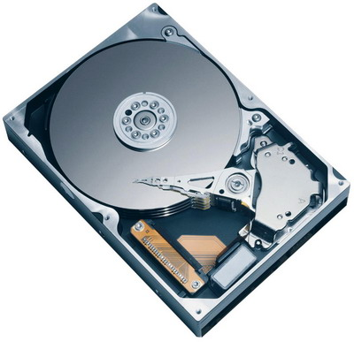

The [**3.5 inch hard drive**](http://www.newegg.com/Product/ProductList.aspx?Submit=ENE&N=2010150014+1036007800&Subcategory=14&description=&Ntk=&srchInDesc=) is the mainstream form factor for the desktop PC and workstation/server hard drives. Though these hard drives are relatively large, they provide the largest data storage capacities. Moreover, desktop PCs and workstations/servers chassis provide more than enough space to install these hard drives.

**2.5-inch**

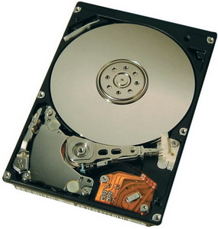

Notebook users should be familiar with the [**2.5-inch hard drive**](http://www.newegg.com/Product/ProductList.aspx?Submit=ENE&N=2010150014+1036007801&Subcategory=14&description=&Ntk=&srchInDesc=). You can find more detailed information about the 2.5-inch hard drive in our notebook hard drive buying guide. Currently, the 2.5-inch drive is also used as enterprise storage as it offers usable space savings, reduces power consumption and heat, and increased reliability as well.

**1.0-inch**

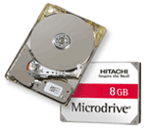

1.0-inch hard drives (called the Microdrive by Hitachi) are designed for small consumer electronics such as MP3 players, digital cameras and PDAs. Due to its diminutive size current capacities are only in the single digit GBs, but this already represents a significant amount of storage for handheld consumer electronics products.

**Capacity**

Data storage capacity is becoming more and more important for internal hard drives with the increasing size of operating systems, programs, games and multimedia. Currently, the Operating System, 3D games and high definition videos each require several GBs of storage. 3.5-inch internal hard drives can provide over 500GB. The 2.5 inch form factor has reached 160GB.  Even the tiny 1.0-inch hard drive has reached the amazing capacity of 8GB. We can expect capacities to keep climbing in the future, too.

**RPM**

Car owners are no strangers to the term RPM (revolutions per minute). It is an index used to measure the rotational speed of engines. The spindle inside the hard drive and its RPM are closely related to the drive’s performance. Higher RPM means less time is spent accessing stored data for greater performance. Performance-sensitive enterprise storage applications generally use [**10,000~15,000**](http://www.newegg.com/Product/ProductList.aspx?Submit=Property&Subcategory=14&Description=&Type=&N=2010150014&srchInDesc=&MinPrice=&MaxPrice=&PropertyCodeValue=355%3A7821&PropertyCodeValue=355%3A7779)RPM internal hard drives, while personal applications are well-served by [**7200 RPM**](http://www.newegg.com/Product/ProductList.aspx?Submit=ENE&N=2000150014+1035507776&Subcategory=14&description=&Ntk=&srchInDesc=) products.   
  
**Cache**

The cache refers to high-speed RAM (random access memory) integrated on the PCB of a hard drive. Cache is used as buffer among the CPU, memory and hard drive. Drives with more cache generally perform at a higher level than drives with less. Cache sizes of [**2MB**](http://www.newegg.com/Product/ProductList.aspx?Submit=ENE&N=2000150014+1035407758&Subcategory=14&description=&Ntk=&srchInDesc=), [**8MB**](http://www.newegg.com/Product/ProductList.aspx?Submit=ENE&N=2000150014+1035407759&Subcategory=14&description=&Ntk=&srchInDesc=) and [**16MB**](http://www.newegg.com/Product/ProductList.aspx?Submit=ENE&N=2000150014+1035407760&Subcategory=14&description=&Ntk=&srchInDesc=) are currently standard options for 2.5-inch and 3.5-inch internal hard drives, while 1.0-inch products may only be equipped with 128KB.

**Interface**

The interface is used to connect the hard drive with the computer. Here we list the most commonly used interfaces.

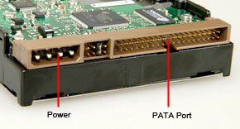

ATA is the acronym for Advanced Technology Attachment. It has been an industry standard hard drive interface for 15 years. ATA uses a 16-bit parallel connection to make the link between storage devices and motherboards, and is also called PATA to distinguish it from the newer SATA standard. In addition, ATA is also known as IDE or EIDE (Enhanced Integrated Drive Electronics).   
  
Currently the two most popular standards for ATA hard drives are the [**ATA-6**](http://www.newegg.com/Product/ProductList.aspx?Submit=ENE&N=2000150014+1035907789&Subcategory=14&description=&Ntk=&srchInDesc=) (which is also known as Ultra ATA 100 or Ultra DMA 100) and [**ATA 133**](http://www.newegg.com/Product/ProductList.aspx?Submit=ENE&N=2000150014+1035907788&Subcategory=14&description=&Ntk=&srchInDesc=). The maximum bandwidth for the former is 100MB/s, and 133 MBs for the latter. Most of today's optical drives utilize the IDE/PATA interface.

**SATA**

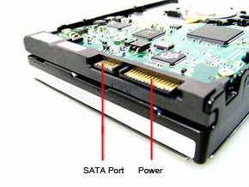The newer SATA interface is also an industry standard for connecting hard drives to computer systems, and is based on serial signaling technology. The advantages over PATA include longer, thinner cables for more efficient airflow within a computer chassis, fewer pin conductors for reduced electromagnetic interference, and lower signal voltage to minimize noise margin. The bandwidth of SATA is also far improved over PATA - the [**SATA 1.0**](http://www.newegg.com/Product/ProductList.aspx?Submit=ENE&N=2000150014+1035907918&Subcategory=14&description=&Ntk=&srchInDesc=) can reach a maximum of 1.5Gb/s (1500MB/s), while the latest [**SATA 2.5**](http://www.newegg.com/Product/ProductList.aspx?Submit=ENE&N=2000150014+1035915133&Subcategory=14&description=&Ntk=&srchInDesc=) standard can support up to 3Gb/s (3000MB/s). The latter also sports additional features such as NCQ (Native Command Queuing), port multiplier and port selector, although certain non-SATA 2.5 devices may also provide some of these features. As a result, the SATA interface is gradually replacing PATA as the mainstream hard drive interface in the personal storage market.

**SCSI**

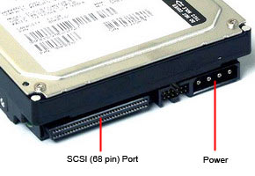[**SCSI**](http://www.newegg.com/Product/ProductList.aspx?Submit=Property&Subcategory=14&Description=&Type=&N=2000150014&srchInDesc=&MinPrice=&MaxPrice=&PropertyCodeValue=359%3A7829&PropertyCodeValue=359%3A23463&PropertyCodeValue=359%3A7828), or Small Computer System Interface has the outstanding ability to compartmentalize diverse operations, making SCSI more suitable for multitasking operating environments. In addition, SCSI enhances critical performance in situations where more than one hard drive is used, such as in workstation/server or RAID environments. SCSI hard drives are typically available with less seek times, lower latencies and much higher transfer rates than an equivalent-capacity ATA drive. Before serial signaling technology was applied to the SCSI field, all SCSI interface standards used parallel technology to transfer data.

**SAS (Serial Attached SCSI)**

Utilizing serial signaling technology, [**SAS**](http://www.newegg.com/Product/ProductList.aspx?Submit=ENE&N=2000150014+1035917796&Subcategory=14&description=&Ntk=&srchInDesc=) is earmarked as the next-generation enterprise storage interface for its high bandwidth and high throughput performance for enterprise applications. Thanks to SAS’ compatibility with serial ATA, it may also be the interface of choice for future high performance desktop storage.

**CF (Compact Flash) Compatible**

Originally used as a flash storage card interface, the CF compatible interface has been applied to the 1.0-inch hard drive to give it compatibility with consumer electronic products utilizing the CF slot. There are two types of CF card: CF Type I and CF Type II. The main difference between them is the greater thickness of the CF Type II. Microdrives typically use the CF Type II.

**How do I Choose the Right Internal Hard Drive?**

**Filter by Application and Interface**

As we found out in the Applications Overview section, there are three types of internal hard drive application: Enterprise storage, Personal storage, and Consumer electronics. Based on the obvious differences between the applications, you can easily decide what type of interface you need for your internal hard drive.

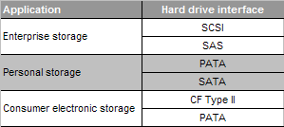

If you are building a brand new system, it is recommended that you choose either SAS for Enterprise storage or SATA for Personal storage as a means of future-proofing your new system. If you are simply adding new hard drive(s) to your current system, please check the type of interface provided by your motherboard.

**Moving on to Performance**

Spindle RPM is the main factor related to the performance of a hard drive. Though there are many speed options, there is actually some relation between RPM and the interface.

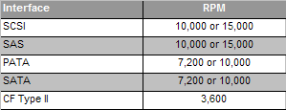

The above table lists the mainstream relationship between interface and RPM. Higher RPMs reduce access and write times of a hard drive, and is one of the areas in which internal hard drives are rapidly improving. 10,000 RPM hard drives using the SATA interface have already begun to appear in the market for personal storage applications, but tend to cost more than their 7200RPM counterparts.

**Capacity**

Although higher capacities tend to sound appealing, it can sometimes result in per unit storage cost increases instead.   
  
Example:

1. Hard drive A is priced at $103, and offers 250GB storage. The cost per GB storage of this hard drive is $0.412/GB ($103/250GB).

2. Hard drive B is priced at $330, and offers 500GB storage. The cost per GB storage of hard drive B is $0.66/GB.   
  
Cost per GB may be helpful if you are having problems deciding between several hard drives that differ only in terms of storage capacity. It is less useful when comparing hard drives with different interfaces, RPMs or cache sizes.   
  
**Cache Size**

Like RPM, a larger cache size is better for performance. Currently, 8MB and 16MB cache is mainstream configuration for 3.5-inch and 2.5-inch internal hard drives, while 128KB is more common on 1.0-inch internal hard drives. A larger cache tends to cost more, however.