PERSONAL PORTFOLIO WEBSITE(Github project)
Project Report

Full Name: Ritesh Chauhan
Enrollment Number: 202403103510556
Subject code : IT4048 Version Control with Git and GitHub
Submission Date: 4/11/2025

2. Project Overview

2.1 Project Objective
The main objective of this Portfolio Website project is to design and develop a personal website that showcases an individual’s skills, education, projects, and achievements in a professional and interactive manner. It aims to create a strong online presence that allows visitors such as employers or collaborators to easily learn about the individual’s technical abilities and background.

2.2 Problem Statement
In today’s digital world, professionals and students often find it difficult to present their work and achievements effectively. Traditional resumes are limited in visual appeal and interactivity. This portfolio website helps to overcome that by providing an engaging and organized platform to display skills, projects, and contact information
.

2.3 Project Scope and Features
This project focuses on creating a simple, elegant, and user-friendly personal website that can be used to highlight personal information, skills, projects, and education details. It acts as an online resume with an attractive layout and responsive design.

Key Features
• Home Page – Introduction with name, photo, and tagline.
• About Page – Biography, goals, and achievements
• Skills Page – List of technical skills with icons and Experience section
• Projects Page – Personal or academic projects with GitHub links.
• Contact Page – Contact form and social links.
• Resume Download Option – Button to download resume.
• Responsive Design – Works well on multiple devices.

Home page ( Desktop ) :
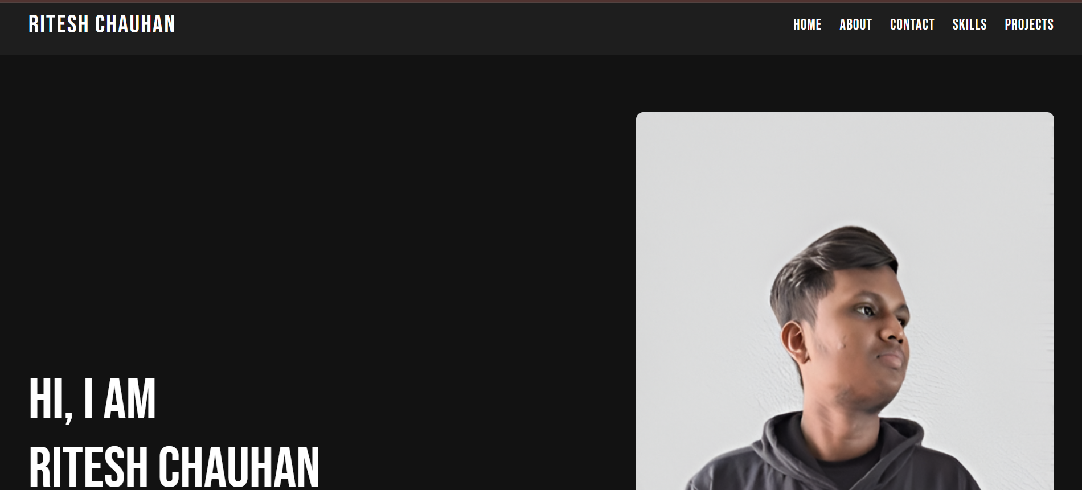
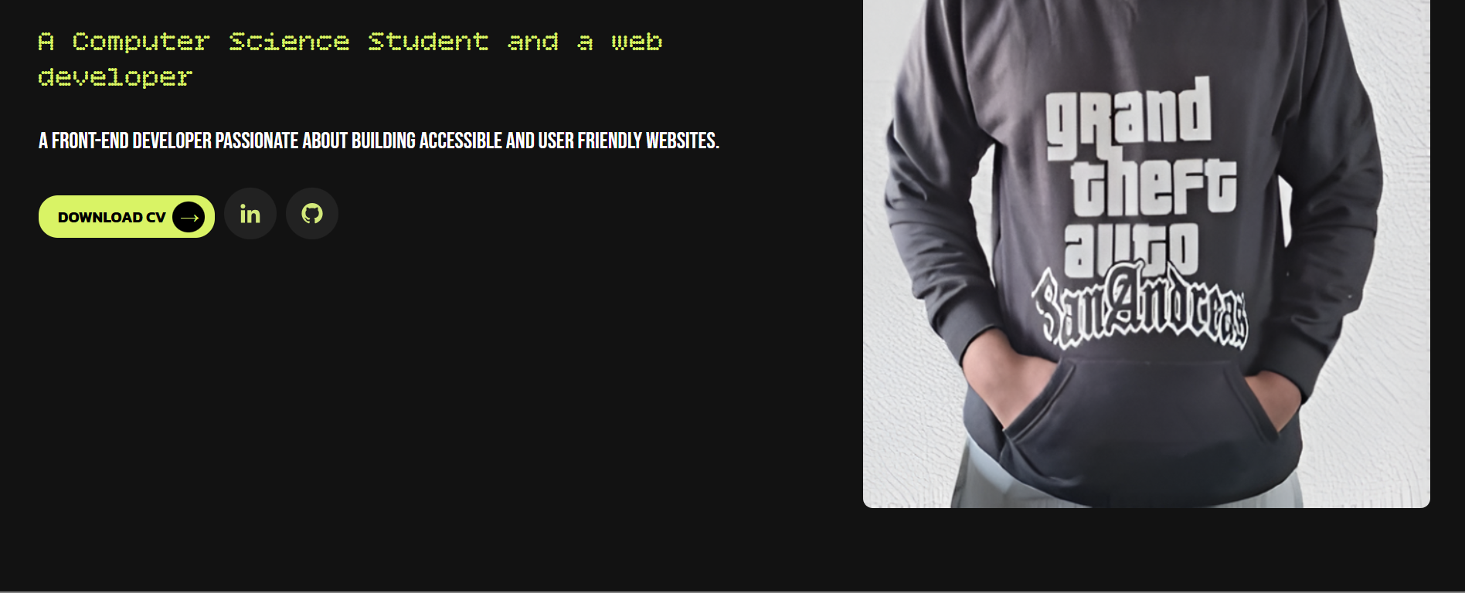

Home page ( Desktop ) :
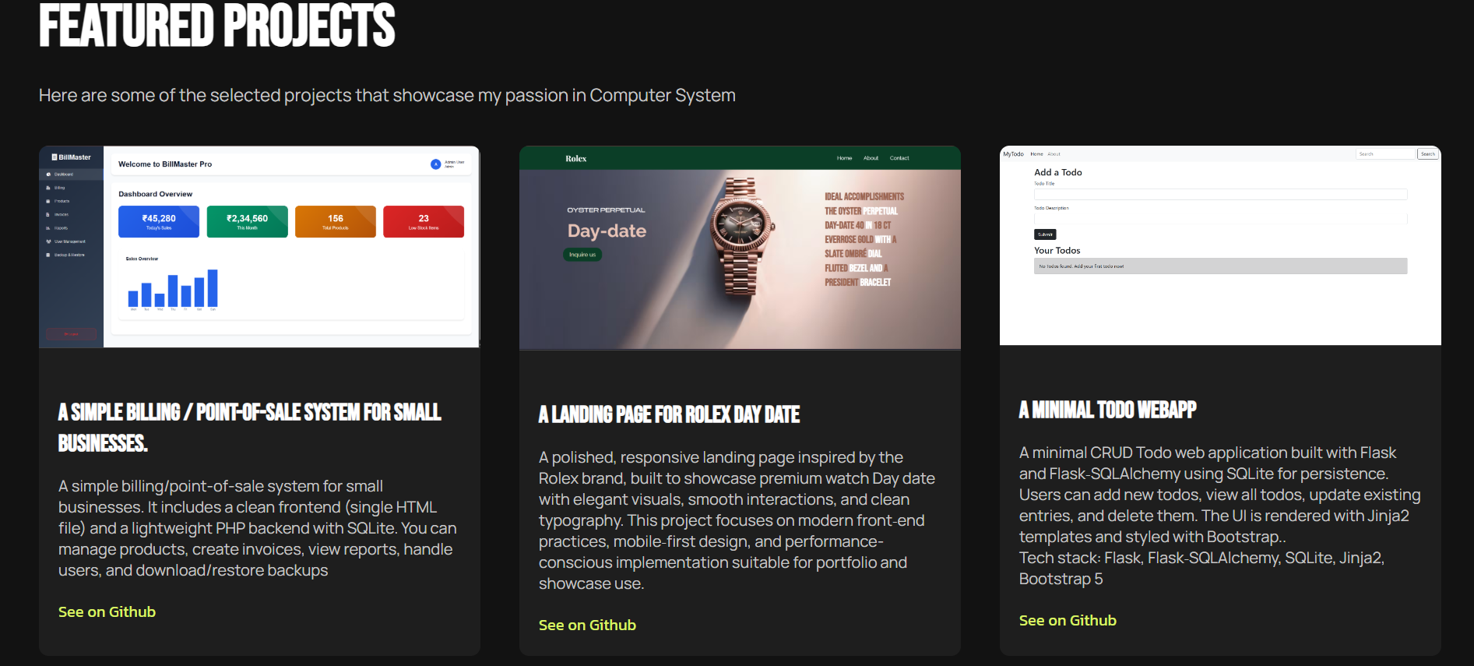

Home page ( Desktop ) :
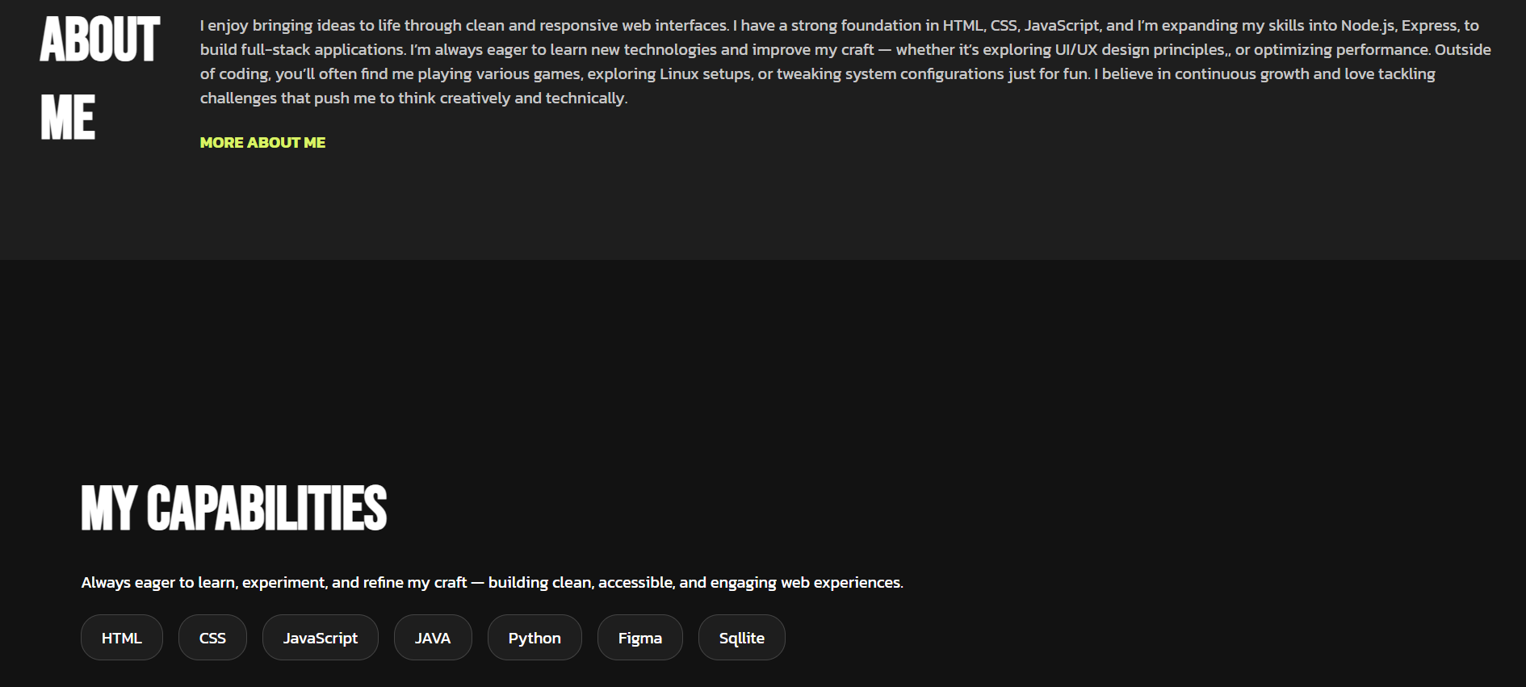

3. Technology Stack
Frontend Technologies:
HTML : Defines the Structure/ Skeleton of webpage
CSS : Used for
JavaScript
Development Tools: Visual Studio Code, Git & GitHub

4. Implementation Documentation
4.1 Home Page: Displays the introduction and navigation links.
4.2 About Page: Shows brief biography and career goals.
4.3 Skills Page: Displays categorized technical skills.
4.4 Projects Page: Lists personal projects with GitHub links.
4.5 Contact Page: Includes contact details and form for messages.

5. Project Resources
Code Repository: https://github.com/riteshc852/Portfolio_website_Ritesh_Chauhan-
Live Website URL: (if hosted online)

