BRACT’s
Vishwakarma Institute of Technology, Pune

Practical Implementation Sheet
Department: CSE-AI Semester: 5 Academic Year: 2026-27
Division:C Batch: 2 Practical No: 4
Roll no: 22 PRN No: 12411023 Name of Student: Ritesh Kale

Subject Name : Deep Learning

Problem Statement : . Develop an LSTM-based model for time-series forecasting using stock price, weather, or sales datasets.

Algorithm : LSTM-Based Stock Price Forecasting

- Start
- Load the stock price dataset containing Date and Close Price.
- Select the Close Price column for forecasting.
- Normalize the data using Min-Max Scaling between 0 and 1.
- Create input sequences using the previous 60 days of prices to predict the next day's price.
- Split the data into training and testing datasets.
- Reshape the data into the format required by LSTM:
[samples, time steps, features]
- Build the LSTM model:
- Add an LSTM layer.
- Add a Dropout layer to reduce overfitting.
- Add a Dense output layer.
- Compile the model using Adam optimizer and Mean Squared Error (MSE) loss.
- Train the model using the training dataset.
- Predict stock prices using the testing dataset.
- Apply inverse scaling to convert predictions back to the original price range.
- Calculate performance using RMSE/MAE.
- Plot the actual vs predicted stock prices.
- Stop.

Code :

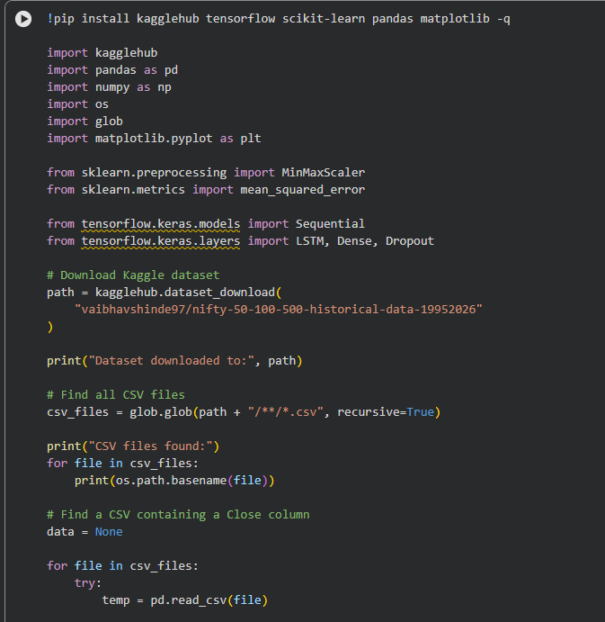

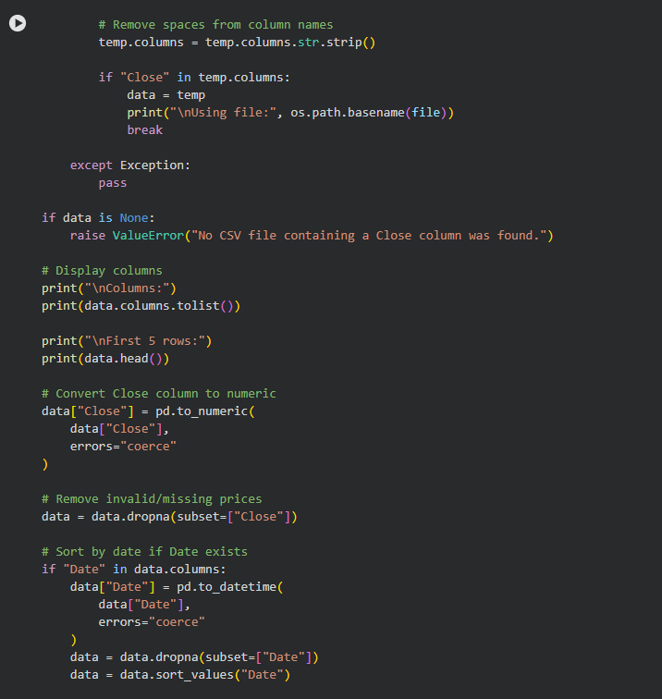

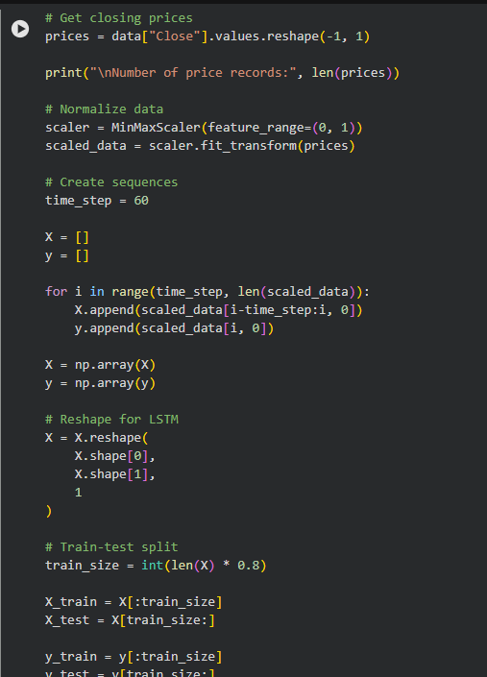

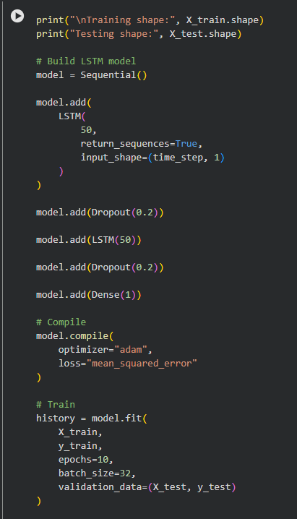

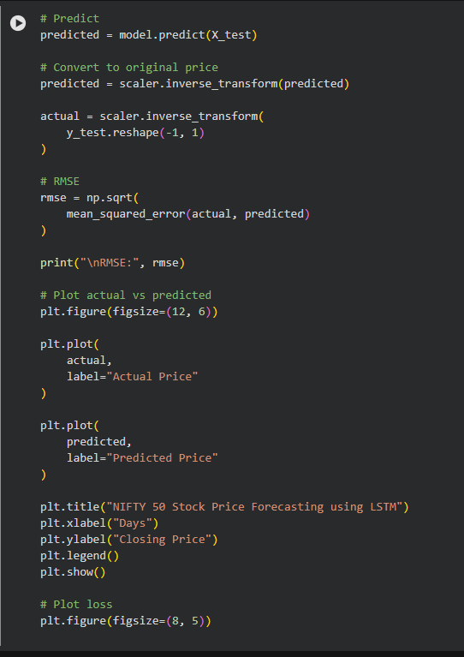

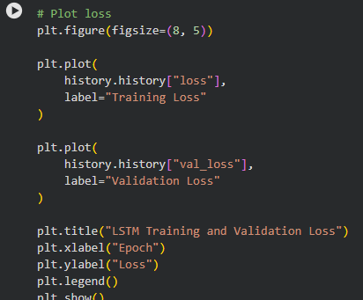

OUTPUT:

