BRACT’s
Vishwakarma Institute of Technology, Pune

Practical Implementation Sheet
Department: CSE-AI Semester: 5 Academic Year: 2026-27
Division:C Batch: 2 Practical No: 5
Roll no: 22 PRN No: 12411023 Name of Student: Ritesh Kale

Subject Name : Deep Learning

Problem Statement : implement and compare RNN, LSTM, and GRU models for sequence classification, and analyze their performance using appropriate evaluation metrics.

Algorithm : RNN, LSTM and GRU for Sequence Classification

- Start
- Load the IMDb Movie Reviews dataset containing text sequences and sentiment labels.
- Set the vocabulary size and maximum sequence length.
- Convert the text into numerical sequences using the IMDb word index.
- Apply padding so that all sequences have the same length.
- Split the dataset into training and testing sets.
- Create an Embedding layer to convert word indices into dense vectors.
- Build three separate models:
- RNN model using SimpleRNN.
- LSTM model using LSTM.
- GRU model using GRU.
- Add a Dense layer with sigmoid activation for binary classification.
- Compile each model using Adam optimizer and binary cross-entropy loss.
- Train each model using the training dataset.
- Predict the sentiment labels for the test dataset.
- Calculate Accuracy, Precision, Recall, and F1-Score for each model.
- Compare the performance of RNN, LSTM, and GRU using a table and graph.
- Identify the model with the best classification performance.
- Stop.

Code :

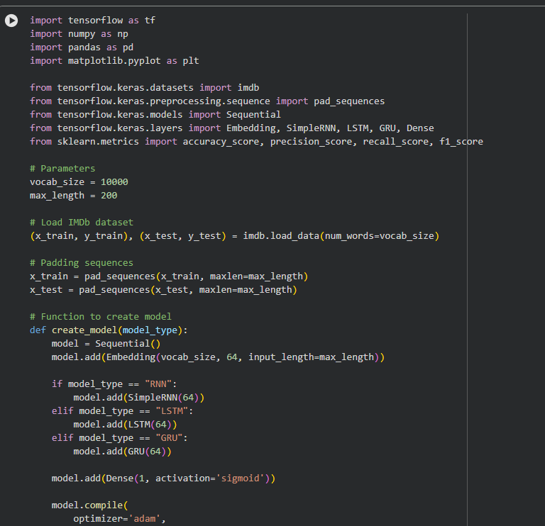

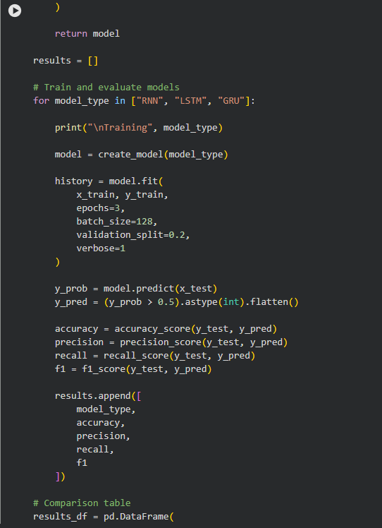

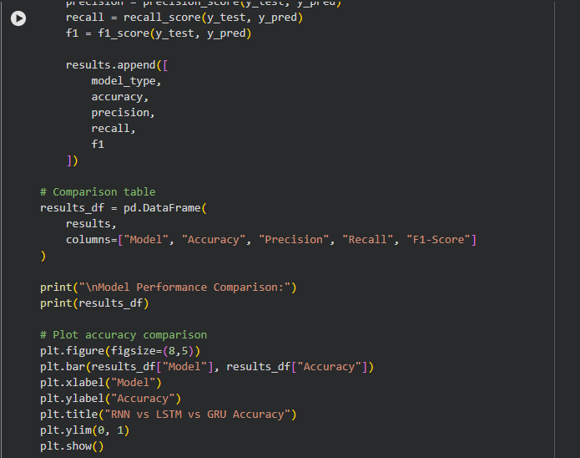

OUTPUT:

