BRACT’s
Vishwakarma Institute of Technology, Pune

Practical Implementation Sheet
Department: CSE-AI Semester: 5 Academic Year: 2026-27
Division:C Batch: 2 Practical No: 7
Roll no: 22 PRN No: 12411023 Name of Student: Ritesh Kale

Subject Name : Deep Learning

Problem Statement : . Implement transfer learning using pre-trained AlexNet, VGG16, ResNet50, and EfficientNetB0 models for image classification, and compare their performance.

Algorithm : Transfer Learning Using Pre-trained CNN Models

- Start
- Load the image dataset and divide it into training, validation, and testing sets.
- Resize all images to the required input size of the models.
- Normalize/preprocess the images according to each pre-trained model.
- Load the pre-trained AlexNet, VGG16, ResNet50, and EfficientNetB0 models with ImageNet weights.
- Remove the original classification layer from each model.
- Freeze the pre-trained convolutional layers to retain the learned features.
- Add new classification layers suitable for the number of classes in the dataset.
- Compile each model using:
  - Suitable optimizer
  - Categorical cross-entropy loss
  - Accuracy as the evaluation metric
- Train each model using the training dataset.
- Validate each model using the validation dataset.
- Evaluate all four models on the test dataset.
- Calculate performance metrics such as:
- Accuracy
- Precision
- Recall
- F1-score
- Compare the performance of all four models.
- Identify the model with the best classification performance.
- Stop.

Code :
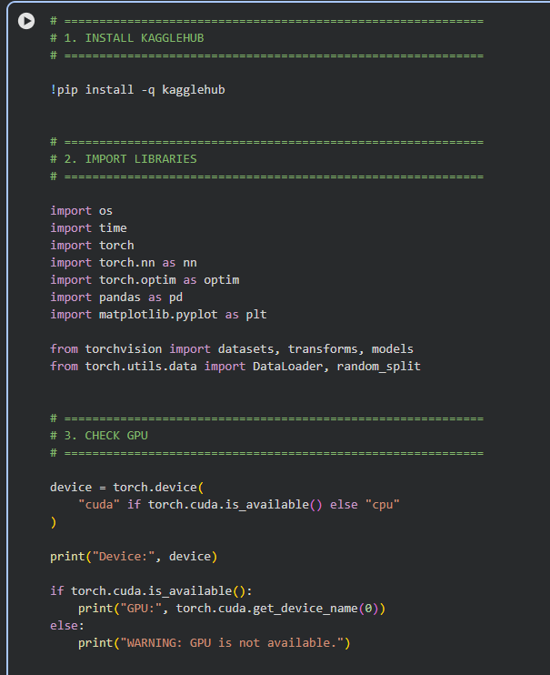

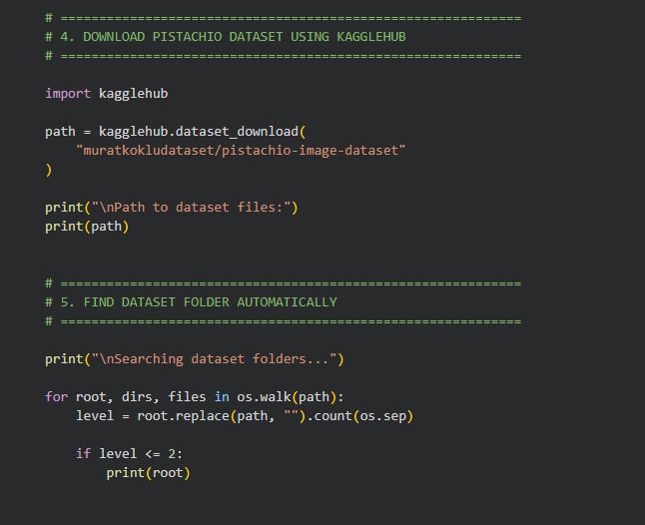

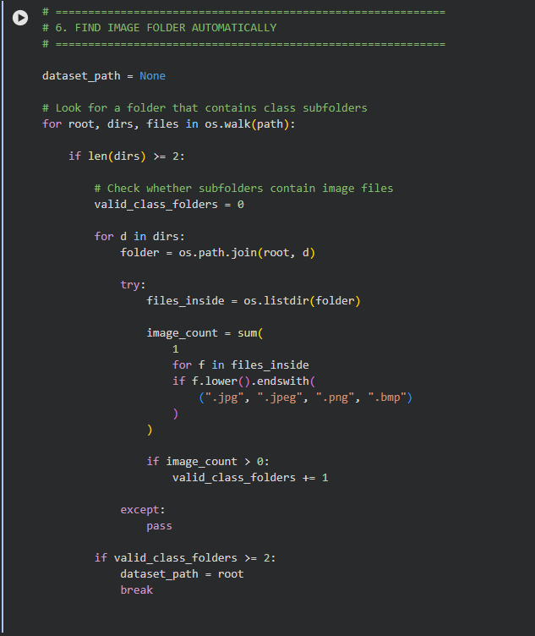

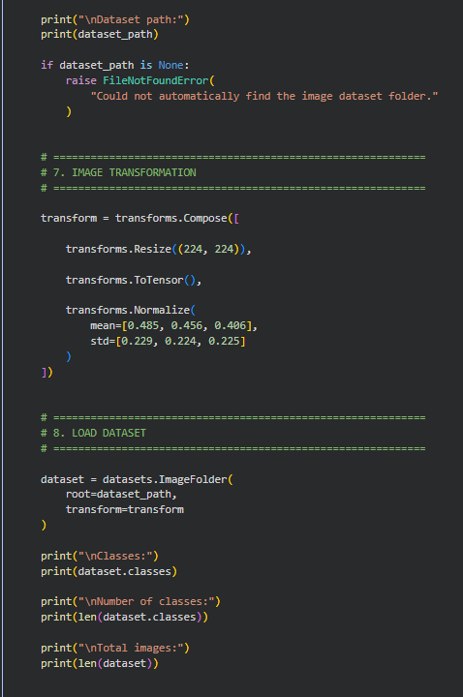

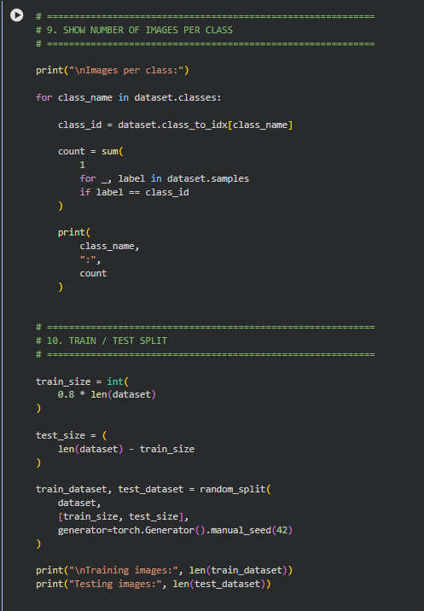

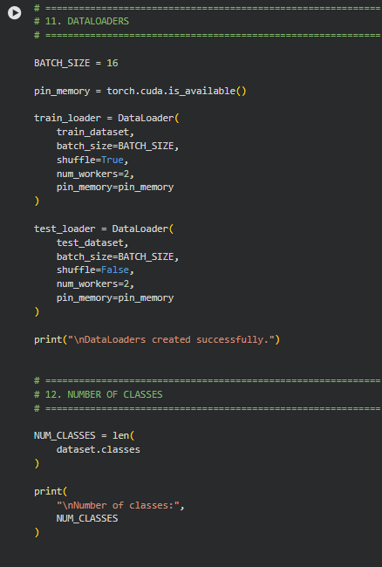

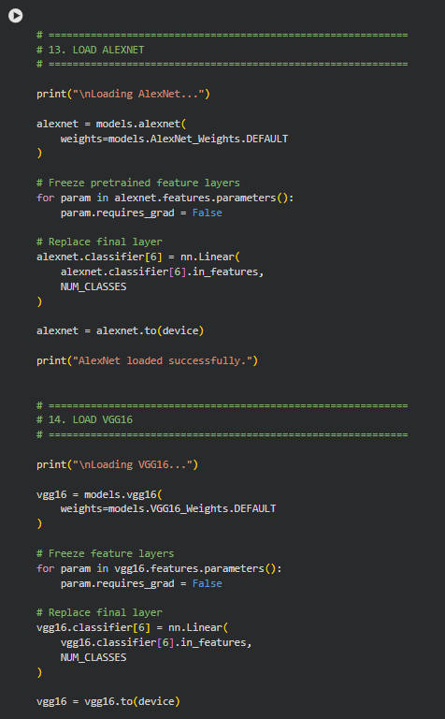

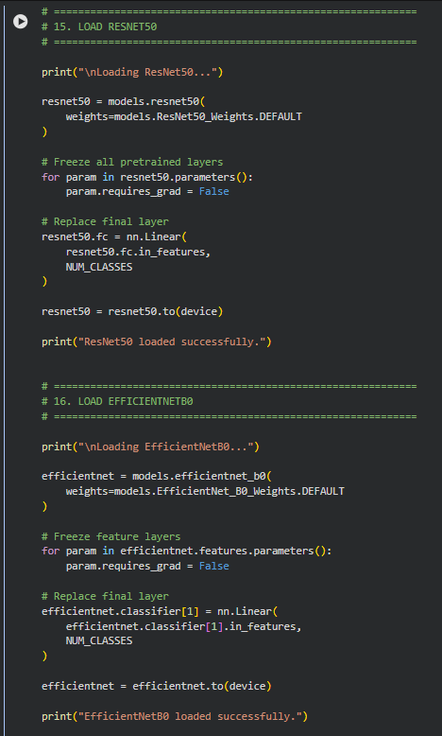

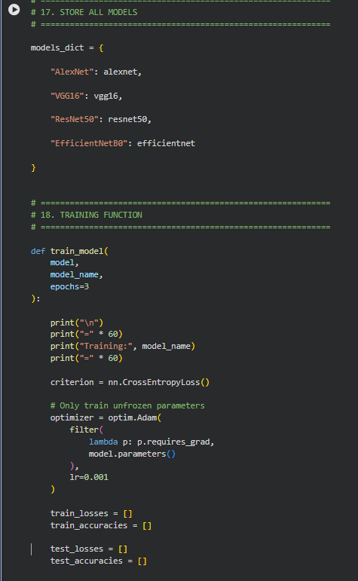

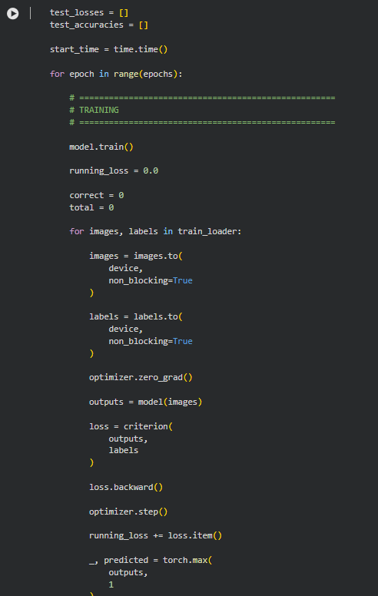

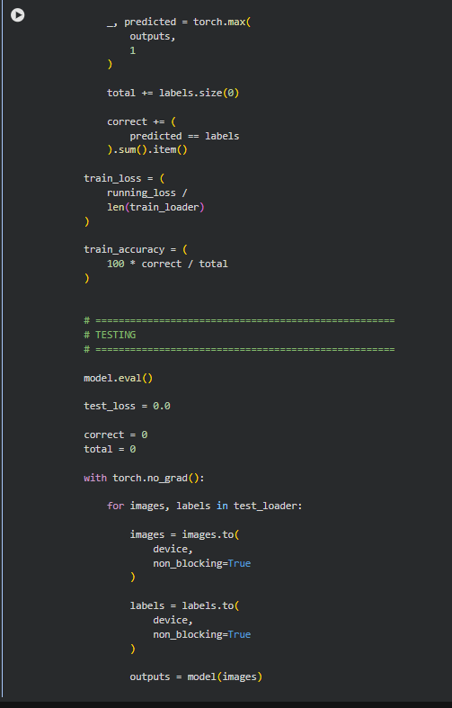

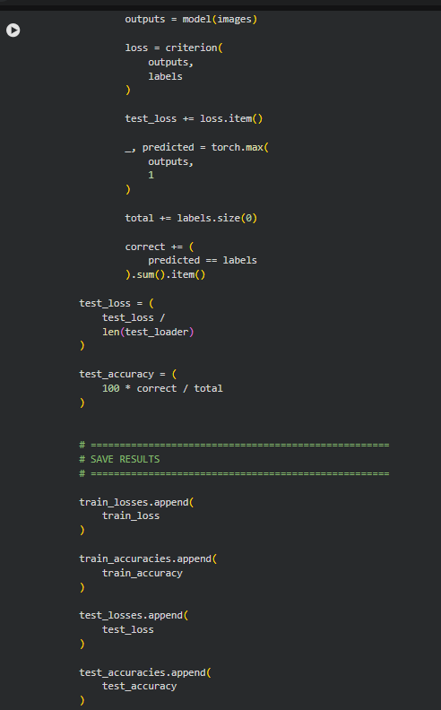

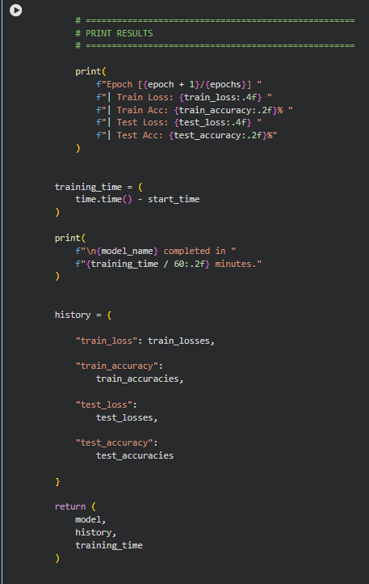

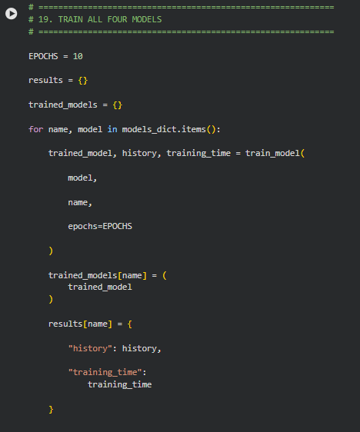

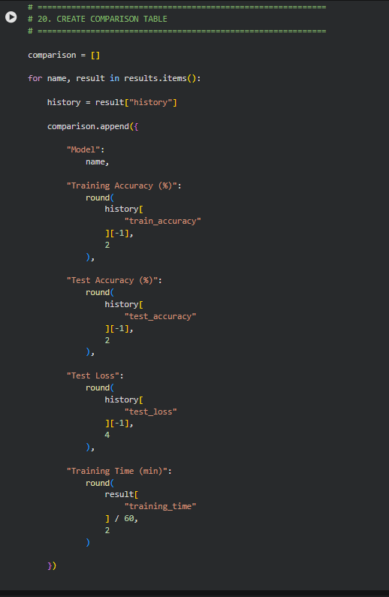

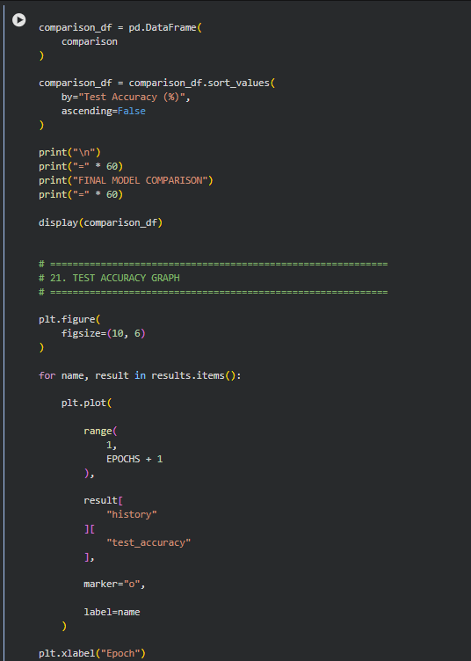

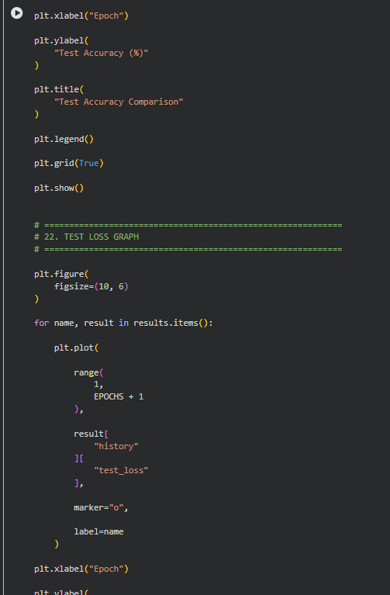

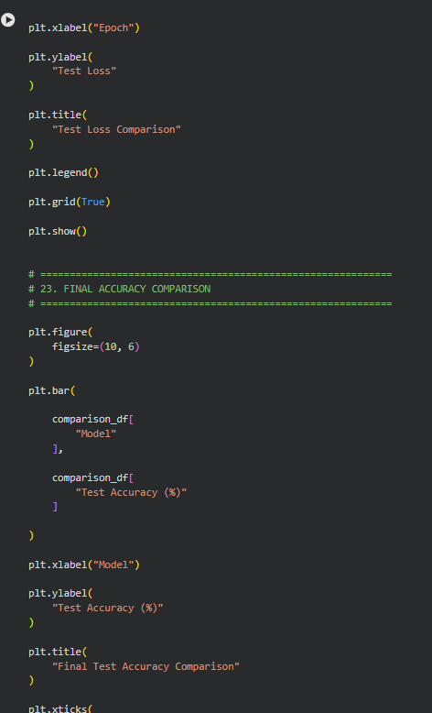

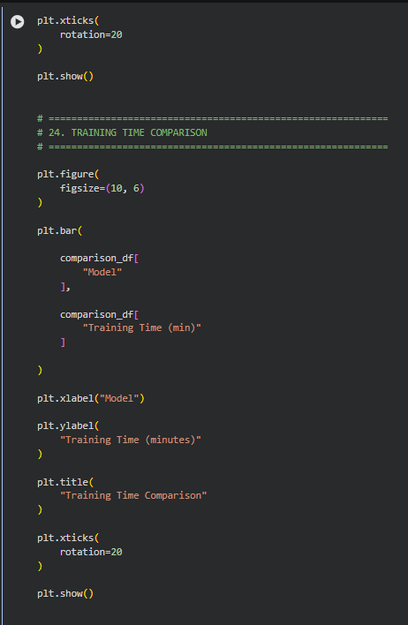

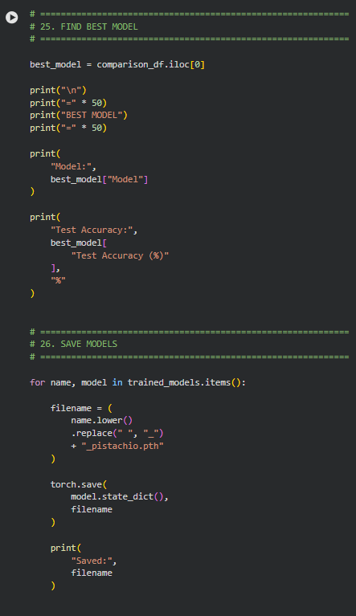

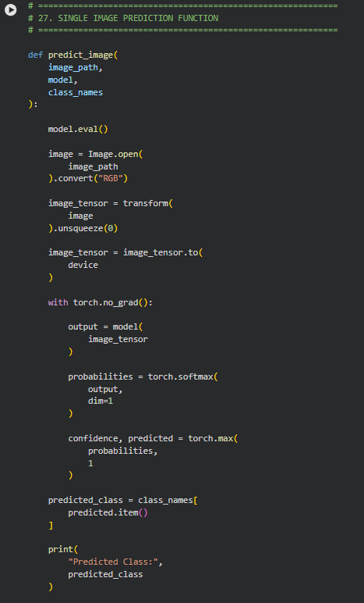

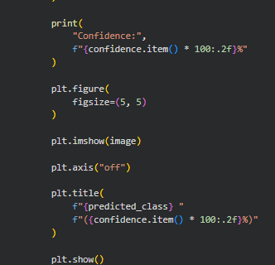

Output :

