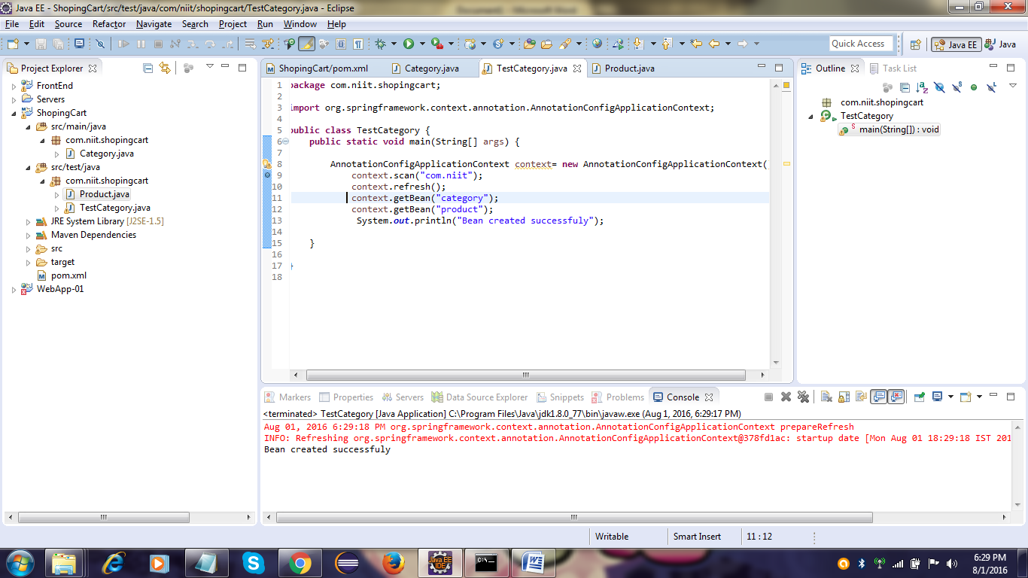

Here I did the program successfully.. Bean created successfully shown in above pic

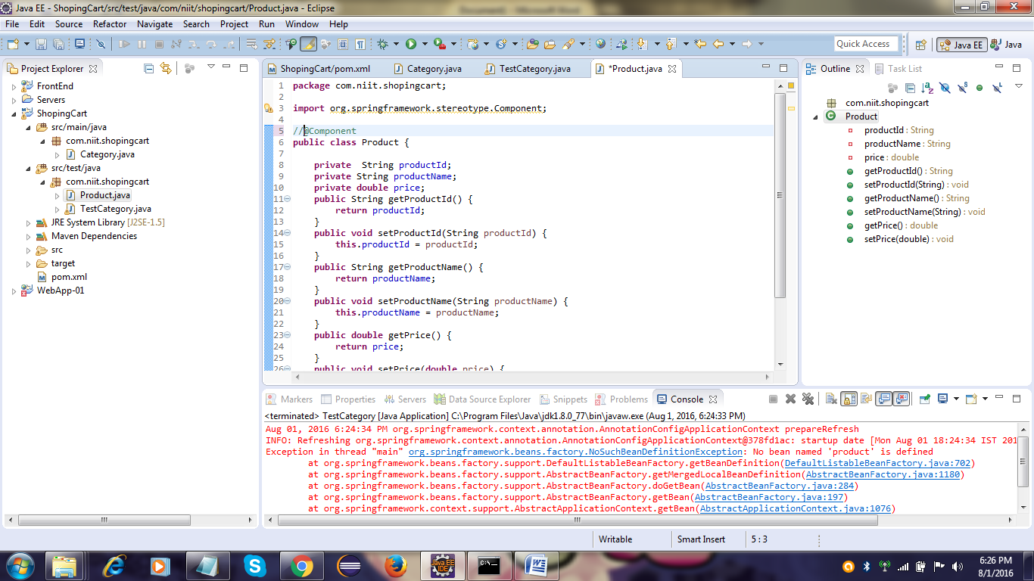

I have commented the Annotation before the class, for that I got an exception on this pic.