DataFlow
Intelligent Data Analytics Platform
Technical Design Document
Version 2.0 | March 2026 | Ritesh Mohan
Document Info
Type | Technical Design Document (TDD)
Scope | Backend API + Frontend Landing Page (The Data Vortex)
Stack | FastAPI · PostgreSQL · pandas · scikit-learn · Three.js · GSAP
Repo | github.com/riteshmohancs23-beep/DataFlow
Related Doc | DataFlow PRD v2.0
Status | Active Development — 24-hour Sprint

1. Introduction
This Technical Design Document (TDD) describes the complete architecture, technology choices, data models, API contracts, frontend rendering system, and implementation details for DataFlow v2.0. It is intended for engineers building the system, reviewers evaluating the design, and interviewers assessing technical depth.

DataFlow is a FastAPI backend that exposes a REST pipeline: upload a structured dataset → profile it → clean it → run statistical analytics → train a machine learning model. Every stage persists results to PostgreSQL and disk. A Three.js landing page (The Data Vortex) visualizes this pipeline as an animated 3D particle funnel.

2. System Overview

2.1 High-Level Architecture
The backend follows a strict three-layer architecture. Each layer has an explicit contract about what it may and may not do:

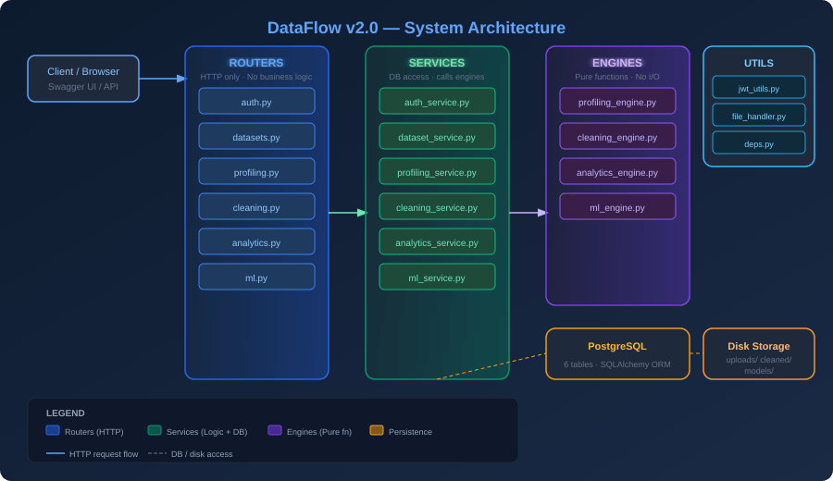
Figure 1 — Three-layer architecture: Routers (HTTP) → Services (logic + DB) → Engines (pure functions)

Layer | Location | Contract | Forbidden
Routers | app/routers/ | Parse HTTP, call service, return JSON response | pandas, sklearn, joblib, any DB query
Services | app/services/ | Orchestrate engines, read/write DB, handle transactions | HTTP primitives (Request, Response), raw SQL
Engines | app/engines/ | Accept DataFrame, return dict. Stateless pure functions. | DB access, file I/O, HTTP, global state
Utils | app/utils/ | JWT, file I/O, FastAPI dependency injection | Business logic, ML computation

2.2 Dataset Pipeline State Machine
Every dataset has a status field that acts as a gate. Services enforce these transitions — calling an endpoint out of order returns HTTP 400:

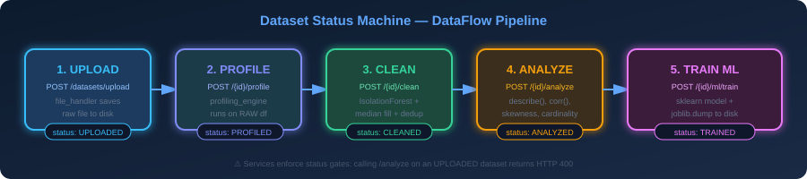
Figure 2 — Dataset status machine. Each stage gates the next.

Status | Set By | Enables Next | Input Source
UPLOADED | dataset_service.upload_dataset() | POST /{id}/profile | Raw file saved to storage/uploads/
PROFILED | profiling_service.profile_dataset() | POST /{id}/clean | Raw DataFrame (pre-cleaning)
CLEANED | cleaning_service.clean_dataset() | POST /{id}/analyze | Cleaned CSV saved to storage/cleaned/
ANALYZED | analytics_service.analyze_dataset() | POST /{id}/ml/train | Reads from storage/cleaned/ path
TRAINED | ml_service.train_model() | End state | Reads from storage/cleaned/ path

3. Technology Stack

3.1 Backend Stack
Technology | Version | Role | Why Chosen
FastAPI | Latest | Web framework + OpenAPI generation | Async-ready, Pydantic-native, auto Swagger UI
SQLAlchemy | >=2.0 | ORM — models, sessions, queries | Pythonic ORM, supports PostgreSQL fully
PostgreSQL | 15+ | Relational database | JSONB support, UUID native, ACID transactions
psycopg2-binary | Latest | PostgreSQL driver | Standard sync driver, no extra setup
Pydantic v2 | >=2.0 | Request/response validation + settings | Fast, strict typing, native with FastAPI
python-jose | Latest | JWT creation and verification | Industry standard, supports HS256/RS256
passlib[bcrypt] | Latest | Password hashing | bcrypt is the correct choice for passwords
pandas | Latest | DataFrame operations in engines | Standard for tabular data manipulation
scikit-learn | Latest | IsolationForest + ML models | Unified API for all ML operations
joblib | Latest | Model serialization to disk | Sklearn-native serialization format
openpyxl | Latest | Excel file reading | pandas dependency for .xlsx support
pyarrow | Latest | Parquet file reading | pandas dependency for .parquet support
uvicorn | Latest | ASGI server | Production-grade ASGI, works with FastAPI
python-multipart | Latest | File upload parsing | Required by FastAPI for UploadFile

3.2 Frontend Stack (The Data Vortex)
Technology | Version | Role | Key Usage
Three.js | r128 | WebGL 3D rendering | InstancedMesh particles, TorusGeometry rings, PerspectiveCamera
GSAP 3 | Latest | Scroll + timeline animations | ScrollTrigger for speed ramp, gsap.to() for ring pulses
React 18 | 18+ | Component shell + state | Canvas ref management, DOM overlay for labels
Tailwind CSS | 3+ | UI styling | Overlay text, CTA buttons, responsive layout
Vite | Latest | Build tool + HMR | Fast dev server, tree-shaking Three.js modules
@types/three | r128 | TypeScript definitions | If using TypeScript; ensures correct API usage

4. Project Directory Structure
DataFlow/
├── app/
│ ├── main.py # App factory, lifespan, CORS, router registration
│ ├── config.py # Pydantic settings (existing)
│ ├── database.py # Engine, SessionLocal, Base, get_db()
│ ├── models/
│ │ ├── user.py # User model (existing)
│ │ ├── dataset.py # Dataset model (existing)
│ │ ├── profiling.py # ProfilingReport model
│ │ ├── cleaning.py # CleaningResult model
│ │ ├── analytics.py # AnalyticsResult model
│ │ └── ml_model.py # MLModel + ModelResult models
│ ├── schemas/
│ │ ├── auth.py # Register/Login/Token/User schemas
│ │ ├── dataset.py # DatasetResponse, DatasetListResponse
│ │ ├── profiling.py # ProfilingResponse
│ │ ├── analytics.py # AnalyticsResponse
│ │ └── ml_model.py # MLTrainRequest, MLTrainResponse
│ ├── engines/
│ │ ├── profiling_engine.py # run_profiling(df) -> dict
│ │ ├── cleaning_engine.py # run_cleaning(df) -> dict
│ │ ├── analytics_engine.py # run_analytics(df) -> dict
│ │ └── ml_engine.py # run_ml(df, target, task, model) -> dict
│ ├── services/
│ │ ├── auth_service.py # register_user, login_user
│ │ ├── dataset_service.py # upload, list, get_by_id
│ │ ├── profiling_service.py # profile_dataset
│ │ ├── cleaning_service.py # clean_dataset
│ │ ├── analytics_service.py # analyze_dataset
│ │ └── ml_service.py # train_model
│ ├── routers/
│ │ ├── auth.py # /auth/*
│ │ ├── datasets.py # /datasets/*
│ │ ├── profiling.py # /datasets/{id}/profile
│ │ ├── cleaning.py # /datasets/{id}/clean
│ │ ├── analytics.py # /datasets/{id}/analyze
│ │ └── ml.py # /datasets/{id}/ml/train
│ └── utils/
│ ├── jwt_utils.py # create_access_token, verify_token
│ ├── file_handler.py # save_upload, load_df, save_cleaned
│ └── deps.py # get_db, get_current_user
├── storage/
│ ├── uploads/ # Raw uploaded files
│ ├── cleaned/ # Cleaned CSVs (used by analytics + ML)
│ └── models/ # joblib .pkl model files
├── frontend/
│ ├── src/
│ │ ├── main.jsx # React entry point
│ │ ├── components/
│ │ │ ├── VortexScene.jsx # Three.js canvas wrapper
│ │ │ ├── HeroOverlay.jsx # Text + CTA overlay
│ │ │ └── PipelineLabels.jsx # Ring stage labels
│ │ └── lib/
│ │ ├── vortex.js # Three.js scene builder
│ │ ├── particles.js # InstancedMesh particle system
│ │ └── rings.js # Stage ring geometry + pulse
│ └── vite.config.js
├── requirements.txt
└── .env # DATABASE_URL, JWT_SECRET_KEY

5. Database Schema
All tables use UUID(as_uuid=True) primary keys with default=uuid.uuid4. JSON columns store engine output dicts/lists directly, avoiding additional migration overhead for schema changes within pipeline results.

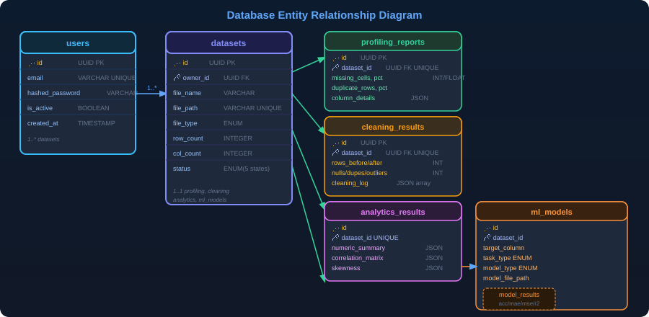
Figure 3 — Entity Relationship Diagram — 6 tables, FK cascade on user delete

5.1 UUID Column Pattern (Critical)
Every UUID column must use this exact pattern. The existing models have Column(UUID) without as_uuid=True — this causes type mismatches between Python uuid.UUID objects and PostgreSQL's UUID type:
import uuid
from sqlalchemy import Column
from sqlalchemy.dialects.postgresql import UUID

# CORRECT
id = Column(UUID(as_uuid=True), primary_key=True, default=uuid.uuid4)

# WRONG — causes bytes/str mismatch errors
id = Column(UUID, primary_key=True) # missing as_uuid=True

5.2 JSON Column Pattern
from sqlalchemy import Column, JSON

# Store dict/list results from engines
column_details = Column(JSON) # dict keyed by column name
cleaning_log = Column(JSON) # list of change description strings
numeric_summary = Column(JSON) # df.describe().to_dict()
correlation_matrix = Column(JSON) # df.corr().to_dict()

5.3 Table Definitions Summary
Table | Primary Key | Foreign Keys | Notable Columns | Unique Constraint
users | id UUID | — | email, hashed_password, is_active | email
datasets | id UUID | owner_id → users.id | file_path, status ENUM, file_type ENUM | file_path
profiling_reports | id UUID | dataset_id → datasets.id | column_details JSON, missing_cells_pct FLOAT | dataset_id
cleaning_results | id UUID | dataset_id → datasets.id | cleaned_file_path, cleaning_log JSON | dataset_id
analytics_results | id UUID | dataset_id → datasets.id | correlation_matrix JSON, skewness JSON | dataset_id
ml_models | id UUID | dataset_id → datasets.id | task_type ENUM, model_type ENUM, model_file_path | —
model_results | id UUID | model_id → ml_models.id | accuracy/precision/recall/f1, mae/mse/r2 (all nullable) | —

6. API Endpoint Reference

6.1 Authentication
Method | Path | Auth | Request Body | Response | Status
POST | /auth/register | None | { email: str, password: str(min 8) } | UserResponse | 201 / 400
POST | /auth/login | None | { email: str, password: str } | TokenResponse { access_token, token_type } | 200 / 401

6.2 Datasets
Method | Path | Auth | Request | Response | Status
POST | /datasets/upload | Bearer | multipart/form-data: file | DatasetResponse | 201 / 422
GET | /datasets/ | Bearer | — | DatasetListResponse | 200
GET | /datasets/{id} | Bearer | — | DatasetResponse | 200 / 404

6.3 Pipeline Endpoints
Method | Path | Required Status | Engine Called | Response
POST | /datasets/{id}/profile | UPLOADED | profiling_engine.run_profiling(raw_df) | ProfilingResponse
POST | /datasets/{id}/clean | PROFILED | cleaning_engine.run_cleaning(raw_df) | CleaningResult data
POST | /datasets/{id}/analyze | CLEANED | analytics_engine.run_analytics(clean_df) | AnalyticsResponse
POST | /datasets/{id}/ml/train | ANALYZED | ml_engine.run_ml(clean_df, ...) | MLTrainResponse

6.4 Auth Flow Detail
The JWT flow uses python-jose with HS256 signing. The Bearer token is extracted in deps.py:
# utils/deps.py
async def get_current_user(token: str = Depends(oauth2_scheme), db = Depends(get_db)):
payload = verify_token(token) # raises HTTPException(401) if invalid
user_id = payload.get('sub') # subject = user UUID string
user = db.query(User).filter(User.id == UUID(user_id)).first()
if not user or not user.is_active:
raise HTTPException(status_code=401, detail='Inactive or missing user')
return user

7. Engine Specifications
Engines are the compute heart of DataFlow. They are pure functions — no side effects, no imports from services or routers. This makes them independently testable with pytest.

7.1 Profiling Engine
# engines/profiling_engine.py
def run_profiling(df: pd.DataFrame) -> dict:
total_cells = df.shape[0] * df.shape[1]
missing = int(df.isnull().sum().sum())
dupes = int(df.duplicated().sum())
numeric = df.select_dtypes(include='number')
categorical = df.select_dtypes(include='object')
datetime_cols = df.select_dtypes(include='datetime')

column_details = {}
for col in df.columns:
details = {
'dtype': str(df[col].dtype),
'missing_count': int(df[col].isnull().sum()),
'missing_pct': round(df[col].isnull().mean() * 100, 2),
'unique_count': int(df[col].nunique()),
}
if col in numeric.columns:
details.update({'mean': df[col].mean(), 'std': df[col].std(),
'min': df[col].min(), 'max': df[col].max()})
column_details[col] = details
return { 'row_count': len(df), 'col_count': len(df.columns),
'missing_cells': missing,
'missing_cells_pct': round(missing/total_cells*100,2) if total_cells else 0,
'duplicate_rows': dupes,
'duplicate_rows_pct': round(dupes/len(df)*100,2) if len(df) else 0,
'numeric_cols': len(numeric.columns),
'categorical_cols': len(categorical.columns),
'datetime_cols': len(datetime_cols.columns),
'column_details': column_details }

7.2 Cleaning Engine
Three-step cleaning pipeline. IsolationForest contamination=0.05 means it treats the 5% most anomalous points as outliers:
# engines/cleaning_engine.py
from sklearn.ensemble import IsolationForest

def run_cleaning(df: pd.DataFrame) -> dict:
log = []; nulls_filled = dupes_removed = outliers_removed = 0
df = df.copy()

# Step 1: Fill nulls
for col in df.select_dtypes(include='number').columns:
n = df[col].isnull().sum()
if n > 0:
df[col].fillna(df[col].median(), inplace=True)
nulls_filled += n; log.append(f'Filled {n} nulls in {col} with median')
for col in df.select_dtypes(include='object').columns:
n = df[col].isnull().sum()
if n > 0:
df[col].fillna('Unknown', inplace=True)
nulls_filled += n; log.append(f'Filled {n} nulls in {col} with Unknown')

# Step 2: Drop duplicates
before = len(df)
df = df.drop_duplicates()
dupes_removed = before - len(df)
if dupes_removed: log.append(f'Removed {dupes_removed} duplicate rows')

# Step 3: IsolationForest outlier removal
numeric_df = df.select_dtypes(include='number')
if not numeric_df.empty:
iso = IsolationForest(contamination=0.05, random_state=42)
mask = iso.fit_predict(numeric_df) == 1
outliers_removed = (~mask).sum()
df = df[mask]
if outliers_removed: log.append(f'Removed {outliers_removed} outliers via IsolationForest')

return { 'cleaned_df': df, 'log': log,
'nulls_filled': int(nulls_filled),
'duplicates_removed': int(dupes_removed),
'outliers_removed': int(outliers_removed) }

7.3 Analytics Engine
# engines/analytics_engine.py
def run_analytics(df: pd.DataFrame) -> dict:
numeric = df.select_dtypes(include='number')
categorical = df.select_dtypes(include='object')
high_card = [c for c in categorical.columns if df[c].nunique() > 50]
return {
'numeric_summary': numeric.describe().to_dict(),
'correlation_matrix': numeric.corr().to_dict(),
'skewness': numeric.skew().to_dict(),
'high_cardinality_cols': high_card
}

7.4 ML Engine
# engines/ml_engine.py
from sklearn.model_selection import train_test_split
from sklearn.linear_model import LogisticRegression, LinearRegression
from sklearn.ensemble import RandomForestClassifier, RandomForestRegressor
from sklearn.metrics import accuracy_score, precision_score, recall_score, f1_score
from sklearn.metrics import mean_absolute_error, mean_squared_error, r2_score

MODEL_MAP = {
('classification','logistic_regression'): LogisticRegression,
('regression','linear_regression'): LinearRegression,
('classification','random_forest'): RandomForestClassifier,
('regression','random_forest'): RandomForestRegressor,
}

def run_ml(df, target_column, task_type, model_type) -> dict:
X = df.drop(columns=[target_column]).select_dtypes(include='number')
y = df[target_column]
X_train, X_test, y_train, y_test = train_test_split(X, y, test_size=0.2, random_state=42)
model = MODEL_MAP[(task_type, model_type)]()
model.fit(X_train, y_train)
y_pred = model.predict(X_test)
if task_type == 'classification':
metrics = { 'accuracy': accuracy_score(y_test,y_pred),
'precision': precision_score(y_test,y_pred,average='weighted'),
'recall': recall_score(y_test,y_pred,average='weighted'),
'f1': f1_score(y_test,y_pred,average='weighted') }
else:
metrics = { 'mae': mean_absolute_error(y_test,y_pred),
'mse': mean_squared_error(y_test,y_pred),
'r2': r2_score(y_test,y_pred) }
return { 'model': model, 'metrics': metrics }

8. Service Layer Patterns

8.1 Transaction Pattern
Every service function that writes to the database follows this try/except/rollback pattern:
def profile_dataset(db: Session, dataset_id: UUID, current_user: User) -> ProfilingResponse:
# 1. Load + verify ownership
dataset = db.query(Dataset).filter(
Dataset.id == dataset_id,
Dataset.owner_id == current_user.id
).first()
if not dataset: raise HTTPException(404, 'Dataset not found')

# 2. Load raw DataFrame (ALWAYS raw for profiling)
df = load_dataframe(dataset.file_path)

# 3. Call engine (pure function, no side effects)
result = run_profiling(df)

# 4. Persist with rollback protection
try:
report = ProfilingReport(id=uuid4(), dataset_id=dataset_id, **result)
db.add(report)
dataset.status = DataSetStatus.PROFILED
db.commit()
db.refresh(report)
return ProfilingResponse.model_validate(report)
except Exception as e:
db.rollback()
raise HTTPException(500, f'Failed to save profiling report: {e}')

8.2 Status Gate Pattern
Services that require a specific status before running raise HTTP 400 with a clear message:
# In cleaning_service.py
if dataset.status != DataSetStatus.PROFILED:
raise HTTPException(400,
f'Dataset must be PROFILED before cleaning. Current status: {dataset.status}')

# In analytics_service.py
if dataset.status != DataSetStatus.CLEANED:
raise HTTPException(400, 'Dataset must be CLEANED before analyzing')

# In ml_service.py
if dataset.status != DataSetStatus.ANALYZED:
raise HTTPException(400, 'Dataset must be ANALYZED before training')

8.3 Cleaned File Path Rule
Analytics and ML services NEVER read from the raw upload path. They always load from the CleaningResult.cleaned_file_path. This is the single most important correctness rule in the pipeline:
# analytics_service.py — CORRECT
cleaning_result = db.query(CleaningResult).filter(
CleaningResult.dataset_id == dataset_id).first()
df = load_dataframe(cleaning_result.cleaned_file_path) # reads storage/cleaned/

# analytics_service.py — WRONG (would run analytics on dirty data)
df = load_dataframe(dataset.file_path) # NEVER do this for analytics or ML

9. Frontend — The Data Vortex
The landing page hero is a Three.js 3D animation called The Data Vortex. It visualizes the DataFlow pipeline as a particle funnel where raw data enters as chaotic cubes and exits as organized clusters.

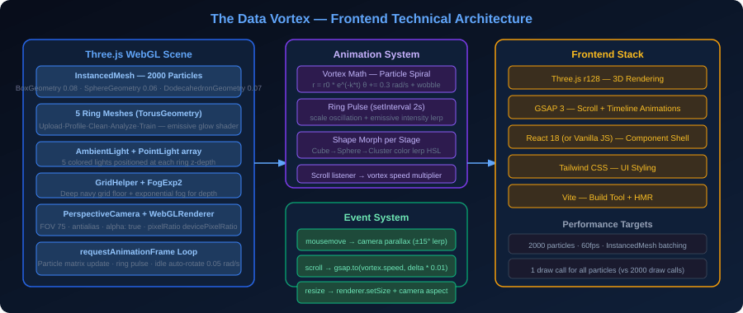
Figure 4 — Data Vortex frontend architecture: Three.js scene, animation system, and event layer

9.1 Visual Concept
Element | Three.js Implementation | Behavior
2000 Particles | InstancedMesh — single draw call for all | Spiral inward via logarithmic spiral math. Wobble via sin(time + seed)
5 Stage Rings | TorusGeometry(r=2, tube=0.05) × 5 | Pulse scale 1.0→1.08 every 2s. Emissive color per stage.
Particle Shapes | BoxGeo(0.08) / SphereGeo(0.06) / DodecahedronGeo(0.07) | Shape changes color as particle crosses each ring's Z-plane
Background | FogExp2(0x040d1a) + GridHelper | Deep navy exponential fog + subtle grid floor
Ambient Lighting | AmbientLight + 5 PointLights | Each PointLight positioned at ring Z depth, ring accent color
Camera | PerspectiveCamera(FOV 75, near 0.1, far 100) | Idle auto-rotate at 0.05 rad/s. Mouse parallax ±15°

9.2 Particle System — InstancedMesh
InstancedMesh renders all 2000 particles in a single WebGL draw call instead of 2000 separate calls. This is the key performance optimization:
// lib/particles.js
const geometry = new THREE.BoxGeometry(0.08, 0.08, 0.08);
const material = new THREE.MeshPhysicalMaterial({
color: 0x60a5fa, transparent: true, opacity: 0.7,
roughness: 0.1, metalness: 0.3,
transmission: 0.4 // glass-morphic translucency
});
const mesh = new THREE.InstancedMesh(geometry, material, PARTICLE_COUNT);
scene.add(mesh);

// Per-frame update — compute each particle's matrix
const dummy = new THREE.Object3D();
particles.forEach((p, i) => {
p.theta += 0.3 * dt + Math.sin(time + p.seed) * 0.02; // wobble
p.radius = p.r0 * Math.exp(-0.15 * p.t); // spiral in
p.t += dt * 0.5;
dummy.position.set(
p.radius * Math.cos(p.theta),
p.radius * Math.sin(p.theta) * 0.4, // flatten to funnel shape
p.z // z is the pipeline depth axis
);
dummy.rotation.set(time*0.3 + p.seed, time*0.2, 0);
dummy.updateMatrix();
mesh.setMatrixAt(i, dummy.matrix);
});
mesh.instanceMatrix.needsUpdate = true;

9.3 Stage Ring Pulse
// lib/rings.js
const RING_COLORS = [0x38bdf8, 0x818cf8, 0x34d399, 0xf59e0b, 0xe879f9];
const RING_LABELS = ['Upload', 'Profile', 'Clean', 'Analyze', 'Train'];
const rings = RING_COLORS.map((color, i) => {
const geo = new THREE.TorusGeometry(2, 0.05, 16, 100);
const mat = new THREE.MeshStandardMaterial({
color, emissive: color, emissiveIntensity: 0.8
});
const torus = new THREE.Mesh(geo, mat);
torus.position.z = -i * 4; // each ring 4 units deeper
torus.rotation.x = Math.PI / 2;
scene.add(torus);
return { mesh: torus, mat };
});

// Pulse every 2s per ring, offset by 400ms
rings.forEach((ring, i) => {
setInterval(() => {
gsap.to(ring.mesh.scale, { x:1.08, y:1.08, z:1.08, duration:0.3,
yoyo:true, repeat:1, ease:'power2.out' });
gsap.to(ring.mat, { emissiveIntensity: 1.5, duration:0.3,
yoyo:true, repeat:1 });
}, 2000 + i * 400);
});

9.4 Mouse Parallax + Scroll Speed
// Event handlers in VortexScene.jsx
let targetRotX = 0, targetRotY = 0;

window.addEventListener('mousemove', (e) => {
targetRotY = (e.clientX / window.innerWidth - 0.5) * 0.52; // ±15 deg
targetRotX = (e.clientY / window.innerHeight - 0.5) * 0.26;
});

// In animation loop — smooth lerp to target
scene.rotation.y += (targetRotY - scene.rotation.y) * 0.05;
scene.rotation.x += (targetRotX - scene.rotation.x) * 0.05;

// Scroll speed multiplier via GSAP ScrollTrigger
gsap.to(vortexState, {
speedMultiplier: 3.0,
scrollTrigger: {
trigger: '#hero',
start: 'top top',
end: 'bottom top',
scrub: 1
}
});

9.5 Performance Budget
Metric | Target | Technique
Draw calls | 3–5 total | InstancedMesh for all particles (1 call), 5 rings (5 calls), 2 lights
Frame time | <16ms (60fps) | No per-frame geometry recreation, matrix math only
Memory | <150MB GPU | Shared geometry across InstancedMesh instances
Mobile | Reduce to 500 particles | Detect via navigator.hardwareConcurrency < 4
First render | <500ms | Three.js loaded from CDN (r128), scene init deferred

10. Security Considerations
Threat | Mitigation | Implementation
Password storage | bcrypt hashing | passlib[bcrypt] with default 12 rounds — never store plain text
JWT tampering | HS256 signature | python-jose verifies signature on every request via verify_token()
Expired tokens | 30-min expiry | ACCESS_TOKEN_EXPIRE_MINUTES in config, checked on decode
Unauthorized data access | Owner check in every service query | All queries filter by Dataset.owner_id == current_user.id
File upload abuse | Extension validation in file_handler | load_dataframe() rejects unrecognized extensions with ValueError
CORS (MVP) | Allow all origins | TODO: restrict to frontend origin before any production deploy
SQL injection | ORM parameterized queries | SQLAlchemy never constructs raw SQL strings from user input
Path traversal | UUID-based filenames | save_upload_file() stores as {uuid4}_{original_name}, no .. allowed

11. Error Handling Strategy
HTTP Code | When Raised | Example
400 Bad Request | Status gate violation | POST /analyze when status is UPLOADED (not CLEANED)
401 Unauthorized | Missing/invalid/expired JWT | Bearer token not present or verify_token() fails
404 Not Found | Dataset not found or wrong owner | GET /datasets/{id} for a dataset owned by another user
422 Unprocessable | Pydantic validation failure | RegisterRequest with password shorter than 8 chars
500 Internal Error | DB commit failure, engine exception | Caught in service try/except, rollback triggered

12. Application Startup Sequence
main.py uses FastAPI's lifespan context manager to handle startup tasks:
# main.py
from contextlib import asynccontextmanager
from fastapi import FastAPI
from fastapi.middleware.cors import CORSMiddleware

@asynccontextmanager
async def lifespan(app: FastAPI):
# Create storage directories if they don't exist
for d in [settings.UPLOAD_DIR, settings.CLEANED_DIR, settings.MODELS_DIR]:
Path(d).mkdir(parents=True, exist_ok=True)
# Auto-create all DB tables from SQLAlchemy models
Base.metadata.create_all(bind=engine)
yield # App runs here
# Shutdown: nothing to clean up for MVP

app = FastAPI(title=settings.PROJECT_NAME, lifespan=lifespan)

app.add_middleware(CORSMiddleware,
allow_origins=['*'], # TODO: restrict in production
allow_methods=['*'], allow_headers=['*'], allow_credentials=True)

app.include_router(auth_router, prefix='/auth')
app.include_router(datasets_router, prefix='/datasets')
app.include_router(profiling_router, prefix='/datasets')
app.include_router(cleaning_router, prefix='/datasets')
app.include_router(analytics_router, prefix='/datasets')
app.include_router(ml_router, prefix='/datasets')

13. Testing Strategy

13.1 Engine Unit Tests (Priority 1)
Engines are pure functions — the easiest and most valuable tests to write. No mocking needed:
# tests/test_profiling_engine.py
import pandas as pd
from app.engines.profiling_engine import run_profiling

def test_profiling_basic():
df = pd.DataFrame({'a': [1, 2, None], 'b': ['x', 'y', 'x']})
result = run_profiling(df)
assert result['row_count'] == 3
assert result['missing_cells'] == 1
assert result['numeric_cols'] == 1
assert result['categorical_cols'] == 1
assert 'a' in result['column_details']
assert result['column_details']['a']['mean'] == 1.5

13.2 API Integration Tests (Priority 2)
# tests/test_auth.py
from fastapi.testclient import TestClient
from app.main import app

client = TestClient(app)

def test_register_and_login():
r = client.post('/auth/register', json={'email':'t@test.com','password':'password123'})
assert r.status_code == 201
r2 = client.post('/auth/login', json={'email':'t@test.com','password':'password123'})
assert r2.status_code == 200
assert 'access_token' in r2.json()

14. Future Scope
Feature | Complexity | Description
Async SQLAlchemy | Medium | Replace sync Session with AsyncSession for non-blocking DB queries
Celery Task Queue | High | Background ML training for large datasets — return task_id immediately
Model Inference | Medium | POST /datasets/{id}/ml/{model_id}/predict — load joblib model, run predictions
Streamlit UI v2 | Low | Update existing Streamlit app to call v2 endpoints
S3 Storage | Medium | Replace local disk with S3/GCS — update file_handler.py only
Dataset Sharing | Medium | Add is_public flag + shared dataset read endpoint
Pytest Suite | Low | Full test coverage for all engines + auth + pipeline endpoints
Docker Compose | Low | One-command local setup: postgres + fastapi + frontend
Vortex Interactivity | Medium | Click on a ring to scroll page to that pipeline section
Auto-Feature Selection | High | Replace 'drop non-numeric' with automated feature engineering

Technical Design Document — DataFlow v2.0 | Ritesh Mohan | March 2026
This document reflects the complete technical specification for the 24-hour build sprint. All architectural decisions, engine contracts, and API shapes described here are binding for the implementation.

