**Github tutorial**

**Part 3**

A github is a service which is web-based repository which has all the revision control and all SCM functionality of Git and it can also add its owns features. Github was created in 2008 by Tom Preston- Werner and Chris Wanstrath and P J Heytt. SourceForge, BitBucket, GitLab are the similar platforms like GitHuB. Github is basically used for social networking functionality like feeds, followers and network graphs to work on the versions of repository.

**Part 4**

Press enter to submit commands

> git init

Initialized empty Git repository in /.git/

Success!

$

git status

Success!

$ git push -u origin master

Branch master set up to track remote branch master from origin.

Success!

$ git pull origin master

Updating 3852b4d..3e70b0f  
Fast-forward  
yellow_octocat.txt | 1 +  
1 file changed, 1 insertion(+)  
create mode 100644 yellow_octocat.txt

Success!

$ git diff HEAD

**diff --git a/octocat.txt b/octocat.txt  
index 7d8d808..e725ef6 100644  
--- a/octocat.txt  
+++ b/octocat.txt  
@@ -1 +1 @@  
-A Tale of Two Octocats  
+[mA Tale of Two Octocats and an Octodog**

Success!

$ git add octofamily/octodog.txt

Success!

$ git diff --staged

**diff --git a/octofamily/octodog.txt b/octofamily/octodog.txt  
new file mode 100644  
index 0000000..cfbc74a  
--- /dev/null  
+++ b/octofamily/octodog.txt  
@@ -0,0 +1 @@  
+[mwoof**

Success!

$ git reset octofamily/octodog.txt

Success!

$ git checkout -- octocat.txt

Success!

$ git branch clean_up

Success!

$ git checkout clean_up

Switched to branch 'clean_up'

Success!

$ git rm '*.txt'

rm 'blue_octocat.txt'  
rm 'octocat.txt'  
rm 'octofamily/baby_octocat.txt'  
rm 'octofamily/momma_octocat.txt'  
rm 'red_octocat.txt'

Success!

$ git commit -m "Remove all the cats"

[clean_up 63540fe] Remove all the cats  
5 files changed, 5 deletions(-)  
delete mode 100644 blue_octocat.txt  
delete mode 100644 octocat.txt  
delete mode 100644 octofamily/baby_octocat.txt  
delete mode 100644 octofamily/momma_octocat.txt  
delete mode 100644 red_octocat.txt

Success!

$ git checkout master

Switched to branch 'master'

Success!

$ git merge clean_up

Updating 3852b4d..ec6888b  
Fast-forward  
blue_octocat.txt | 1 -  
octocat.txt | 1 -  
octofamily/baby_octocat.txt | 1 -  
octofamily/momma_octocat.txt | 1 -  
red_octocat.txt | 1 -  
5 files changed, 5 deletions(-)  
delete mode 100644 blue_octocat.txt  
delete mode 100644 octocat.txt  
delete mode 100644 octofamily/baby_octocat.txt  
delete mode 100644 octofamily/momma_octocat.txt  
delete mode 100644 red_octocat.txt

Success!

$ git branch -d clean_up

Deleted branch clean_up (was ec6888b).

Success!

$ git push

To https://github.com/try-git/try_git.git  
3e70b0f..618785a master -> master

Success!

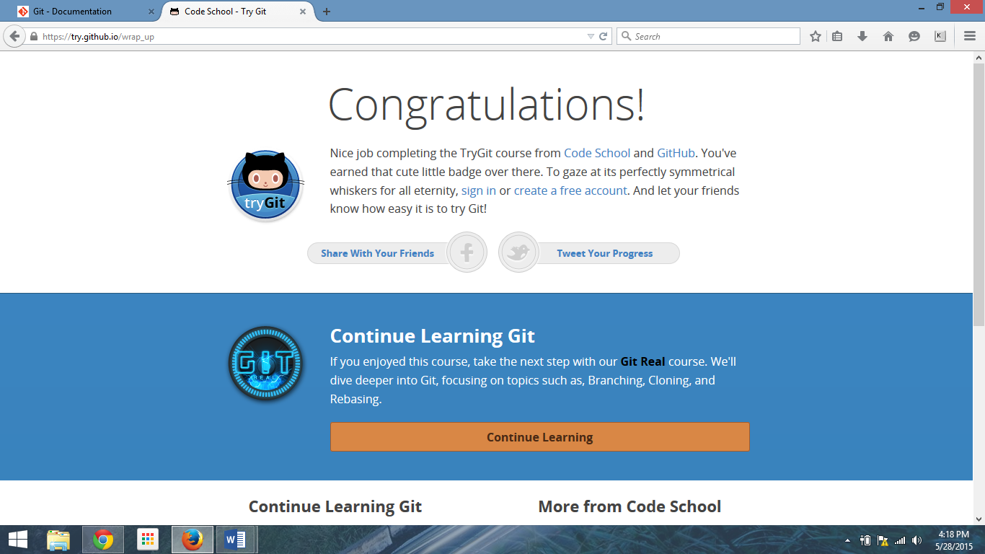

**Part 5**

1. Repository: It is basically like an history where you can see all your work done before. It also stays in .git working copy or subdirectory.
2. Commit: This process is very simple and straightforward it only helps or allows to add changes in the history of the repository and then can assign a commit name to it.
3. Push: The Push process is similar to Pull process it takes all the commit data and merges it.
4. Branch: In the repository system there can be more than one or more branches which can be merged when needed. It is the control system of the independent process.
5. Fork: Fork is nothing but a copy of repository, by forking the repository it allows us to make changes freely without affecting the original program.
6. Merge: merging is basically used to merge two or more commits it is not an direct branch to the commit it also known an ancestor branch.
7. Clone: A clone is an copy of object or data of the same object.
8. Pull: This process is nothing but it changes from the remote repository into the current git repository.
9. Pull request: Pull request you to tell others about the changes you have pushed to one repository. Once a request is sent the parties interested in it will see the changes made in the repository.