# **ARVO CMS®**

# **Construction Management System**

**USER MANUAL**

# **Oga Technologies Private Limited**



Table of Contents

Table of Contents 2

**1.** **Executive Summary** 3

1.1. **Pre-Sales** 3

1.2. **Sales** 3

**2.** **Detailed Functionality** 4

**1.Pre-Sales Module:** 4

**1.1.** **Create New Prospect** 4

**1.2.** **View Prospect** 5

**2.** **Sales Module** 8

**2.1** **Application Form** 9

**2.2** **Cost Calculation** 11

**2.3** **Allotment Letter** 12

**2.4** **Agreement Letter** 13

**2.5** **Documentation** 14

**2.6** **Site Report** 15

**2.7** **Demander** 16

**2.8** **Invoice & Payments** 17

**2.9** **Interest Calculation** 18

**2.10** **Applicant Bank information** 19

1. **GETTING STARTED IN REAL ESTATE SOFTWARE**

HOME SCREEN

We begin with a welcome screen of this product on the top of the page there are four buttons.

* + Home
  + About
  + Copyright
  + License

It contains information of the company and about the license agreement. At the bottom of the page there are three tabs.

1.1. Login.

1.2. Reset password.

1.3. Administration. As shown in Fig 1

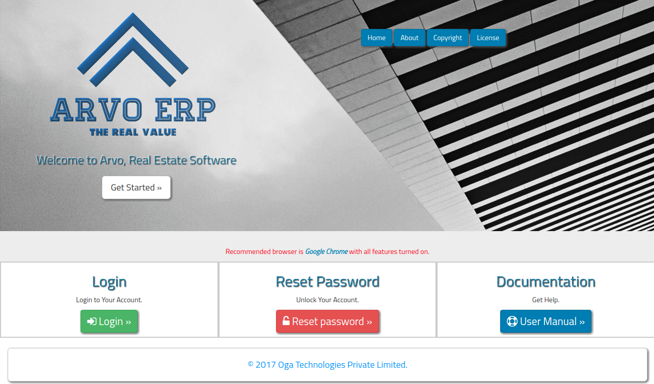  
Fig 1

**1.1. Login:** For executive login, click on login button/Get Started button as shown in Fig 1. The login screen will be appears on the screen as shown in Fig 1.1.

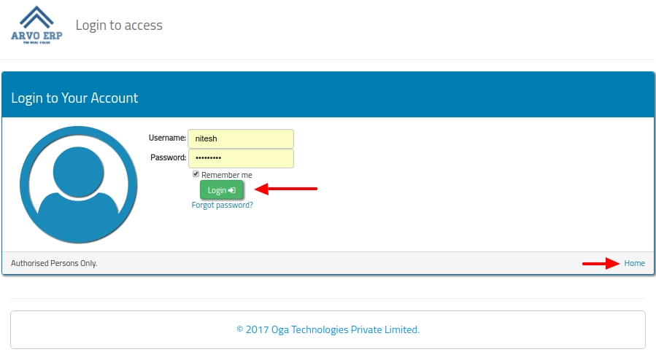

Fig 1.1

* Enter Username and Password for admin login which is provided by our Company then click on “Login” button, as shown in Fig 1.1.
* If executive wants to go back to the home screen then he has to click on Home link as shown in Fig 1.1.
* If Username or Password is incorrect then it displays login failure message as shown in Fig 1.1(a).

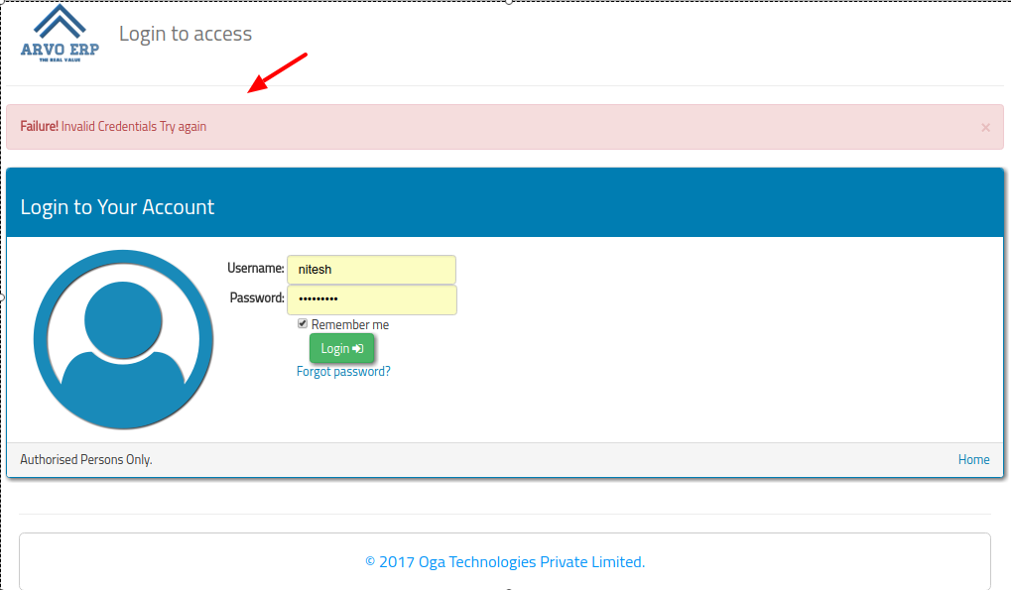

Fig 1.1(a)

**1.2. Reset Password:** This feature allows the executive/admin to reset/change their password by click on **“Reset Password”** button as shown in Fig 1

* After clicked on **“Reset Password”** button, “Reset your Password” screen will be displays on the screen as shown in Fig 1.2

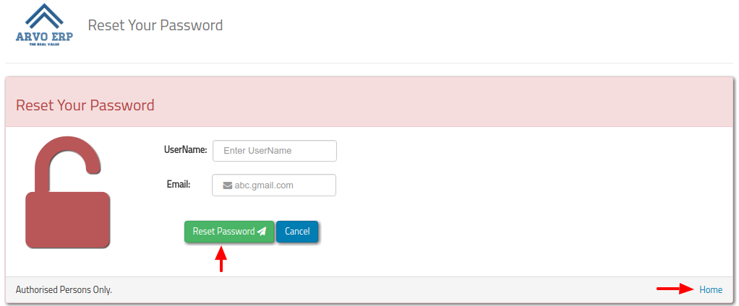

Fig 1.2

Fig 1.2

* From this screen, executive/admin has to enter valid “username” and “email” in order to change their password and then click on “Reset Password” button as shown in Fig 1.2.
* After clicked on “Reset Password” button, “Create New Password” screen will be displays on the screen as shown in Fig 1.2(a). From this screen enters the “New Password” and “Confirm Password” and then click on “Reset Password” button. Click on Home link if go back to home screen.

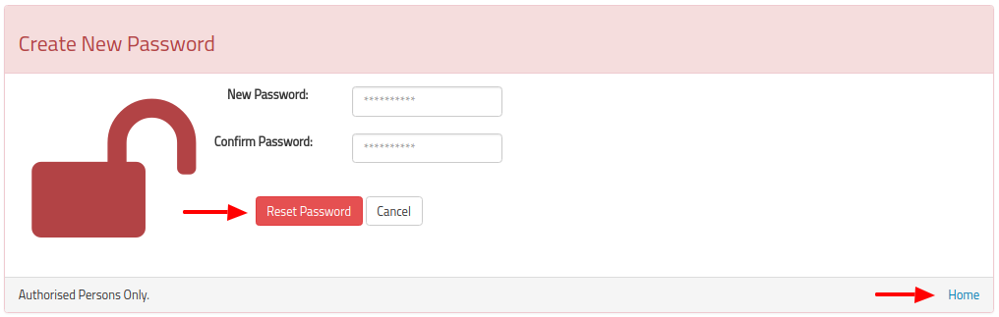Fig 1.2(a)

**1.3. Documentation:** This feature guides you the functionality of the software, for this click on “User Manual” button as shown in Fig 1.

1. **A TOUR OF THE REAL ESTATE SOFTWARE INTERFACE**

Now, we’re ready to take a look at Real Estate Software Interface. There are four basic regions: the Top-Bar and the Pre-dashboard, the Side-Menu, and the Work Area (The work area will change according to the user navigation).

1. **Top Bar**

The Top Bar displays the Company Information, Notifications and Profile setting. As shown in Fig 3.

1. **Side Bar**

It contains all the Menu Items which vary according to the modules.

1. **Pre-Dashboard**

The Pre-Dashboard contains four modules i.e.; Pre-Sales, Sales, Procurement and Contractor management. As shown in Fig 3.

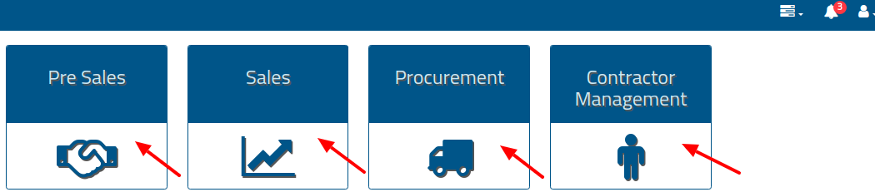  
Fig 3

1. **Pre Sales :**

Presales provide the feature to add a new prospect as well as you can view the existing prospects and can also revert the customer(from customer to prospect). Also provides the facility to do cost calculation of that prospect as well as edit the cost calculation as per the requirement. Convert the prospect into a customer. Pre-sales executive can also add /view/delete discussions.

* 1. **Create New Prospect :**

For creating new prospect click on Pre-Sales module as shown in Fig 3.

Now click on “Add New” button to add new Prospect as shown in Fig 6.1.

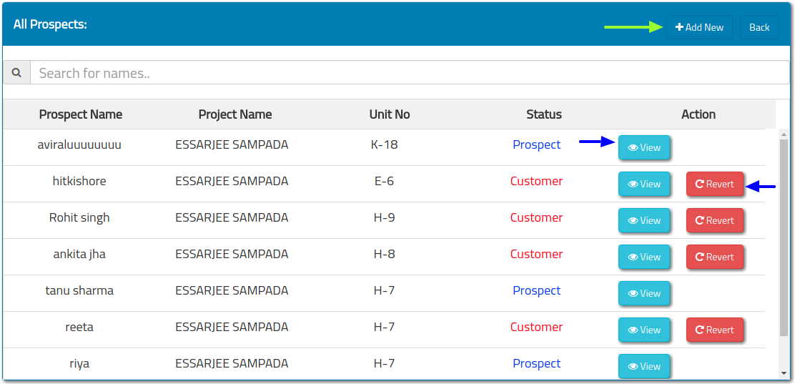

Fig 6.1

The following information will be filled here then click on the submit button as shown in Fig 6.1(a).

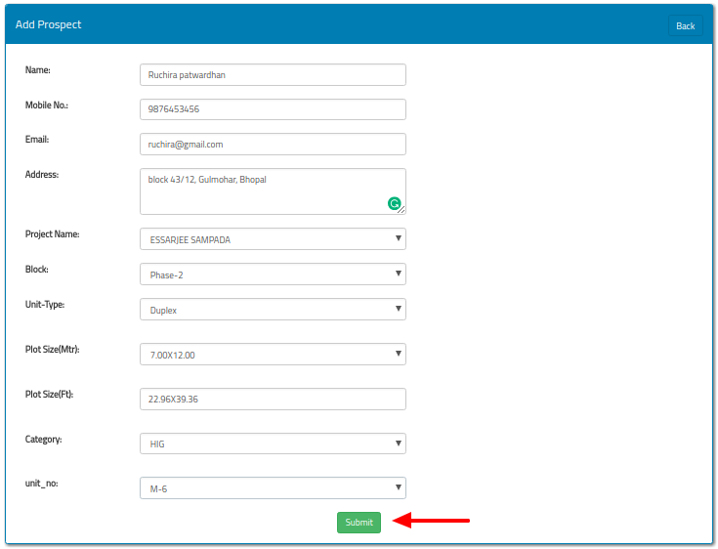

Fig 6.1(a)

After click on submit button, the prospect is added and can also display in the “All prospects list” as shown in Fig 6.1(b)

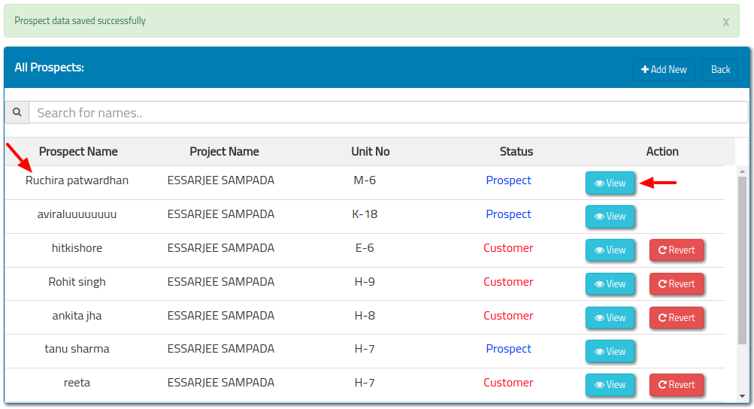

Fig 6.1(b)

1. **View Prospect:** For View Prospect, click on “View” button as shown in Fig 6.1(b), the Prospect Details Information will appear on the screen as shown in Fig 6.2.

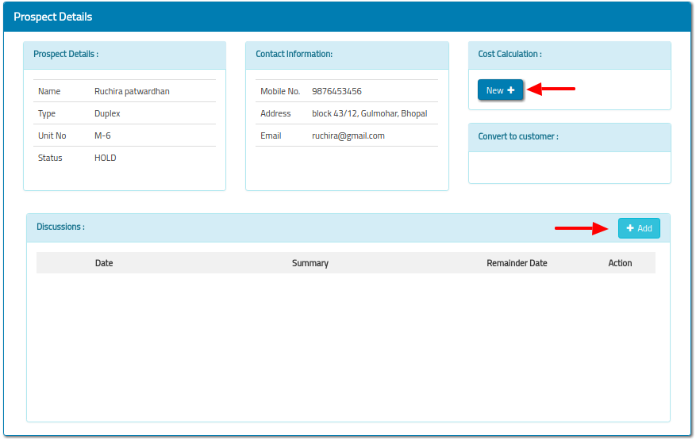

Fig 6.2

1. **Cost Calculation :** For doing cost calculation of the particular prospect

click on "view" button as shown in Fig 6.1(b). Now click on "New" button which displays under cost calculation section as shown in Fig 6.2. The CostCalculation sheet will appear on the screen as shown in Fig 6.3.

* The sales person can modify the “Rates per Sq. Ft.” at the time of negotiations (done by MD or sales Executive).
* Enter the Other fix charges as well as description related to other fix charges.
* Enter the Premium location charges as well as description related to Premium location charges.
* Enter discount in rupees if required.
* Enter your discussion with prospect inside the “discussion section” at the bottom of the sheet (optional) and click on “submit” button.
* After click on "submit" button, the cost calculation sheet appears on the screen with a Print button. For print, click on "print" button appears on the top bar. If you don't want to print the page then click on "Back" button. As shown in Fig 6.3(a).
* When you click on “Back” button, Prospect Detail screen will appear on the screen as shown in Fig 6.3(b).

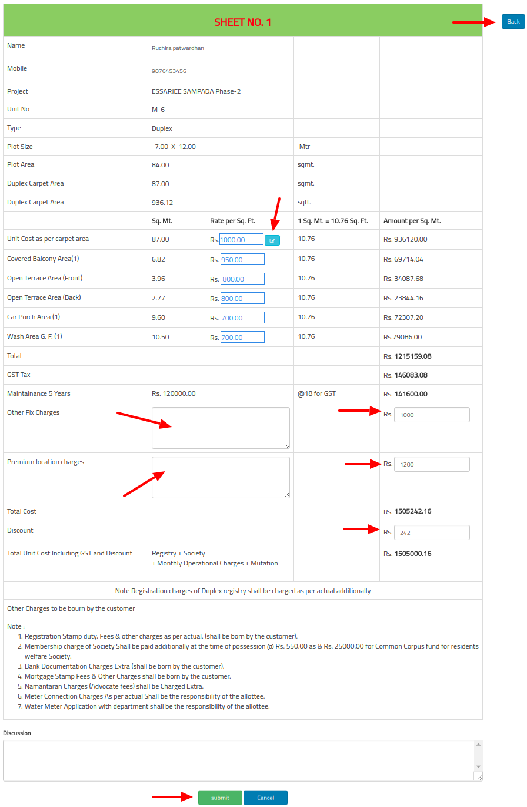

Fig 6.3

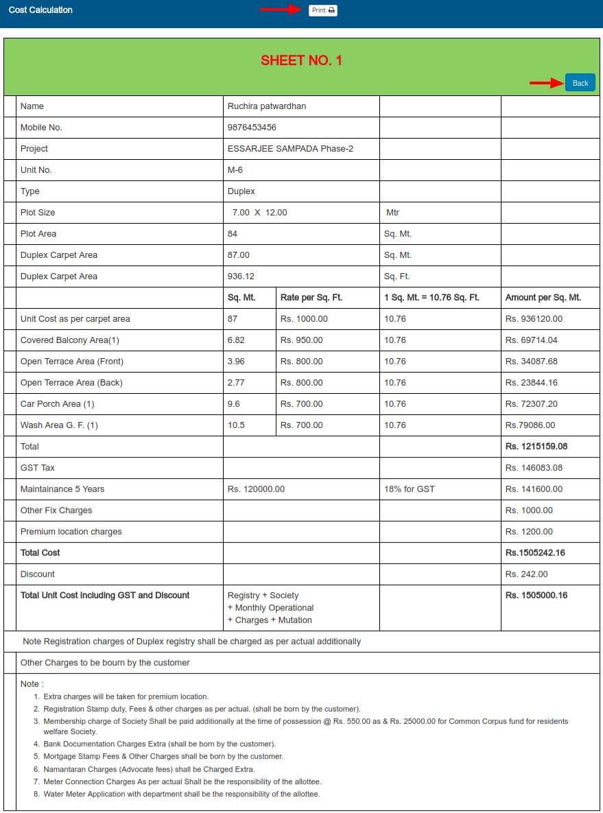

Fig 6.3(a)

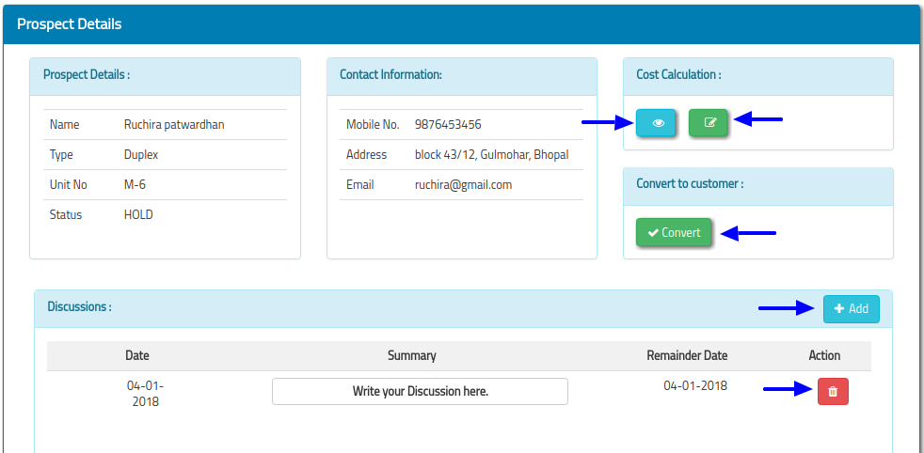  
Fig 6.3(b)

* From this screen, you can view the cost calculation sheet by click on “view (eye)” button and can also edit the cost calculation sheet by click on “Edit” button.
* Discussion can be added by click on “Add” button. As well as also view the discussion and can also delete the discussion by click on “Delete” button.
* Prospect can be converted into customer by click on convert button. The All prospect screen will display on the screen as shown in Fig 6.3(c).

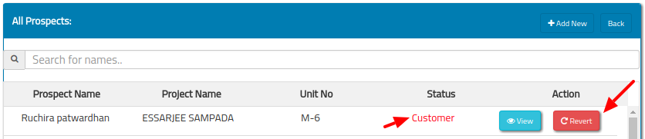

Fig 6.3(c)

In order to convert the customer into prospect then click on “Revert” button as shown in Fig 6.3(c). Now you can see the status “Customer” change into “Prospect” again and the Revert button disappears. As shown in Fig 6.3(d).

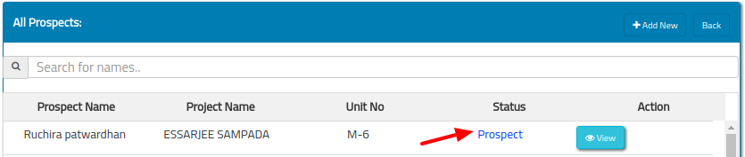

Fig 6.3(d)

After this select the Sales module from Pre-Dashboard as shown in Fig 3.

1. **Sales :**

Sales provide the following features which can be described below and used after the completion of Pre-Sales module features.

* + 1. **Application:** This feature allows you to search the applicant using three ways via Name or Project or Unit Number and then click on “Search” button. The Application list will display on the screen as shown in Fig 7.1.

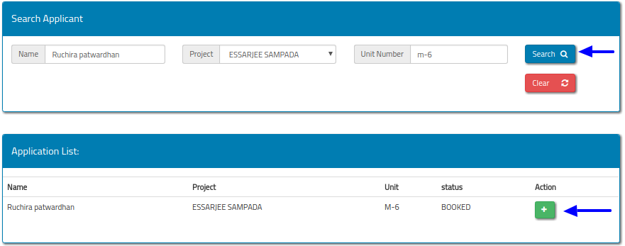

Fig 7.1

* To fill application form, click on button as shown in Fig 7.1. The application form will be displayed on the screen as shown in Fig 7.1(a).
* Now fill the project, Professional and Personal details and click on “submit” button as shown in Fig 7.1(a).

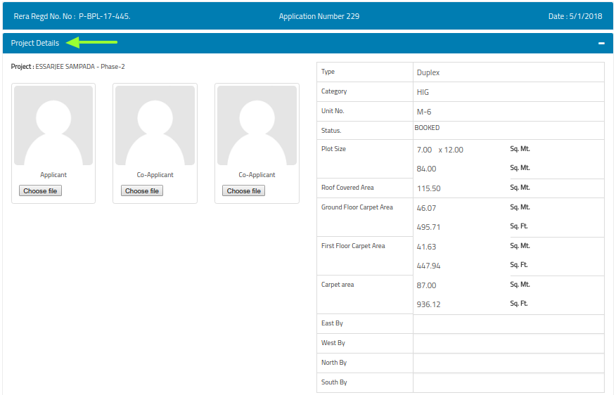

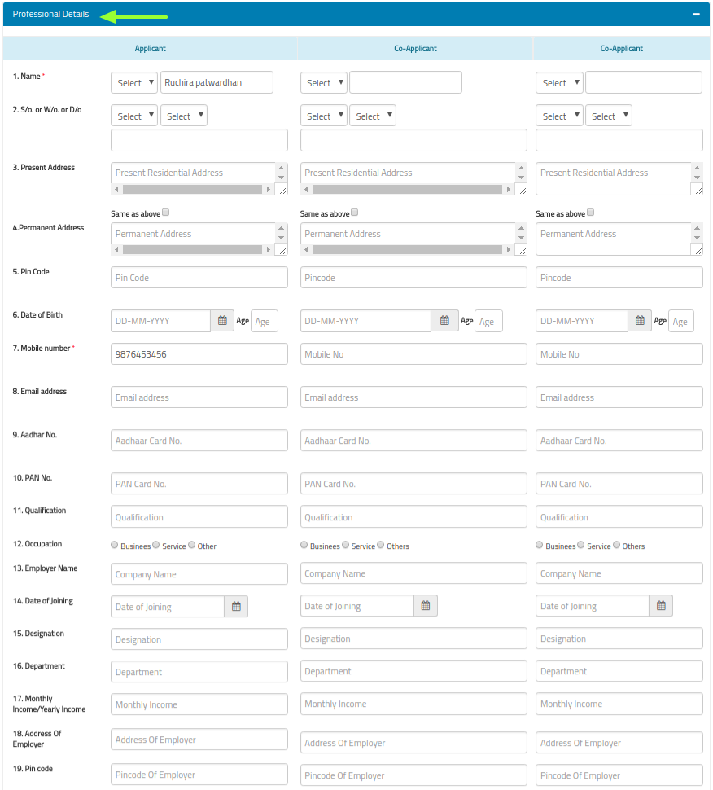

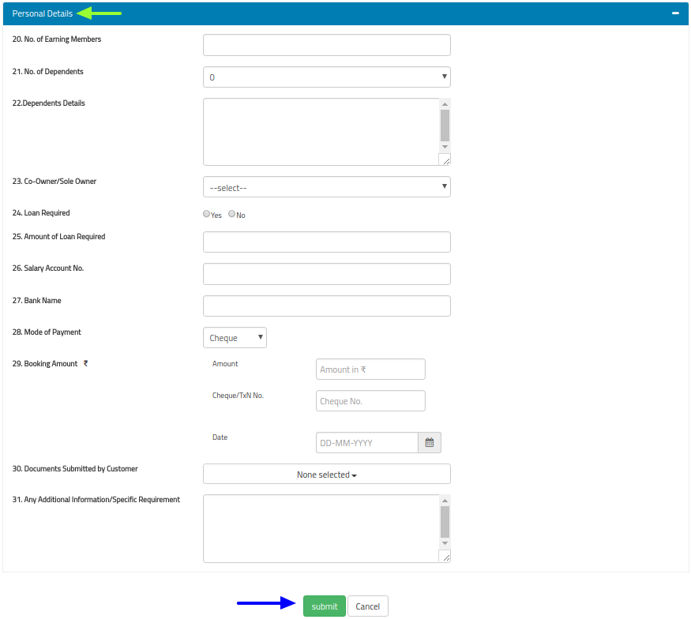

Fig 7.1(a)

1. **View Application Form:**

* To view the application form, select the Application menu from the Side-menu bar.
* Now search the applicant using three ways; either enter Name or select Project or enter Unit Number and then click on "Search" button as shown in Fig 7.1.1



* Now click on button to view Application form as shown in Fig 7.1.1.The “View Application Form” will be displayed on the screen as shown in Fig 7.1.1(a).
* To print application form click on “print” button , if you want to go back to the previous page click on “go back“ button as shown in Fig 7.1.1(a).

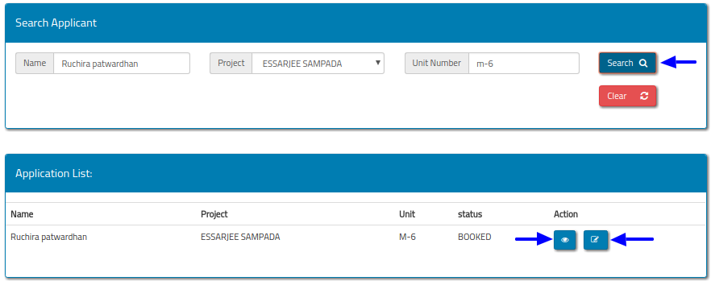

Fig 7.1.1

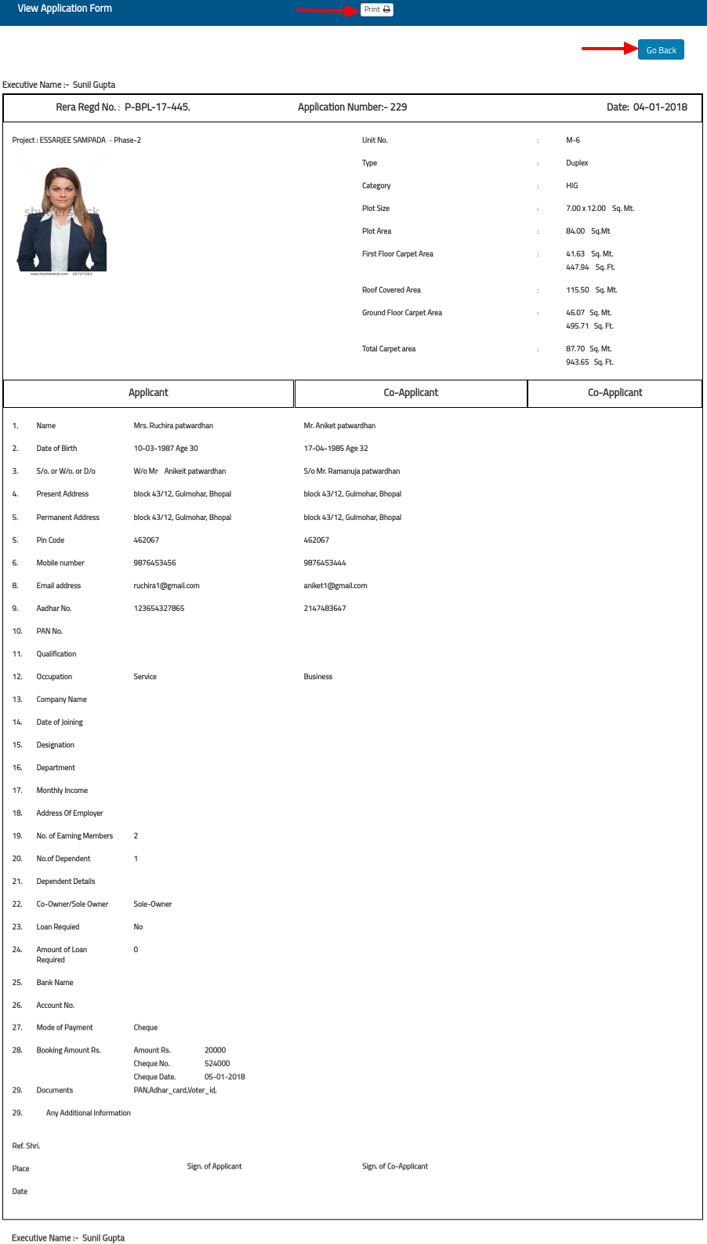

Fig 7.1.1(a)

1. **Update Application Form:**

* To update application form click on  button as shown in Fig 7.1.1.
* The “Application Form Update” screen displays on the screen, you can edit/update the information and click on “submit” button as shown in Fig 7.1.2
* To go back to the previous page click on “go back“ button as shown in Fig 7.1.2

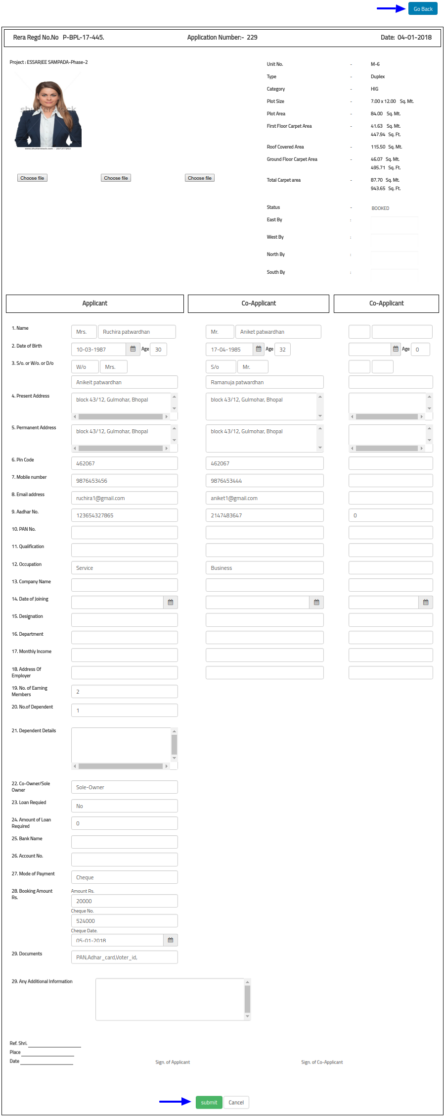

Fig 7.1.2

* + 1. **Cost Calculation:** This feature allows you to view the cost calculation of the customer. There are three ways to search cost calculation. Enter Customer Name or Select Project or Enter Unit Number and then click on Search button , “Cost Calculation Results” appears on the screen as shown in Fig 7.2

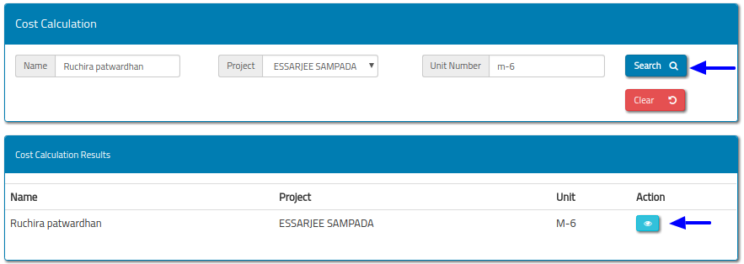

Fig 7.2

* To view the cost calculation sheet/form click on “view (Eye)” button as shown in Fig 7.2. The Cost Calculation sheet/form will be displayed on the screen as shown in Fig 7.2(a).
* To print cost calculation sheet/form click on “print” button .To go back to the previous page then click on “go back“ button as shown in Fig 7.2(a).

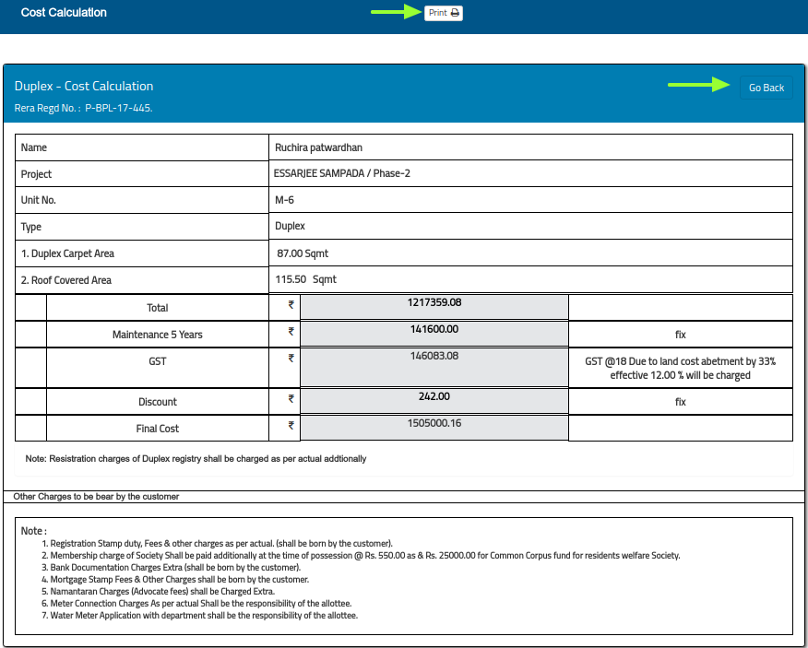

Fig 7.2(a)

* + 1. **Allotment:** This feature allows you to view the allotment letter. For this search the allotment letter. There are three ways to search allotment letter: Enter application number or applicant name or unit number in a Search Tab (Enter single value at a time) as shown in Fig 7.3

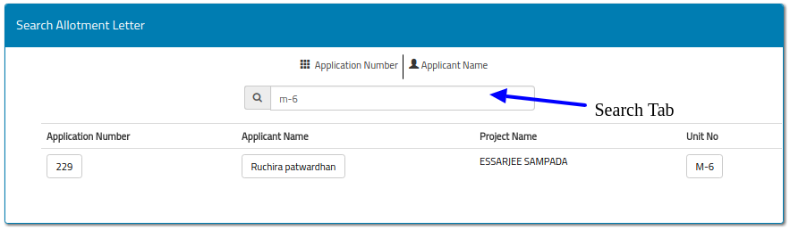

Fig 7.3

* + - Now click on any one of the option as shown in Fig 7.3(a).

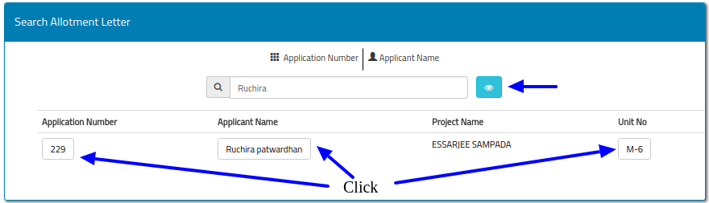

Fig 7.3(a)

* + - Now click on “View (Eye)” button as shown in Fig 7.3(a). The View Allotment letter displays on the screen as shown in Fig 7.3(b).
* To print Allotment letter click on “print” button .To go back to the previous page then click on “go back“ button as shown in Fig 7.3(b).

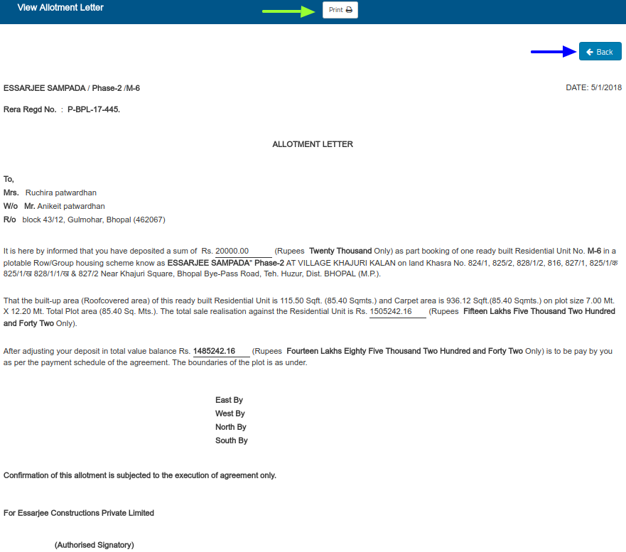

Fig 7.3(b)

1. **Agreement:** This feature allows you to view the agreement letter. There are three ways to search agreement letter. Either enter customer Name or select project or enter unit number and then click on “Search” button as shown in Fig 7.4

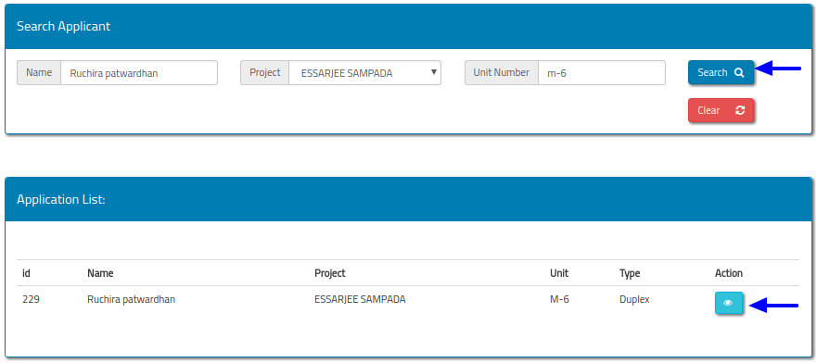

Fig 7.4

* + - Now click on “View(Eye)” button as shown in Fig 7.4. The View Agreement letter displays on the screen as shown in Fig 7.4(a).
    - To print Agreement letter click on “print” button .To go back to the previous page then click on “Back“ button as shown in Fig 7.4(a).

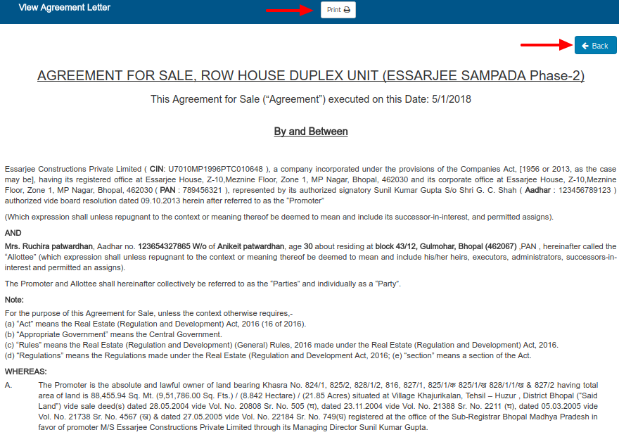

Fig 7.4(a)

1. **Documentation:** This feature allows you to add/view documents of a particular customer such as Pan Card, Aadhar Card and so on.

* To view/add document of a particular customer, first search the applicant. There are three ways to search the Applicant, Either enter customer Name or select project or enter unit number and then click on “Search” button as shown in Fig 7.5

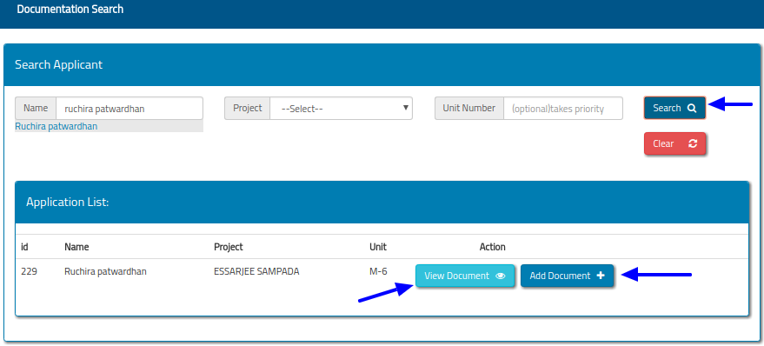

Fig 7.5

* Now click on “Add Document” button as shown in Fig 7.5. The “Upload Document” screen will be displayed on the screen as shown in Fig 7.5(a).

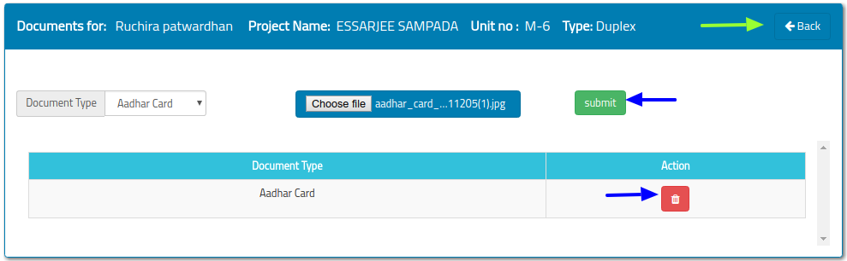

Fig 7.5(a)

* From this screen select the document type then choose the file and click on "Submit" button as shown in Fig 7.5(a).
* You can also delete the document by click on button as shown in Fig 7.5(a).
* To go back to the previous page, click on “Back” button as shown in Fig 7.5(a).
* To view documents click on “View Document” button as shown in Fig 7.5. The “Documents List” screen will be displayed on the screen as shown in Fig 7.5(b)

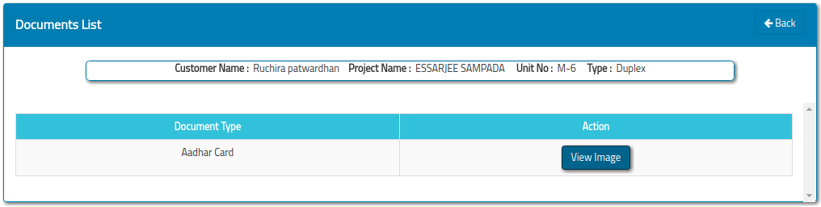

Fig 7.5(b)

1. **Site Report:**
2. **reeeee**

Fig 7.5(a)

Fig 7.5(a)

* 1. **Cost Calculation**

By clicking the Cost calculation option in the side menu the user will be redirected to the **Cost calculation Search** page. With this the cost calculation of a customer property is maintained. Here the cost calculation can only be viewed and can be printed.

Note: - At this stage the cost calculation of the customer can’t be updated.

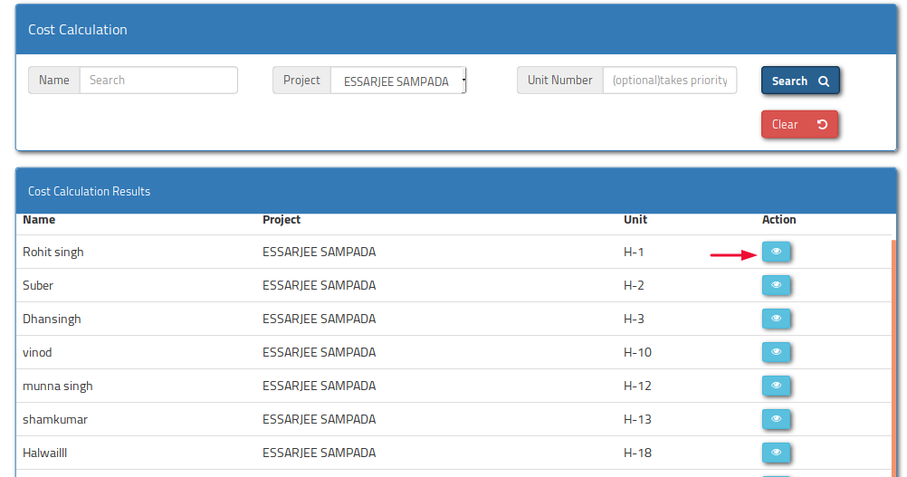

After clicking the **‘eye icon’** button shown in the above image the user will see the cost calculation page and can take the printout if required.

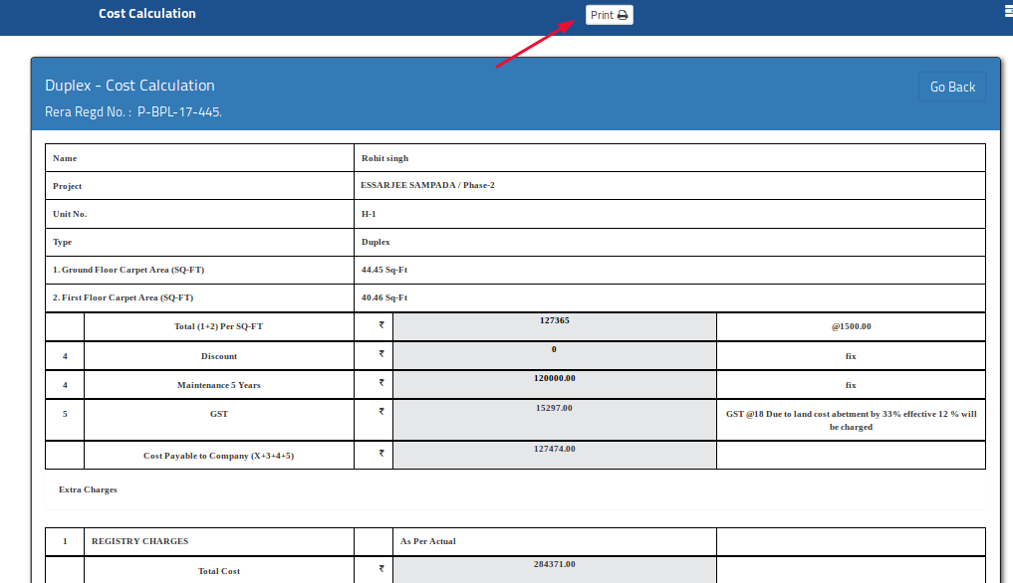

* 1. **Allotment Letter**

Allotment Letter is automatically generated after the customer pays the booking amount. The booking amount is that amount that is given by customer at the time of application form filling.

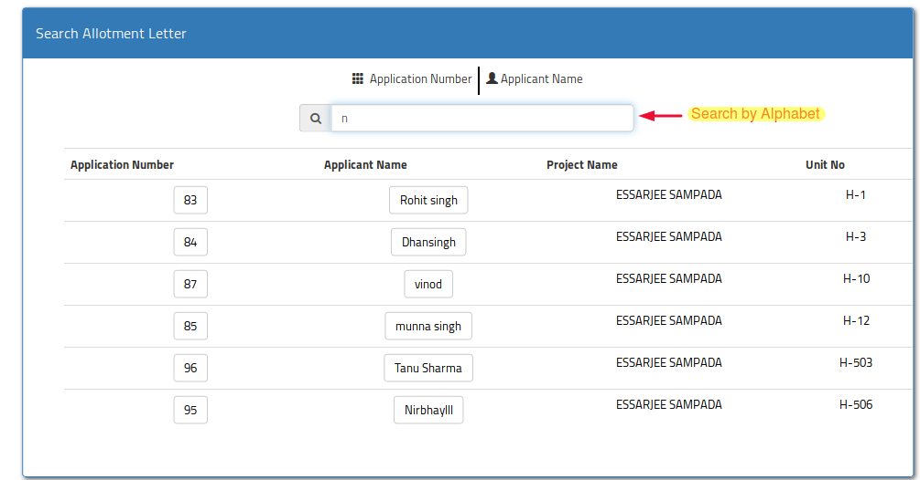

The **Allotment Letter search** form allows you to search by alphabet and a list is displayed, after clicking the eye icon the allotment letter is displayed

* 1. **Agreement Letter**

This document is a complete agreement between customer and the Company. In this agreement the cost of the property, breaking of cost of each stage details and how much amount will be taken after the completion of each stage is also written in this agreement. This is a complete document from beginning to possession of the property. The format of Agreement is designed as per **RERA** Rules.

The following is the searching interface of the agreement search. The user can search either by Applicant name or Project Name or Unit number. User can click the ‘eye’ icon to view the agreement and also can take the printout of the agreement.

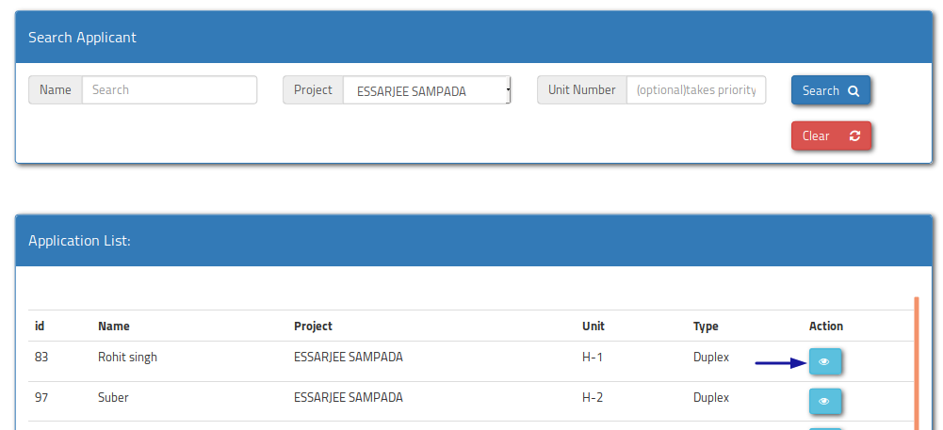

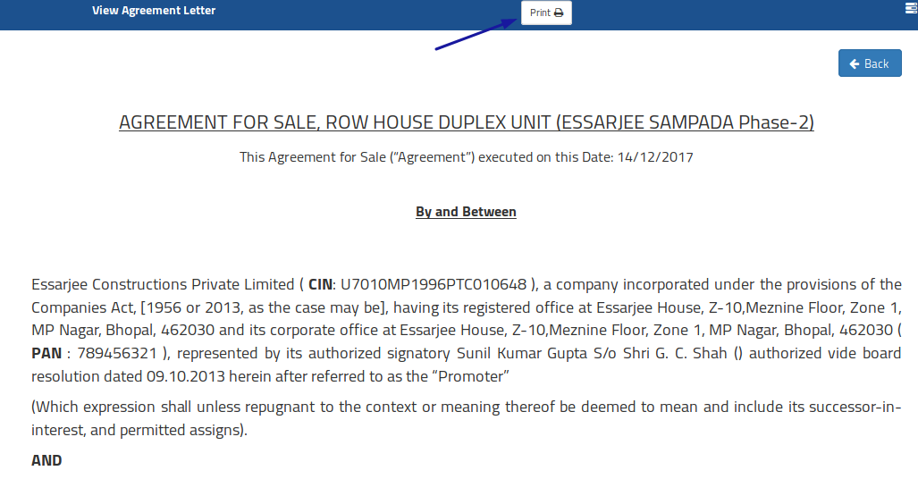

* 1. **Documentation**

All the signed and unsigned documents given by the user at the time of cost calculation and booking form are uploaded here for the further process and for future use.

* Document can be uploaded by clicking the ‘Add Document’ button shown in the below image.

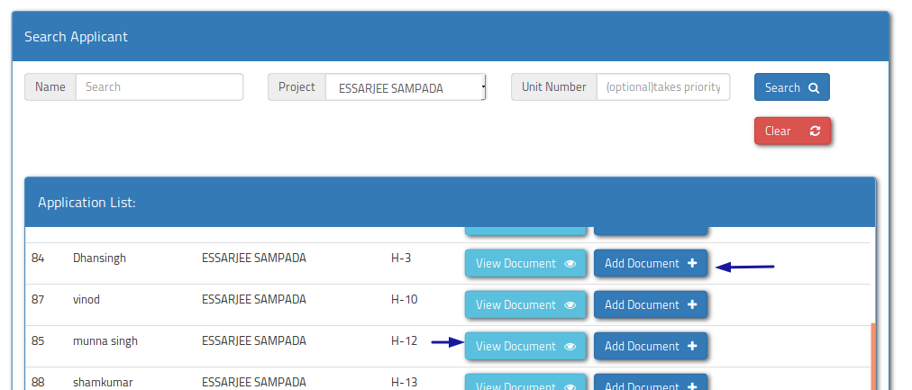

* Below interface for uploading the document submitted by the applicant, User can add document by selecting the document type and can select the document by clicking browse button from the system drive and can also delete document by clicking the delete button.

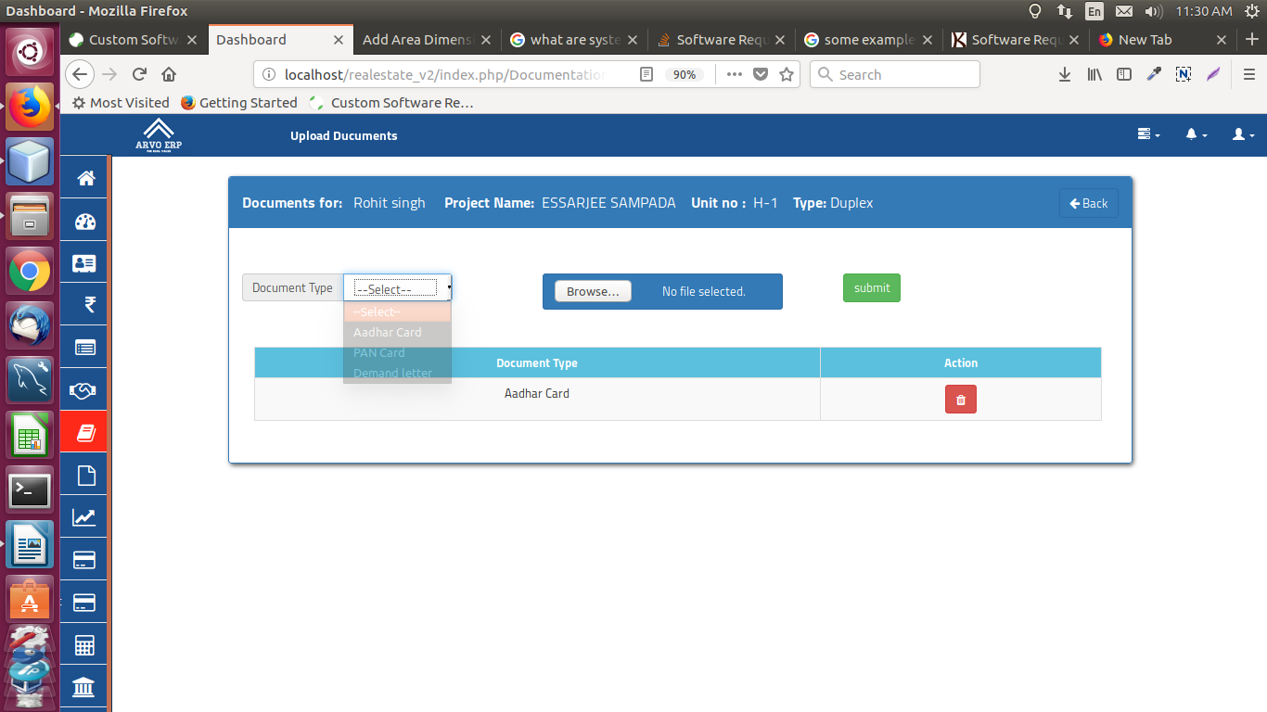

* By clicking the ‘**View Document**’ button on search document page, user can downloads the document given by the customer as show below.

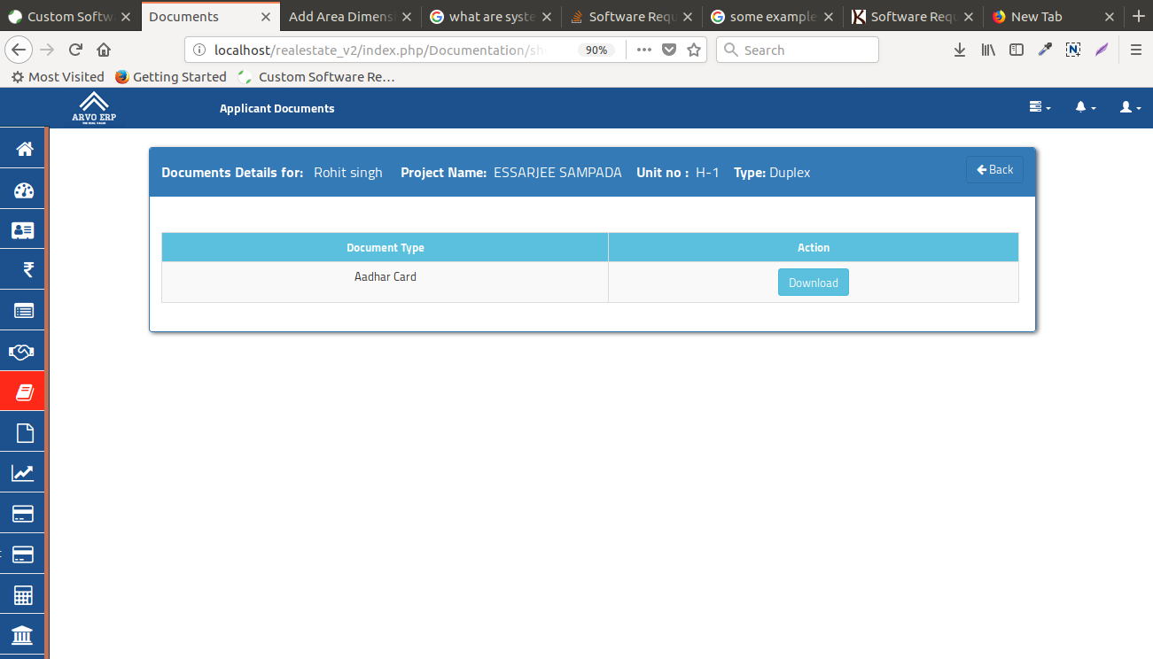

* 1. **Site Report**

Whenever construction stage is completed, the information of that stage with its image is uploaded. The **Demand Letter** is generated only after the site report is filled by the user.

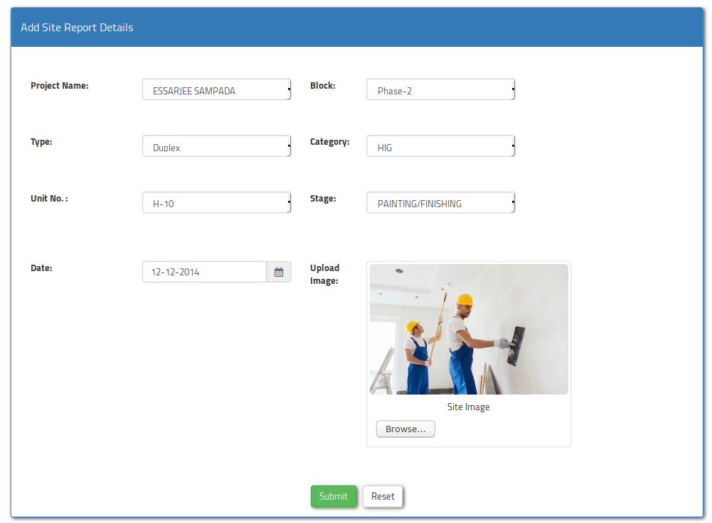

* 1. **Demand Letter**

After the completion of every stage the demand letter is raised. Two Demand letters are generated, one is the Bank part and another is the customer part.

* **Demand Letter** search interface page is shown below; demand letter can be searched either by name, project, and unit no.
* By clicking the ‘eye button’ as shown below the user will be able to see all the demand letters.

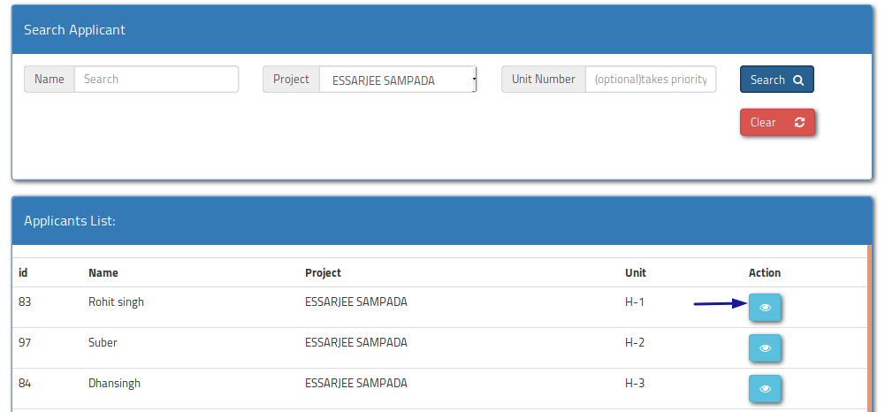

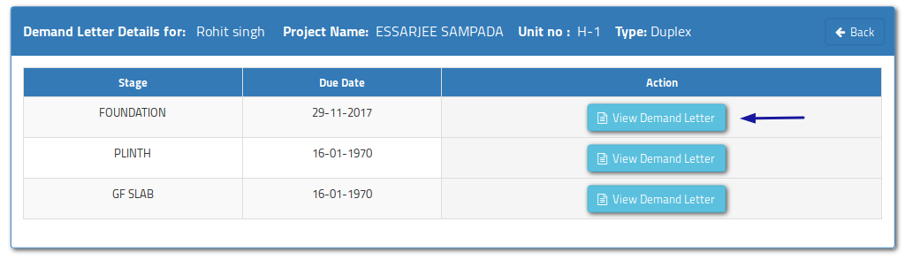

* 1. **Invoice & Payments**

Invoice is raised after the demand letter is generated. First of all previous part payment is checked, if there is any due of amount then the previous due is adjusted from the current amount and then the remaining amount will be utilized. And if the given amount is more than the required amount then it will be kept as the advance payment by the applicant.

Please note that the stage will not be available on the invoice or payment unless the site report with site stage is submitted to the system.

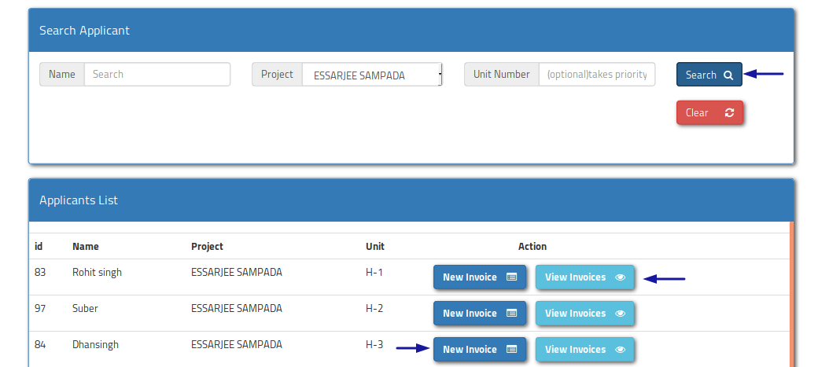

**Direct Payment Receipt:** A receipt can directly be given to the customer against the cheque before the invoice is generated. And the receipt can be viewed any time for future reference.

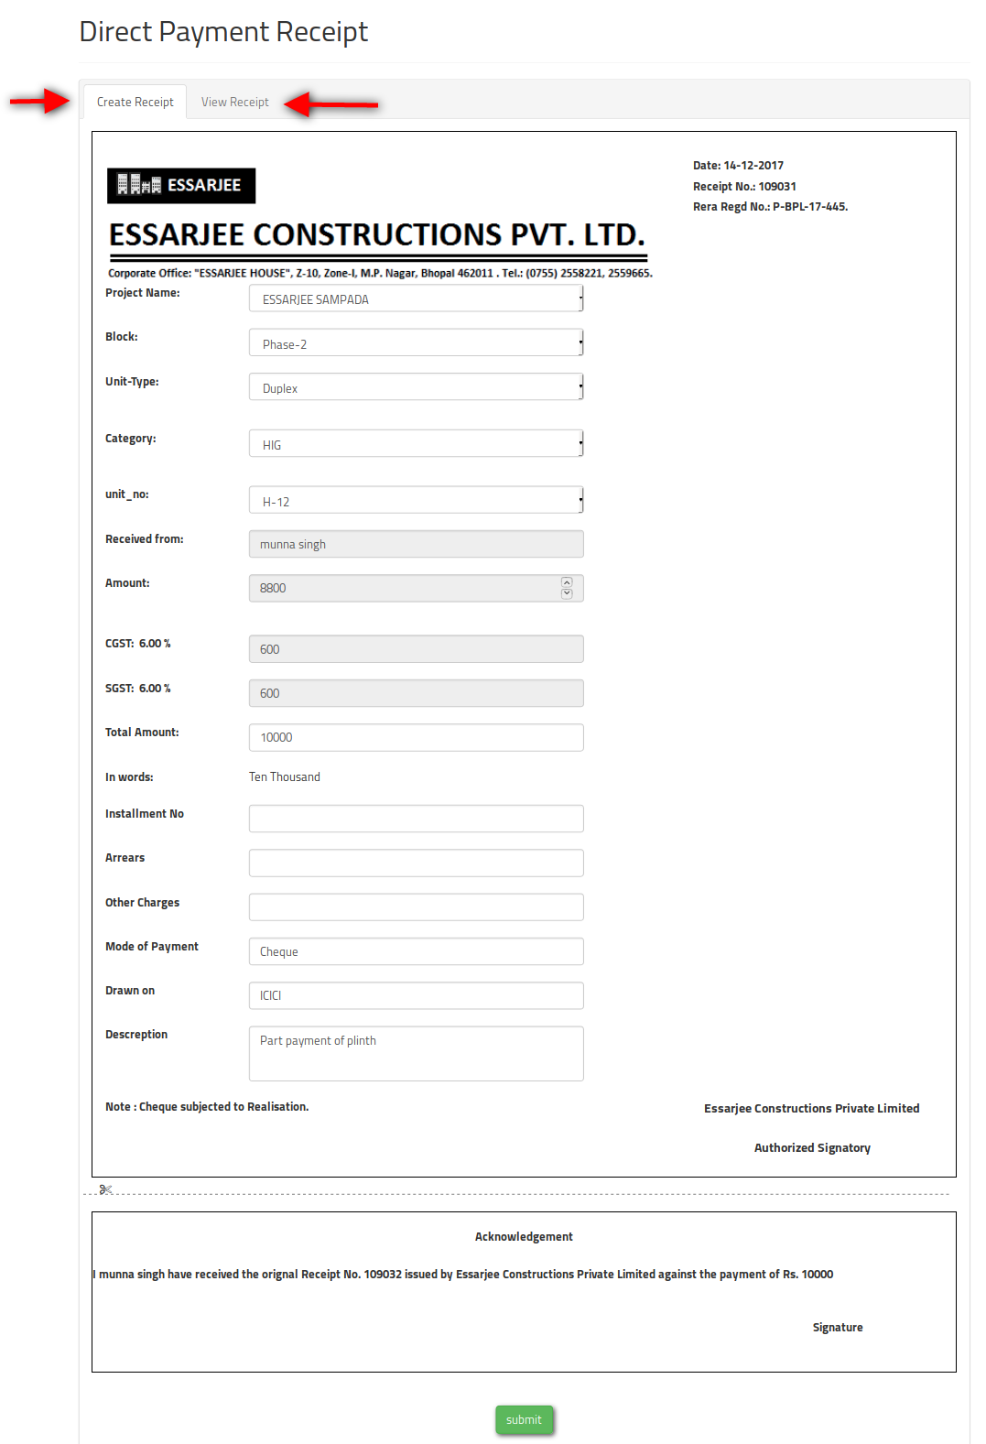

* 1. **Interest Calculation**

As soon as the Demand Letter is issued the first 15 days time is given to the customer after 15 days the interest will be calculated by 0.11% per day. From the due date given to the customer

Example

Amount is: 100

DL generated on 1-11-2017 and due date is (15-11-2017)

And today is 15-12-2017 (total 30 days delay)

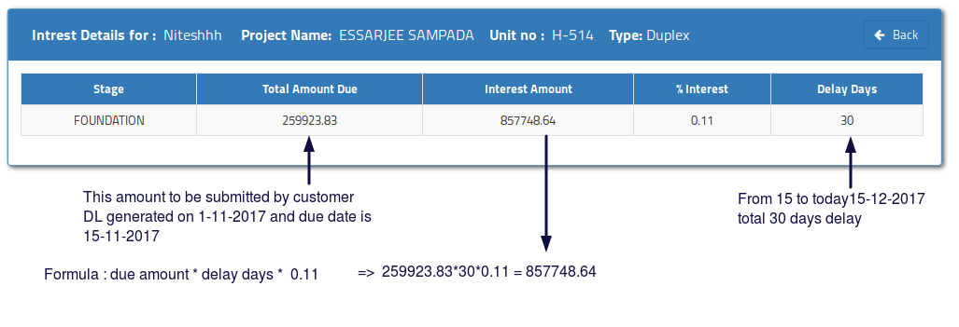Now: 100 * 30 * 0.11 => 330

* 1. **Applicant Bank information**
* In this module user can search the existing applicants either by name, project name or unit number.

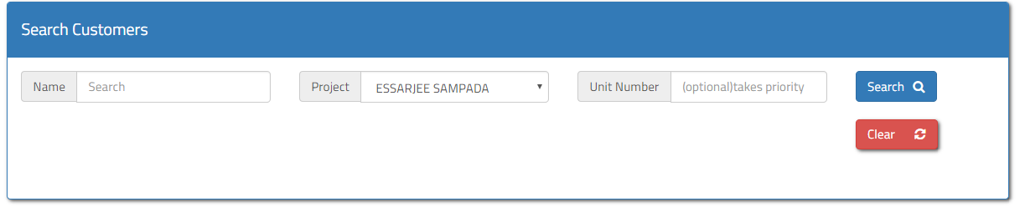

* By clicking the search button as shown in above figure existing applicant list is shown as below

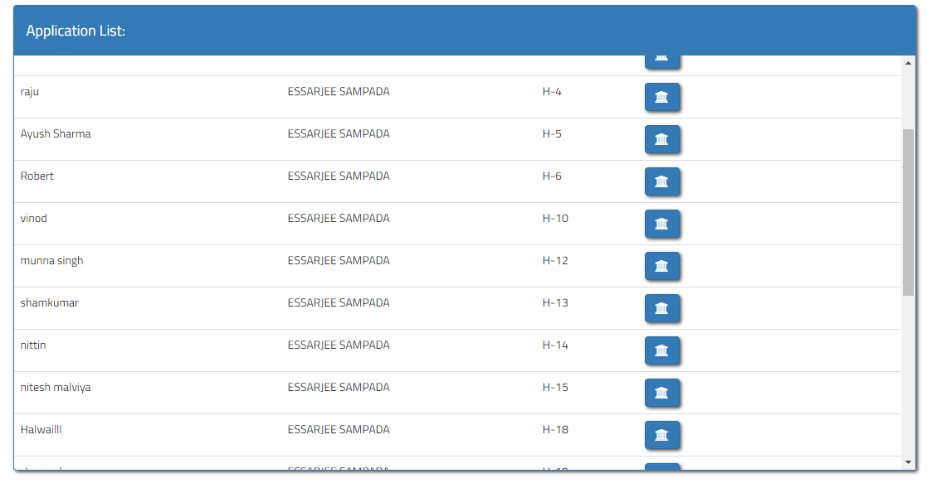

* By clicking the Bank icon button user can fill the customer’s bank information Shown in below image

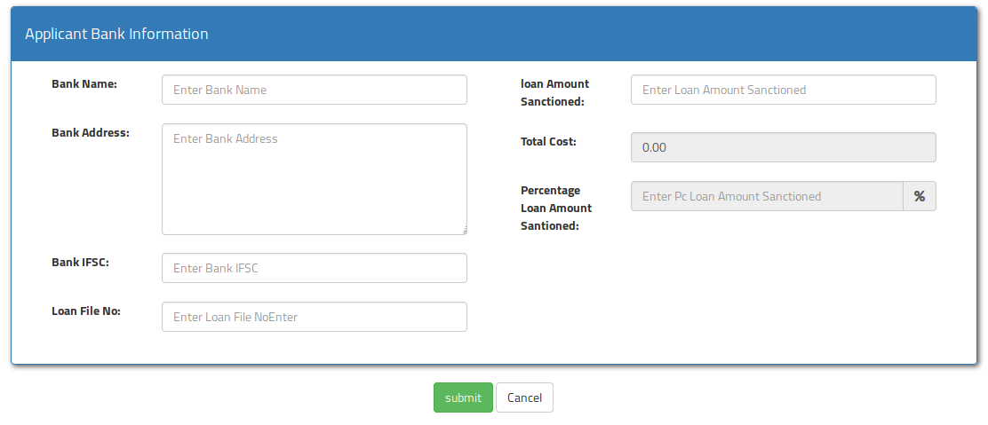

**Role Based Access Control Facility**

The Oga Real-estate Management System allows the access to specific features based on responsibility or role assigned to the ESSARJEE employees who will be using this software. The following details are captured.

|  |  |
| --- | --- |
| **Role** | **Having Access To** |
| Presales | Only to the operations related to Presales |
| MD | To all the operations |
| Accountant | Only to the WebPages related to the Accounts |