
INDIVIDUAL ASSIGNMENT
NON-CREDIT
REACT JS
Project Title: Documentation of the Mini Jersey E-Commerce Web Application (KITHAUS)

Submitted By: Ritesh Tamang (NP071201)

Abstract
This document describes the Mini Jersey E-Commerce Web Application, a browser-based football jersey store built with React and Vite and branded KITHAUS in its interface. The application lets visitors browse club and national team kits, search, filter, and sort the catalogue, view product details, add a printed name and number, manage a shopping bag, and complete a demonstration checkout. The documentation explains the purpose, technology, folder structure, architecture, data model, saved data, and each major feature in simple language, supported by technical detail. It also gives installation instructions, a short user guide, a glossary, and a list of current limitations with recommended improvements. The system is a front-end demonstration: it has no server, database, sign-in, or real payment, and it stores information only in the visitor's own browser.
Keywords: e-commerce, React, Vite, front-end, documentation, football jersey store

Documentation of the Mini Jersey E-Commerce Web Application (KITHAUS)
Online shopping is now one of the most common ways for people to buy sports clothing, including football jerseys. A good online store must let a visitor find a product, understand it, choose a size, and complete a purchase with little effort. The Mini Jersey E-Commerce Web Application, shown to visitors under the brand name KITHAUS, is a small store that demonstrates each of these steps. It is written with React, a widely used library for building user interfaces (Meta Platforms, Inc., n.d.), and it is started and packaged with Vite, a modern build tool (Vite, n.d.).
This document explains the project in plain language first and technical detail second. It is written for non-technical readers, such as instructors and clients, who want to know what the store does, and for developers who must install, understand, or extend the code. Clear documentation matters because software is changed long after its first release (Sommerville, 2016). The document follows the seventh edition of the Publication Manual of the American Psychological Association (American Psychological Association, 2020).

Purpose and Scope
The purpose of this document is to give one complete reference for the project: what it is, how it is built, how it works, and how it can be improved. The project's README file describes it as a starting point for an online sports store and a base that could later receive a real server, sign-in, and payment features. This document expands that short description. It covers the code inside the src folder, the configuration files in the project root, and the behavior a visitor sees in the browser. It does not cover hosting, domain names, or business matters such as suppliers and delivery. The findings come from a careful reading of the source files in the project archive. The application was not run, so descriptions of on-screen behavior reflect what the code instructs the browser to do. Non-technical readers can focus on the overview, features, user guide, and glossary (Table 6), while developers will also want the technical sections.

Project Overview
In simple terms, the application is a digital shop window. A visitor arrives at a home page, chooses between club and national team jerseys, opens a product, picks a size and colour, optionally adds a name and number to print on the back, places the item in a shopping bag, and completes a checkout form. The store then shows an order number and keeps a record of the order on an account page. Behind the scenes, seven parts make this possible: a home page, a catalogue with search and filters, a product page, a shopping bag, a checkout, an account page, and saved data that lets the store remember a visitor between visits.
It is important to understand the boundaries of the project. The application is a front-end demonstration, which means it runs entirely inside the visitor's web browser. It has no server, no database, no sign-in system, and no payment processing. The checkout page and the header both state that no real payment is collected, and everything a visitor does stays inside that visitor's own browser.

Technology Stack
A technology stack is the set of tools used to build software. Table 1 lists the tools declared in the project's package.json file, using the version ranges written there. A caret (^) before a version number means that newer compatible releases are also accepted.

Table 1
Tools Used in the Project
Tool | Declared version | Role in plain words
React and React DOM | ^19.2.8 | Builds each screen from small reusable pieces called components
Vite | ^8.3.0 | Starts the development server and packages the finished site
@vitejs/plugin-react | ^6.1.1 | Lets Vite understand the JSX writing style used by React
Tailwind CSS with @tailwindcss/vite | ^4.3.3 | Styles pages through short class names placed on each element
React Router | ^8.4.0 | Switches between pages without reloading the browser
Motion | ^13.4.4 | Provides page fade transitions and banner animations
Lucide React | ^1.47.0 | Supplies line icons such as the bag, search, and arrows
React Icons | ^5.7.0 | Supplies the social media icons in the footer
ESLint | ^10.10.0 | Checks the code for common mistakes
Note. Versions are taken from the dependency lists in package.json.
Tailwind CSS applies design directly through class names on each element (Tailwind Labs, n.d.). React Router changes what is displayed while keeping the same web page open, which makes navigation feel quick (React Router, n.d.). Icons come from Lucide (Lucide Contributors, n.d.), animation from Motion (Motion, n.d.), and the Inter font from Google Fonts (Google, n.d.).

Installation and Running the Project
A computer with Node.js, its package manager npm, and a modern web browser is required. The exact Node.js version depends on Vite, so its documentation should be checked first (Vite, n.d.). The steps below follow the project's README file.
- Open the project folder in a terminal window.
- Run npm install to download the libraries the project needs.
- Run npm run dev to start the development server.
- Open the address printed in the terminal, usually http://localhost:5173.
Three other commands are defined in package.json. The command npm run build creates an optimized production version in the dist folder, npm run preview serves that build locally for testing, and npm run lint runs ESLint to report code problems. The archive already contains a dist folder from an earlier build.

Project Structure
The folder layout separates what appears on every page (layouts), what is a reusable piece (components and features), and what is a full screen (pages). Table 2 describes each important file and folder.
Table 2
Important Files and Folders
Path | Contents
index.html | The single HTML page that loads the app and holds the empty root element
vite.config.js | Turns on the React and Tailwind plugins
package.json | Project name, commands, and the list of libraries
public/ and dist/ | Static files such as the site icon, and the output of an earlier build
src/main.jsx | Entry point: shared providers, page layout, and routes
src/App.jsx | Assembles the home page from its sections
src/layouts/ | Header and footer shown on every page
src/components/ | Small shared parts: brand mark, social icons, and an image with a fallback
src/features/ | Reusable modules: home sections, cart logic, category tiles, and product cards
src/pages/ | One folder per full page: account, cart, catalogue, checkout, and product
src/data/products.js | The product list and helper collections

System Architecture

Entry Point and Layout
When the browser opens the site, index.html loads src/main.jsx, which places the application inside the root element. The application is wrapped in layers. The outermost layer is the CartProvider, which shares cart, profile, and order information with every screen. Inside it sits MotionConfig, set to respect the visitor's reduced-motion preference, and then BrowserRouter, which follows the address in the browser. Within the router, the page is built from a sticky header, a changing page area, and a footer (Figure 1).
Figure 1
Structure of the Application
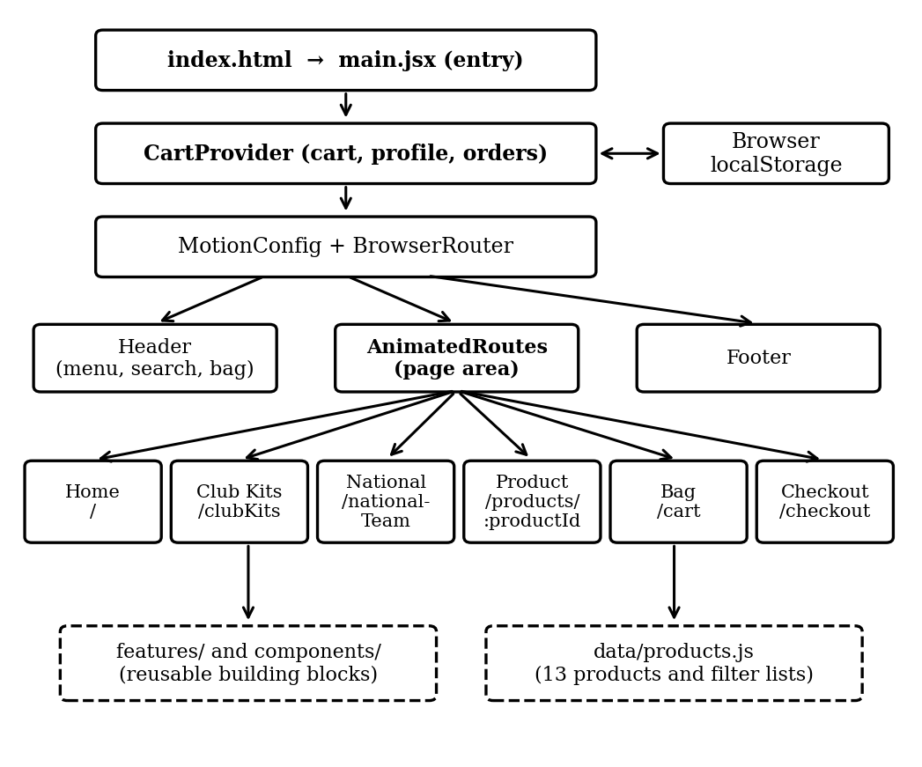
Note. Solid boxes show running layers and pages. Dashed boxes show supporting code and data.

Routing
Routing decides which screen is shown for each web address. Table 3 lists the seven routes defined in main.jsx. An unknown product address sends the visitor to the club kits list, while unlisted addresses show no page content because no "not found" page exists. Each time the address changes, the page area fades in over 0.2 seconds using Motion (Motion, n.d.).
Table 3
Routes Defined in the Application
Address | Screen | Behavior
/ | Home | Assembled in App.jsx
/clubKits | Club kits catalogue | Shows the eight club products
/nationalTeam | National team catalogue | Shows the four national products
/products/:productId | Product detail | Unknown identifiers redirect to /clubKits
/cart | Shopping bag | Shows a friendly message when empty
/checkout | Checkout | Redirects to /cart when the bag is empty
/account | Account dashboard | Profile form and order history

Data and Saved Information

Product Data
All products live in one file, src/data/products.js. A helper function named makeProduct receives the essential facts about a jersey and fills in the rest with defaults. Each record holds an identifier used in the web address, a name, season, category, price in United States dollars, a main image address, popularity and release-rank numbers for sorting, a new-release flag, a league and jersey type for filters, a description, three colour options (Home, Away, and Special), and six sizes from XS to XXL. The colours and sizes are the same for every product.
The file contains 13 products: eight club jerseys, four national team jerseys, and one Barcelona jersey that is not placed in either catalogue list (see Table 5). From the master list the file creates ready-made groups, such as clubProducts, nationalProducts, and newDropProducts, and an object named productFilterOptions that gathers the unique leagues, jersey types, and sizes so filter menus always match the data. A lookup built with JavaScript's Map lets getProduct find any jersey by its identifier.

Shared Cart State and Saved Data
State is information that changes while the application runs, such as the contents of the bag. The project keeps this shared state in one place, src/features/cart/CartContext.jsx, and any screen can read it through a helper called useCart. The provider offers five actions. The action addItem validates the product and quantity, then adds a new line or increases an identical line. The action updateQuantity sets a new quantity and removes the line if it falls below one. The actions removeItem and updateProfile delete a line and save the trimmed contact details. The action placeOrder refuses to run when the bag is empty. Otherwise it builds an order record with an identifier starting with KH-, a status of Processing, the payment method, a copy of the customer details and items, and the total, then places it at the top of the history, updates the profile, and empties the bag (Figure 2).
Figure 2
Path From Product Choice to Saved Order
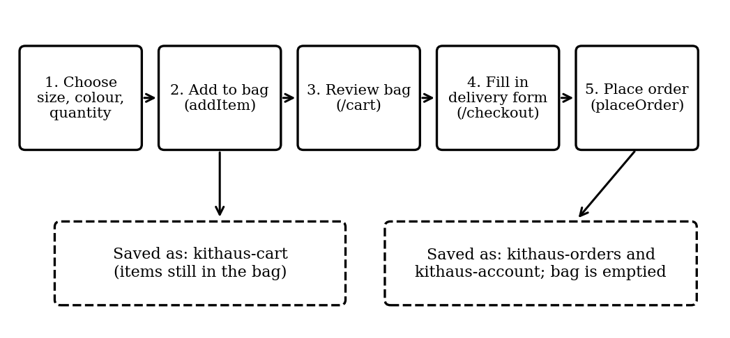
Note. Function names in parentheses are the cart actions described in the text.
The application saves data with the browser's localStorage, which keeps small pieces of text on the visitor's device even after the browser is closed (MDN Web Docs, n.d.). Table 4 lists the storage keys. Before saved data is used, the provider checks its shape with functions named isCart, isProfile, and isOrders, and data that fails the check is ignored, which protects the app from corrupted storage.
Table 4
Storage Keys Used by the Application
Key | Holds
kithaus-cart | The items currently in the shopping bag
kithaus-account | The saved name, email, and phone number
kithaus-orders | The list of past demonstration orders
kithaus-newsletter | Email addresses entered in the home page newsletter form

Feature Descriptions

Header and Search
The header stays fixed at the top of the screen. A notice strip states that the store is a demonstration without payments. Below it are the brand mark, links to Home, Club Kits, and National Teams, a search box, an account icon, and a bag icon that reflects the number of items. On small screens the links move into a menu that locks page scrolling and closes with the Escape key. Search compares the typed words with each product's name, category, season, league, and jersey type. If every match is a national team product, the visitor is sent to the national catalogue; otherwise the club catalogue is used. The search text travels in the web address, so results can be bookmarked.

Home Page
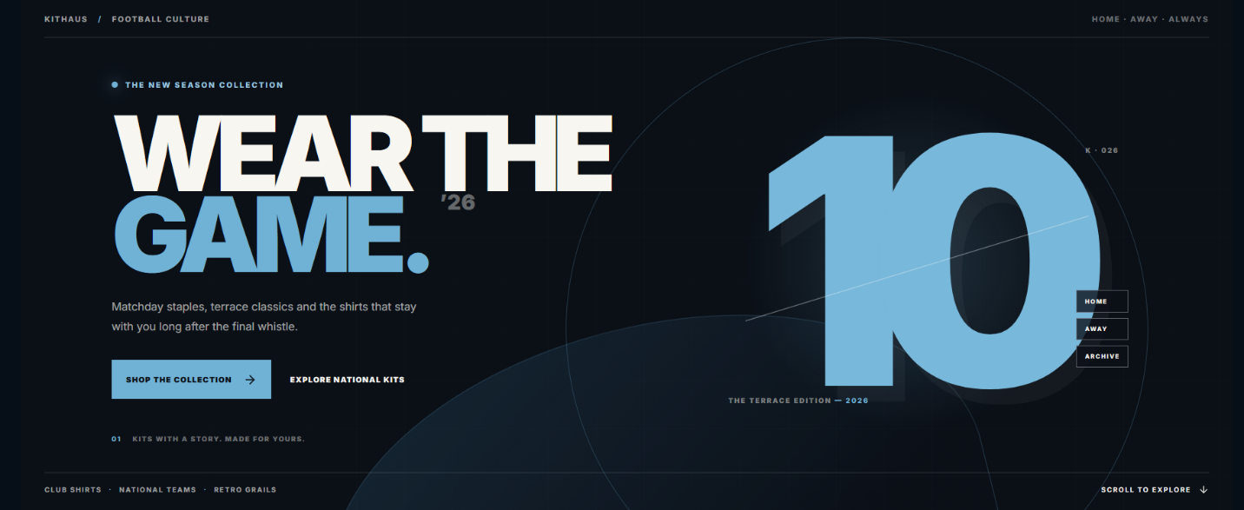
The home page, assembled in App.jsx, stacks seven sections: a hero banner, a category section with four tiles (National Teams, Club Kits, Retro and Vintage, and Kit Personalizer), a trending section that shows four products at a time with previous and next buttons, a retro section, a new products section, a customization banner, and a newsletter form. The form saves a lowercase version of the email in localStorage, warns about duplicates, and reports success or failure.

Catalogue Pages
The club and national team pages are almost identical because both use one shared component, ProductCatalog, and differ only in the title, description, and product list they pass in. It reads the search word and sort choice from the address, applies the selected filters, sorts the result, and shows six products per page. Filters are grouped into league, jersey type, size, and price range (under $75, $75 to $110, $110 to $150, and above $150). Choosing several options within one group means a product may match any of them, while options in different groups must all be satisfied. Seven sorting choices exist: featured (the default, which puts the newest listings first), popularity, trending (popularity, then release rank), newest (release rank, then popularity), price from low to high, price from high to low, and name from A to Z. Changing a filter or sort choice returns the list to page one, and a clear button removes all filters and the search word.
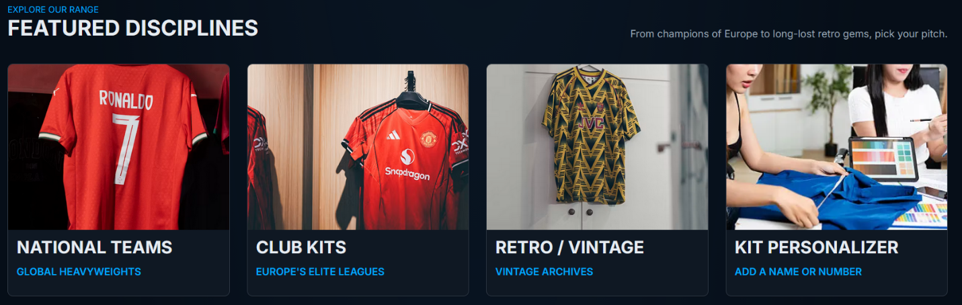

Product Detail Page
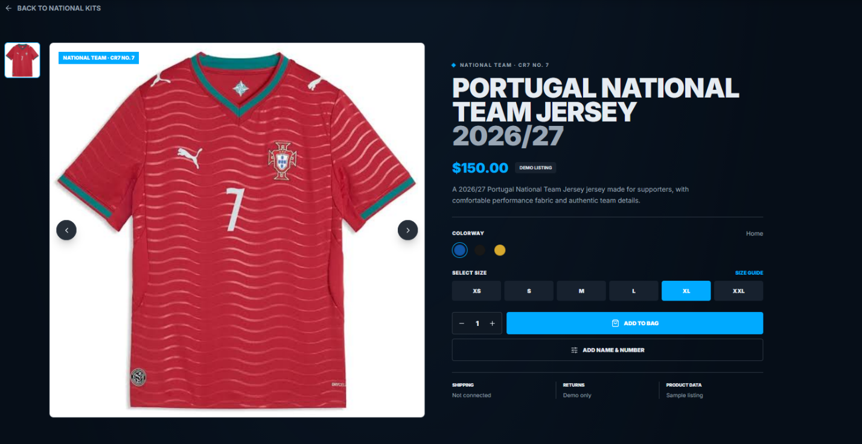
The product page has a picture gallery with thumbnails and previous and next buttons, and an information panel showing the category, name, season, price, description, colour choices, size choices (XL is selected first), and a quantity control that cannot go below one. A button labelled Add Name & Number opens a form in which the name is limited to twelve characters and converted to capital letters, and the number must be a whole number from 0 to 99. Four tabs (Description, Size Guide, Shipping & Returns, and Reviews) give more detail, and three other kits are suggested at the bottom.
When a visitor adds a jersey to the bag, the code joins the product identifier, colour, size, and any print name and number into one identifier, for example liverpool-away-Home-XL-RIVERA-10. Because the identifier includes these choices, two sizes of the same jersey become two separate lines in the bag, while identical choices merge into one line with a larger quantity.

Bag, Checkout, and Account Pages
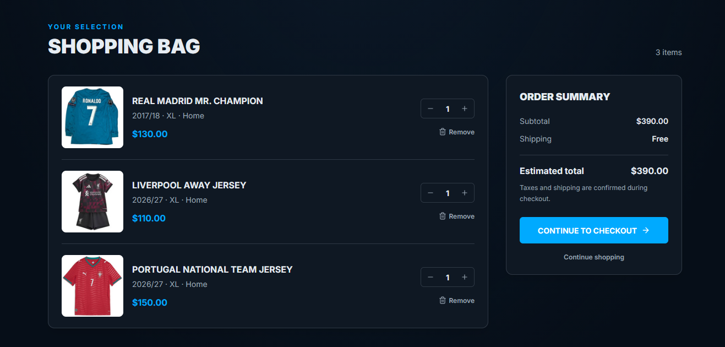
The bag page lists each item with its picture, name, season, size, colour, and any printed name and number. Buttons change the quantity, a bin icon removes the line, and a summary shows the subtotal with a link to checkout. The checkout page asks for full name, email, phone, address, city, and postal code, pre-fills them from the saved profile, and offers cash on delivery as the only payment choice. On submission, placeOrder creates the order and the page shows a confirmation with the order number and total. A visitor who opens checkout with an empty bag is sent back to the bag page. The account page has a profile form and an order history with the newest order first. Because sign-in does not exist, this page is a convenience for one browser rather than a secure personal account.
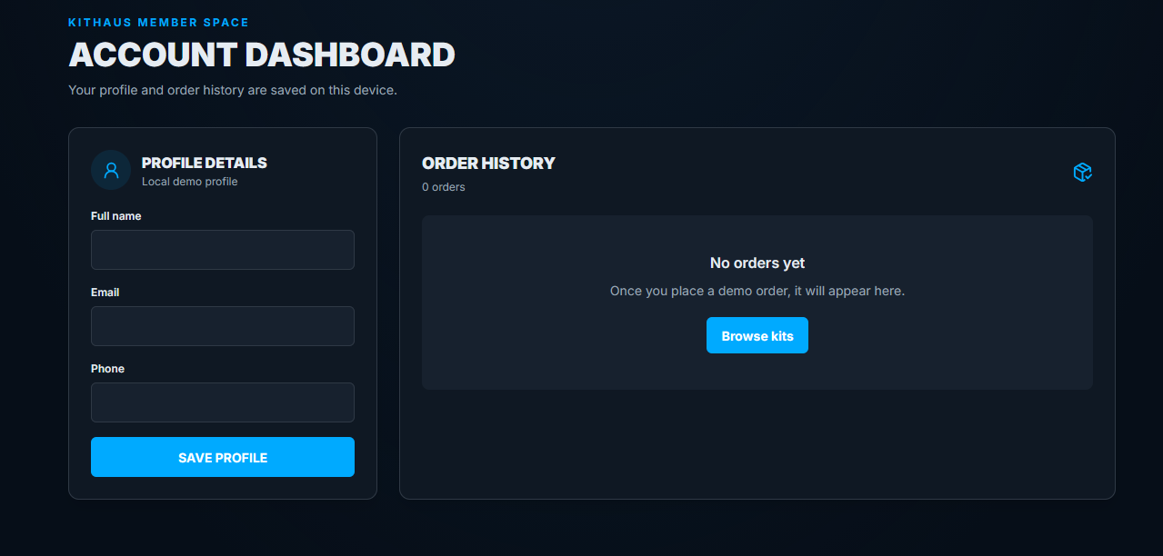
User Guide for Shoppers
The following steps describe a normal visit for a person with no technical background.
- Open the home page and choose a category tile, or type a team name into the search box.
- On the catalogue page, use the filters and the sort menu to narrow the list, and select a jersey.
- On the product page, choose a colour and size, set the quantity, and optionally add a name and number.
- Select Add to Bag, then open the bag icon in the header to review the items.
- Choose Checkout, complete the delivery form, and submit the order.
- Note the order number on the confirmation screen and open the account page later to see the order in the history.

Design, Accessibility, and Code Quality
Colours are defined once as named variables in src/index.css and mapped to Tailwind class names, so the look of the whole store can be changed by editing a few lines. The interface uses a dark colour scheme and adapts to phones, tablets, and large screens through responsive breakpoints. Accessibility practices are visible in the code: icon-only buttons carry labels for screen readers, selected tabs and page numbers are marked with aria-pressed or aria-current, a focus outline appears during keyboard use, and animations are shortened for people who prefer reduced motion. Images that fail to load are replaced by a local placeholder through the StoreImage component.
The project includes an ESLint configuration with recommended JavaScript rules and React hook rules (ESLint, n.d.), and the cart code validates its inputs and stored data. No automated test files were found in the archive, so correctness currently depends on manual checking.

Limitations and Recommendations
Because the project is a demonstration, several limitations are expected. Table 5 lists those found during the review, explains why each matters, and suggests an improvement. The first four rows matter most for turning the demonstration into a real business.
Table 5
Limitations and Suggested Improvements
Limitation | Why it matters | Recommended improvement
No server or database | Bag, profile, and orders exist only in one browser and vanish if browser data is cleared | Add a back-end service and database
No sign-in | The account page is only a saved form, visible to anyone using the same browser | Add secure authentication
No real payment | Orders are neither paid for nor fulfilled | Connect a payment provider
Pictures from outside websites | Many product images load from third-party addresses that can change or disappear, and usage rights are unclear | Host licensed images in the project or on a content delivery service
Products written in code | Changing prices or adding items needs a code edit, and there is no stock control | Move products to a database with an admin screen
Barcelona jersey outside catalogue lists | It is in the master list but not in clubProducts, so catalogue pages and search cannot show it | Build the lists from product fields instead of fixed identifiers
No automated tests | Changes may break features unnoticed | Add unit and end-to-end tests
Generic page title and no not-found page | The browser tab reads mini-jersey-ecommerce, and unknown addresses show an empty page | Set page titles and add a not-found route

The most valuable next step is a back end. With a server and database, products, accounts, and orders could be shared across devices and managed by store staff, and payment and stock levels could be built on that foundation. Tests should be added early so larger changes can be made safely.

Glossary of Common Terms
Table 6 explains technical words used in this document in everyday language.
Table 6
Glossary
Term | Meaning
Component | A reusable building block of a screen, such as a product card
Route | A web address paired with the screen that should appear for it
State | Information that changes while the app is used, such as the bag contents
localStorage | Small storage space inside the browser that survives closing the browser
Build | The process of turning source code into optimized files ready for publishing
Dependency | An outside library that the project needs to work
Responsive design | Layouts that adjust to different screen sizes

Conclusion
The Mini Jersey E-Commerce Web Application is a well-organized front-end store that demonstrates the complete shopping path from browsing to order confirmation. Its clear folder structure and shared cart provider keep the code understandable and the bag, profile, and orders saved between visits. Search, filtering, sorting, and jersey personalization add depth, while the store is honestly presented as a demonstration. With the improvements recommended here, it can become a strong foundation for a real online jersey shop.

References
American Psychological Association. (2020). Publication manual of the American Psychological Association (7th ed.). https://doi.org/10.1037/0000165-000
ESLint. (n.d.). ESLint: Find and fix problems in your JavaScript code. https://eslint.org
Google. (n.d.). Google Fonts. https://fonts.google.com
Lucide Contributors. (n.d.). Lucide. https://lucide.dev
MDN Web Docs. (n.d.). Window: localStorage property. Mozilla. https://developer.mozilla.org/en-US/docs/Web/API/Window/localStorage
Meta Platforms, Inc. (n.d.). React: The library for web and native user interfaces. https://react.dev
Motion. (n.d.). Motion for React. https://motion.dev
React Router. (n.d.). React Router. https://reactrouter.com
Sommerville, I. (2016). Software engineering (10th ed.). Pearson.
Tailwind Labs. (n.d.). Tailwind CSS. https://tailwindcss.com
Vite. (n.d.). Vite: Next generation frontend tooling. https://vite.dev

