**K.P.B. HINDUJA COLLEGE OF COMMERCE**

***(Affiliated to University of Mumbai)***

**MUMBAI-MAHARASHTRA-400004**

**DEPARTMENT OF INFORMATION TECHNOLOGY**



**CERTIFICATE**

This is to certify that the project entitled, _______________, is bonafied work of **_________________** bearing Seat.No: **_____________** submitted in partial fulfillment of the requirements for the award of degree of BACHELOR OF SCIENCE in INFORMATION TECHNOLOGY from University of Mumbai.

**Coordinator Principal**

**Internal Examiner External Examiner**

**Date: College Seal**

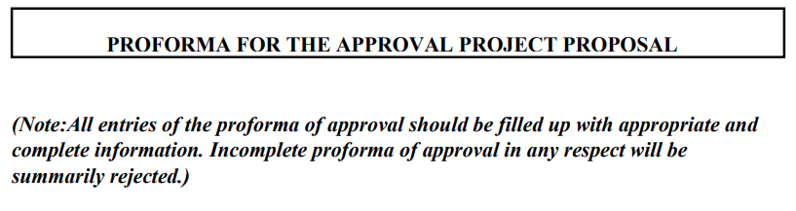

**PRN NO:** _______________________  **ROLL NO:** ______

1. **Name of Student:** _______________________
2. **Title of the Project:** _______________________
3. **Name of Guide:** _______________________
4. **Teaching Experience of Guide:** ___________
5. **Is this your first Submission:** Yes

**Signature of the Student Signature of the Guide**

**Date:** 2nd March 2024 **Date:** 2nd March 2024

**Signature of the Coordinator**

**Date:**

Smt. P.D. Hinduja Trust’s

K.P.B. Hinduja College of Commerce

(Autonomous)

NAAC Re-Accredited A+ (3rd Cycle )

College with Potential for Excellence by UGC

CERTIFICATE

This is to certify that Mr. / Miss / Mrs. **___________________** of **T. Y. B. Sc. [IT]**

**Roll No. ____ , University Exam Seat No. _________** 2023-24 has completed his/her practical work in the subject of **Software Quality Assurance**, as required by the University of Mumbai for the partial fulfilment of **T. Y. B. Sc. IT SEM VI** The information submitted is true and original to the best of my knowledge.

_____________ _________________ __________________

Co-Ordinator Dr. Ansari M. Nasir Dr. (Ms) M. B. Madlani

Principal

______________ _______________ ______________

Internal Examiner External Examiner College Seal