**ONLINE BOOK SHOPPING**

**(BACHLOR OF SCIENCE IN INFORMATION TECHNOLOGY)**

**By**

Ritesh Tendolkar

51

Vinod Surve

49

**UNDER THE GUIDANCE OF**

**Dr.Mohd.Ansari.Nasir**

(Co-Ordinator Of Department Of Information Technology)



**DEPARTMENT OF INFORMATION TECHNOLOGY**

**K.P.B. HINDUJA COLLEGE OF COMMERCE**

***(Affiliated To University Of Mumbai)***

**MUMBAI 400004**

**MAHARASHTRA**

**2023-2024**

**PROFORMA FOR THE APPROVAL PROJECT PROPOSAL**

**PRN NO:** 2021016400927055 **ROLL NO:** 49

1. **Name of Student:** SURVE VINOD DATTATRAY
2. **Title of the Project:** Online Book Shopping
3. **Name of Guide:** DR. MOHD. ANSARI NASIR
4. **Teaching Experience of Guide:** 15 years
5. **Is this your first Submission:** Yes

**Signature of the Student Signature of the Guide**

**Date:** 2nd March 2024 **Date:** 2nd March 2024

**Signature of the Coordinator**

**Date:**

**K.P.B. HINDUJA COLLEGE OF COMMERCE**

***(Affiliated to University of Mumbai)***

**MUMBAI-MAHARASHTRA-400004**

**DEPARTMENT OF INFORMATION TECHNOLOGY**



**CERTIFICATE**

This is to certify that the project entitled, "**Online Book Shopping**", is bonafied work of **Tendolkar Ritesh Eknath and** **Surve Vinod Dattatray** bearing Seat.No: **2020426 and 2020421** submitted in partial fulfillment of the requirements for the award of degree of BACHELOR OF SCIENCE in INFORMATION TECHNOLOGY from University of Mumbai.

**Internal Guide Coordinator**

**External Examiner**

**Date: College Seal**

Smt. P.D. Hinduja Trust’s

K.P.B. Hinduja College of Commerce

(Autonomous)

NAAC Re-Accredited A+ (3rd Cycle )

College with Potential for Excellence by UGC

CERTIFICATE

This is to certify that Mr. / Miss / Mrs. **Tendolkar Ritesh Eknath** of **T. Y. B. Sc. [IT]**

**Roll No. 51 , University Exam Seat No. 2020426** 2023-24 has completed his/her practical work in the subject of **Software Project Management**, as required by the University of Mumbai for the partial fulfillment of **T. Y. B. Sc. IT SEM V** The information submitted is true and original to the best of my knowledge.

_____________ _________________ __________________

Subject Teacher Dr. Ansari M. Nasir Dr. (Ms) M. B. Madlani

Co-Ordinator, Principal

B. Sc. IT

______________ _______________ ______________

Internal Examiner External Examiner College Seal

Smt. P.D. Hinduja Trust’s

K.P.B. Hinduja College of Commerce

(Autonomous)

NAAC Re-Accredited A+ (3rd Cycle )

College with Potential for Excellence by UGC

CERTIFICATE

This is to certify that Mr. / Miss / Mrs. **Surve Vinod Dattatray** of **T. Y. B. Sc. [IT]**

**Roll No. 49 , University Exam Seat No. 2020421** 2023-24 has completed his/her practical work in the subject of **Software Project Management**, as required by the University of Mumbai for the partial fulfillment of **T. Y. B. Sc. IT SEM V** The information submitted is true and original to the best of my knowledge.

_____________ _________________ __________________

Subject Teacher Dr. Ansari M. Nasir Dr. (Ms) M. B. Madlani

Co-Ordinator, Principal

B. Sc. IT

______________ _______________ ______________

Internal Examiner External Examiner College Seal

**ABSTRACT**

The objective of this project is to develop an e-book store where books can be bought from the comfort of home through the Internet. An online book store is a virtual store on the Internet where customers can browse the catalog and select books of interest. The selected books may be collected in a shopping cart. The customer can then proceed to a checkout process, where the payment and delivery options are selected. The payment can be made using a credit card or other electronic payment methods. Once the payment is confirmed, the books are delivered to the customer's address. The system also provides an interface for the administrator to manage the books, customers, orders, and payments.

This project report on "Online Book Shopping" an e-commerce website that includes the following chapters:

- Introduction

- Survey of Technology

- Requirements and Analysis

- System Design

**ACKNOWLEDGEMENT**

We are pleased to present the “Online Book Shopping” project and take this opportunity to express our profound gratitude to all those who helped us complete this project.

We thank our college for providing us with excellent facilities that helped us to complete and present this project. We would also like to thank the staff members and lab assistants for permitting us to use computers in the lab as and when required.

We express our deepest gratitude towards our project guide for his/her valuable and timely advice during the various phases of our project. We would also like to thank him/her for providing us with all the proper facilities and support as the project co-coordinator. We would like to thank him/her for support, patience and faith in our capabilities and for giving us flexibility regarding working and reporting schedules.

We would like to thank all our friends for their smiles and friendship making the college life enjoyable and memorable. Family members always stood beside us and provided the utmost important moral support. Finally, we would like to thank everyone who has helped us directly or indirectly in our project.

**Table Of Contents**

**Chapter 1: Introduction**

* 1. Background
  2. Objectives
  3. Purpose, Scope, and Applicability
  4. Achievements

**Chapter 2: Survey of Technology**

* 1. Justification of selection of technology

**Chapter 3: Requirements and Analysis**

* 1. Problem Definition
  2. Working of Existing system
  3. Limitations of existing system
  4. Working of proposed system
  5. Features of proposed system
  6. Requirements Specification
     1. Hardware requirement
     2. Software requirement
  7. Requirement Analysis
     1. Fact Finding Techniques
        1. Observation
        2. Record review
        3. Interview
        4. Questionnaires
     2. Feasibility study
        1. Economical feasibility
        2. Technical feasibility
        3. Operational feasibility

**Chapter 4: System Design**

1. Basic Modules (Module division)
2. Schema/Database Design (Data Dictionary)
3. Gantt Chart
4. ER Diagram
5. Class Diagram
6. Object Diagram
7. Use case diagram
8. Collaboration/Sequence diagram
9. Activity diagram
10. State diagram
11. Package diagram
12. Component diagram
13. Deployment diagram

**Chapter 5: Implementation and Testing**

1. Code (Place Core segments) -Content includes description about coding phase in your project
2. Testing Approach (Black Box Testing and White Box Testing)
3. Unit Testing: Boundary Value Analysis (apply for project and write its test case with test result)
4. Equivalence Class Partitioning (apply for project and write its test case with test result)

**Chapter 6: Results** (Place Screen Shots and write the functionality of each screen at the bottom)

**Chapter 7: Conclusion and Future Work**

**Chapter 8: References** (Title of the book, Author, Full URL of online references etc.)

**Chapter 1**

**Introduction**

**Online shopping** is the process whereby consumers directly buy goods, services etc. from a seller interactively in real-time without an intermediary service over the internet.

Online shopping is the process of buying goods and services from merchants who sell on the Internet. Since the emergence of the World Wide Web, merchants have sought to sell their books to people who surf the Internet. Shoppers can visit web stores from the comfort of their homes and shop as they sit in front of the computer. Consumers buy a variety of items from online stores. In fact, people can purchase just about anything from companies that provide their books online. Books, clothing, household appliances, toys, hardware, software, and health insurance are just some of the hundreds of books consumers can buy from an online store.

Many people choose to conduct shopping online because of the convenience. For example, when a person shops at a brick-and-mortar store, she has to drive to the store, find a parking place, and walk throughout the store until she locates the books she needs. After finding the items she wants to purchase, she may often need to stand in long lines at the cash register.

**1.1** **Background**

Online shopping allows you to browse through endless possibilities, and even offers merchandise that's unavailable in stores. If you're searching for a niche product that may not be distributed locally, you're sure to find what you're looking for on the internet. What's even more useful is the ability to compare items, similar or not, online. You can search through multiple stores at the same time, comparing material quality, sizes and pricing simultaneously.

Online bookstores offer a wide range of books, including textbooks, novels, biographies, and more. They also provide customers with the ability to search for books by author, title, or subject matter.

Say 'goodbye' to the days when you stood in line waiting, and waiting, and waiting some more for a store clerk to finally check out your items. Online shopping transactions occur instantly-saving you time to get your other errands done! Additionally, unlike a store, online shopping has friendly customer service representatives available 24 hours a day, 7 days a week to assist you with locating, purchasing and shipping your merchandise.

**1.2 Objective**

Our objective is to design such an application using which one can say 'goodbye' to the days when you stood in line waiting, and waiting some more for a store clerk to finally check out your items. The objective of an online book shopping (e-commerce) website is to provide a platform where customers can browse, select, and purchase books from the comfort of their homes. Here are some specific objectives –

* Online bookstores are accessible 24/7, allowing customers to shop at their convenience.
* They offer a vast selection of books across various genres, authors, and languages.
* They provide efficient search and filter options to help customers find specific books.
* They offer home delivery services, sometimes even globally.

My main aim is to design such a book store where customer can visit our site anytime of the day from anywhere to view the available books, choose any of them and can order by paying online or can opt for cash on delivery as well. The administrator will regularly add any new books available to them for sale. The administrator will take books from the reputed publishers and vendors only.

* 1. **Purpose and Scope**

1.3.1 Purpose

The purpose of an online book shopping e-commerce website is to provide customers with a convenient and affordable way to purchase books. Online book shopping offers a number of advantages over traditional brick-and-mortar bookstores, including:

* Convenience: Customers can shop for books online from anywhere in the world, at any time of day or night. They do not need to travel to a physical store or wait in line to purchase a book.
* Selection: Online book stores typically have a much wider selection of books than brick-and-mortar stores. This is because online bookstores do not have the same physical space constraints as brick-and-mortar stores.
* Price: Online book stores often offer lower prices than brick-and-mortar stores. This is because online book stores have lower overhead costs.

Reviews: Online bookstores typically allow customers to read and write reviews of books. This can help customers make informed decisions about which books to purchase.

1.3.2. Scope

In project management, the “scope” refers to the specific goals, deliverables, features, and tasks that define the boundaries of the project.

1. Complete E-Commerce Functionality: Develop a comprehensive e-commerce platform that allows users to browse products, add items to cart, and make purchases. This includes:

* Product Listing: Display a wide range of books available for purchase.
* Shopping Cart: Allow users to add their chosen books to a shopping cart.
* Checkout System: Enable users to review their cart and proceed to checkout.

2. User and Admin Dashboard: Implement a user-friendly interface for both customers and administrators. This includes:

* User Dashboard: Provide customers with a personal dashboard where they can view their purchase history, track their orders, and manage their account details.
* Admin Dashboard: Develop an admin dashboard for managing product listings, tracking sales, and handling customer inquiries.

3. Advanced Features: Incorporate advanced features to enhance user experience and streamline operations. This includes:

* Payment Options: Integrate multiple payment options (credit/debit cards, net banking, digital wallets) to provide flexibility to customers.
* Responsive Design: Ensure the website is responsive and provides optimal viewing experience across a range of devices (desktop, mobile, tablet).
* Email Notifications: Implement an automated system for sending emails to users regarding order confirmation, shipping details, and other updates.
* Online Deployment: Deploy the project online to make it accessible to users across the globe.

4. The main issues being addressed in the project are:

* The project will address the need for advanced features such as diverse payment options, responsive web design.
* Protecting customer data and ensuring secure transactions are critical issues that the project will address.
* SQL injection attacks pose a significant threat to database security by manipulating SQL queries through user inputs.
  1. **Achievements**

Through this project, we achieved a deep understanding of e-commerce principles and website development. We had successfully designed and implemented an online book shopping platform that meets the objectives of providing convenience, a wide selection of books, efficient search options, and user-friendly interfaces for both customers and administrators.

Through the development process, we gained hands-on experience in various technical aspects such as website development, database management, user interface design, and payment integration, thus expanding our technical skill set.

The project emphasized user-centric design principles, resulting in an intuitive and user-friendly interface that enhances the overall shopping experience for customers, fostering increased user engagement and satisfaction.

**Chapter 2**

**Survey of Technology**

**Latest technology**

**JavaScript :-** It is a lightweight, interpreted, object-oriented programming language that is mainly used for client-side web development. It enables dynamic interactivity on web pages by manipulating the HTML document object model (DOM) and applying various effects and features. It also supports scripting, first-class functions, prototype-based inheritance, and asynchronous and event-driven programming.

**Java :-** It is a **general-purpose, object-oriented, platform-independent** programming language that is widely used for creating **web, desktop, and mobile applications**. It also supports **robust, secure, and high-performance** features, such as automatic garbage management, integrated development environment (IDE), and a rich application programming interface (API). Java has a large and active community of developers and good documentation.

**Python** **:-** It is a **high-level, interpreted, multi-paradigm** programming language that is widely used for creating **web, desktop, and data science applications**. It also supports **simple, readable, and expressive** features, such as dynamic typing, multiple inheritance, indentation-based syntax, and built-in data structures. Python has a large and diverse community of developers and a rich collection of libraries and frameworks.

**Crystal** **:-** It is a **compiled, object-oriented, systems programming language** that aims to combine the **speed and efficiency of C** with the **readability and friendliness of Ruby**. Crystal has a syntax close to Ruby’s and features **statically inferred types, C bindings, and macros.** Crystal can be used for creating web, desktop, and blockchain applications.

**Dart :-** It is an **open-source, object-oriented, client-optimized programming language** that is widely used to develop **mobile, web, desktop, and IoT applications** using the Flutter framework. Dart has a C-style syntax and supports **advanced concepts** such as interfaces, mixins, abstract classes, generics, and null safety. Dart also supports **asynchronous programming** with futures and streams.

**Raspbian :-** It is a **free operating system based on Debian** optimized for the **Raspberry Pi** hardware. Raspberry Pi is a **mini-computer** that can be used for various projects, such as robotics, gaming, or smart home. Raspbian comes with over **35,000 packages** of pre-compiled software and utilities that make it easy to install and use on your Raspberry Pi. Raspbian also has some **new features** added in 2018, such as a setup wizard, a recommended software tool, a new PDF viewer, and network booting.

**Windows :-** It is a **popular operating system** developed by Microsoft that runs on personal computers, laptops, tablets, and other devices. Windows has many **features and components** that allow users to perform various tasks, such as browsing the web, managing files, playing games, and working with applications. Windows also lets users **customize** their settings, appearance, and preferences. Windows has different **versions** and **editions** that cater to different needs and preferences of users.

**MacOS :-** Itis an **operating system** developed by Apple that runs on Mac computers. macOS is **graphically based**, meaning that users can interact with icons, menus, and windows using a mouse or a trackpad. macOS has many **features and tools** that allow users to do various tasks, such as browsing the web, checking email, editing photos, listening to music, and playing games. macOS also supports **Handoff** and **Universal Clipboard**, which let users seamlessly switch between Mac and other Apple devices.

**Ubuntu :-** It is a **free and open-source operating system** based on Linux that runs on desktops, laptops, servers, and cloud platforms. Ubuntu is **easy to install, manage, and use**, and supports a wide range of hardware and software. Ubuntu has a **simple and intuitive interface** that lets users launch applications from a launcher or a dash. Ubuntu also has thousands of **apps available for download** from its software center, including office, web, email, photo, and gaming apps.

**Solaris :-** It is an **enterprise-class operating system** developed by Oracle that runs on SPARC and x86-64 systems. Solaris is known for its **scalability, security, and innovation**, and has many features such as **DTrace, ZFS, and Solaris Containers.** Solaris can be installed from various software groups, depending on the user’s needs. Solaris also supports **software-defined networking** and **built-in virtualization** for deploying cloud applications.

**Acros :-** It is a **modern operating system** based on OS/2 that is developed by Arca Noae. Acros supports **symmetric multiprocessing systems** with up to 64 processor cores, and is **ACPI 6.1-compliant**. Acros also has **hardware compatibility** with various devices, such as USB, network, audio, and video. Acros is designed for **business and personal use**, and can run many OS/2, DOS, and Windows applications.

**Oracle :-** It is a **relational database management system** developed by Oracle Corporation. Oracle is used to store, manage, and manipulate data for various applications and purposes. Oracle has many **features** that make it powerful, scalable, and reliable, such as **Real Application Clustering, Portability, Diagnosability, and Performance**. Oracle also has different **versions and editions** that offer different functionalities and options for users. Oracle is widely used by businesses and organizations for its **advantages** such as portability, security, and compatibility.

**MySQL** **:-** It is a **relational database management system (RDBMS)** that uses SQL (Structured Query Language) to store, manage, and manipulate data. MySQL is **open-source and free** under the GNU license, and supported by Oracle Corporation. MySQL has many **features and benefits** that make it popular and widely used, such as **ease of use, security, scalability, reliability, and performance**. MySQL can be used for various applications and purposes, such as data warehousing, online shopping, logging software, and portals.

**MongoDB** **:-** It is a **NoSQL document database** that stores data in flexible JSON-like documents. MongoDB is **schema-less**, meaning that documents in the same collection can have different structures and fields. MongoDB has many **features** that make it powerful, scalable, and easy to use, such as **sharding, replication, indexing, and ad hoc queries**. MongoDB can be used for various applications and purposes, such as big data analytics, content management, real-time applications, and IoT.

**Language Used In Project**

**HTML** (HyperText Markup Language) is a **standard language** for creating web pages and web applications. HTML can be used in a Online Book Shopping website to **display and format** the content of the web pages, such as the Categories and Sub-Categories, the book list, the login form, the search function, etc. HTML can also be used to **link** to other web pages or resources, such as images, CSS, JavaScript, PHP, or MySQL. HTML is essential for creating a **user-friendly and interactive** library website.

**JavaScript** is a **scripting language** that can run in the web browser and on the server. JavaScript can be used in a Online Book Shopping website to **add functionality and interactivity** to the web pages, such as validating the login form, searching for books, etc. JavaScript can also be used to **communicate** with the backend server or database, such as using AJAX, Node.js, Express, or MongoDB. JavaScript is useful for creating a **dynamic and responsive** website.

**CSS** Like HTML, CSS is not a programming language. It's not a markup language either. CSS is a style sheet language. CSS is what you use to selectively style HTML elements. CSS is a language that is used to style and layout web pages. It can change the appearance of elements such as fonts, colors, backgrounds, and more. It can also create animations and other decorative features. CSS works by applying rules to elements that match certain selectors. CSS can be written in external files, internal style blocks, or inline attributes.

**Bootstrap** is a **popular and free CSS framework** that provides ready-made components and templates for creating web pages and web applications. Bootstrap can be used in a Online Book Shopping website to **save time and effort** in designing and developing the web pages, such as the navbar, the form, etc. Bootstrap can also be used to **ensure responsiveness and compatibility** across different browsers and devices. Bootstrap is useful for creating a **professional and consistent** website.

**PHP, or Hypertext Preprocessor** is a server-side scripting language used in web development. In an online book shopping website, PHP is used for server-side processing, database interaction, generating dynamic content, user authentication, and handling backend logic. It plays a crucial role in the functionality and operation of the website.

**VSCode** is a tool that can make and change code for websites and apps. You can use VSCode to change website files from anywhere using FTP or GitHub or Azure Repos. You can also use VSCode to test and fix your code, add more features, and change your settings.

Google Chrome, as a web browser, plays a crucial role in online book shopping. It serves as the platform where users interact with the online bookstore. Users can search for books, read descriptions, add books to their cart, and make purchases all within the Chrome browser.

**Chapter 3**

**Requirement and Analysis**

* 1. **Problem Definition**

**Current online book shopping websites often face challenges with: -**

Limited search options and filters: Difficulty finding specific books based on detailed criteria

Inefficient inventory management: Stock levels are inaccurate, leading to unexpected delays or cancellations.

Unintuitive user interface: Navigation is difficult and checkout process is complex.

Limited customer support options: Difficulty contacting customer service for assistance.

Need for New system:-

* Online Book Store is a specific requirement of the client that integrates the buying and selling services specifically to their customers.
* Reports can be generated at any time within few seconds, so that manual labor is not required, and also analysis can be performed much more frequently which helps in taking decision.
* The details regarding all users, books can also be maintained as their information is very helpful and sometimes becomes a critical requirement.
* Allows user to get registered from their places and transact for the required product.
* To overcome these problems we develop “Online Book Store”.
* Offer advanced search and filtering features: Allow users to easily find specific books by genre, author, publication date, rating, format, etc.
* Utilize accurate inventory management systems: Ensure real-time stock information to avoid delays and cancellations.
* Provide a user-friendly interface: Make navigation and checkout process simple and intuitive.
* Offer various customer support options: Provide live chat, email, phone support, and FAQs to assist customers.

By implementing these improvements, the new system can:

* Increase customer satisfaction and retention.
* Improve sales and revenue.
* Enhance brand image and reputation.
* Gain a competitive advantage in the online book market.
  1. **Working of Existing system**

A traditional bookstore is a physical retail location where people can buy books in person. Here's a simple explanation of how it works:

1. Setting Up: The bookstore typically has a storefront or a building where books are displayed and sold. It may have shelves, racks, or tables to showcase various titles.

2. Inventory: The store stocks a variety of books across different genres and categories. These books may be new releases, bestsellers, classics, or niche titles.

3. Browsing: Customers enter the store and browse through the selection of books. They can pick up books of interest, read blurbs, flip through pages, and decide whether they want to purchase them.

4. Purchase: When a customer decides to buy a book, they take it to the cashier or checkout counter. The cashier scans the book's barcode or manually enters the book's details into the system.

5. Payment: The customer then pays for the book using cash, credit/debit card, or other accepted payment methods.

8. Returns and Exchanges*: If a customer needs to return or exchange a book, they can usually do so within a specified time frame, provided the book is in resalable condition.

9. Staff Assistance*: Bookstore staff members are available to assist customers in finding books, providing recommendations, answering questions, and offering assistance as needed.

Overall, traditional bookstores provide a physical space for people to explore, discover, and purchase books while also offering a unique social and cultural experience.

* 1. **Limitations of existing system**

Traditional bookstores have some limitations:

1. Limited Selection: Traditional bookstores can only carry a certain number of books due to physical space constraints. This means they might not have the book you're looking for.
2. Location Dependency: You have to physically go to the bookstore, which might not be convenient if it's far away or if you don't have transportation.
3. Operating Hours: Bookstores have specific opening and closing times, so you can't shop whenever you want.
4. No Instant Access to Information: If you have a question about a book or need more information, you might have to rely solely on the knowledge of the staff, which could be limited.
5. Limited Inventory: Physical space constraints mean that traditional bookstores can only stock a finite number of titles. This limitation may result in a narrower selection compared to online retailers or larger bookstores.
6. Geographical Constraints: Customers must physically visit the store to make purchases, which can be inconvenient for those living far away or without easy access to transportation.
7. Operating Costs: Maintaining a brick-and-mortar location entails expenses such as rent, utilities, and staffing. These overhead costs can make it challenging for traditional bookstores to compete with online retailers that have lower operating expenses.
   1. **Working of proposed system**

Website comprises two modules with their sub modules as follows:

* **Admin**

1. Login:
2. The admin can log in using their credentials.
3. Insert and View Book:
   1. It displays a list of all the books available on the website, providing basic information such as the book title, author and also admin can add books.
   2. It also displays entries .
4. Order list
5. It provides a comprehensive overview of all the orders placed by users.
6. Each order record includes essential details such as invoice number, order date, total price and order status.
7. Category and Sub-Category
   1. The admin can add categories and its sub-categories which include information.

* **User**

1. Registration
2. New User can create account by filling the following information such as first name, last name, contact, email, password, address.
3. Login
4. User can Login using his/her email/username and password.
5. Search
   1. The “Search” module enables users to find books on the website
6. Category and Sub-Category
7. This module allows user to browse books based on their categories and its sub-categories enhancing the user’s ability to find books of their interest.
8. View Books
   1. The “View Book” module provides detailed information about a specific book when selected by a user, including its title, author, price, stock, description.
9. Cart
10. The "Add to Cart" module allows users to add books they wish to purchase to a virtual shopping cart.
11. It displays the selected books, their quantities, and the total price.
12. Checkout
13. It is the final step in purchasing process.
14. It allows user to input shipping information, select a payment method and confirm their order.
15. Contact
16. User can submit their queries, share review of their books.
17. User also share their email or username.
    1. **Features of proposed system**

These features can help create a robust and user-friendly ecommerce website :-

Admin Module:

1. Login: Admin can log in with their username and password.

2. Insert and View Book: Admin can add new books to the website and see the list of all available books.

3. Order List: Admin can view all orders made by users, including invoice number, date, total price, and status.

4. Category and Sub-Category: Admin can manage book categories and sub-categories, adding information as needed.

User Module:

1. Registration: New users can sign up by providing their name, contact info, email, password, and address.

2. Login: Registered users can log in with their email and password.

3. Search: Users can search for books on the website.

4. Category and Sub-Category: Users can browse books based on categories and sub-categories.

5. View Books: Users can see detailed information about specific books, including title, author, price.

6. Cart: Users can add books they want to purchase to a virtual shopping cart, which shows selected books, quantities, and total price.

7. Checkout: Users can finalize their purchases by entering selecting a payment method, and confirming their order.

8. Contact: Users can submit queries, share book reviews, and provide contact information like email or username.

**3. 6 Requirements Specification**

3.3.2 Hardware requirements:

Hardware requirements for running this project are as follows:

Processor: - Pentium I or above.

RAM: - 128 MB or above.

HD: - 20 GB or above.

3.3.3 Software requirements:

Software required to make working of product is:

Front end- HTML, PHP, CSS, JAVASCRIPT

Back end- MYSQL

Browser- Chrome or Microsoft Edge

Payment Gateway Integration: For processing transactions securely**.**

* 1. **Requirement Analysis**

A requirement specification document for an online book shopping e-commerce website should include both functional and non-functional requirements. Functional requirements describe what the system should do, while non-functional requirements describe how the system should perform.

Functional requirements that could be included in the document:

1. **User registration and login**: Users should be able to create an account and log in to the website.
2. **Search functionality**: Users should be able to search for books by title, author, or keyword.
3. **Product pages**: Each book should have its own product page with cover image, price.
4. **Shopping cart**: Users should be able to add books to their cart and view the contents of their cart.
5. **Checkout process**: Users should be able to enter their shipping and billing information and complete their purchase.

Non-functional requirements that could be included in the document:

1. **Performance**: The website should load quickly and be responsive to user input.
2. **Security**: User data should be stored securely and transactions should be encrypted.
3. **Scalability**: The website should be able to handle a large number of users and transactions.
4. **Compatibility**: The website should be compatible with a variety of devices and web browsers.
5. **Usability**: The website should be easy to navigate and use.
6. Fact-finding techniques are essential for gathering information effectively. Here's how each technique can be applied to gather information for an online book shopping ecommerce website:
   1. Observation:
   2. Observe user behavior on the website: Analyze how users navigate through the website, which pages they visit the most, and where they spend the most time.
   3. Monitor website performance: Look at metrics such as page load times, bounce rates, and conversion rates to identify any issues that may affect the user experience.
   4. Analyze competitor websites: Observe how other online bookstores design their websites, what features they offer, and how users interact with them.
   5. Record Review:
   6. Analyze website analytics: Review data from tools like Google Analytics to understand user demographics, traffic sources, popular books/categories, and conversion funnels.
   7. Study sales and inventory reports: Examine records of book sales, popular authors, bestselling genres, and inventory turnover rates to make informed decisions about stock management and marketing strategies.
   8. Review customer feedback and reviews: Look at customer reviews, ratings, and feedback to identify areas for improvement and understand customer preferences and pain points.
   9. Interview:
   10. Conduct interviews with website users: Talk to frequent users of the website to gather feedback on their experiences, preferences, and suggestions for improvement.
   11. Interview customer service representatives: Gather insights from customer service representatives about common customer inquiries, complaints, and issues encountered on the website.
   12. Interview stakeholders and employees: Speak with key stakeholders, such as the website owner, managers, developers, and marketers, to understand business goals, technical capabilities, and marketing strategies.
   13. Questionnaires:
   14. Design online surveys/questionnaires: Create surveys to gather quantitative data on user preferences, satisfaction levels, and feedback regarding website usability, book selection, pricing, and customer service.
   15. Distribute surveys to website visitors: Implement pop-up surveys or email surveys to collect feedback from users about their experiences with the website and their preferences for online book shopping.
   16. Analyze survey responses: Use survey data to identify trends, preferences, and areas for improvement, and to make data-driven decisions for optimizing the website and enhancing the user experience.

ii. Feasibility Study

1. Economical Feasibility:

* 1. Cost-Benefit Analysis: Determine the costs associated with developing and maintaining the website versus the potential benefits in terms of revenue generation.
  2. Revenue Projections: Estimate potential revenue based on market research, competitor analysis, and projected user traffic.
  3. Return on Investment (ROI): Calculate the expected ROI over a specific period, considering factors like development costs, operational expenses, and projected profits.
  4. Financial Viability: Assess the financial resources required to launch and sustain the website, including initial investment, operational costs, marketing expenses, and expected revenue streams.

2. Technical Feasibility:

* 1. Infrastructure Requirements: Evaluate the technical infrastructure needed to support the website, including web hosting, database management, and security measures.
  2. Scalability: Determine if the website can accommodate increasing user traffic and growing database size without compromising performance.
  3. Technology Stack: Select appropriate technologies and frameworks for website development, considering factors like scalability, security, and compatibility with desired features.
  4. Integration Capabilities: Assess the feasibility of integrating third-party services for payment processing, shipping, and other functionalities.
  5. Development Timeline: Estimate the time required for website development, testing, and deployment, considering factors like complexity of features and availability of resources.

3. Operational Feasibility:

* 1. User Acceptance: Evaluate the willingness of target users to adopt and use the website for purchasing books online, considering factors like convenience, user experience, and available alternatives.
  2. Resource Availability: Assess the availability of human resources, technical expertise, and operational support required to manage and maintain the website effectively.
  3. Regulatory Compliance: Ensure compliance with relevant regulations and standards related to e-commerce, data privacy, and consumer protection.
  4. Risk Management: Identify potential risks and challenges associated with website operations, such as cyber threats, data breaches, and system failures, and develop strategies to mitigate these risks.
  5. Continuous Improvement: Establish processes for gathering user feedback, monitoring website performance, and implementing updates and enhancements to improve user satisfaction and maintain competitiveness.

**Chapter 4**

**System Design**

**4.1 ER-Diagram**

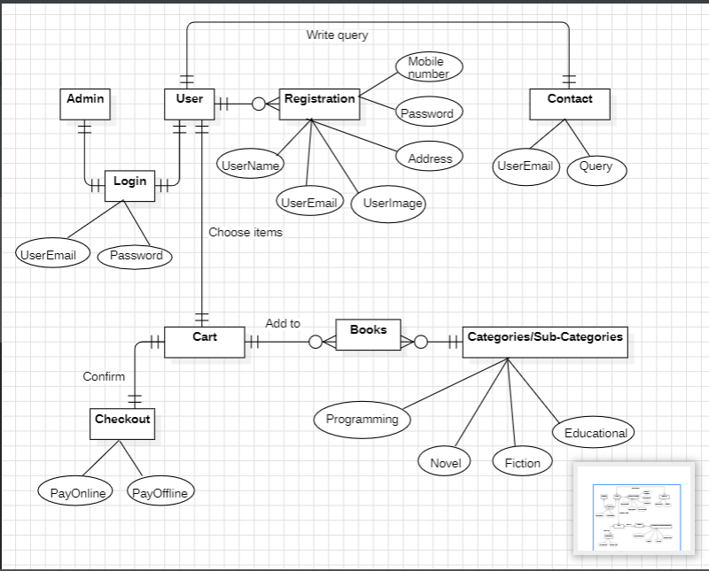

* 1. **Use Case Digram**

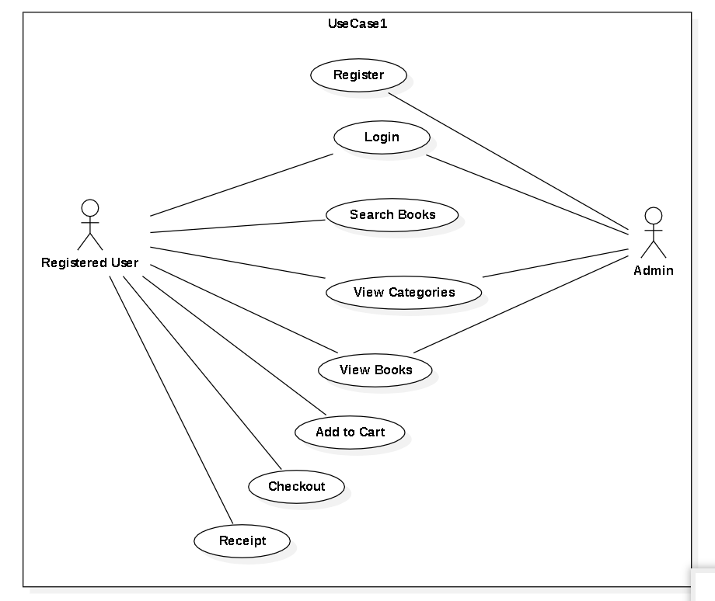

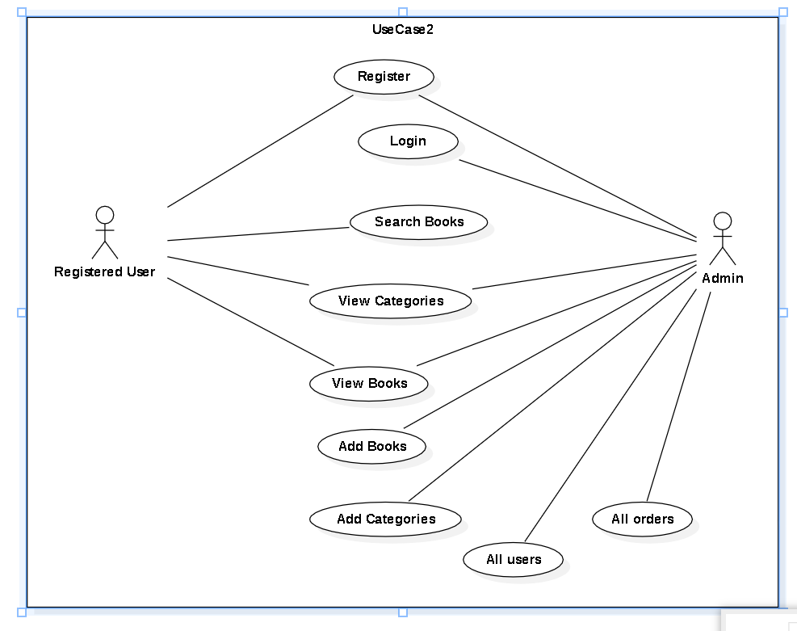

**4.3 Activity Diagram**

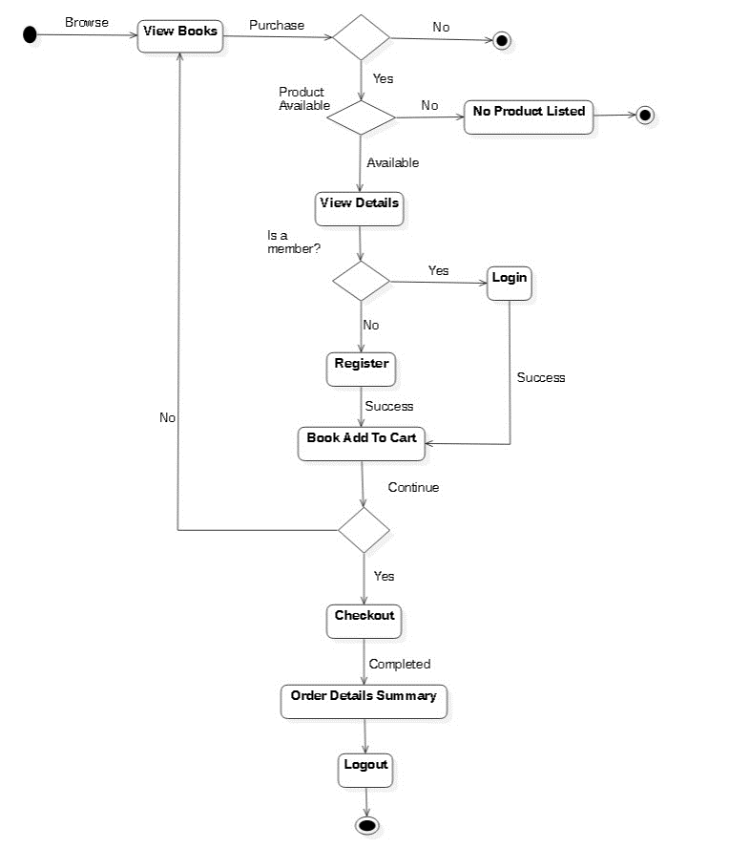

**4.4 Sequence Diagram**

**4.5 Project Lifecycle Details**

## **Waterfall Model**

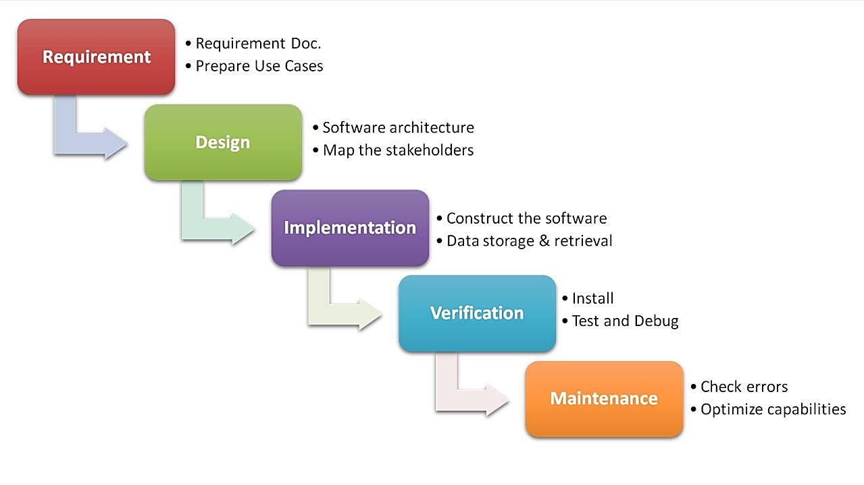

##### **Description**

The Waterfall Model is a linear sequential flow in which progress is seen as flowing steadily downwards (like a waterfall) through the phases of software implementation. This means that any phase in the development process begins only if the previous phase is complete. The waterfall approach does not define the process of going back to the previous phase to handle changes in requirements. The waterfall approach is the earliest approach that was used for software development.

**4.6 Gantt Chart**

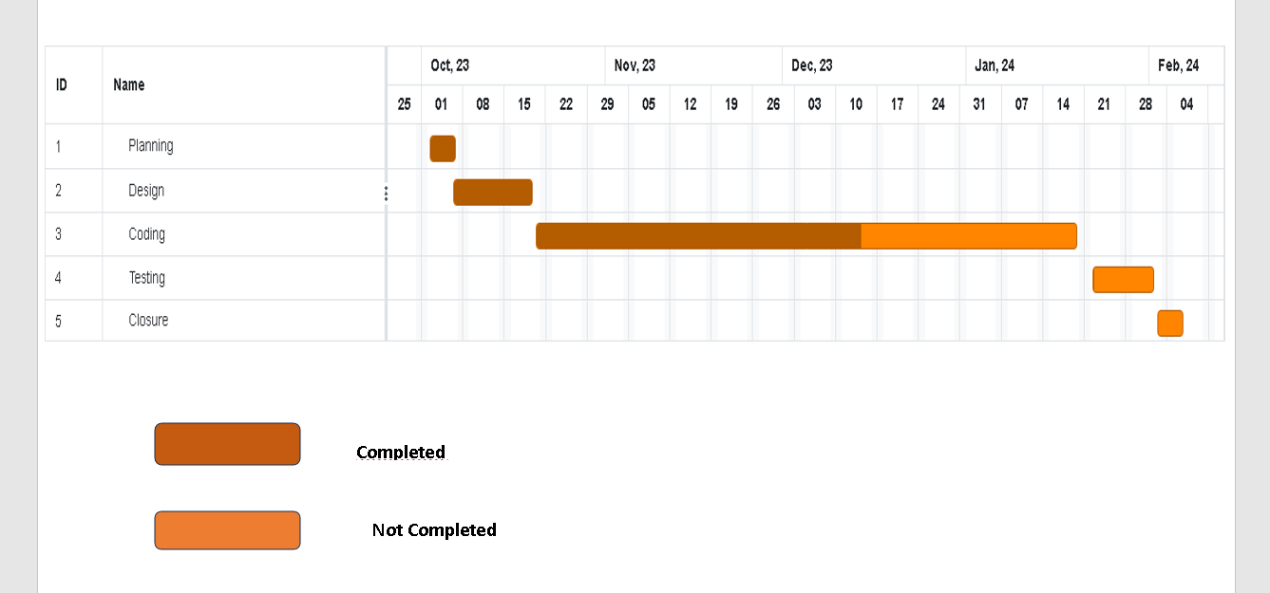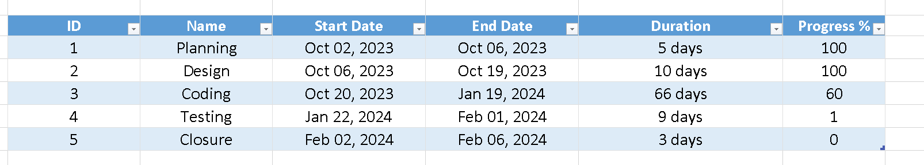

**4.7 State Diagram**

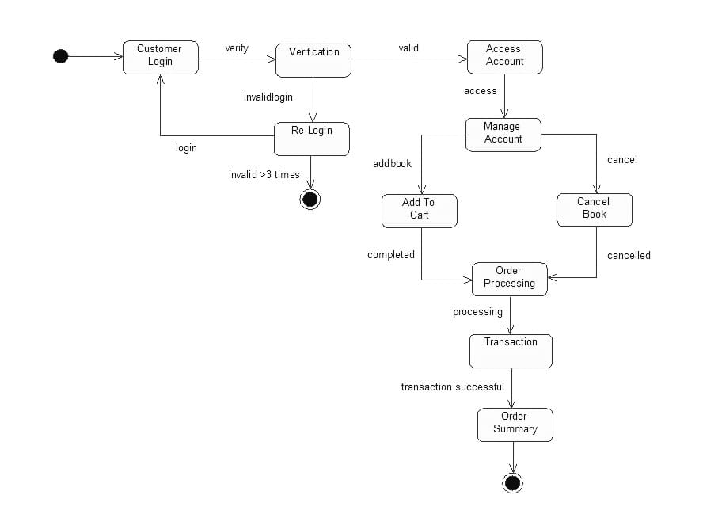

**4.8 Class Diagram**

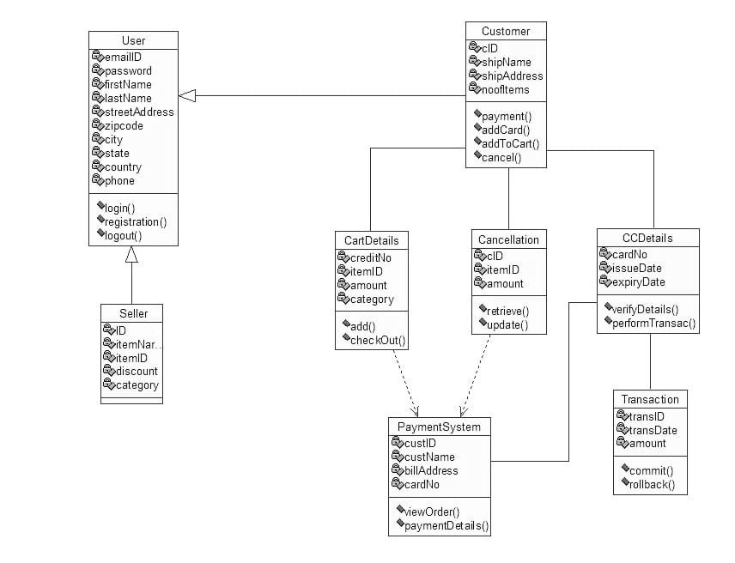

**Notation :-**

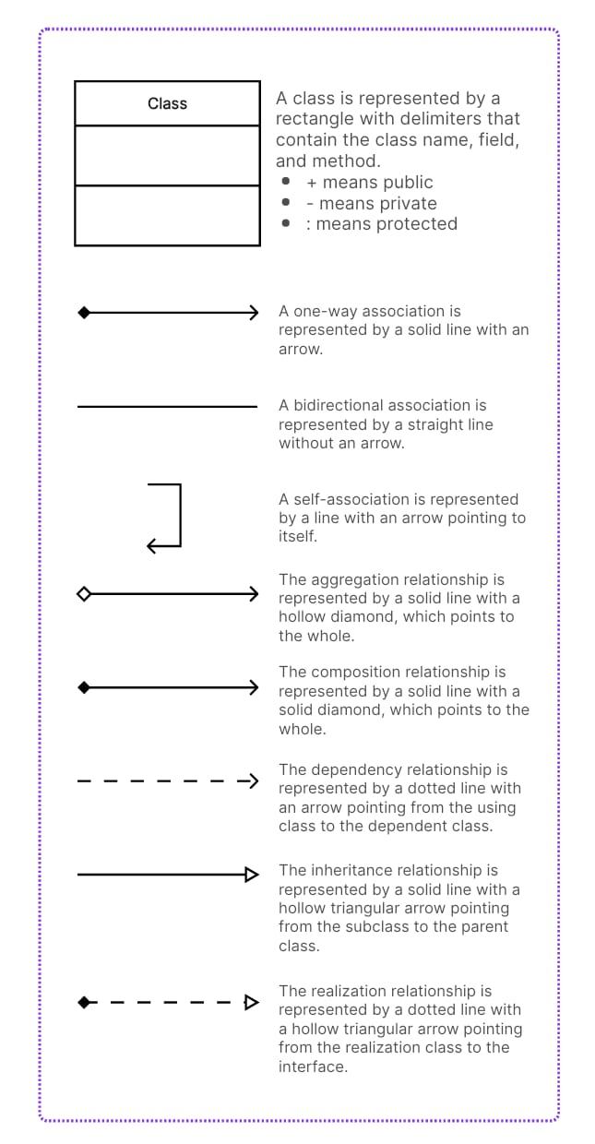

**4.9 Component Diagram**

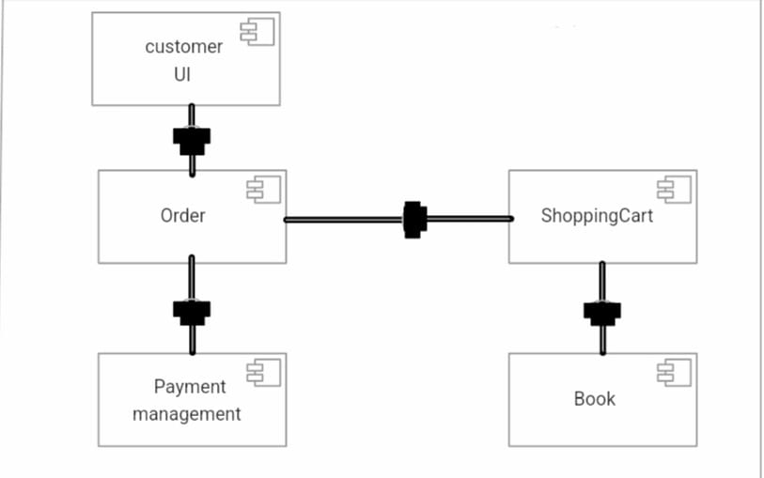

**Notation :-**

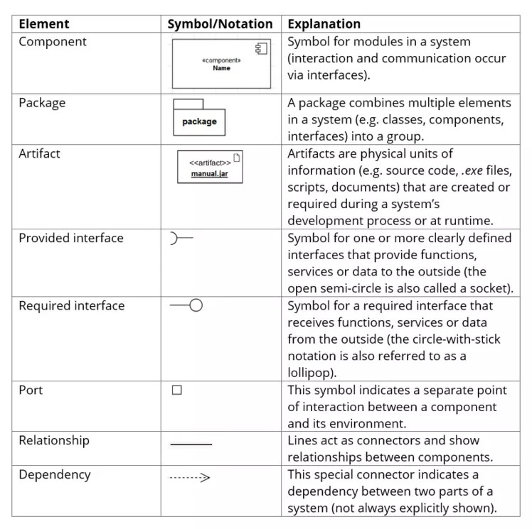

**4.10 Deployment Diagram**

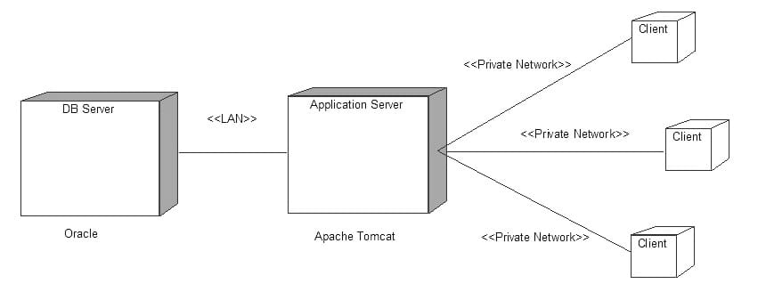

**Notation: -**

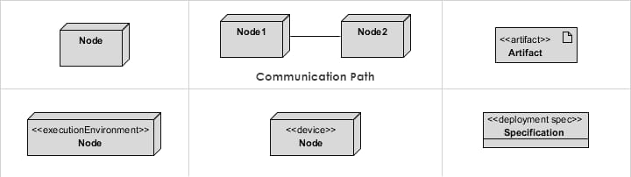

**System diagram description**

* 1. **ER Diagram**

ER diagram is a graphical representation of entities and their relationships to each other. The following are the main components and symbols in ER diagrams:

• Rectangles: Represent entities in the ER model.

• Ellipses: Represent attributes in the ER model.

• Diamonds: Represent relationships among entities.

• Lines: Link attributes to entity types and entity types with other relationship types.

There are some types of relationships in ER Diagrams:

One-to-One

One-to-Many

Many-to-Many

* 1. **Use Case Diagram**

A use case diagram is a UML diagram that represents the interactions between actors and a system. It is used to model the system’s functionality from a user’s perspective. The following are the symbols used in a use case diagram:

* Actor: An actor is a person, organization, or system that interacts with the system being modelled. It is represented by a stick figure icon.
* Use Case: A use case is a set of actions that a system performs to achieve a specific goal. It is represented by an oval shape.
* Association: An association is a relationship between an actor and a use case. It is represented by a line connecting the actor to the use case.
* Include: An include relationship is used to show that one use case includes the functionality of another use case. It is represented by a dashed arrow pointing from the including use case to the included use case.
* Extend: An extend relationship is used to show that one use case can be extended by another use case under specific conditions. It is represented by a dashed arrow with the keyword “extend” written on it.
* Generalization: A generalization relationship is used to show that one actor or use case is a more specific version of another actor or use case. It is represented by a solid line with a hollow arrowhead pointing from the more specific actor or use case to the more general actor or use case.
  1. **Activity Diagram**

An activity diagram is a type of UML diagram that models the flow of control from activity to activity within a system. It is used to model business processes, software applications, and workflows. The following are the main components and symbols in activity diagrams:

* Initial Node: Represents the starting point of the activity diagram.
* Activity: Represents a task or action that is performed in the system.
* Decision Node: Represents a decision point in the activity diagram where the flow of control can take one of several paths.
* Merge Node: Represents a point in the activity diagram where multiple paths converge into a single path.
* Fork Node: Represents a point in the activity diagram where one path splits into multiple paths.

• Join Node: Represents a point in the activity diagram where multiple paths converge into a single path.

• Final Node: Represents the end point of the activity diagram.

These symbols can be used to create a visual representation of the flow of control in a system. By using activity diagrams, developers can better understand the behavior of a system and identify potential problems before they occur.

* 1. **Sequence Diagram**

A sequence diagram is an interaction diagram that shows how objects operate with one another and in what order. It depicts the objects’ interactions in a sequential order, with the vertical axis representing time. The horizontal axis represents the objects involved in the interaction. The following are the symbols used in a sequence diagram:

* + - Lifeline: A lifeline is a vertical line that represents an object’s existence over time. It is used to depict the object’s role in the interaction. The lifeline is labelled with the object’s name and a dashed line extending from it to indicate the duration of the object’s existence.
    - Activation Bar: An activation bar is a rectangle that represents the time during which an object is performing an operation. It is drawn on top of the lifeline and is labelled with the name of the operation being performed.
    - Message: A message is an arrow that represents the communication between two objects. It is drawn from the sender’s lifeline to the receiver’s lifeline and labelled with the name of the message.
    - Return Message: A return message is a dashed arrow that represents the response from the receiver to the sender. It is drawn from the receiver’s lifeline to the sender’s lifeline and labelled with the name of the message.
    - Self-Message: A self-message is a message that is sent from an object to itself. It is represented by a looped arrow that starts and ends on the same lifeline.
    - Create Message: A create message is a message that represents the creation of a new object. It is represented by a dashed arrow that points to the newly created object’s lifeline.
    - Destroy Message: A destroy message is a message that represents the destruction of an object. It is represented by a dashed arrow that points from the object’s lifeline to an X.