ANA 515 Assignment_5

Ritesh Tikhade

4/16/2022

# Histogram: Beer served in the 5 countries.

Beer served in first five countries which include “Afghanistan”,“Albania”,“Algeria”,“Andorra”,“Angola”. From chart we can see that from range (0 to 50) two country and 50-100 one country and 200-250 2 two country has beer servings.

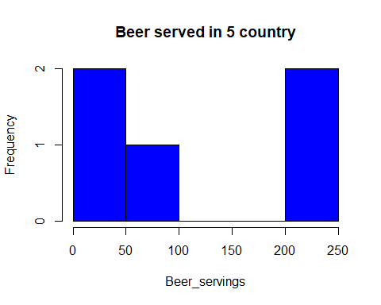

# Barchar of 5 conuntry which serve spirit. From graph we can see that,Afghanistan and Algeria has zero spirit serving and Andorra has highest spirit servings.

