**1. Reading Assignment: A Short History of Java**

* **Task**: Read about the history and development of Java.
* **Link**: <http://sunsite.uakom.sk/sunworldonline/swol-07-1995/swol-07-java.html>

-> Java is made for television but in that time television is not that standard to adopt such technology and Green team saw that the internet is on booming on those days and java can be use for websites in the internet.

**2. Reading Assignment: Java Language Features**

* **Task**: Learn about the main features of Java.
* **Link**: <https://javaalmanac.io/features/>

**-**> Java is platform independent . We can write the java code once andrun it anywhere , which is the slogan also that is given by the Green Team and Here we turn our code to byte code and this code will run in any machine which have JVM on it.

**3. Reading Assignment: Which Version of JDK Should I Use?**

* **Task**: Find out which JDK version is right for you.
* **Link**: https://whichjdk.com/

**4. Reading Assignment: JDK Installation Directory Structure**

* **Task**: Understand the folder structure and files in the JDK installation.
* **Link**: https://docs.oracle.com/javase/8/docs/technotes/tools/windows/jdkfiles.html

**5. Reading Assignment: About Java Technology**

* **Task**: Read about the basics of Java technology and its components.
* **Link**: https://docs.oracle.com/javase/tutorial/getStarted/intro/definition.html

**6. Coding Assignments**

1. **Hello World Program**: Write a Java program that prints "Hello World!!" to the console.
2. 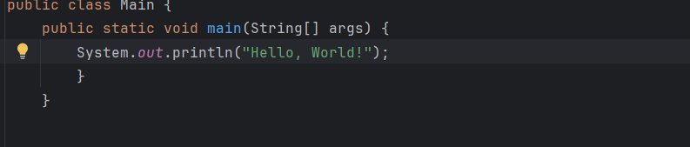
3. **Compile with Verbose Option**: Compile your Java file using the -verbose option with javac. Check the output.
4. 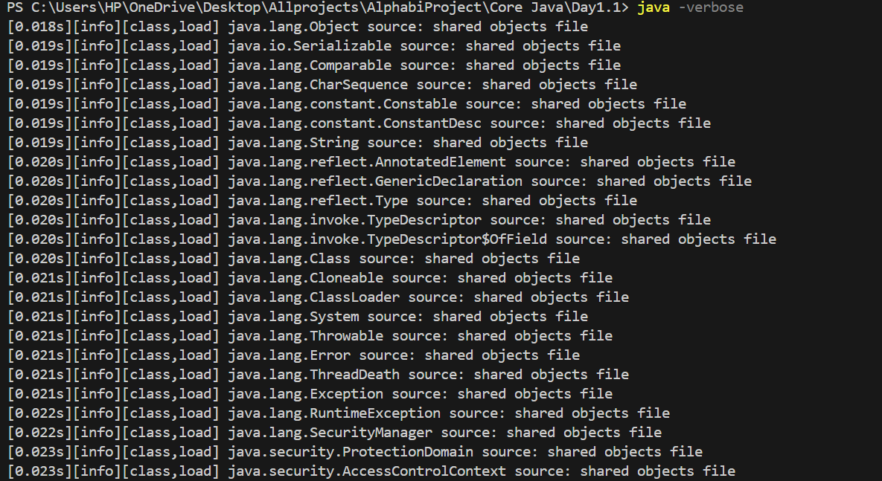
5. **Inspect Bytecode**: Use the javap tool to examine the bytecode of the compiled .class file. Observe the output.

**7. Reading Assignment: The JVM Architecture Explained**

* **Task**: Learn about how the Java Virtual Machine (JVM) works.
* **Link**: https://dzone.com/articles/jvm-architecture-explained

**8. Reading Assignment: The Java Language Environment: Contents**

* **Task**: Explore the content and features of the Java language environment.
* **Link**: https://www.oracle.com/java/technologies/language-environment.html