Part A

What will the following commands do?

• echo "Hello, World!"

* Just print the Hello,World! On the terminal.

• name="Productive"

* Save Productive as name

• touch file.txt

* Create the txt file name as file.txt

• ls -a

* It show all the files present in the directory

• rm file.txt

* Remove the file.txt file present in the directory.

• cp file1.txt file2.txt

* It will copy the content of file1 into file2

• mv file.txt /path/to/directory/

* It moves file.txt to directory folder

• chmod 755 script.sh

• grep "pattern" file.txt

* It print the lines which contains the word pattern in the file file.txt

• kill PID

• mkdir mydir && cd mydir && touch file.txt && echo "Hello, World!" > file.txt && cat file.txt

* Firstly it make the directory name as mydir than go to the directory and make the file.txt file in mydir directory and then append the “Hello, World!” into the file.txt file and the show the result of file.txt.

• ls -l | grep ".txt"

* It will list the long form of the “.txt” files present in the directory.



• cat file1.txt file2.txt | sort | uniq

* It concatenate the file and then sort it and then show the uniq lines of the concatenated output.
* 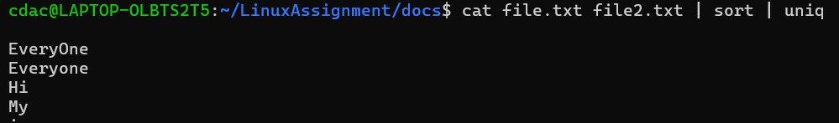

• ls -l | grep "^d"

* List the long form for the directory only in which we are working

• cat file1.txt file2.txt | sort | uniq –d

* It shows the repeated elements only which is present in the file.

• chmod 644 file.txt

• cp -r source_directory destination_directory

• find /path/to/search -name "*.txt"

* It finds the file which ends with .txt

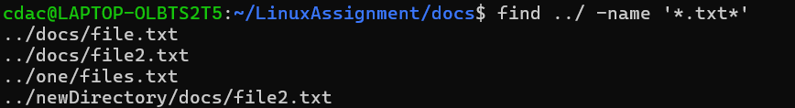

• chmod u+x file.txt

• echo $PATH

* It prints PATH of the current directory.

Part B

Identify True or False:

1. ls is used to list files and directories in a directory.

-> True

2. mv is used to move files and directories. \

-> True

3. cd is used to copy files and directories.

-> False

4. pwd stands for "print working directory" and displays the current directory.

-> True

5. grep is used to search for patterns in files.

-> True

6. chmod 755 file.txt gives read, write, and execute permissions to the owner, and read and execute permissions to group and others.

-> True

7. mkdir -p directory1/directory2 creates nested directories, creating directory2 inside directory1 if directory1 does not exist.

-> True

8. rm -rf file.txt deletes a file forcefully without confirmation.

-> True

Part C

Question 1: Write a shell script that prints "Hello, World!" to the terminal.

* echo “Hello, World!”

Question 2: Declare a variable named "name" and assign the value "CDAC Mumbai" to it. Print the value of the variable.

* name = “CDAC Mumbai”
* echo $name

Question 3: Write a shell script that takes a number as input from the user and prints it.

* echo “Enter the number “
* read num
* echo $num

Question 4: Write a shell script that performs addition of two numbers (e.g., 5 and 3) and prints the result.

* echo “Enter the num1”
* read num1
* echo “Enter the num2”
* read num2
* echo $num1 + $num2

Question 5: Write a shell script that takes a number as input and prints "Even" if it is even, otherwise prints "Odd".

Question 6: Write a shell script that uses a for loop to print numbers from 1 to 5.

Question 7: Write a shell script that uses a while loop to print numbers from 1 to 5.

Question 8: Write a shell script that checks if a file named "file.txt" exists in the current directory. If it does, print "File exists", otherwise, print "File does not exist".

Question 9: Write a shell script that uses the if statement to check if a number is greater than 10 and prints a message accordingly.

Question 10: Write a shell script that uses nested for loops to print a multiplication table for numbers from 1 to 5. The output should be formatted nicely, with each row representing a number and each column representing the multiplication result for that number.

Question 11: Write a shell script that uses a while loop to read numbers from the user until the user enters a negative number. For each positive number entered, print its square. Use the break statement to exit the loop when a negative number is entered.