Name : B L Rithish Barath
Reg No : 24BCE1931
Project : Expense Tracker
MongoDB connected on Port 5000

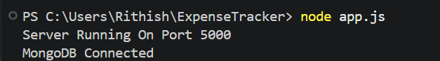

POST /api/auth/signup
201 Created

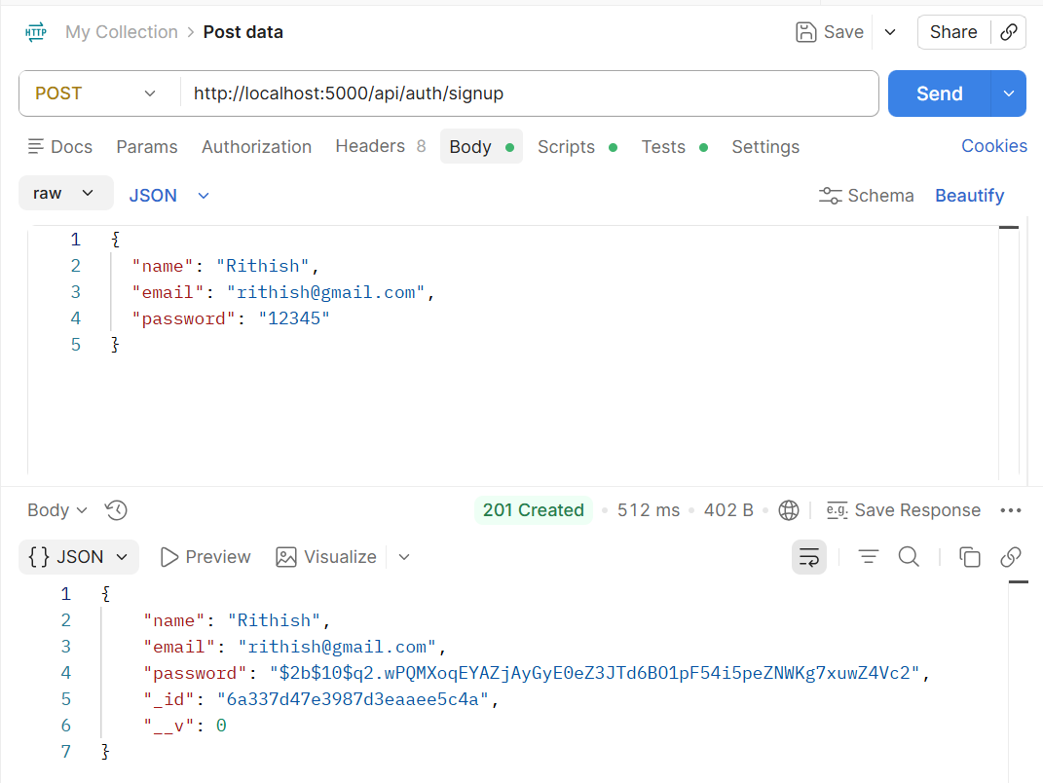

In MongoDB compass , databases -> expensetrackerdb -> users collection , showing the inserted user

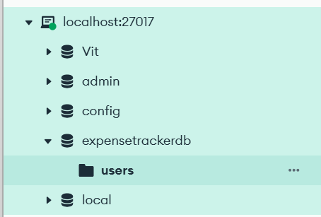

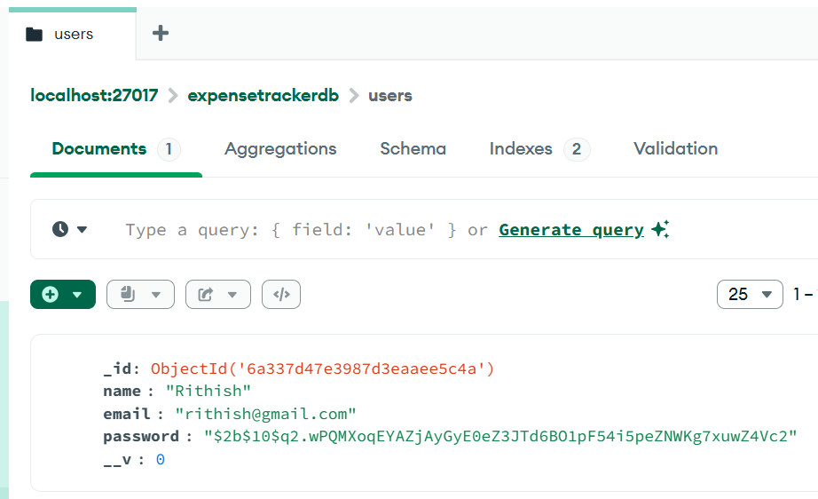

Here the password of the newly created user is hashed up and not directly viewed in the database as we used password encryption using bcryptjs which improves security and showcases authentication module implementation
POST /api/auth/login
200 OK

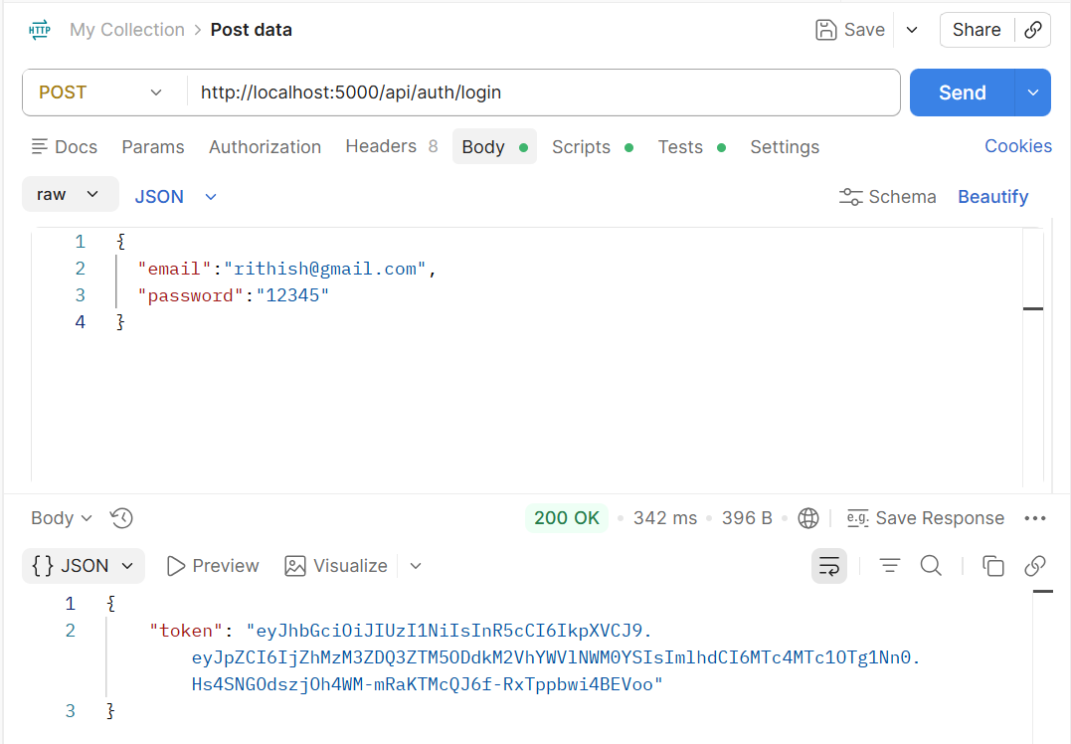

The user login was processed successfully , upon successful password verification , the system generated a JWT Token , using this token , the user can access the protected apis such as expense management, budget management, income management and analytics apis

CREATE Income API
Testing CREATE Income using Postman

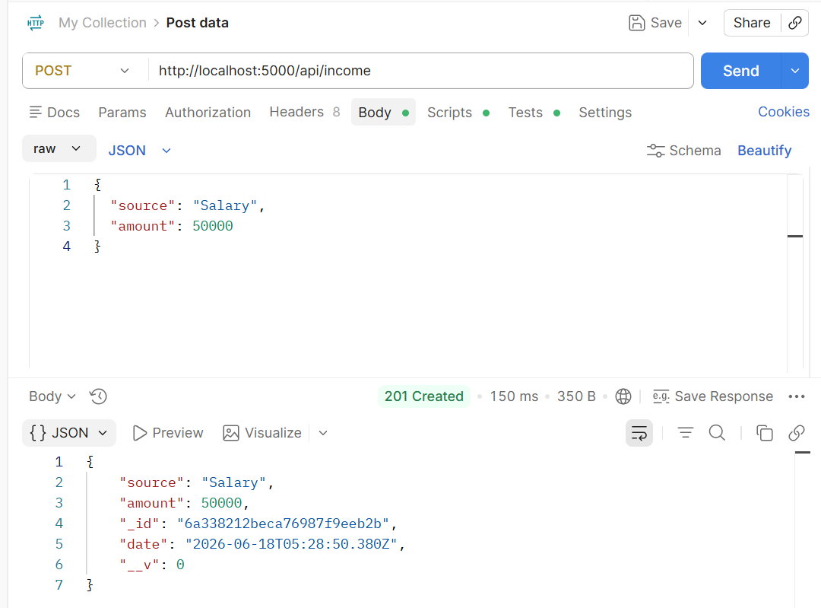

In MongoDB compass , databases -> expensetrackerdb -> incomes collection , showing the inserted inserted income of user

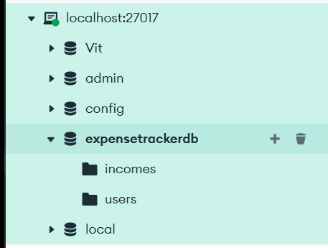

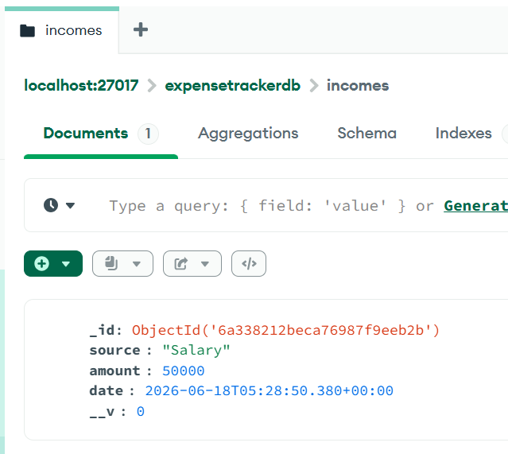

GET Income API
200 OK
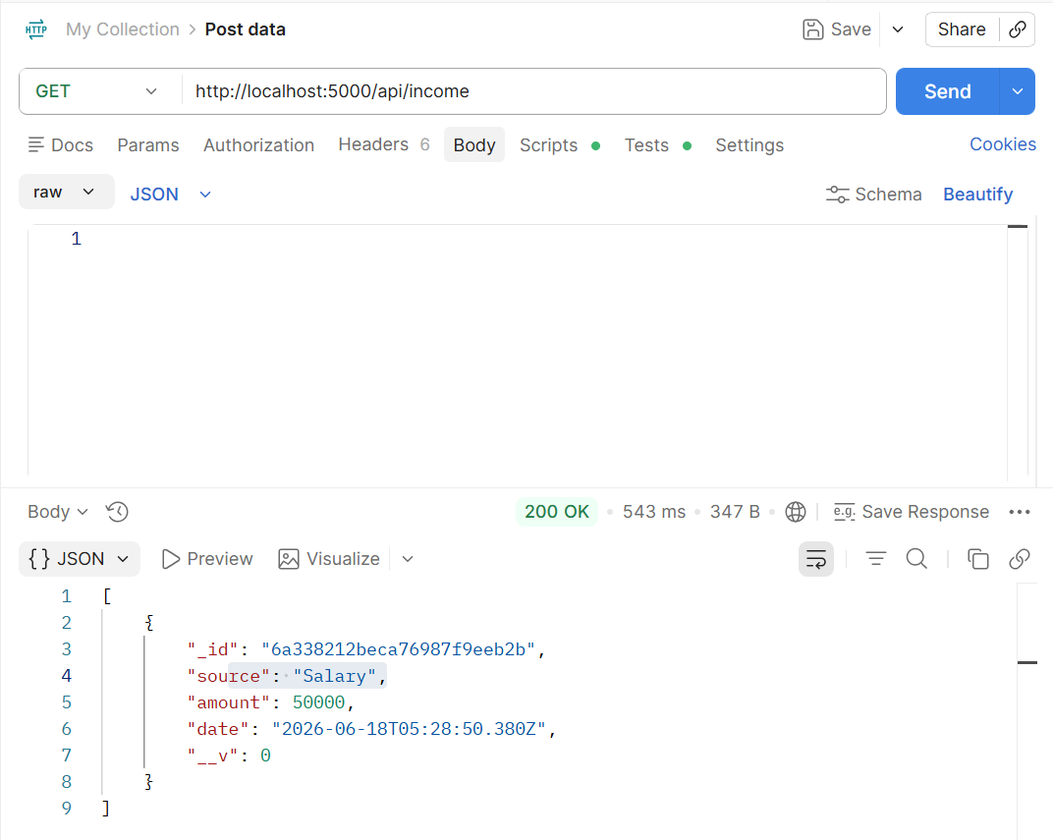

The get api retrieves all the income records stored in database and displays all the available ones.

PUT Income API
200 OK

Before Modification
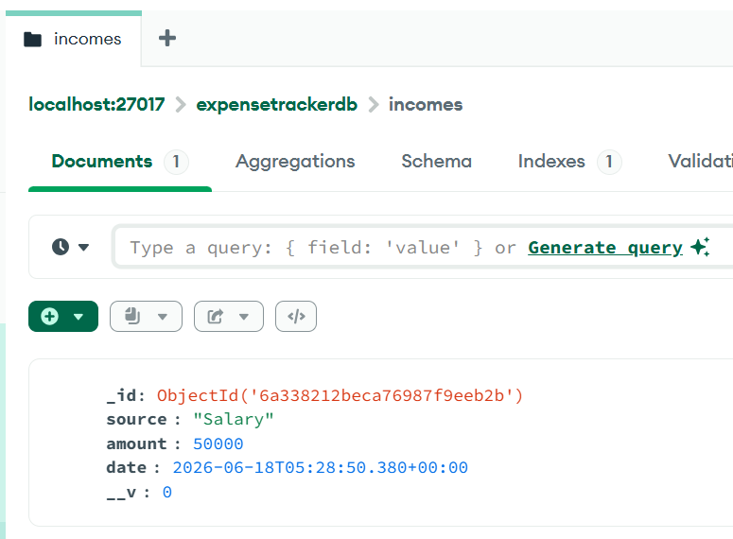
After Modification
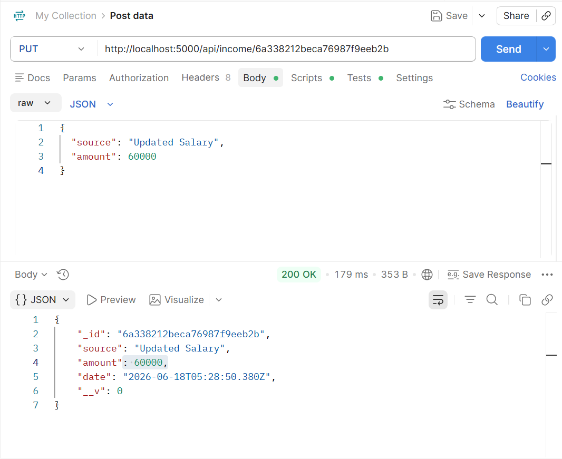
Now the updation can be viewed in the incomes collection of expensetrackerdb in mongodb

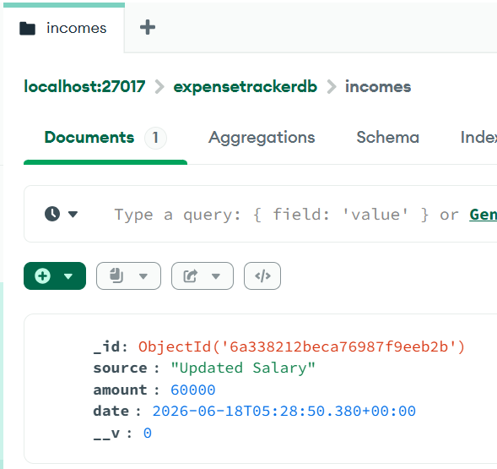

DELETE Income API
200 OK

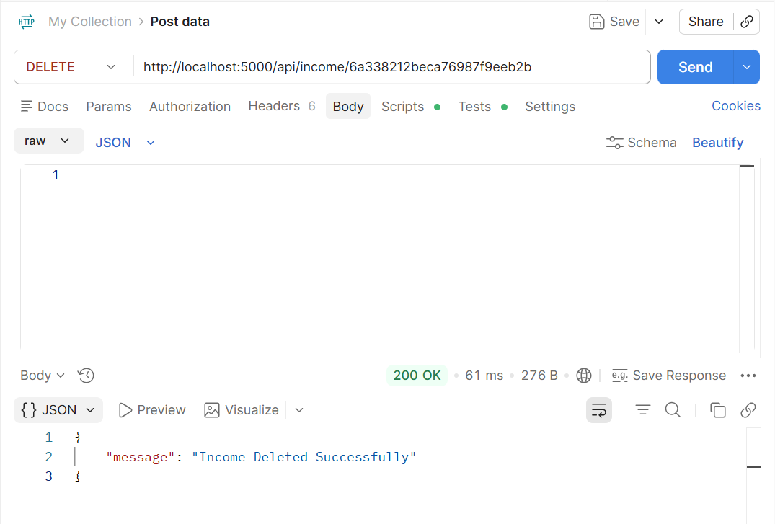

After Deletion , as there was only income record , so it shows there are no records available
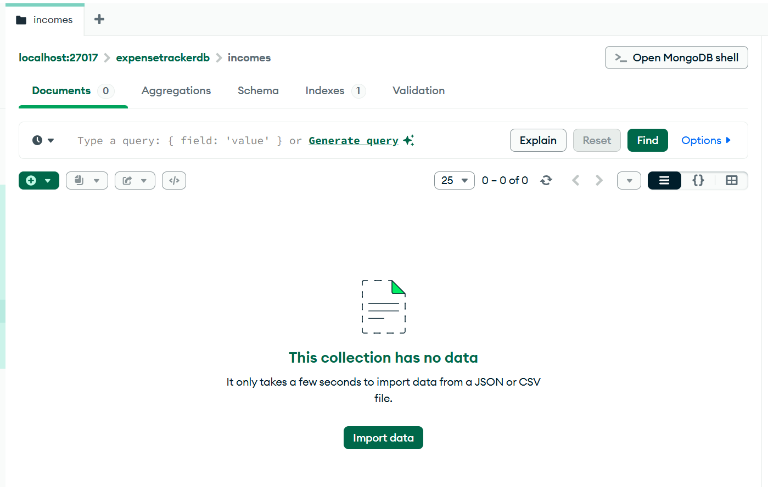
Now Showcasing The live demonstration of tracking expenses

- Creating Income Records
POST Income API
200 OK

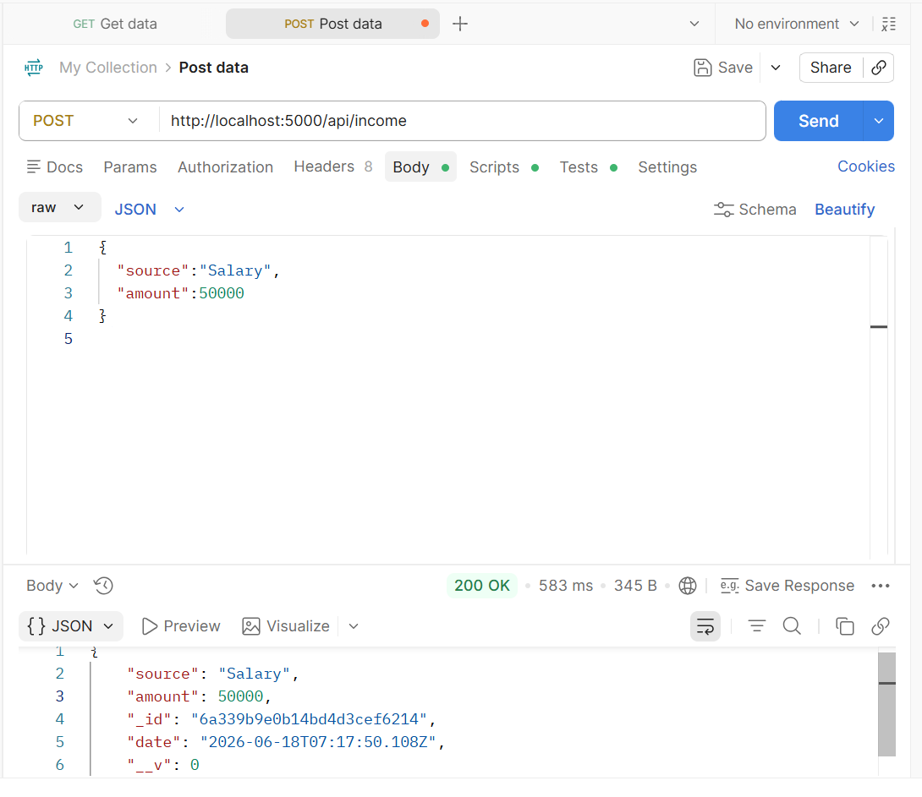

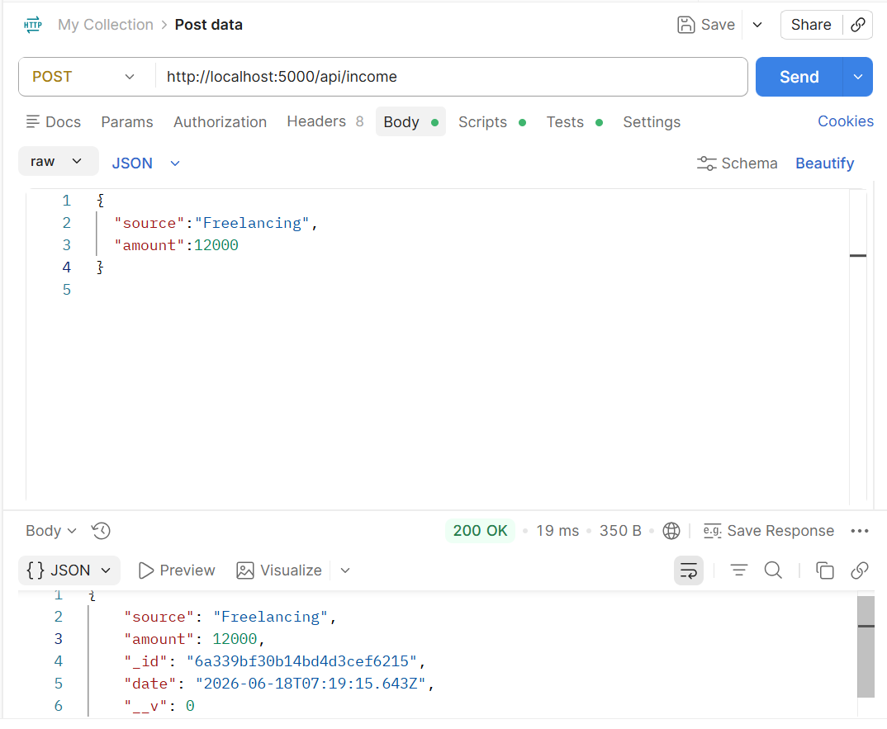

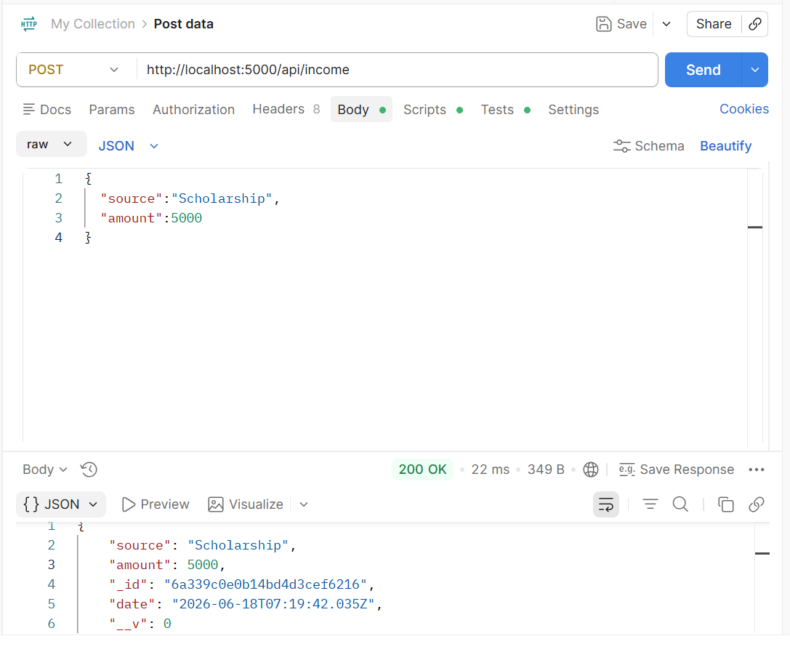

The resultant income collection in MongoDB looks like ,

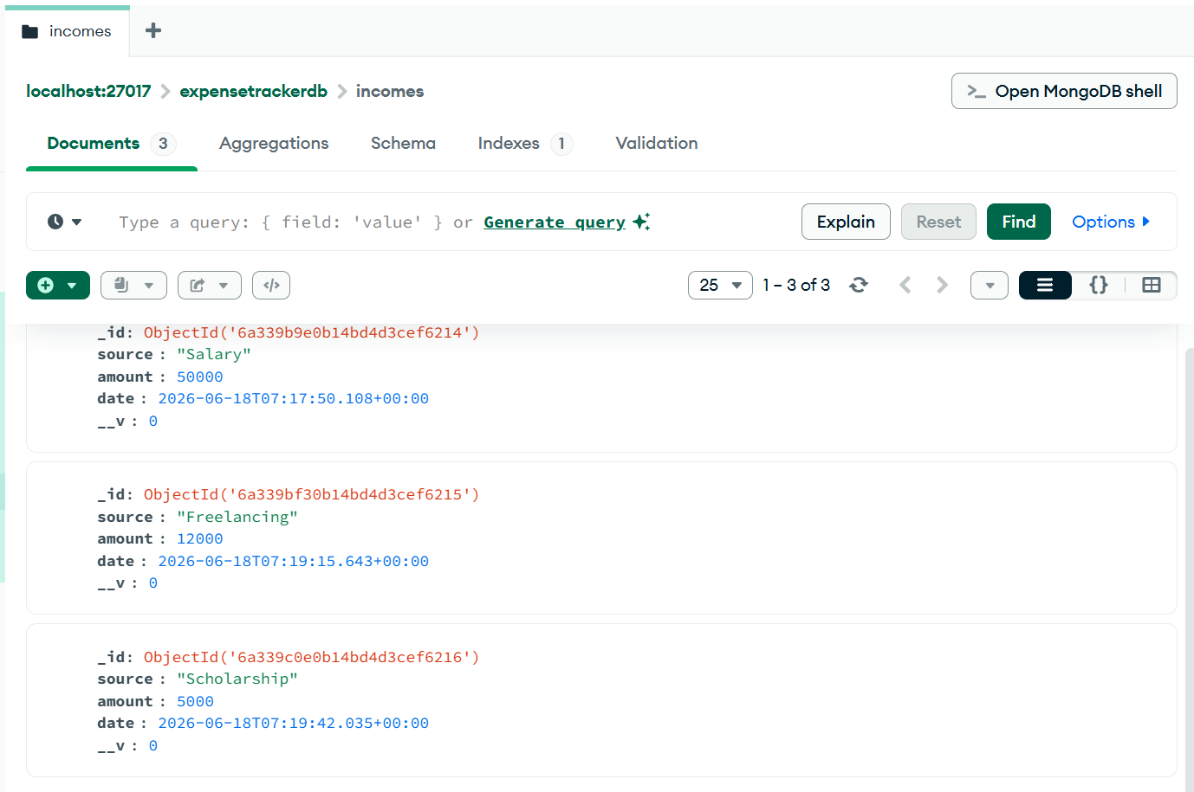

- Creating Expense Records

POST Expense API
200 OK

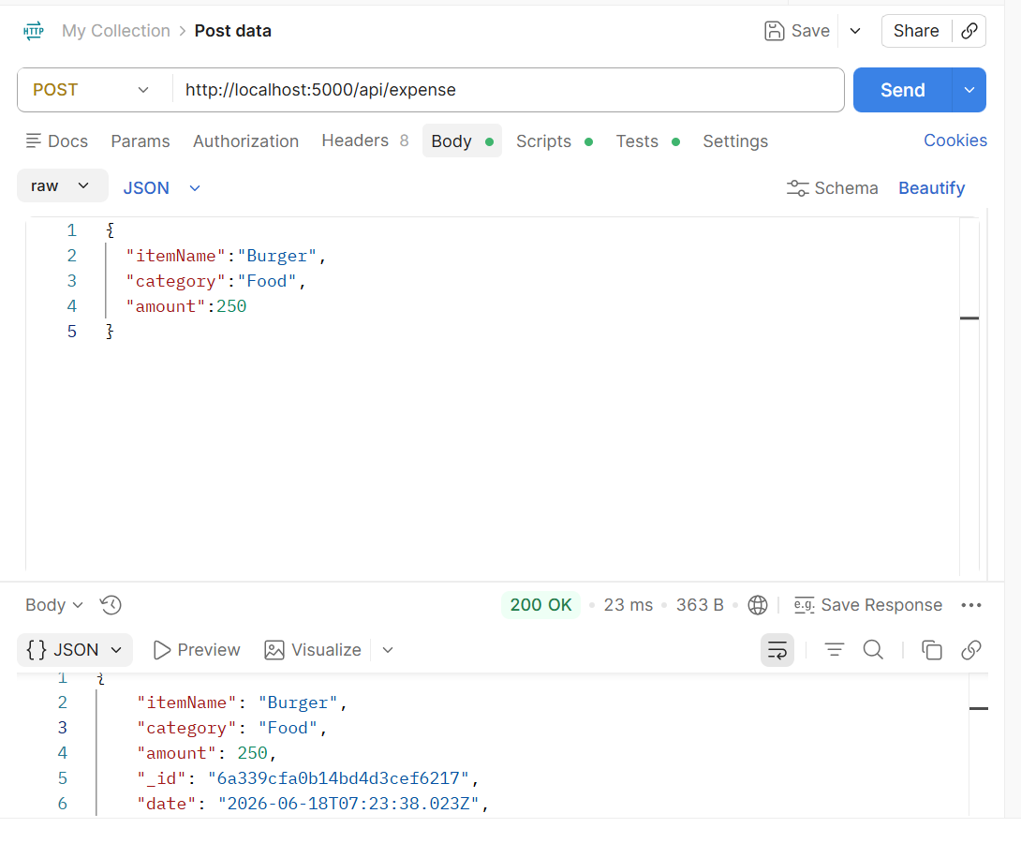
Similarly , other items/services like T-shirt, Jeans, Movie Ticket , Bus-Pass was added and so on

The resultant MongoDB expense collection looks like after the addition of all those items ,

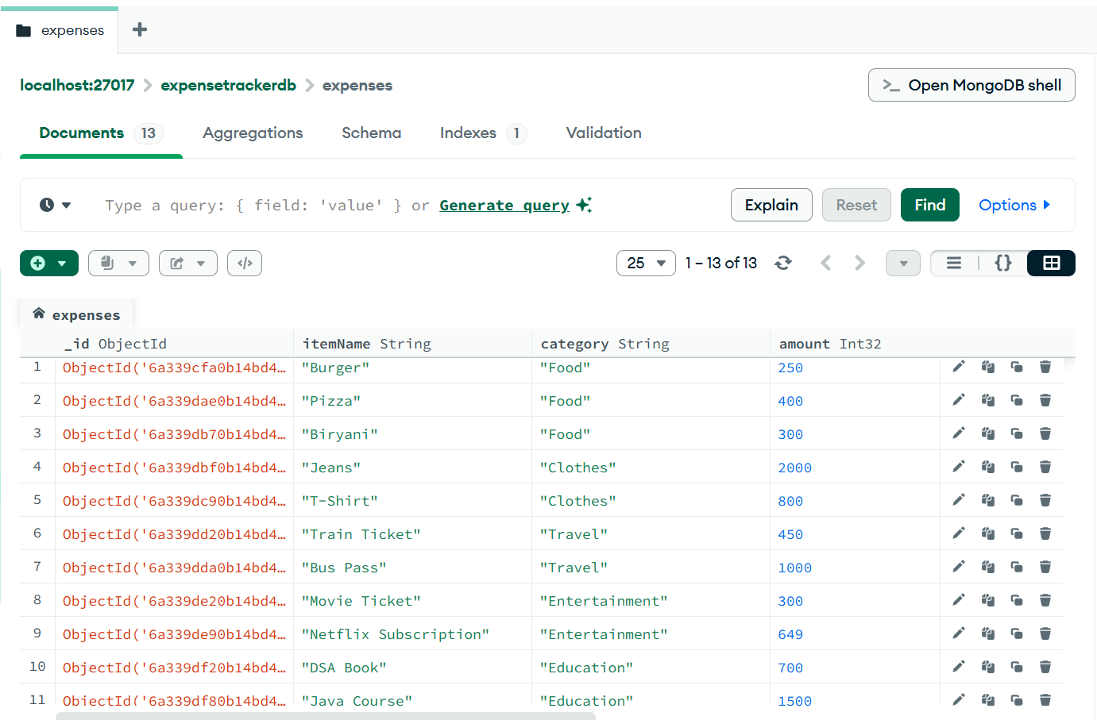

- Assigning a Budget

We assign the specific budget to each of the various categories like foods, clothes, entertainment in which the user has on their mind

POST Budget API
200 OK

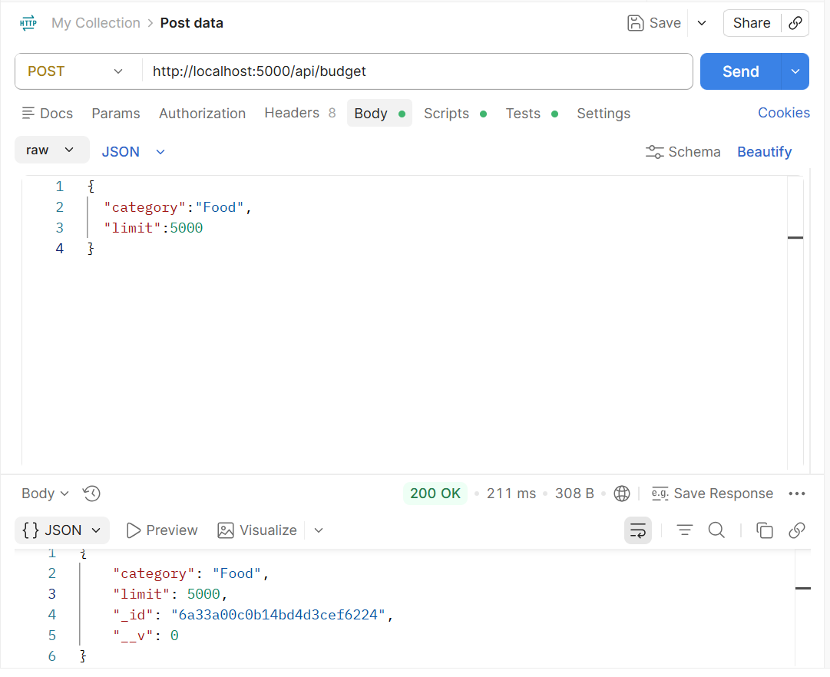
Similarly for the remaining categories like Clothes, Entertainment, Utilities and more, it was done

The resultant MongoDB budget collection looks like ,

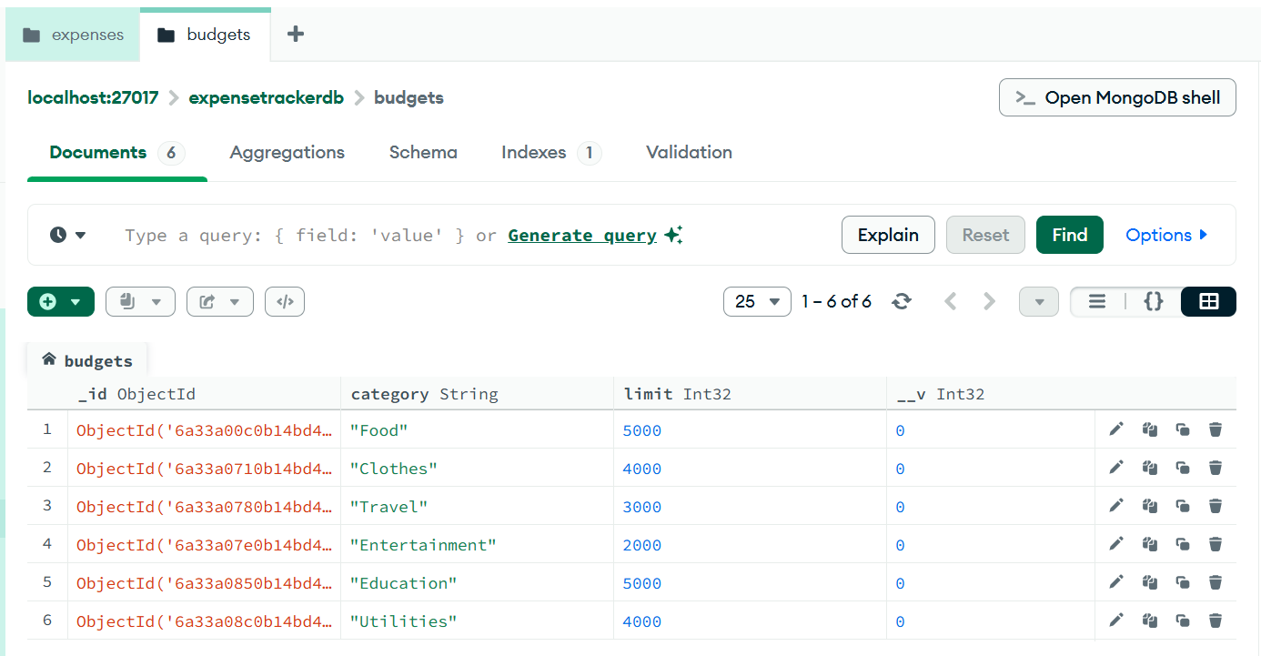

- Review of Analytics of expense , budget with metrics like savings and top-spending

GET metrics/savings API
200 OK

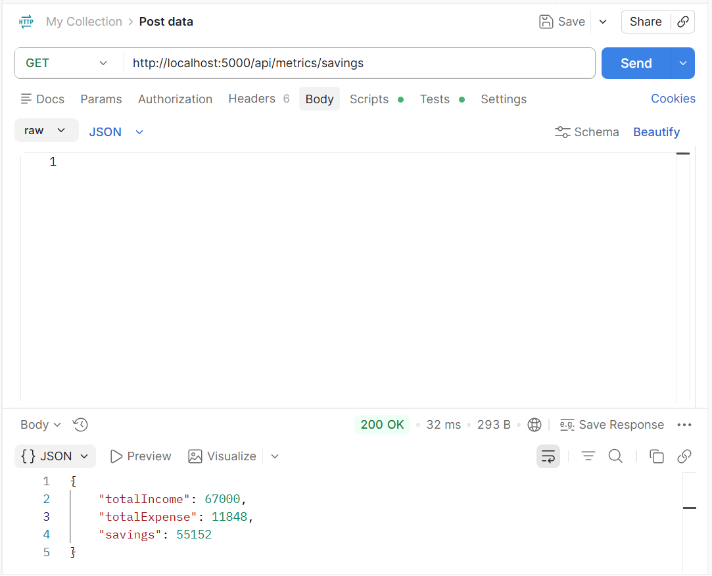

As we can see , the totalIncome after adding incomes from various sources and got around 67,000 and the totalSpendings which was calculated from adding all the spendings on items like pizza, movie ticket and so on which was 11,848 and then got the totalSavings which totalIncome - totalSavings
GET metrics/top-spending API
200 OK

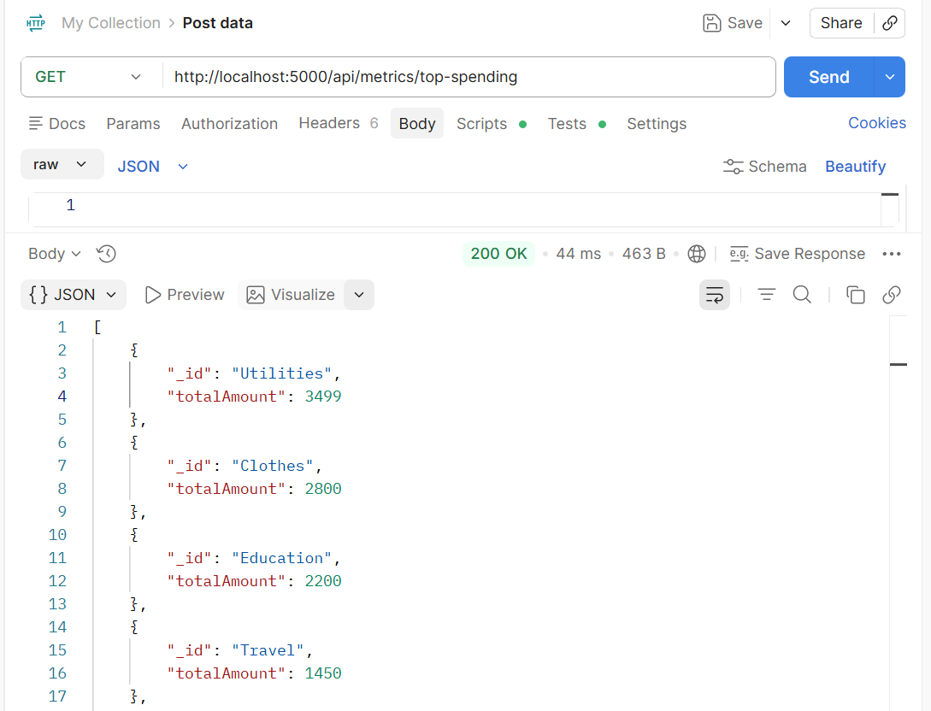
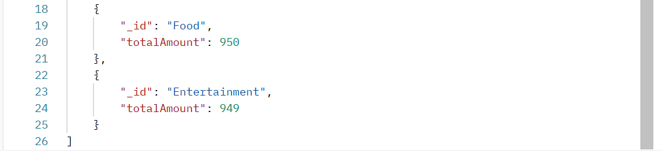
Using this , the user can track the which ones are contributing more expense and then the user can take respective measures like reducing expense on items of that category or increasing budget of the category and plan accordingly.

