EXPENSE TRACKER

Project Report
Submitted By

Name : B L Rithish Barath
Register Number : 24BCE1931

Department of Computer Science and Engineering
Vellore Institute of Technology
Academic Year 2025-2026

ABSTRACT

The Expense Tracker is a financial management application developed using Node.js, Express.js and MongoDB. The system enables users to register and authenticate securely using encrypted passwords and JWT-based authentication.
The application allows users to manage income records, expense records and category-wise budgets. In addition, analytical features such as savings calculation and top-spending category identification provide valuable insights into spending behaviour.
MongoDB is used for persistent storage, while Postman is utilized for API testing and validation. The project demonstrates the implementation of CRUD operations, authentication mechanisms, database integration and analytics processing in a modern web application environment.

INTRODUCTION

Managing personal finances is an important aspect of daily life. Many individuals find it difficult to track income, monitor expenses and maintain budgets across multiple categories.
The Expense Tracker application addresses this problem by providing a centralized platform where users can record incomes, track expenses, assign budgets and analyze spending patterns. The system helps users understand their financial status and make informed decisions regarding savings and expenditure.
The project has been implemented using RESTful APIs developed with Node.js and Express.js, while MongoDB serves as the backend database for storing financial records.

OBJECTIVES

• Develop a secure user authentication system.
• Store and manage income records.
• Store and manage expense records.
• Assign budgets to various spending categories.
• Calculate total savings automatically.
• Identify top spending categories.
• Demonstrate CRUD operations using MongoDB.
• Test all APIs using Postman.

TECHNOLOGIES USED

Frontend Tool
• Postman

Backend
• Node.js
• Express.js

Database
• MongoDB
• MongoDB Compass

Libraries
• Mongoose
• bcryptjs
• jsonwebtoken

Development Environment
• Visual Studio Code

SYSTEM ARCHITECTURE

User
↓
Postman
↓
Express.js APIs
↓
Node.js Application
↓
MongoDB Database

Collections:

• users
• incomes
• expenses
• budgets

DATABASE DESIGN

Users Collection
----------------
name
email
password

Income Collection
----------------
source
amount
date

Expense Collection
----------------
itemName
category
amount
date

Budget Collection
----------------
category
limit
MongoDB connected on Port 5000

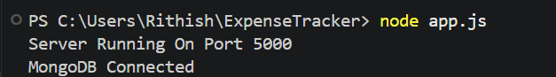

POST /api/auth/signup
201 Created

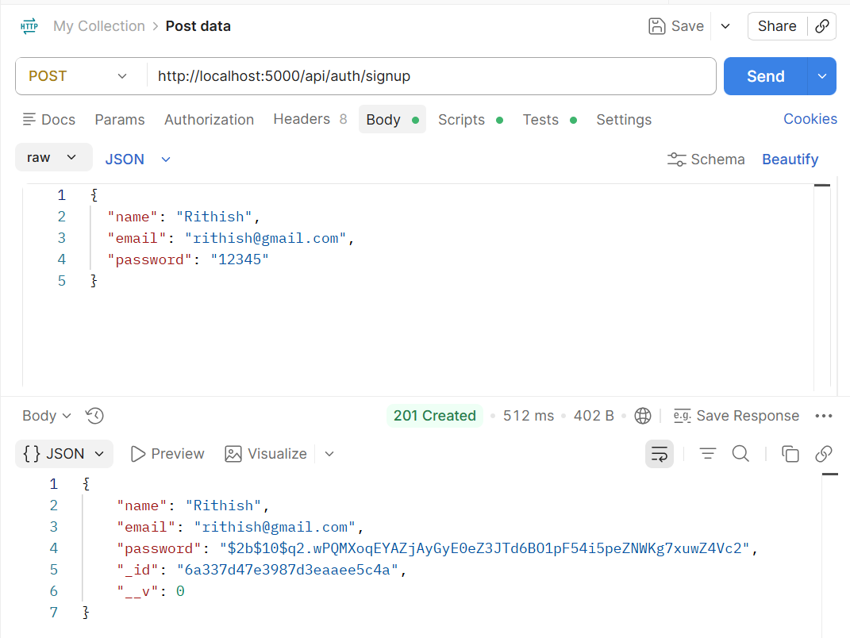

In MongoDB compass , databases -> expensetrackerdb -> users collection , showing the inserted user

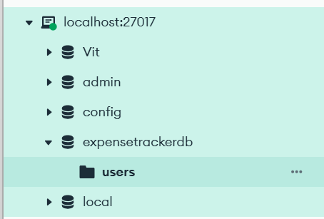

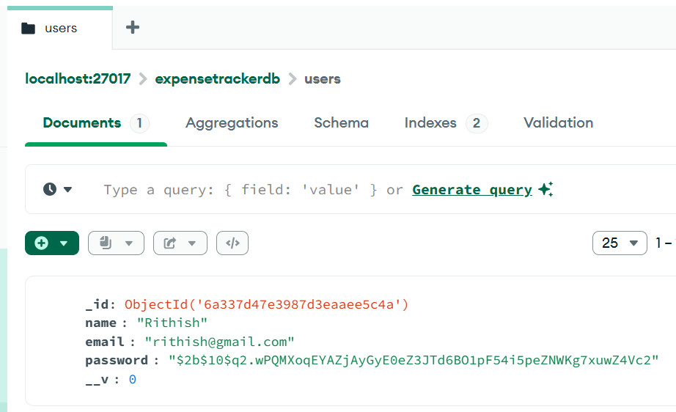

Here the password of the newly created user is hashed up and not directly viewed in the database as we used password encryption using bcryptjs which improves security and showcases authentication module implementation
POST /api/auth/login
200 OK

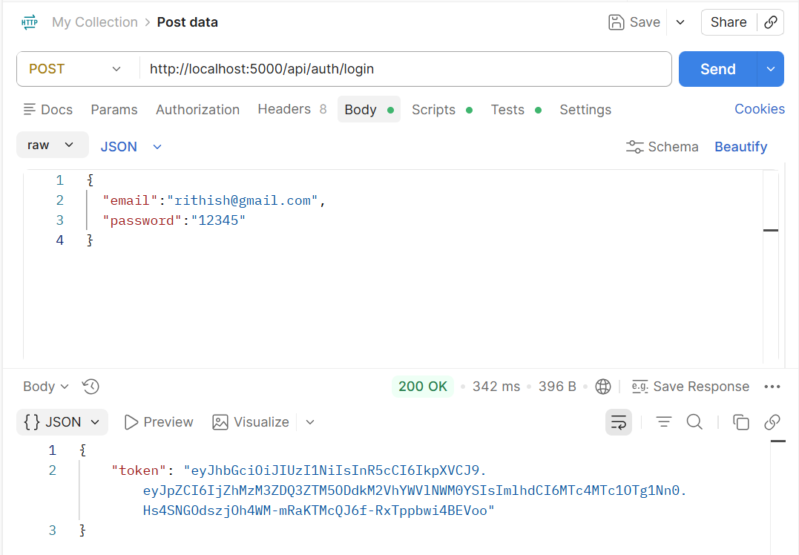

The user login was processed successfully , upon successful password verification , the system generated a JWT Token , using this token , the user can access the protected apis such as expense management, budget management, income management and analytics apis

CREATE Income API
Testing CREATE Income using Postman

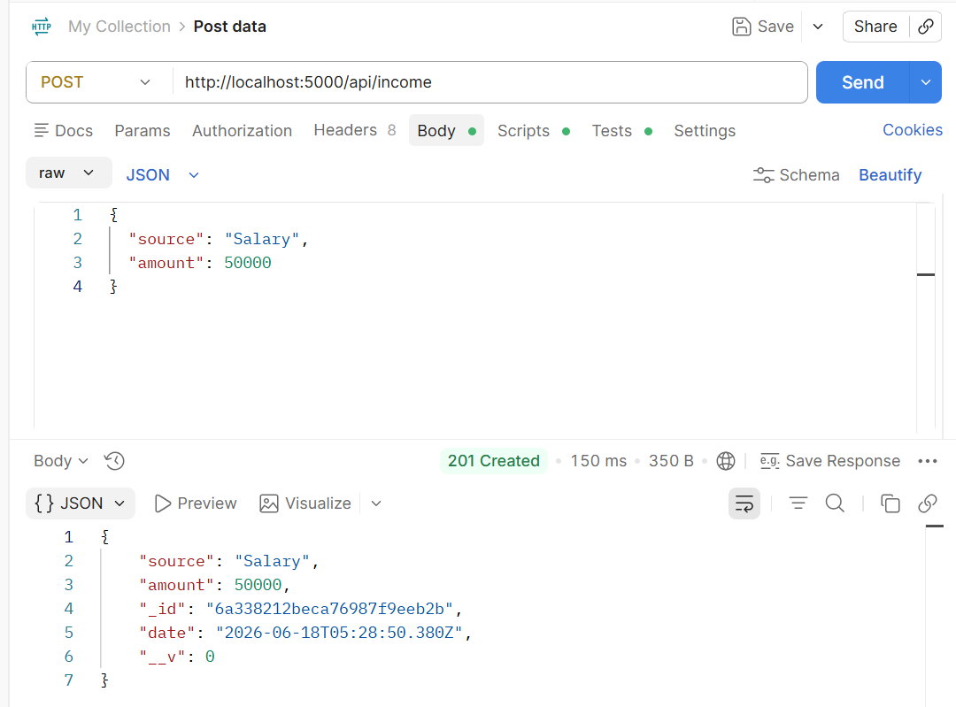

In MongoDB compass , databases -> expensetrackerdb -> incomes collection , showing the inserted inserted income of user

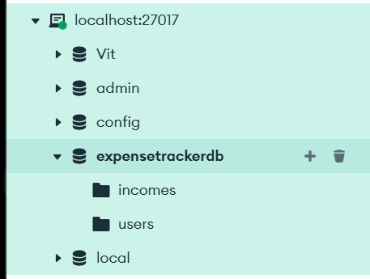

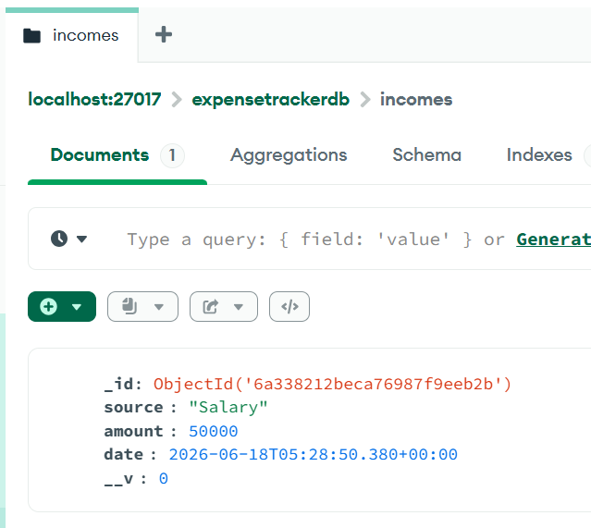

GET Income API
200 OK
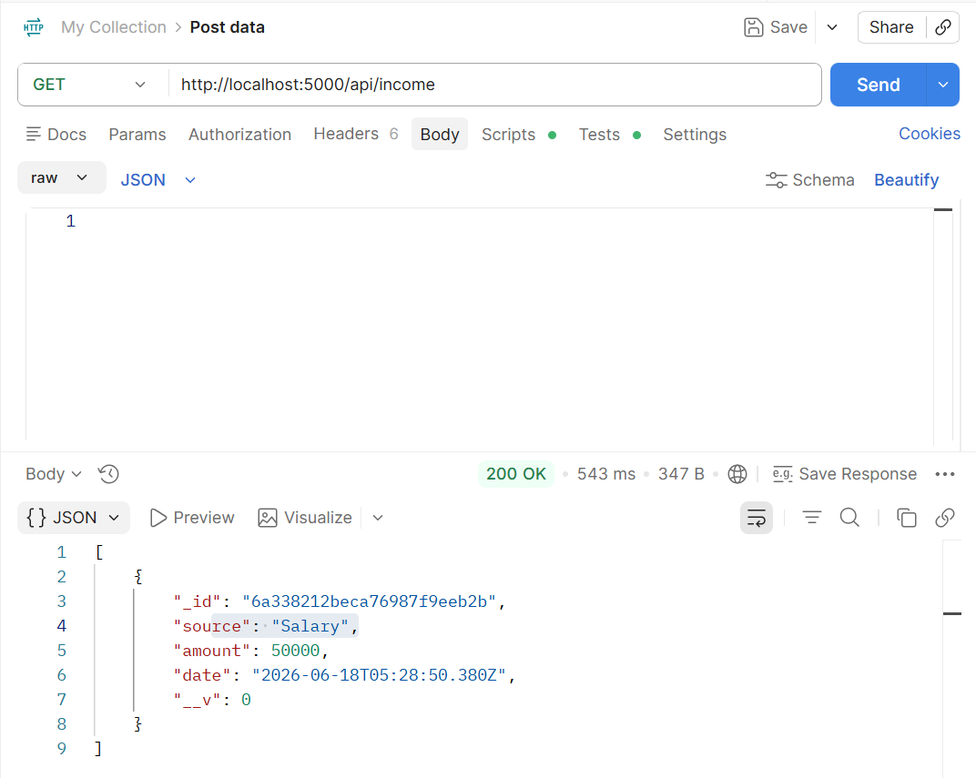

The get api retrieves all the income records stored in database and displays all the available ones.

PUT Income API
200 OK

Before Modification
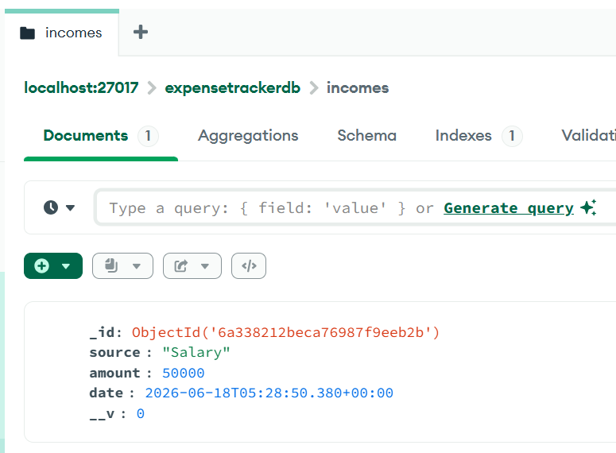
After Modification
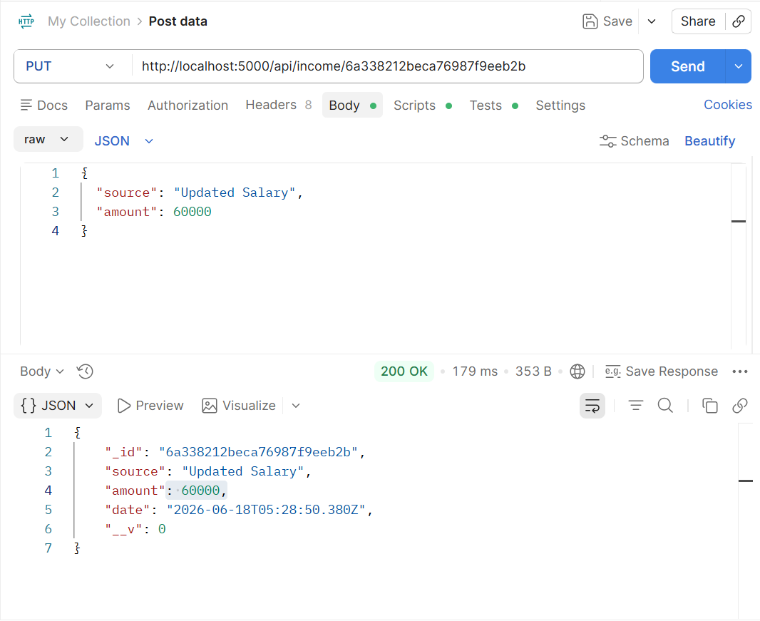
Now the updation can be viewed in the incomes collection of expensetrackerdb in mongodb

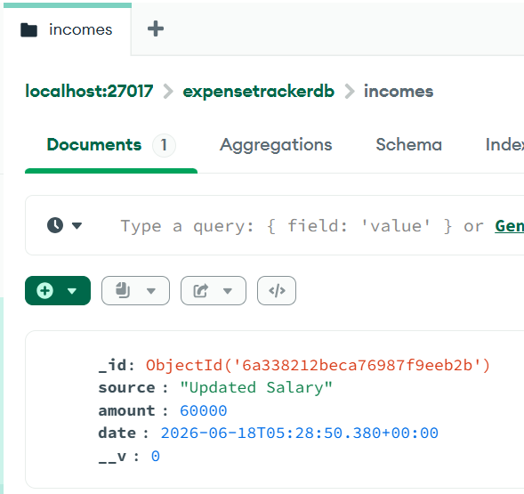

DELETE Income API
200 OK

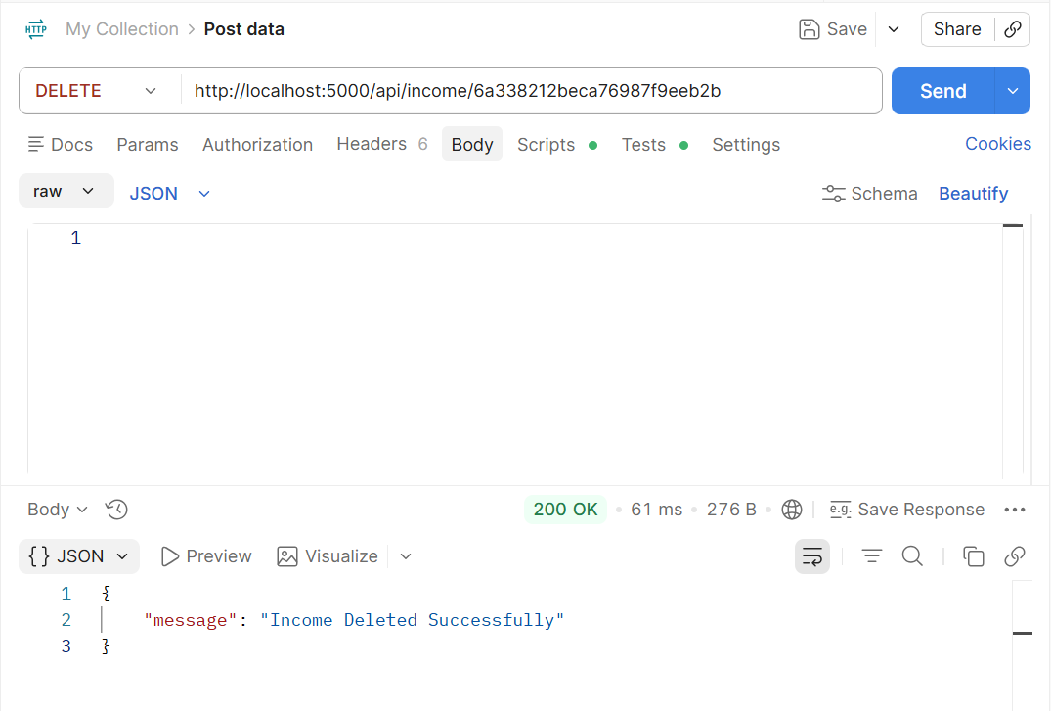

After Deletion , as there was only income record , so it shows there are no records available
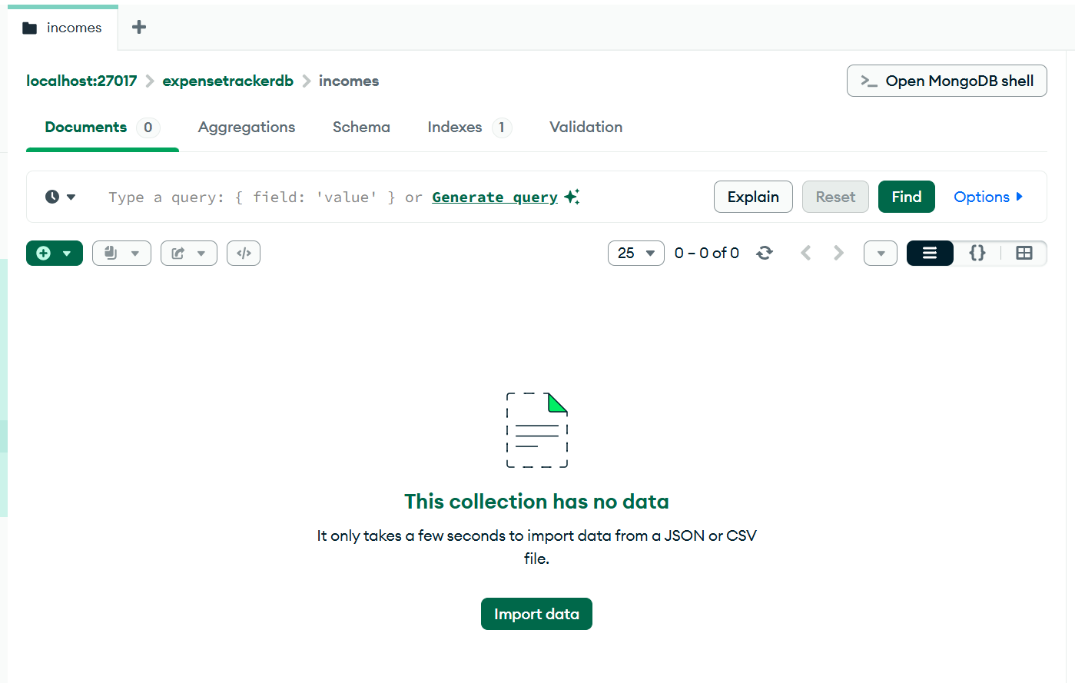
Now Showcasing The live demonstration of tracking expenses

- Creating Income Records
POST Income API
200 OK

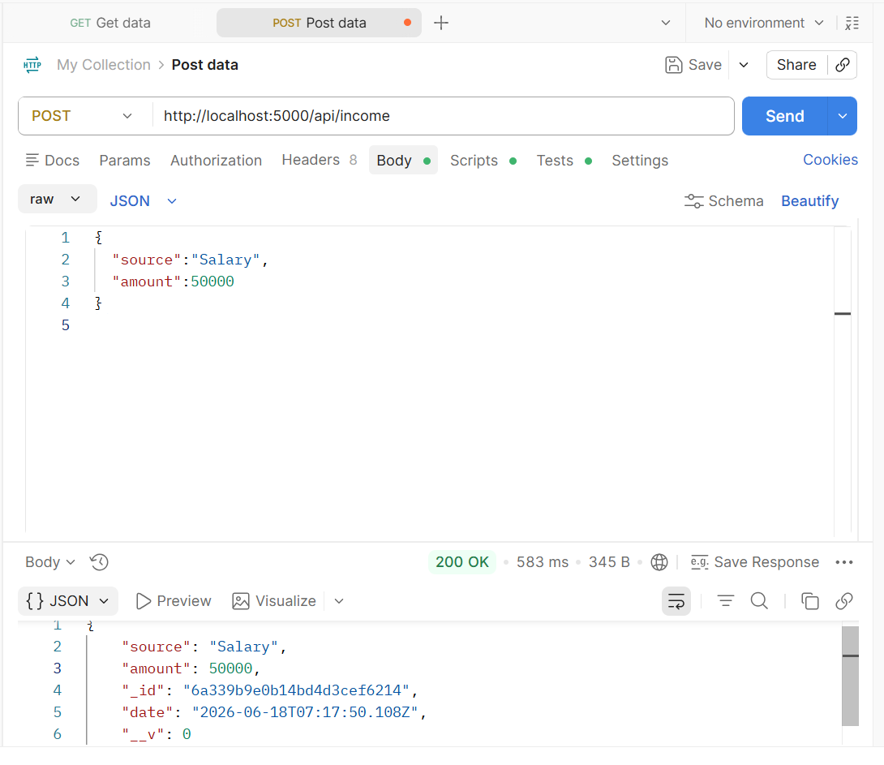

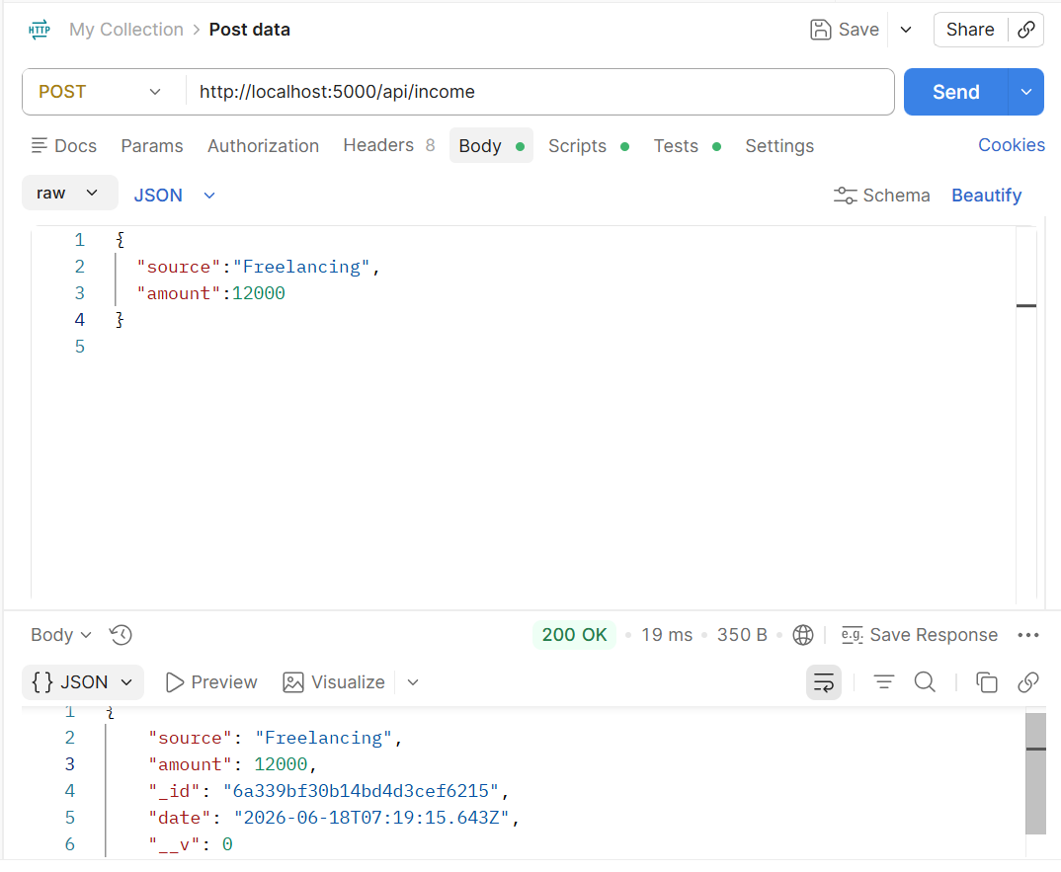

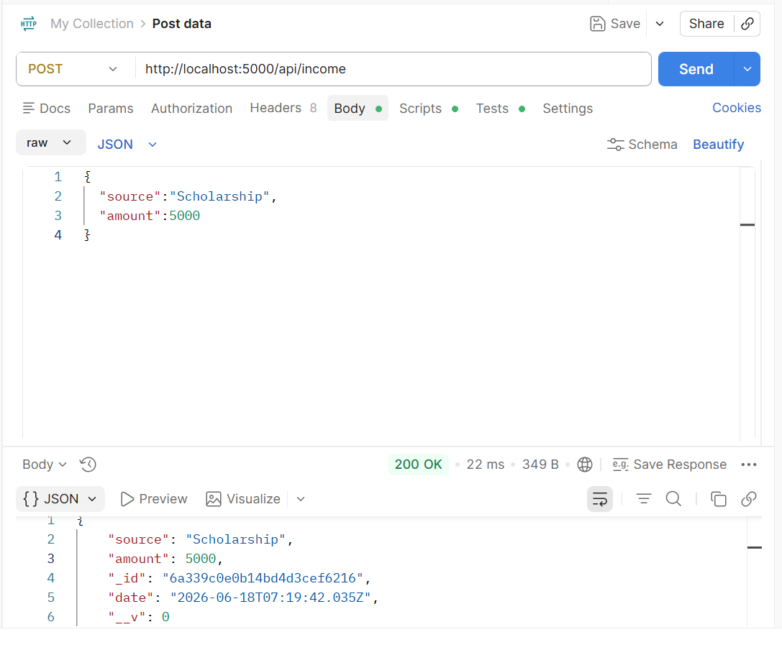

The resultant income collection in MongoDB looks like ,

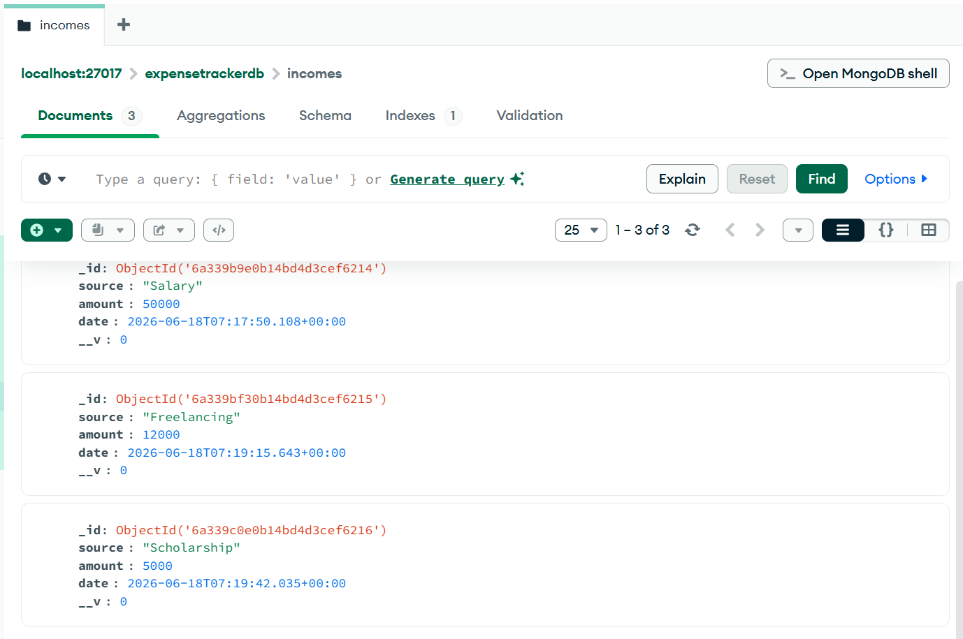

- Creating Expense Records

POST Expense API
200 OK

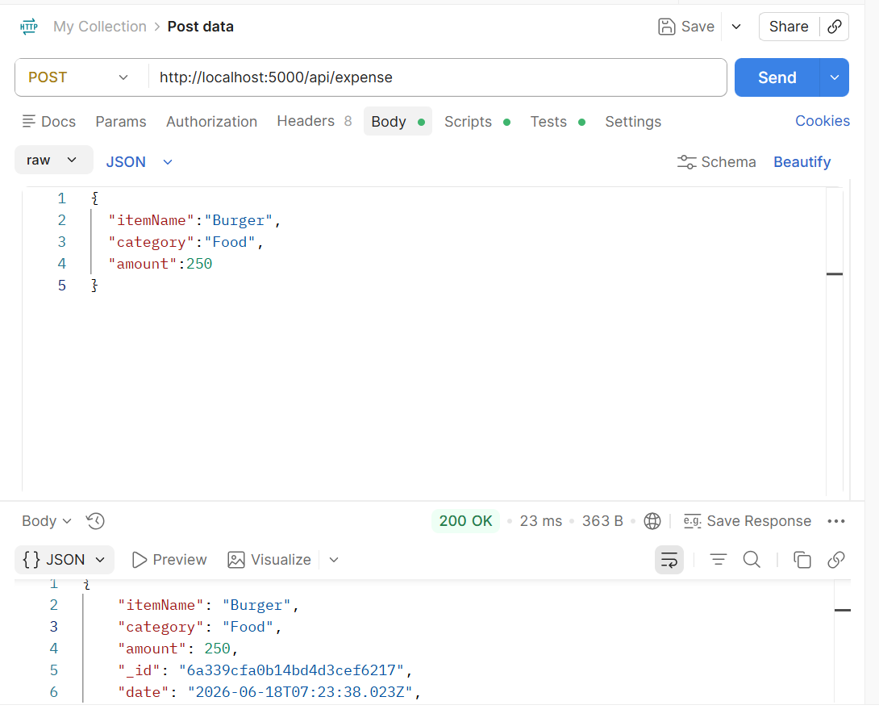
Similarly , other items/services like T-shirt, Jeans, Movie Ticket , Bus-Pass was added and so on

The resultant MongoDB expense collection looks like after the addition of all those items ,

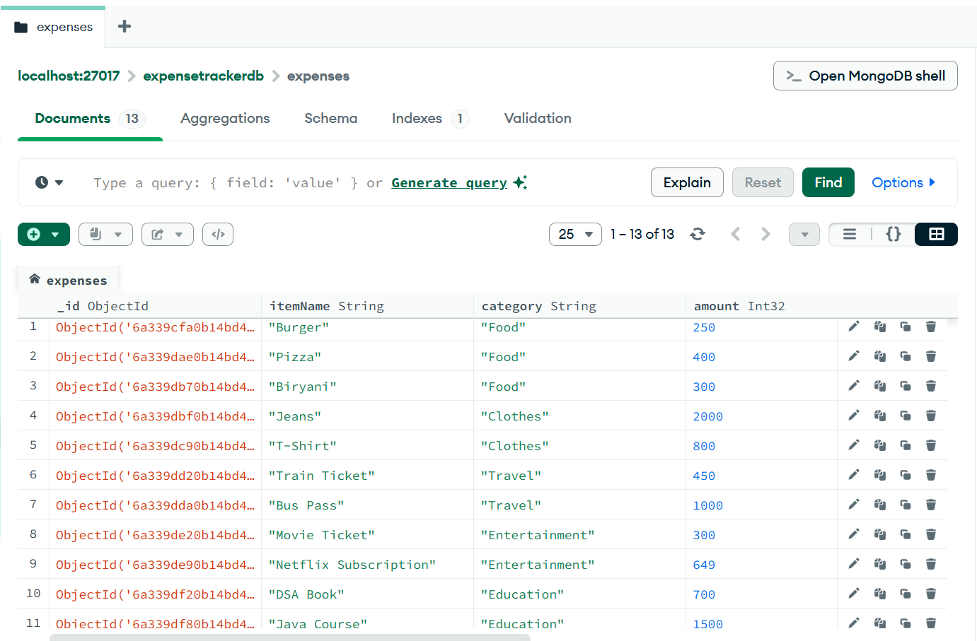

- Assigning a Budget

We assign the specific budget to each of the various categories like foods, clothes, entertainment in which the user has on their mind

POST Budget API
200 OK

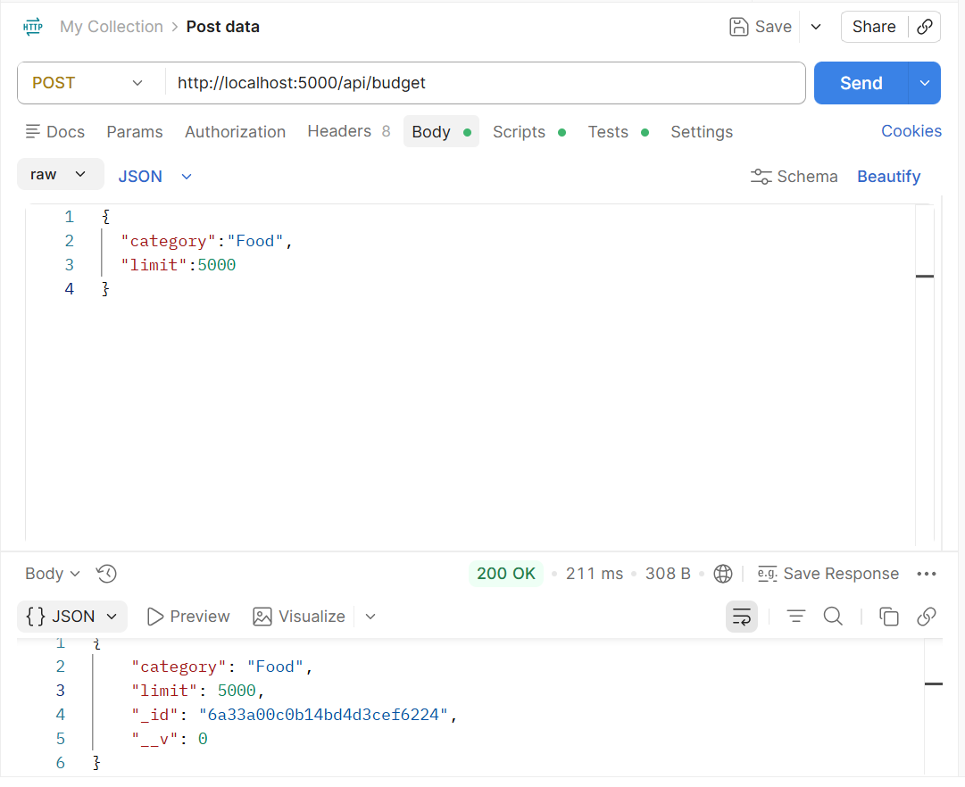
Similarly for the remaining categories like Clothes, Entertainment, Utilities and more, it was done

The resultant MongoDB budget collection looks like ,

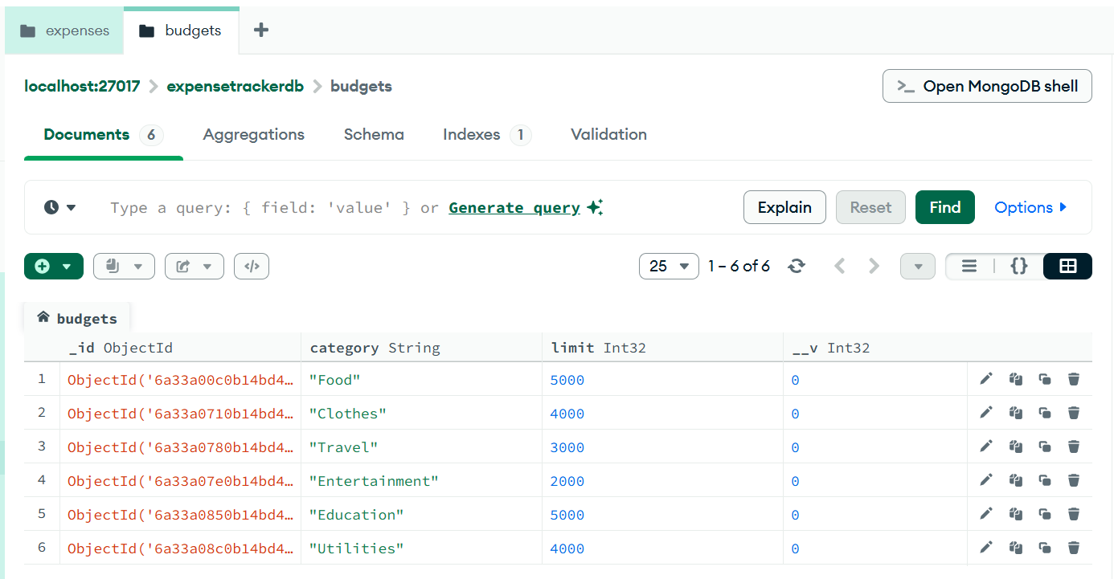

- Review of Analytics of expense , budget with metrics like savings and top-spending

GET metrics/savings API
200 OK

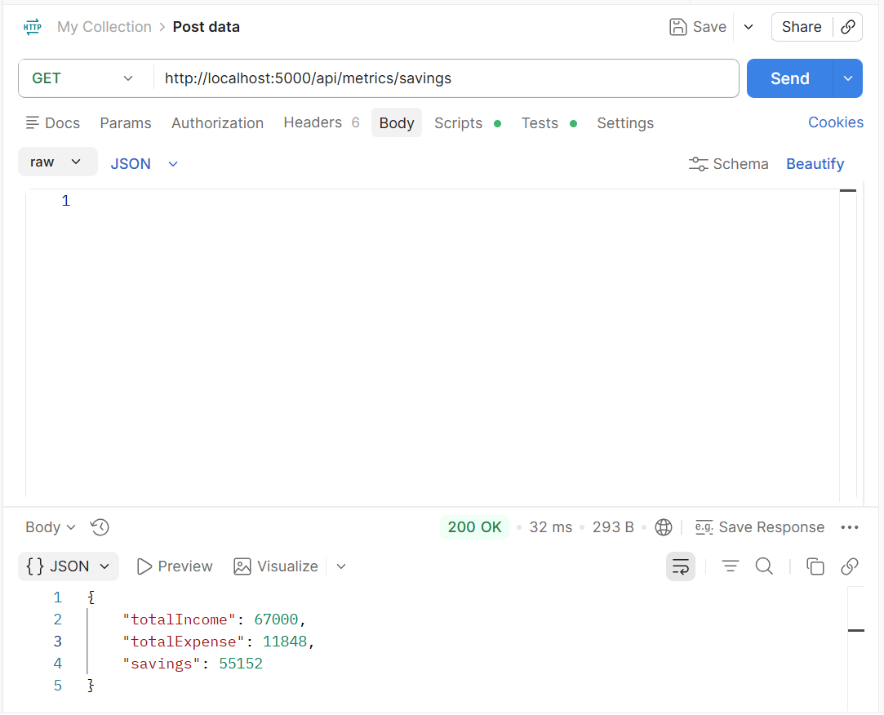

As we can see , the totalIncome after adding incomes from various sources and got around 67,000 and the totalSpendings which was calculated from adding all the spendings on items like pizza, movie ticket and so on which was 11,848 and then got the totalSavings which totalIncome - totalSavings
GET metrics/top-spending API
200 OK

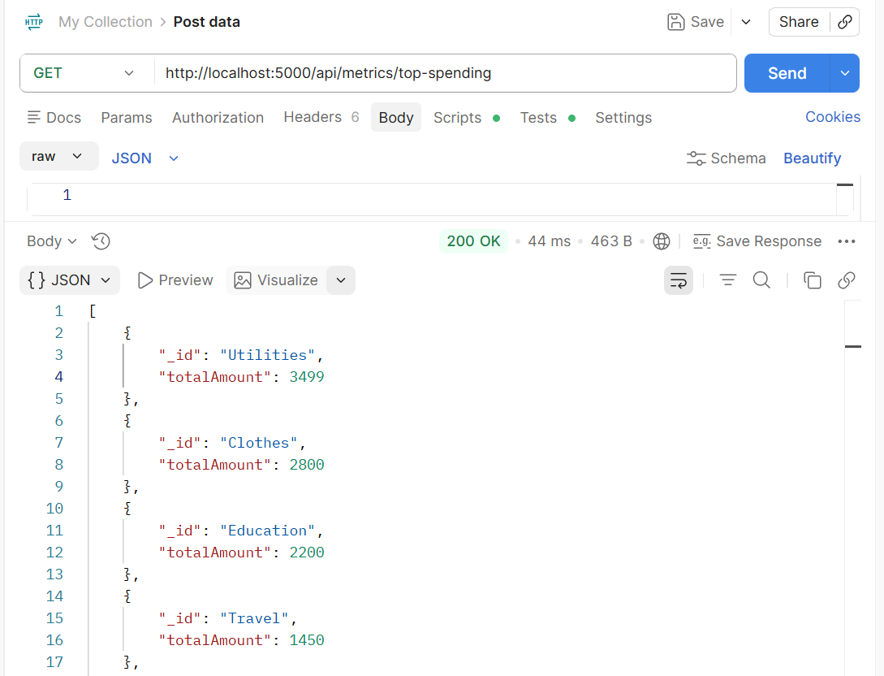
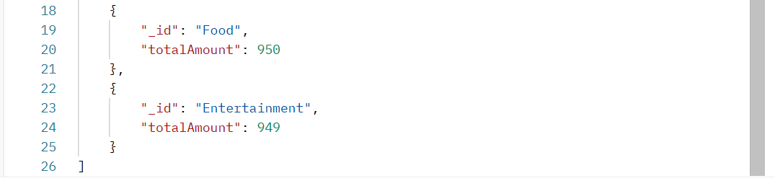
Using this , the user can track the which ones are contributing more expense and then the user can take respective measures like reducing expense on items of that category or increasing budget of the category and plan accordingly.

CONCLUSION

The Expense Tracker application was successfully designed and implemented using Node.js, Express.js and MongoDB. The project provides secure user authentication using bcrypt password hashing and JWT token generation.
The system enables users to manage income records, expense records and category-wise budgets through RESTful APIs. Analytical functionalities such as savings calculation and top-spending category identification help users understand their financial behaviour and make informed decisions.
All functionalities were tested successfully using Postman, and data persistence was verified through MongoDB Compass. The project demonstrates practical implementation of authentication, CRUD operations, database integration and analytics processing in a real-world financial management application.

