NAME: B L RITHISH BARATH

REGNO: 24BCE1931

DATE: 1st June 2026

SCREENSHOTS:

SQL CODE:
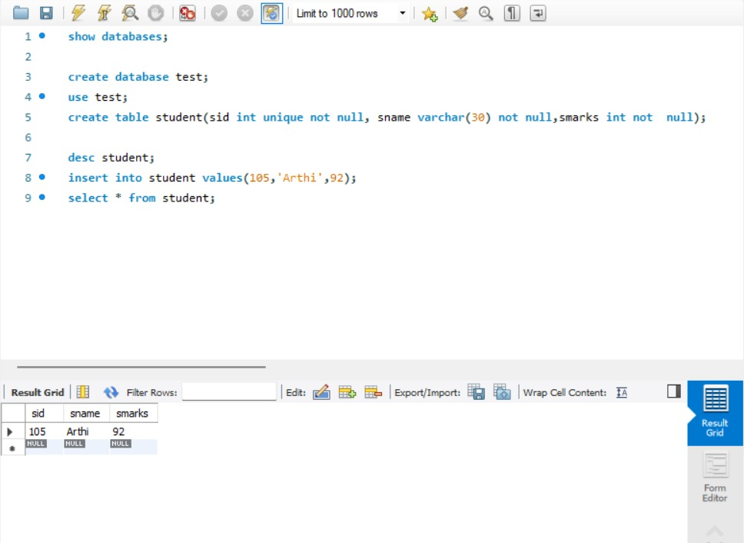

FETCHING THAT USING JAVA:
