Key Factors Influencing Early Agent Performance and Indicators of Nill Risk

# 1. Historical Policy Count Trends

Agents with zero new policies in the previous month, or those showing a pattern of consecutive months with no new policies, are at significant risk of future underperformance. A recurring history of nill performance often reflects deeper issues such as lack of motivation, poor lead conversion skills, or disengagement from the sales process.

* Risk Indicator: Multiple consecutive months with zero new policies.
* Risk Amplifier: Similar patterns observed earlier in their tenure.

The scatterplot below shows the total number of zero-policy counts for each agent over a 20-month period. However, since not all agents were active during the entire period, it's more meaningful to consider the average number of zero-policy months per agent

The scatterplot above highlights agents with a high probability of receiving zero policies this month. It would be wise to closely monitor and support these agents

# 2. Proposal and Quotation Activity

A low number of unique insurance proposals or quotations generated in the weeks leading up to the current month is a strong predictor of nill risk. Proposals and quotes are often the leading indicators of sales intent and engagement. A decline here can signal lack of pipeline development or sales inertia.

* Risk Indicator: Low or declining unique proposals/quotations.
* Suggested Action: Early intervention through coaching or lead support.

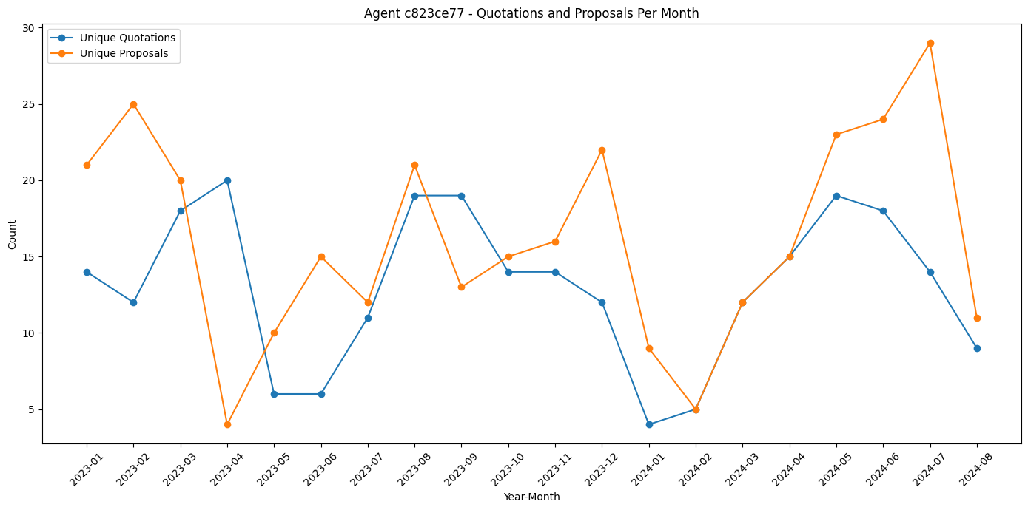

# 3. New Agent Risk Factor

Newly onboarded agents typically face a higher likelihood of nill risk due to a steep learning curve, limited customer base, and lack of market familiarity. This is a normal phase but should be closely monitored to ensure onboarding efforts are effective.

* Risk Indicator: Agents within their first 3–6 months of joining.
* Mitigation: Enhanced mentorship, early goal setting, and regular check-ins.  
    
  A bar code with blue lines

  Description automatically generated

# 4. Delay in First Sale

Agents who take an unusually long time to sell their first policy often carry unresolved challenges—whether in prospecting, product knowledge, or confidence—that may persist throughout their tenure. These agents need targeted support before patterns become ingrained.

* Risk Indicator: First policy sold well after expected onboarding window.
* Suggested Action: Skill-gap analysis and individualized performance plans.

So in our data maximum count of gap between the person who joined and sold the first policy is 1827 months that is approximately 5 years. So

# 5. Irregular Sales Patterns

Agents with inconsistent new policy counts—frequent ups and downs—may struggle with sustaining momentum. Such fluctuations indicate unstable pipelines or sporadic engagement and can be early warning signs of burnout or lack of process adherence.

* Risk Indicator: Highly variable monthly policy counts.
* Suggested Action: Evaluate lead flow consistency and time management practices.