WOXSEN UNIVERSITY
B.Tech Artificial Intelligence and Machine Learning | Design and Analysis of Algorithms
HackerRank Profile
Name | Student ID | Platform / username | Profile link
D. Ritheek (Ritheek Yadav) | 25WU0102057 | HackerRank / ritheekyadav01 | hackerrank.com/profile/ritheekyadav01

1. Profile login screenshot
HackerRank profile, logged in as Ritheek Yadav (@ritheekyadav01). The badge shown is Problem Solving.
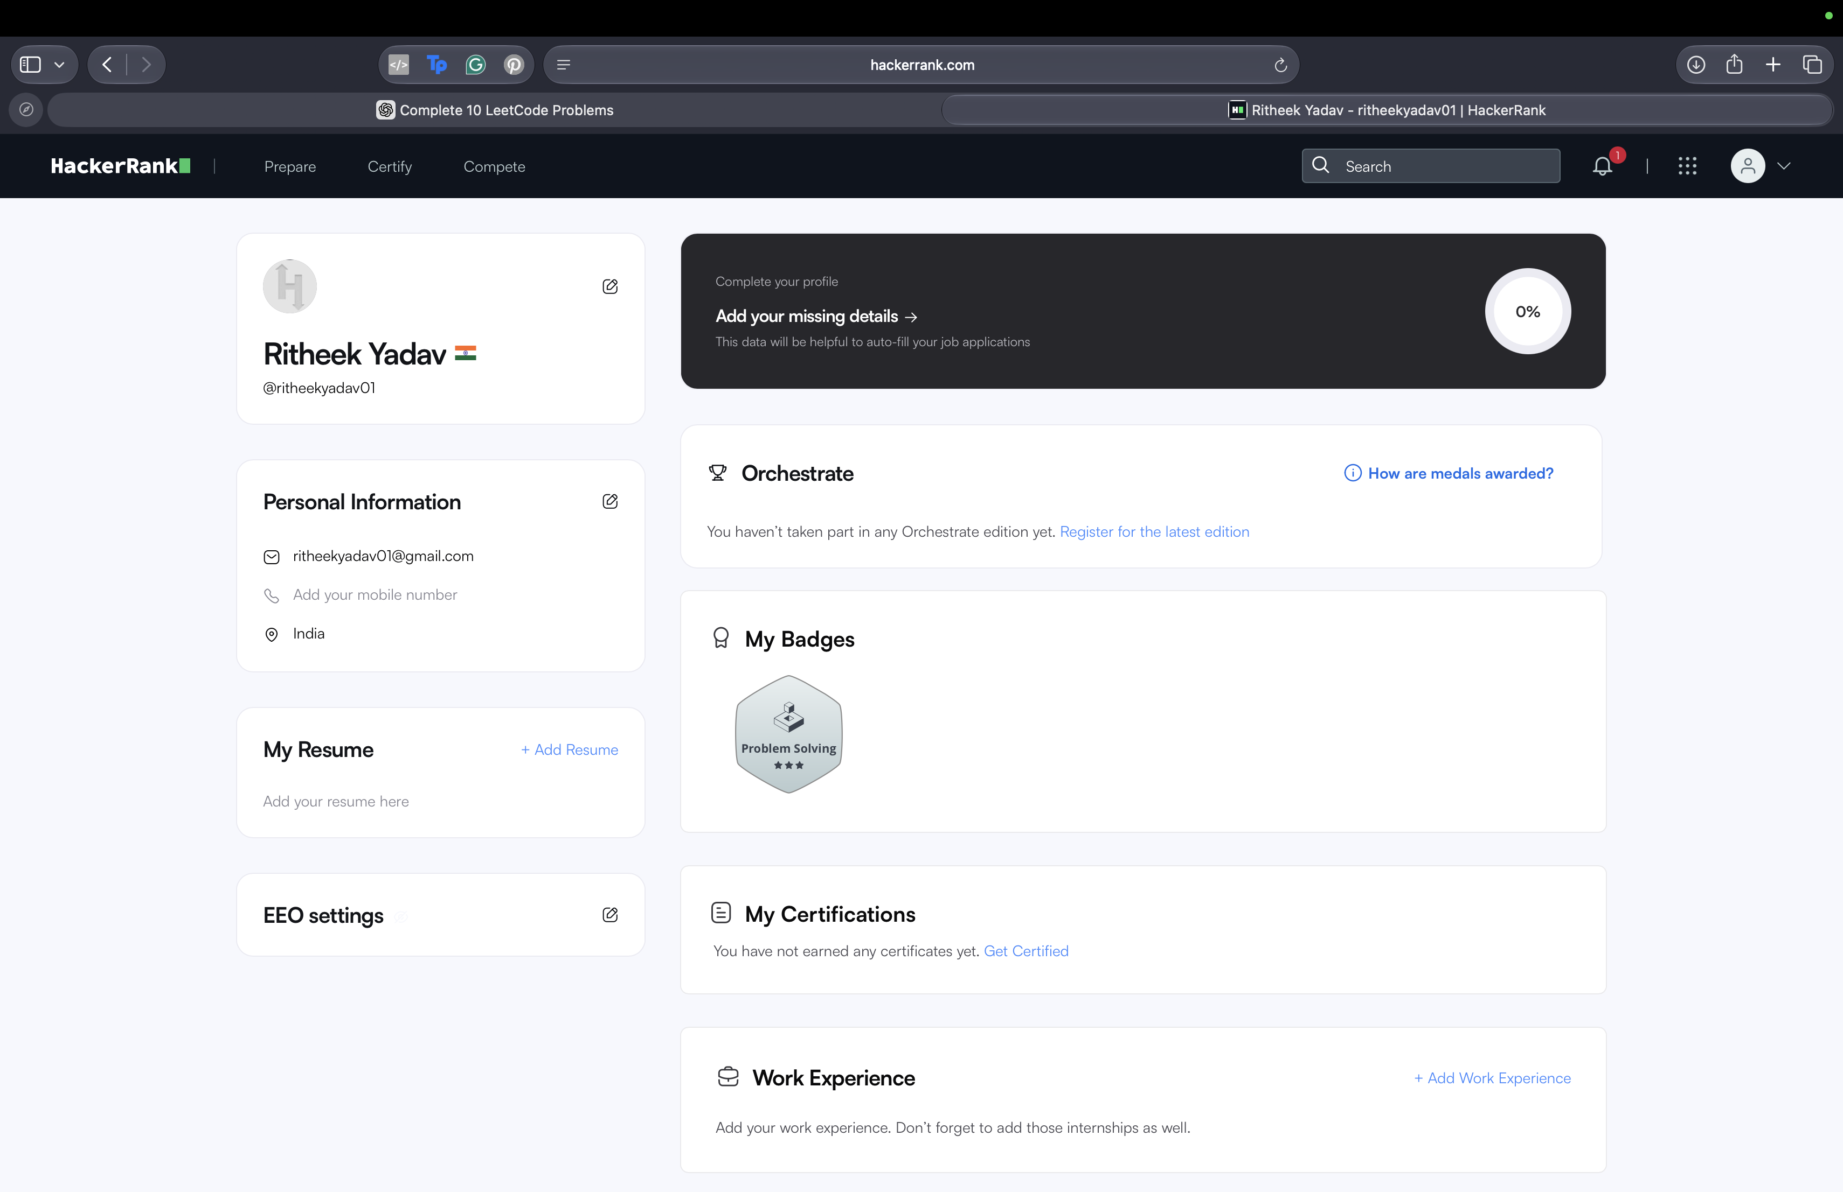

2. Problems solved (10)
All ten problems below show Result: Accepted in the submissions list. Score is the points awarded by HackerRank.
No. | Problem name | Topic | Language | Result | Score
1 | Intro to Tutorial Challenges | Binary Search | Python 3 | Accepted | 30.0
2 | Insertion Sort - Part 1 | Sorting | Python 3 | Accepted | 30.0
3 | Insertion Sort - Part 2 | Sorting | Python 3 | Accepted | 30.0
4 | Counting Sort 1 | Counting Sort | Python 3 | Accepted | 30.0
5 | Counting Sort 2 | Counting Sort | Python 3 | Accepted | 30.0
6 | Mark and Toys | Greedy Algorithm | Python 3 | Accepted | 35.0
7 | Grid Challenge | Sorting / Greedy | Python 3 | Accepted | 20.0
8 | Max Min | Greedy Algorithm | Python 3 | Accepted | 35.0
9 | Candies | Greedy Algorithm | Python 3 | Accepted | 50.0
10 | The Coin Change Problem | Dynamic Programming | Python 3 | Accepted | 60.0

3. Submissions screenshots (page 1 and page 2)
Page 1 of the submissions list: ten problems, all Accepted.
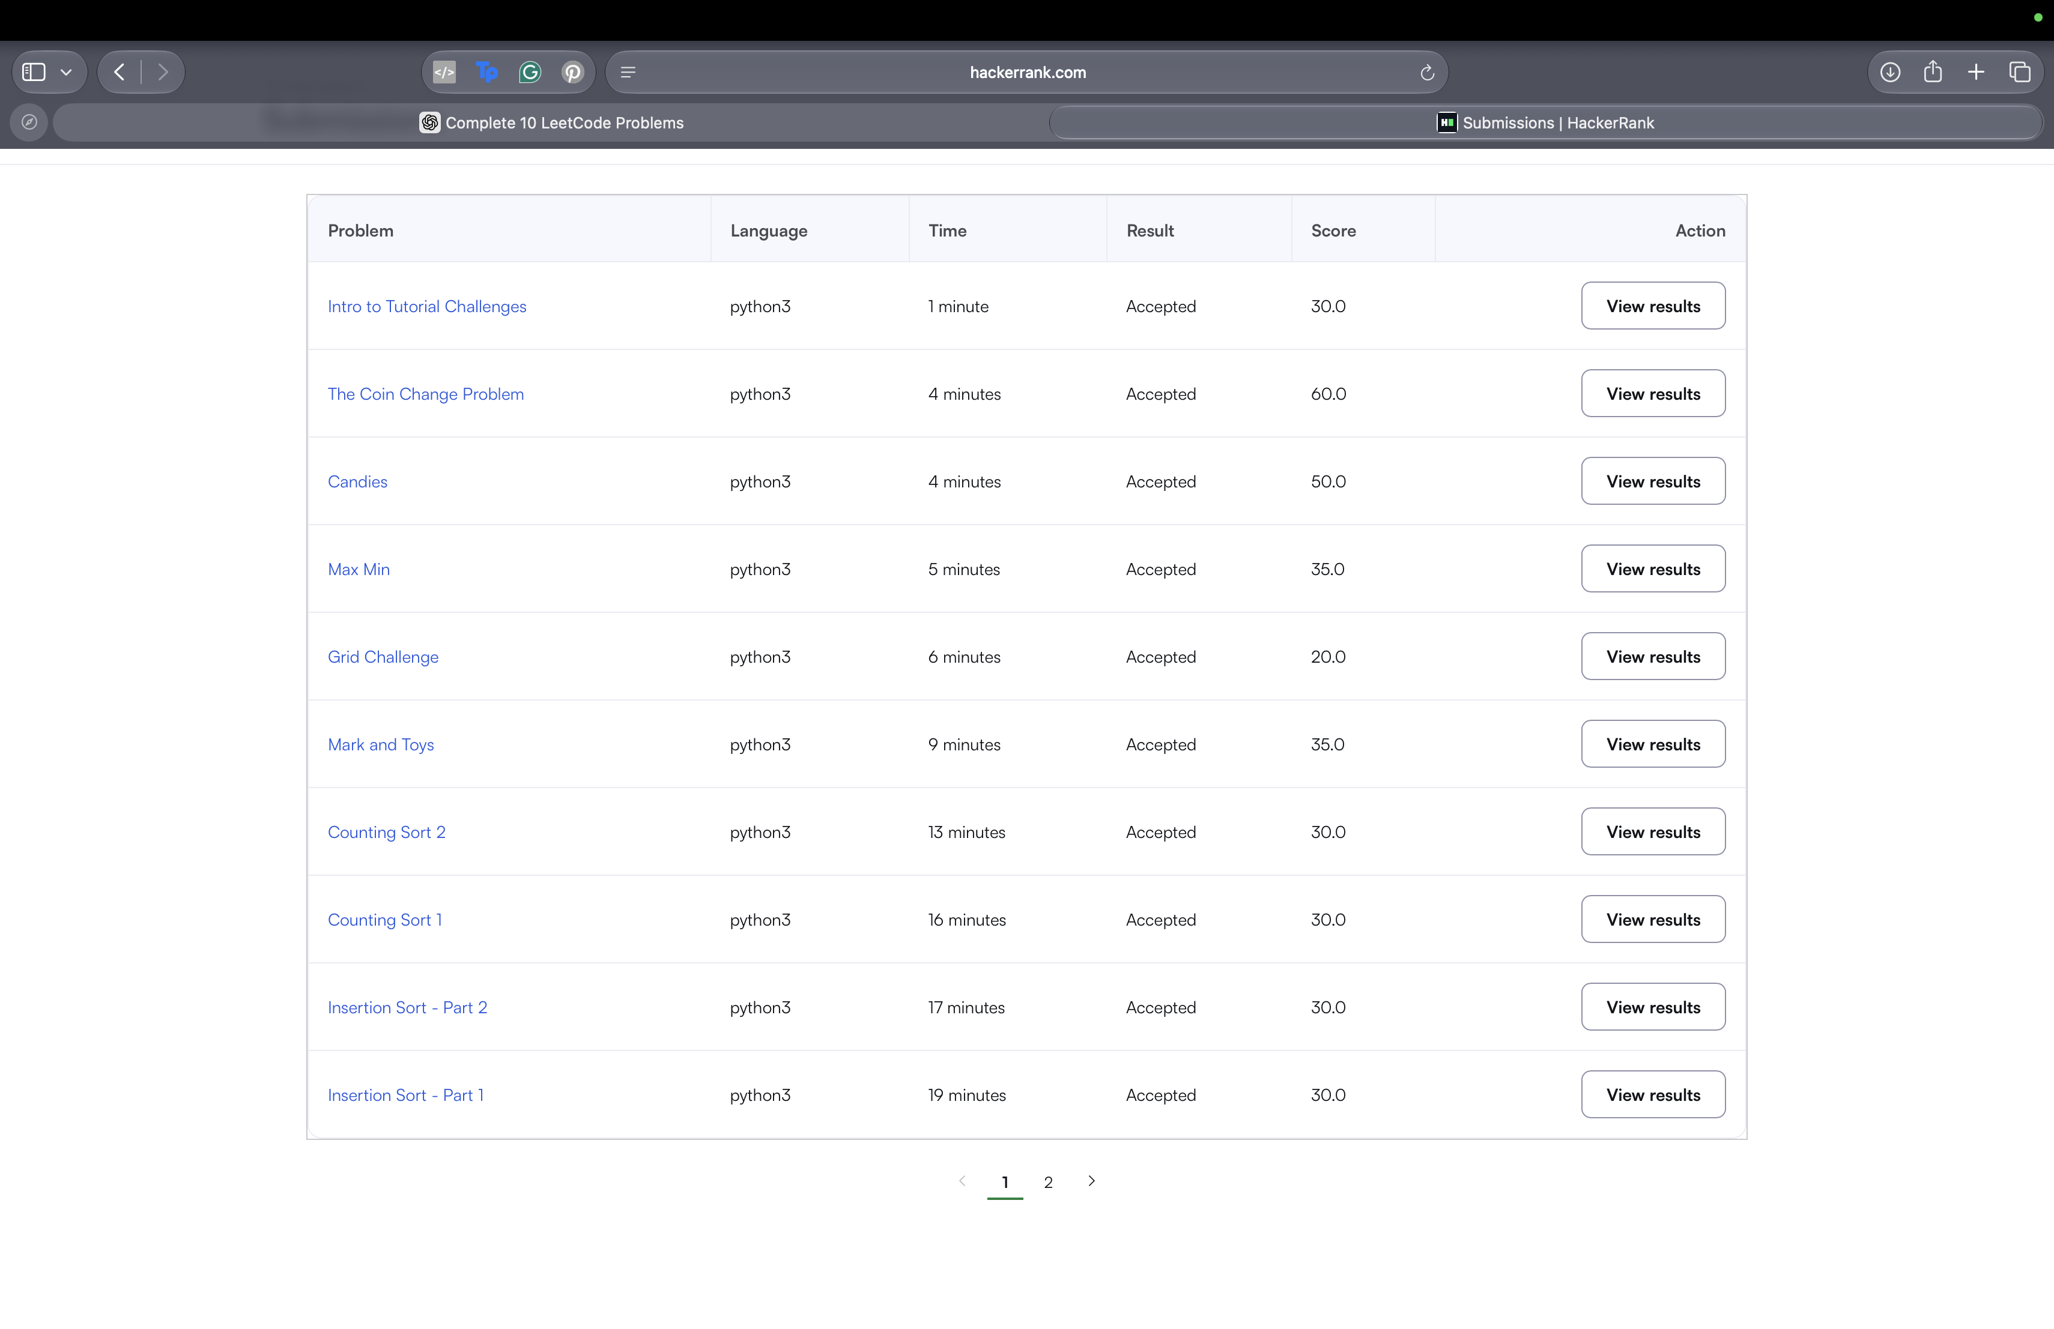
Page 2 of the submissions list: two earlier attempts at Intro to Tutorial Challenges. The first attempt had a runtime error and the second was Accepted (30.0).
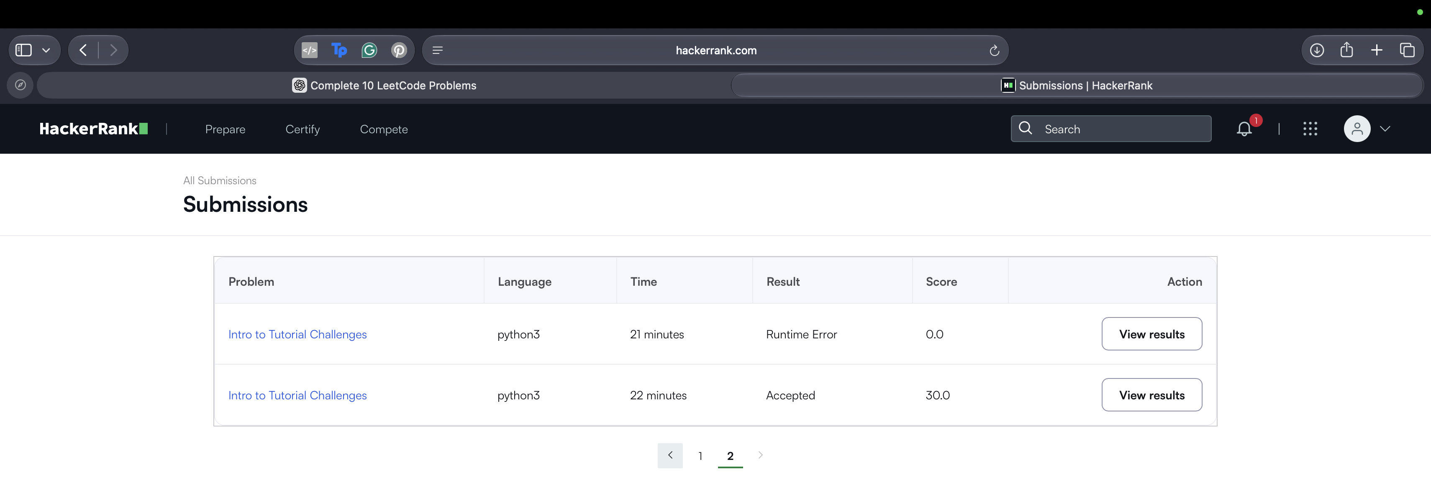

4. Badges and certificates
Badge earned: Problem Solving (3 stars). No HackerRank certificate has been earned yet.

