WOXSEN UNIVERSITY
B.Tech Artificial Intelligence and Machine Learning | Design and Analysis of Algorithms
LeetCode Profile
Name | Student ID | Platform / username | Profile link
D. Ritheek | 25WU0102057 | LeetCode / ritheekyadav | leetcode.com/u/ritheekyadav

1. Profile login screenshot
LeetCode profile of ritheekyadav: 15 problems solved (3 Easy, 11 Medium, 1 Hard), all in Python3.
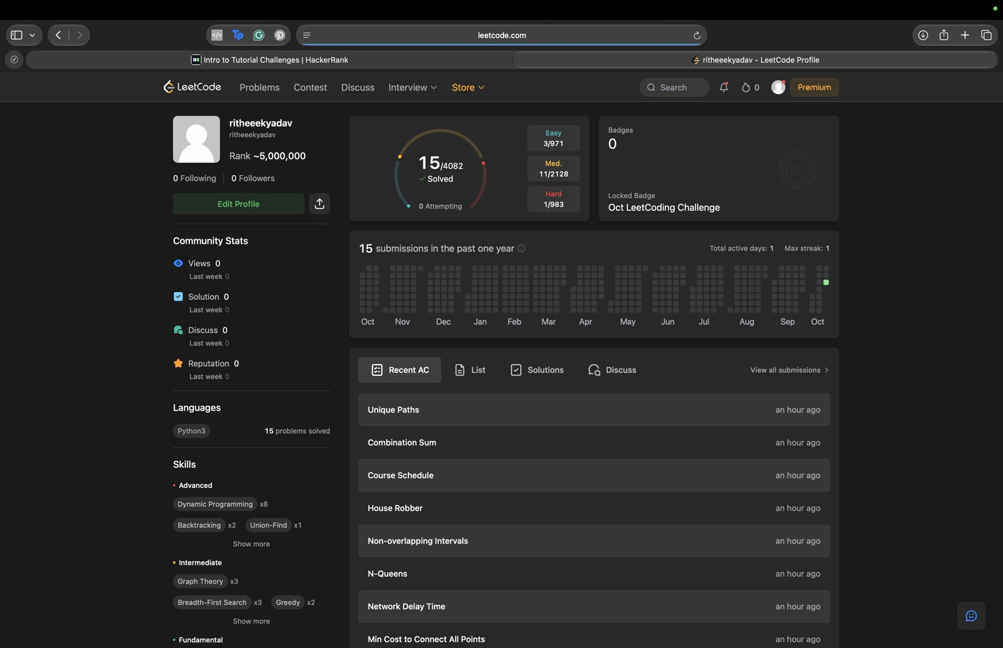

2. Problems solved (15)
Every problem below shows Accepted on LeetCode. Each screenshot is in section 3, in the same order.
No. | Problem name | Difficulty | Topic / technique | Language
1 | Binary Search | Easy | Binary search | Python3
2 | Merge Sorted Array | Easy | Two pointers / sorting | Python3
3 | Maximum Product Subarray | Medium | Dynamic programming | Python3
4 | Climbing Stairs | Easy | Dynamic programming | Python3
5 | Coin Change | Medium | Dynamic programming | Python3
6 | Longest Increasing Subsequence | Medium | Dynamic programming | Python3
7 | Jump Game | Medium | Greedy | Python3
8 | Min Cost to Connect All Points | Medium | MST (Prim / Kruskal) | Python3
9 | Network Delay Time | Medium | Dijkstra shortest path | Python3
10 | N-Queens | Hard | Backtracking | Python3
11 | Non-overlapping Intervals | Medium | Greedy | Python3
12 | House Robber | Medium | Dynamic programming | Python3
13 | Course Schedule | Medium | Graph / topological sort | Python3
14 | Combination Sum | Medium | Backtracking | Python3
15 | Unique Paths | Medium | Dynamic programming | Python3

3. Accepted submission screenshots
1. Binary Search (Easy) - Accepted
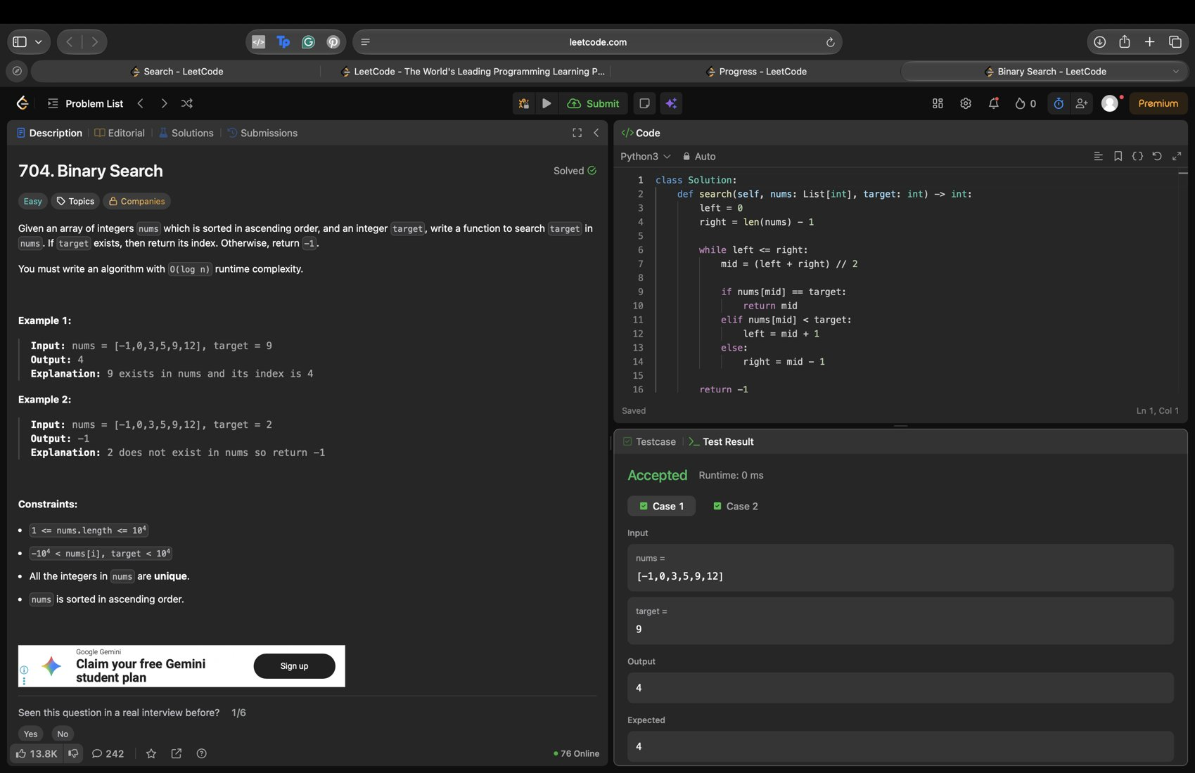
2. Merge Sorted Array (Easy) - Accepted
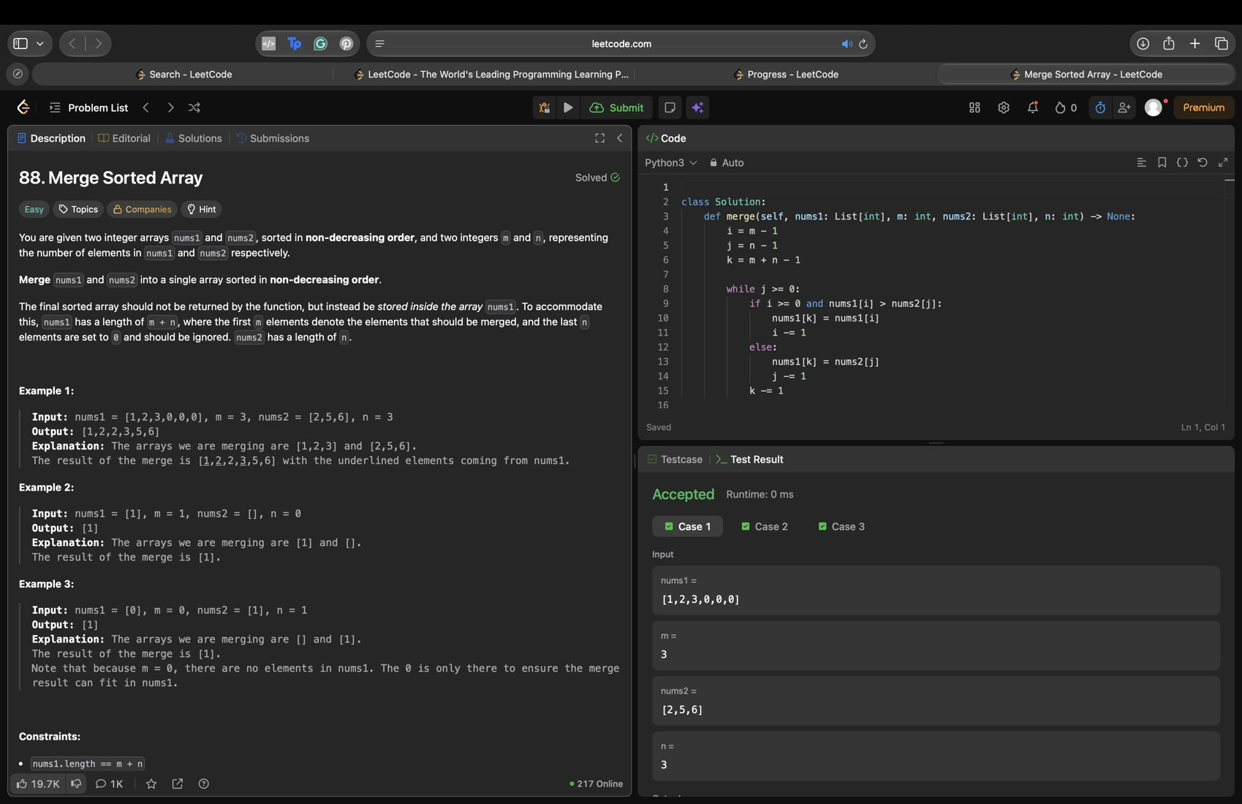
3. Maximum Product Subarray (Medium) - Accepted
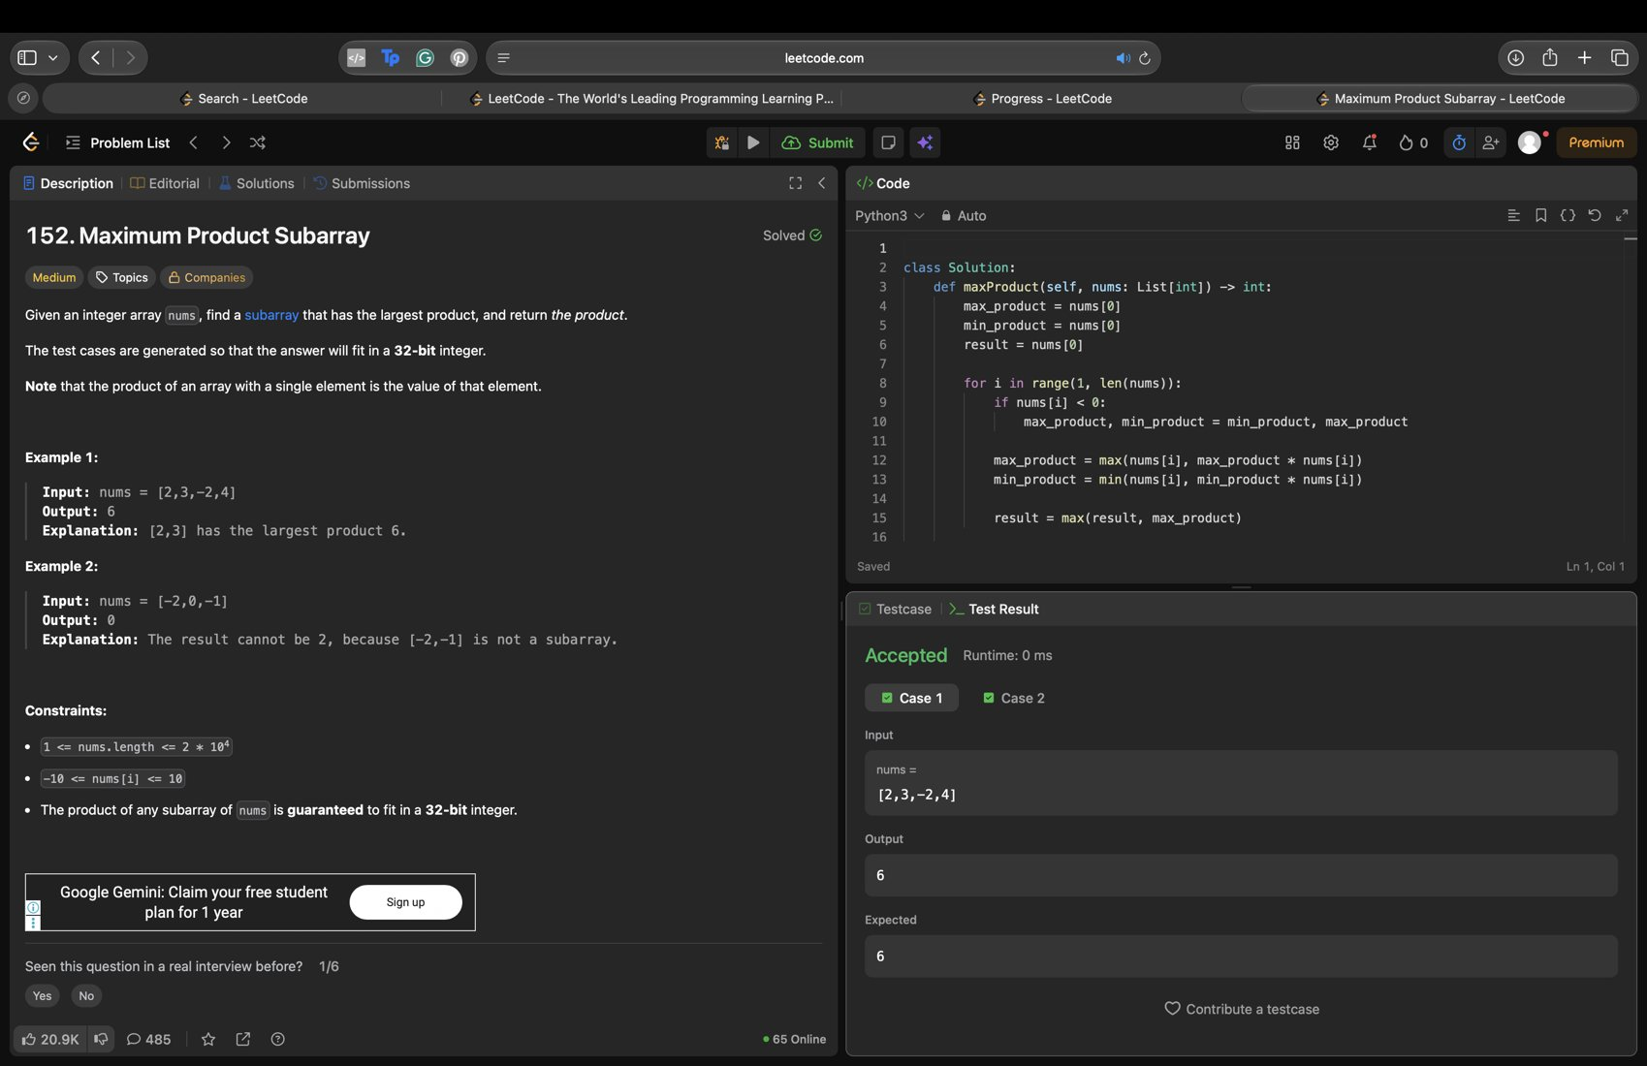
4. Climbing Stairs (Easy) - Accepted
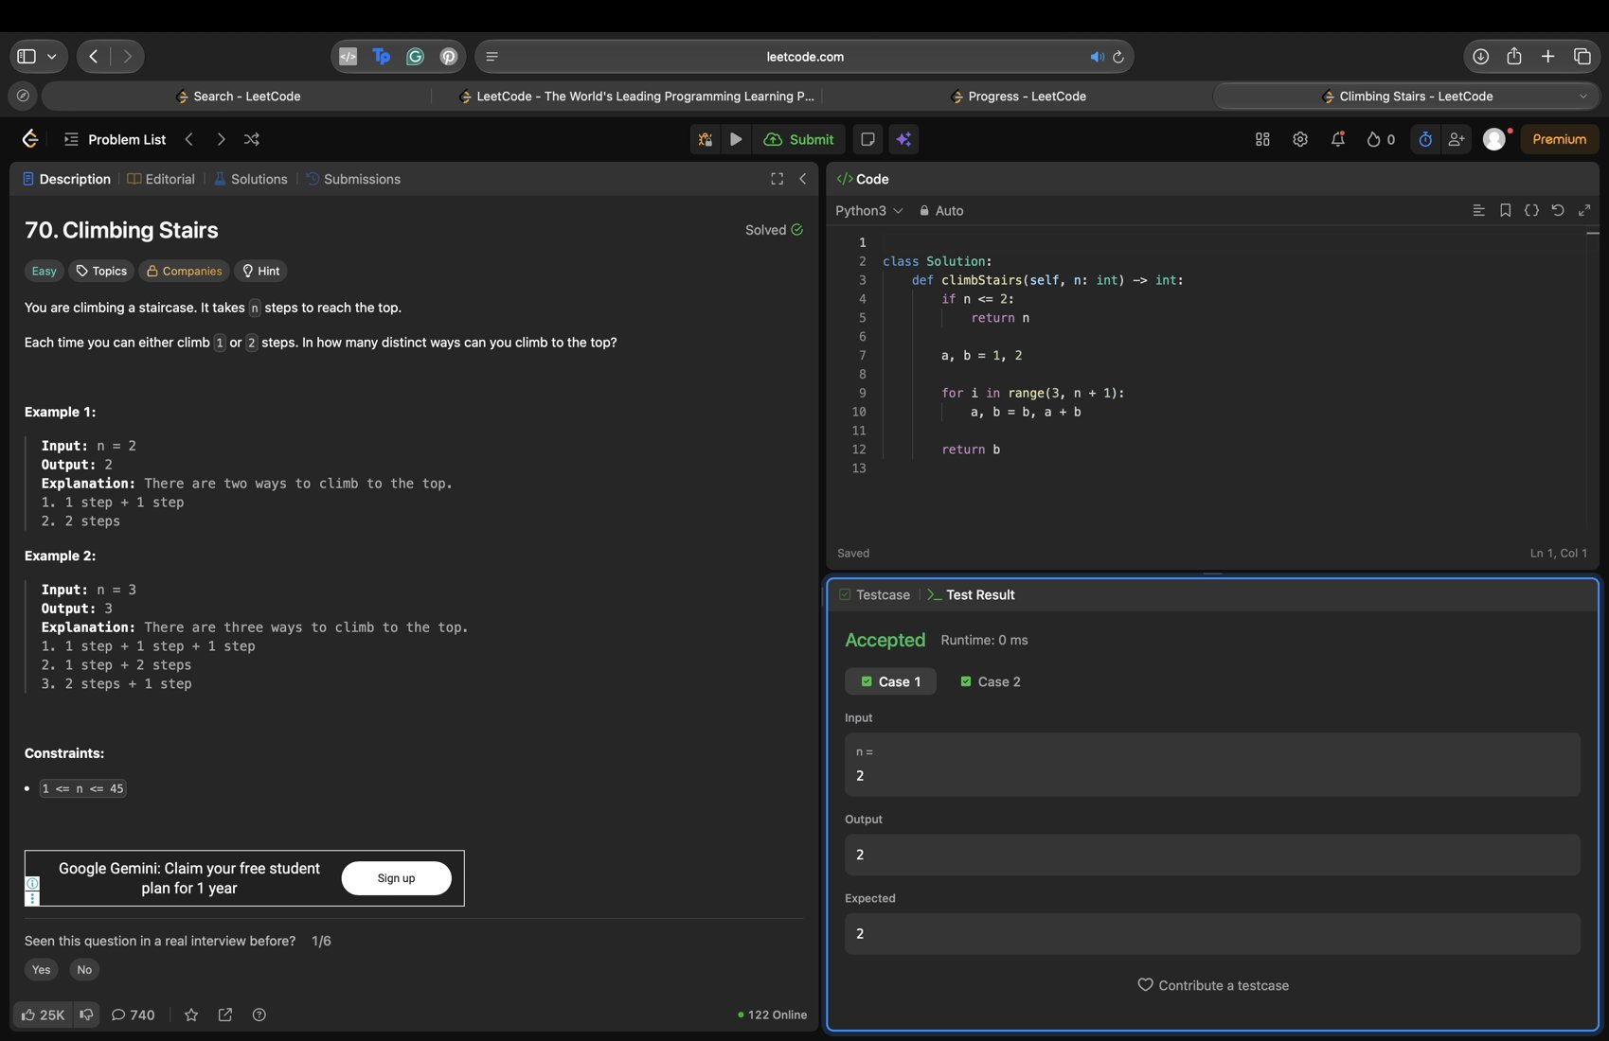
5. Coin Change (Medium) - Accepted
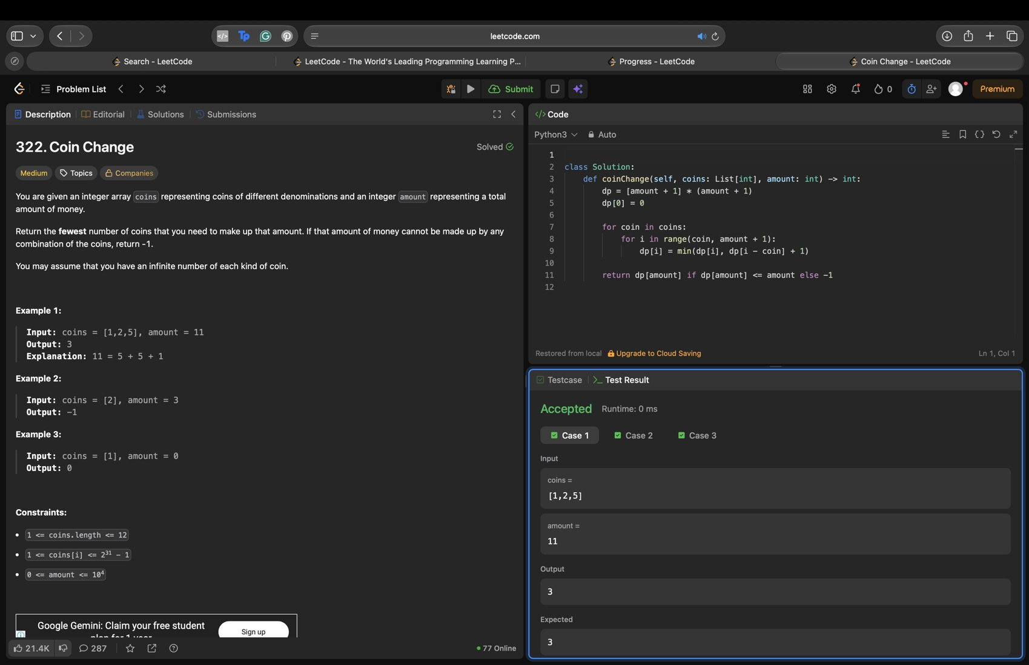
6. Longest Increasing Subsequence (Medium) - Accepted
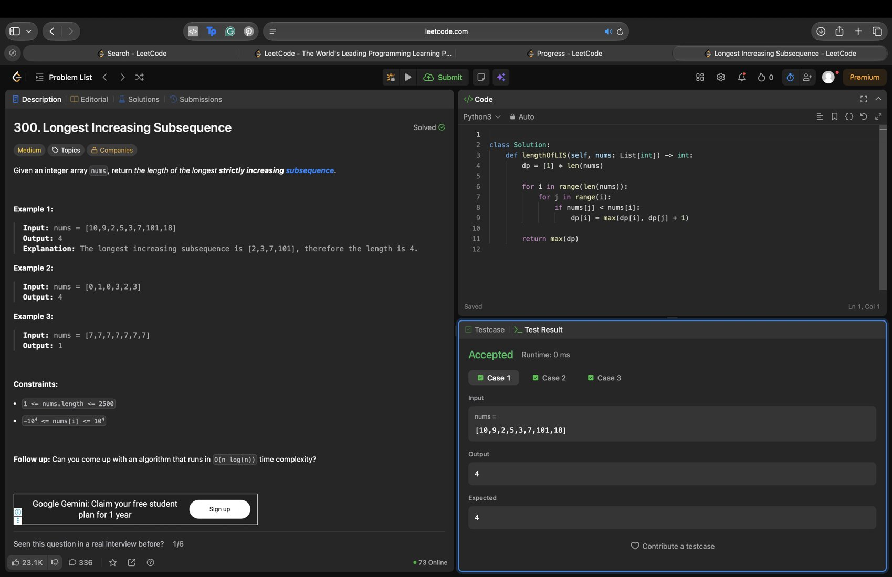
7. Jump Game (Medium) - Accepted
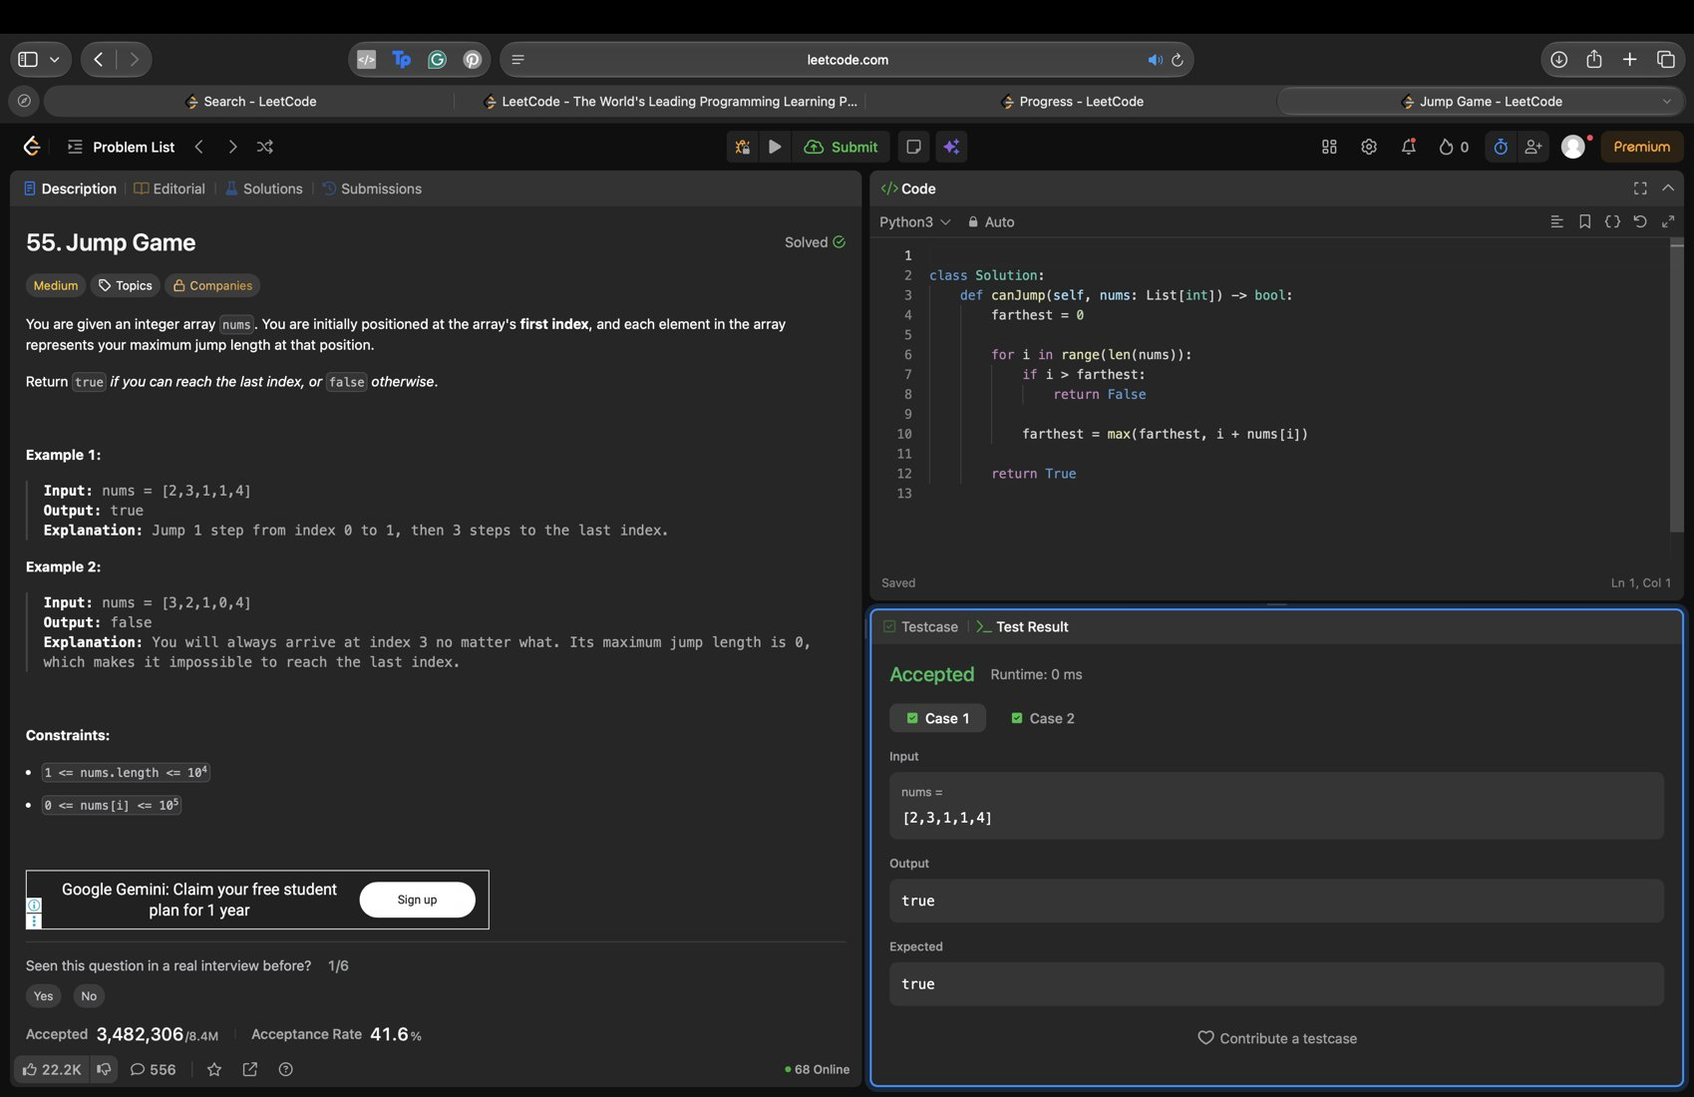
8. Min Cost to Connect All Points (Medium) - Accepted
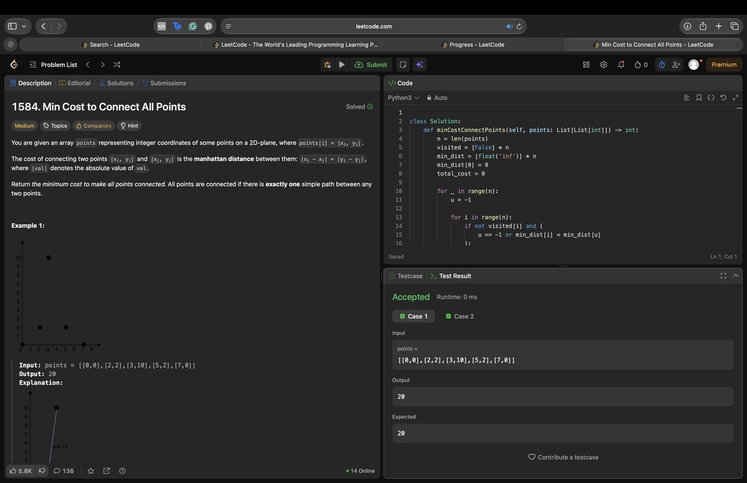
9. Network Delay Time (Medium) - Accepted
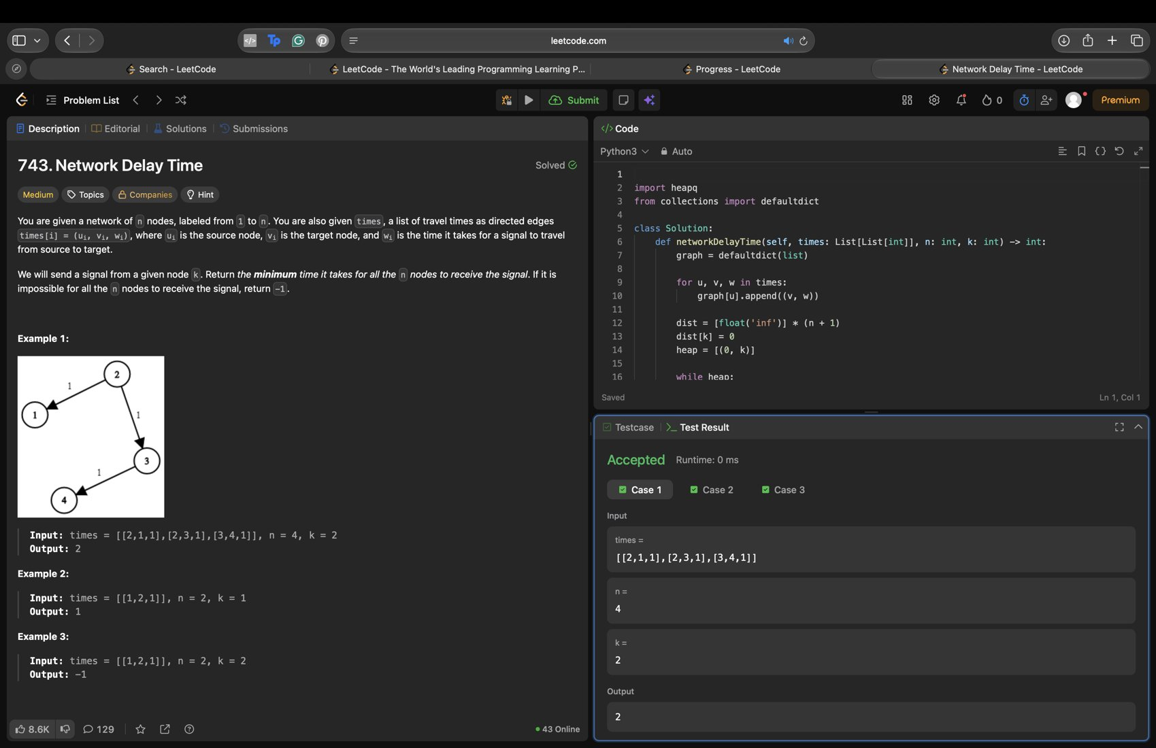
10. N-Queens (Hard) - Accepted
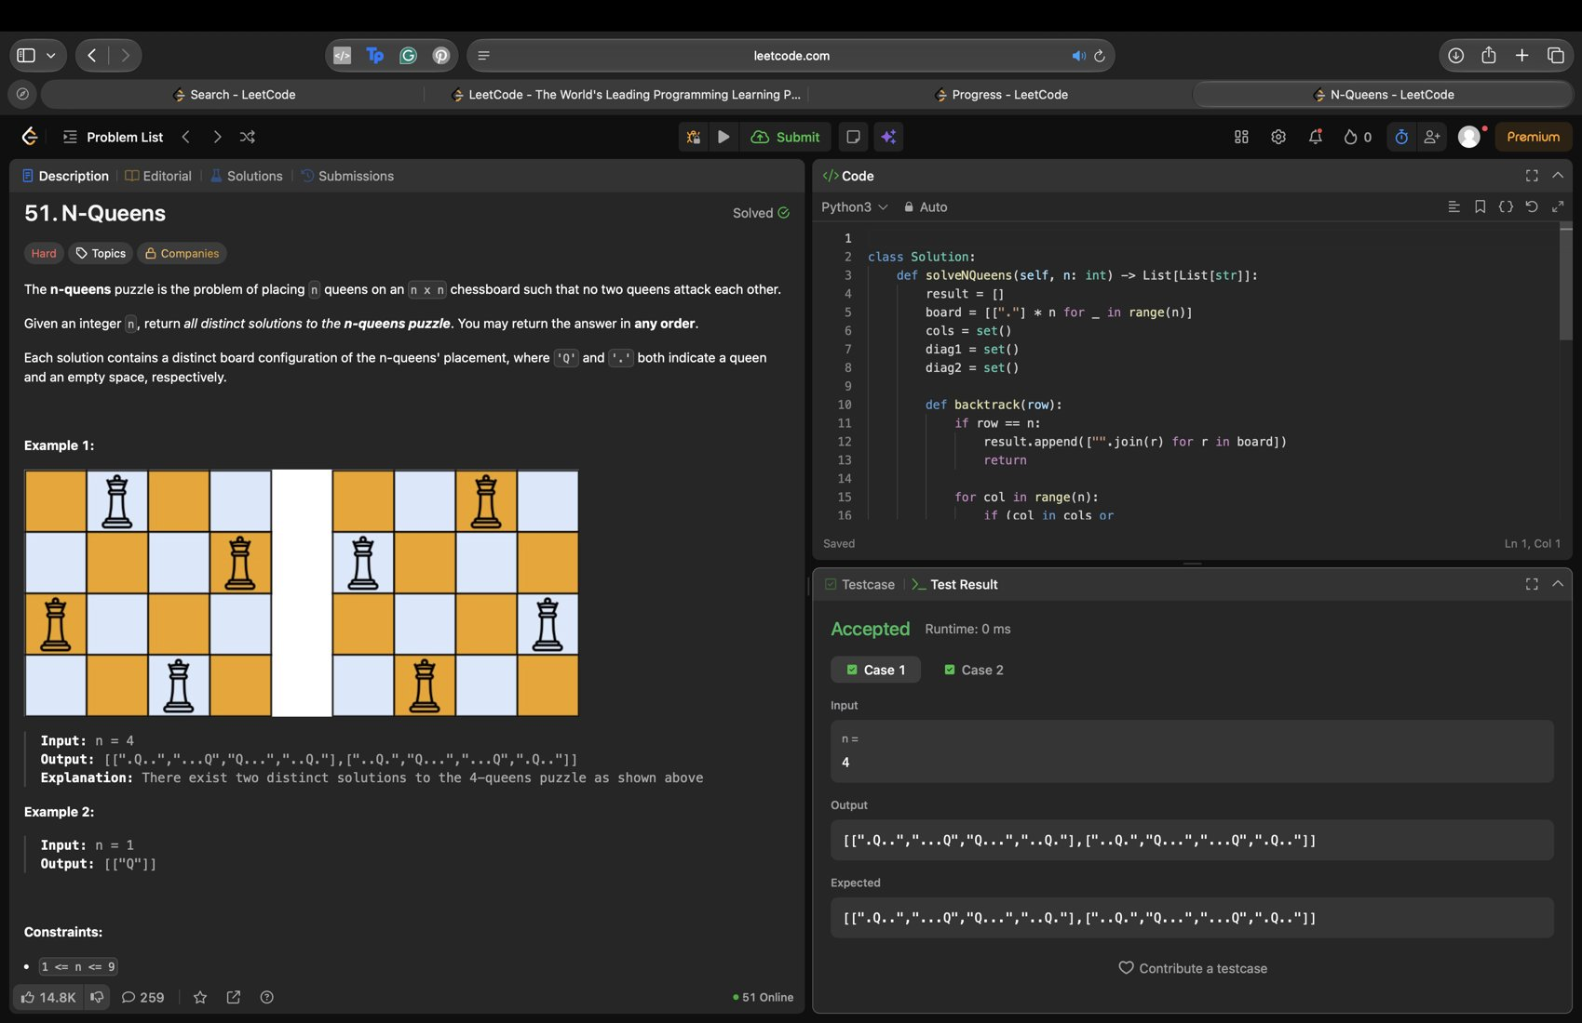
11. Non-overlapping Intervals (Medium) - Accepted
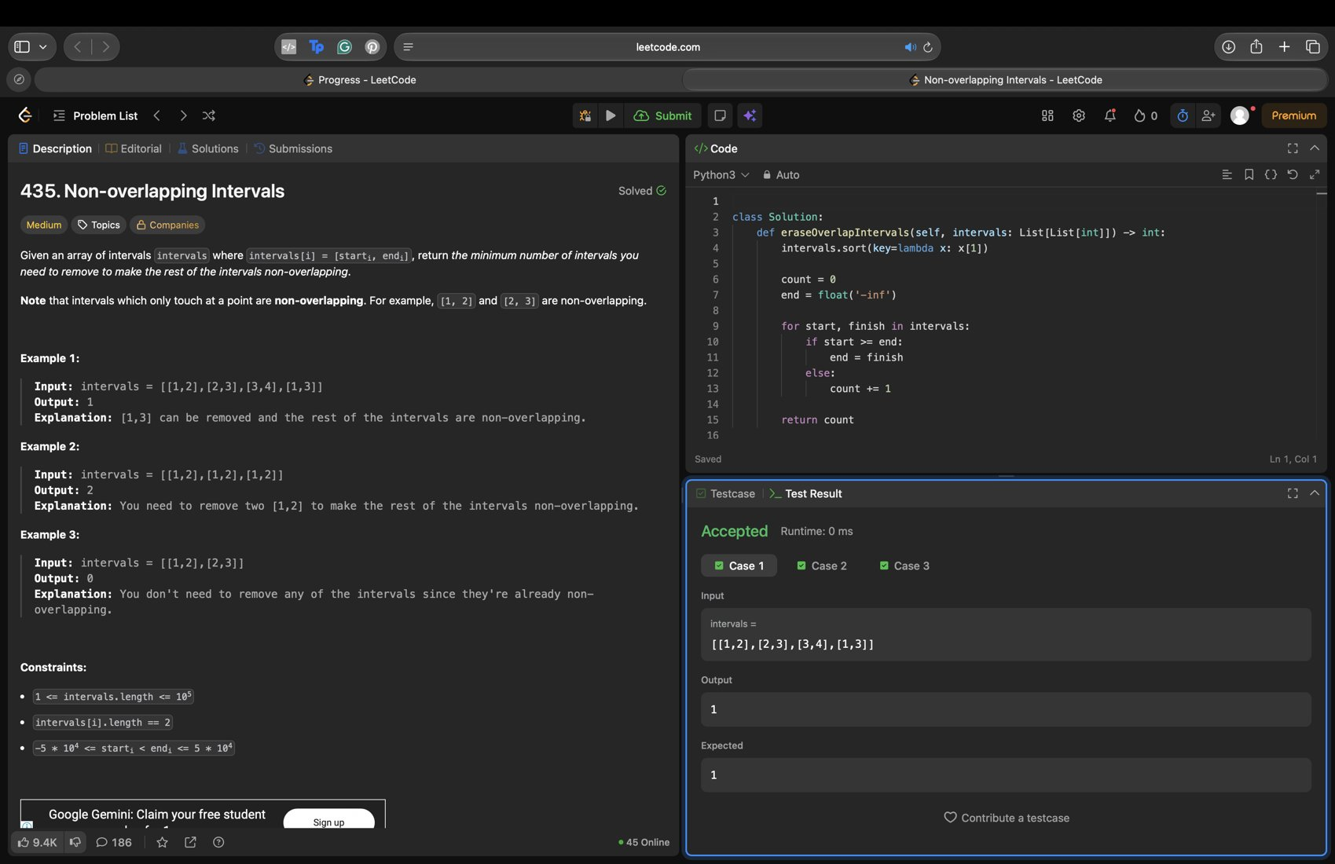
12. House Robber (Medium) - Accepted
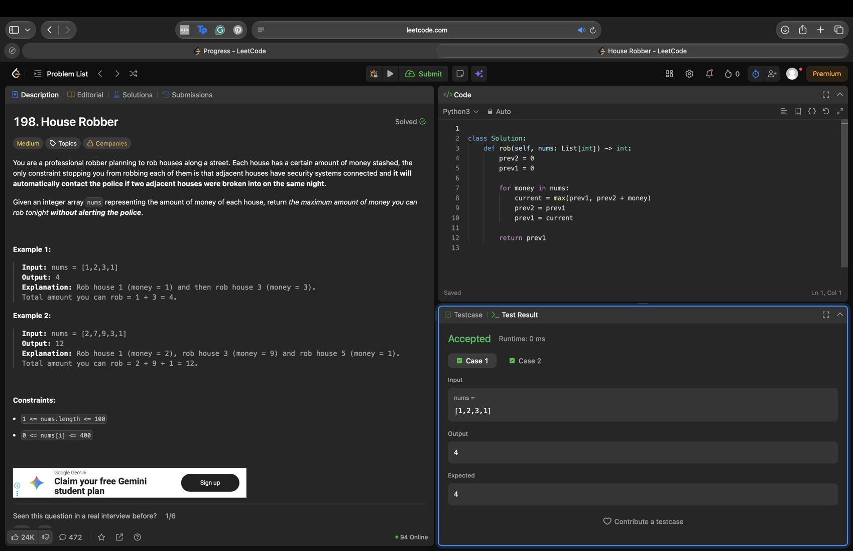
13. Course Schedule (Medium) - Accepted
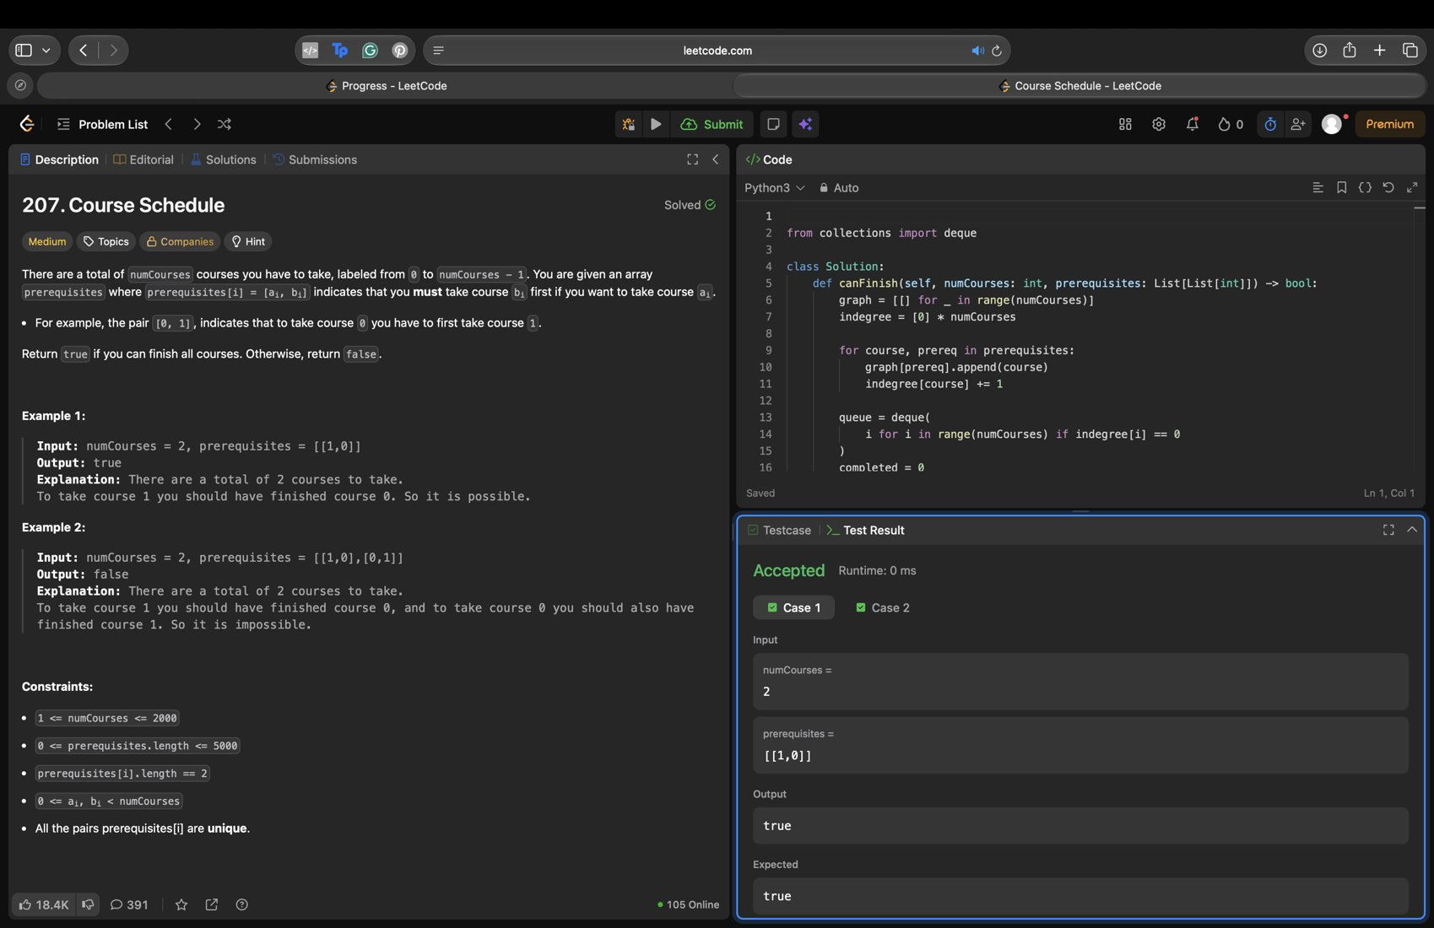
14. Combination Sum (Medium) - Accepted
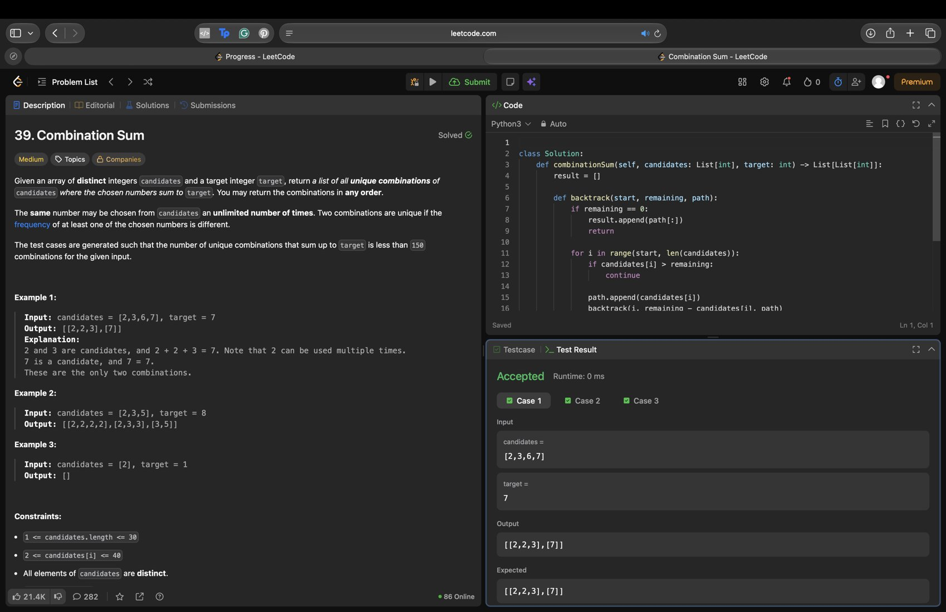
15. Unique Paths (Medium) - Accepted
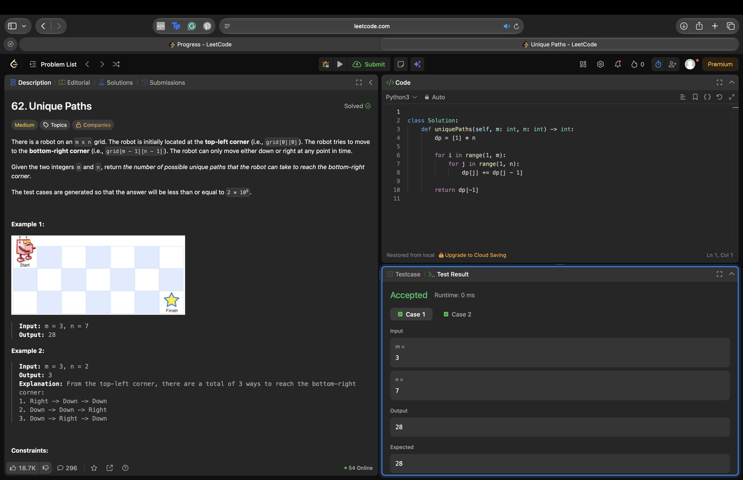

4. Certificates
No LeetCode certificate or badge earned yet.

